

SurvStar User Manual

*V2.0.0 2025*

Copyright © SOUTH SURVEYING & MAPPING TECHNOLOGY CO., LTD.

*All Rights Reserved

Contents

Chapter 1 Installation & Uninstall 1

* 1. Installation 1
  2. Uninstall 2

Chapter 2 Main Interface 3

* 1. Introduction 3
  2. General Information section 4
  3. Function section 6

Chapter 3 Project 7

* 1. Project Wizard 7
  2. Project Manager 9
     1. Search Project 11
     2. Open Project 11
     3. Delete project 12
     4. Create new project 13
     5. Import Project 15
     6. Export Project 17
     7. Project Details 17
  3. Project Data Manager 19
  4. Coordinate System 25
  5. Base Calibration 35
  6. Points Database 48
  7. Point Export 64
  8. APP Settings - RTK 66
  9. APP Settings – Total Station 71
  10. About Software 81

Chapter 4 Device - RTK 85

* 1. Communication 85
  2. Rover Mode 95
     1. Rover-No Datalink 99
     2. Rover-Internal UHF 99
     3. Rover-Cellular Network 103
     4. External Radio 105
     5. Rover-Bluetooth Data Link 106
     6. Rover-Receiver Network 110
  3. Base Mode 112
     1. Base-Internal UHF 115
     2. Base-Cellular Network 117
     3. Base-External Radio 121
  4. Static Mode 122
  5. Device Info 125
  6. Device Register 125
  7. Advanced Setting 126
     1. Receiver Advanced Setting 126
     2. Other Advanced Setting 128
  8. ConfigList 130

Chapter 5 Device – Total Station 133

* 1. Connection 133
  2. Instrument Station Setting 136
  3. BS Check 141
  4. STN. Ht 142

Chapter 6 Survey - RTK 145

* 1. Point Survey 145
  2. Detail Survey 160
  3. Point Stakeout 161
  4. Line Stakeout 167
  5. AR Stakeout 170
     1. WIFI connection 171
     2. Datalink settings 171
     3. Point Stakeout 173
  6. Photogrammetry 178
     1. Online solution 180
     2. Local solution 185
     3. 3D modeling 189
  7. Laser Survey 195
     1. Laser Survey 197
     2. Drawing while collecting 200
     3. Intersection function 202
     4. Laser Ranging 204
  8. Code, Survey and Plot 206
     1. Code library 206
     2. Code box part 209
     3. Graph Part 211
     4. Main operation process 215
  9. CAD 221
  10. PPK Survey 228
  11. Elevation Control 232
  12. GIS Survey 237
  13. Sea Survey 245
  14. Line Construction Stakeout 246
  15. Line Pointwise Stakeout 246
  16. Cross-section Survey 246
  17. Cross-section Stakeout 246

Chapter 7 Survey – Total Station 247

* 1. Point 247
  2. Point Stakeout 248
  3. Line Stakeout 250
  4. CAD Stakeout 253

Chapter 8 Tools 254

* 1. Localization 254
  2. Coordinate Converter 263
  3. Angle Converter 269
  4. COGO 280
     1. Coordinate Inverse 281
     2. Offset Distance/Angle 282
     3. Spatial Distance 283
     4. Angle Calculation 284
     5. Intersection 285
     6. Resection 286
     7. Forward Intersection 287
     8. Coordinate Traverse 287
     9. Offset Point 289
     10. Divide Line Equally 289
     11. Circle Center 290
     12. Traverse Calculation(2 Pts direction) 292
  5. FTP Share 292
  6. File Share 295
  7. Post-Process Points 296

# Chapter 1 Installation & Uninstall

## Installation

1. Copy the APK file to android device storage.

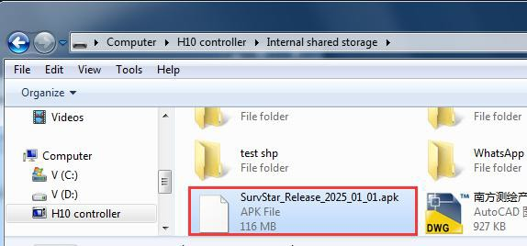

1. Find the APK file in android device and click it to install SurvStar.

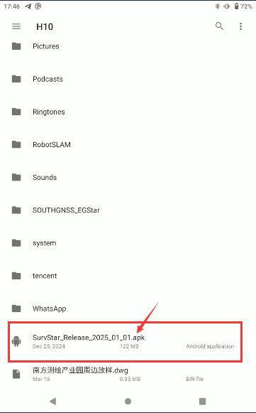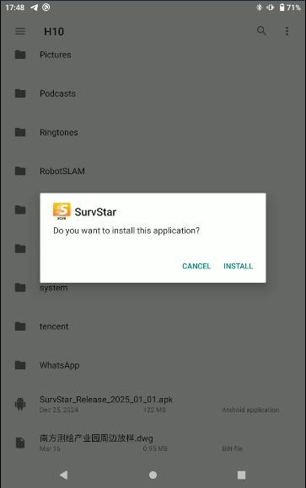

## Uninstall

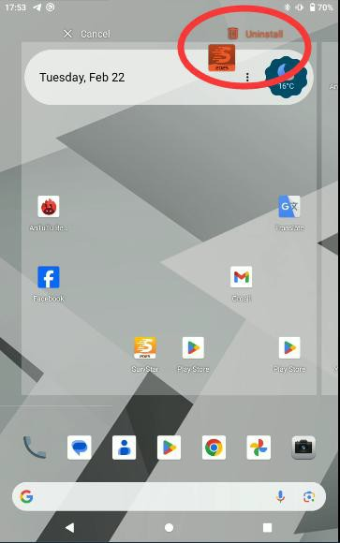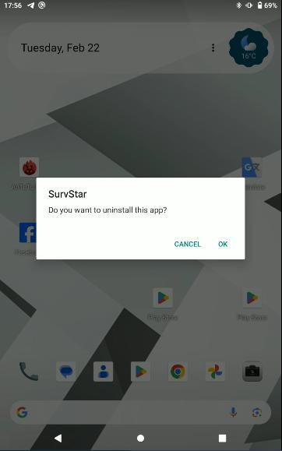Find the SurvStar icon in android device, and long press it then drag and drop it to Uninstall.

# Chapter 2 Main Interface

## Introduction

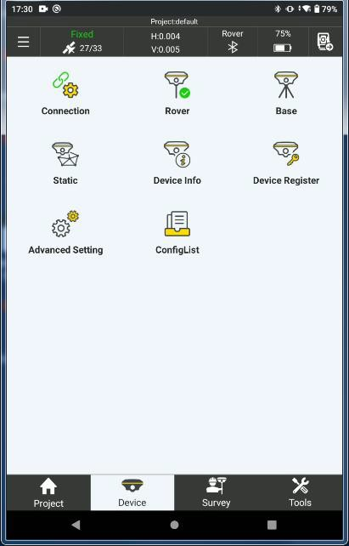Open SurvStar, on the top it is General Information section (including the current project name, gnss quality status, satellite number, HRMS and VRMS, work mode and datalink, device battery percentage, device connection), on the bottom it is the Function section (including four main functions: Project, Device, Survey and Tools)

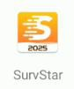

## General Information section

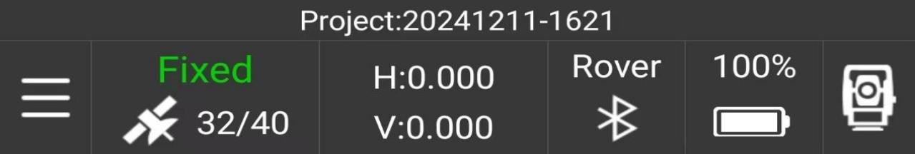

current project name.

gnss status: Single, DGPS, Float or Fixed. satellite number: Used/Tracked satellites.

H and V: HRMS and VRMS, displayed in meters. work mode: Base, Rover or Static.

datalink: UHF, internet, external or Bluetooth (by collector internet). device battery percentage.

device connection: check the device connection quickly.

Click 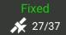 , we will enter to SAT Information page. In that page, we can check the position information, accuracy, base position, SAT skylot, SNR and SAT list.

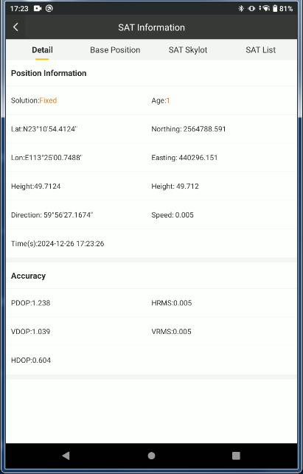 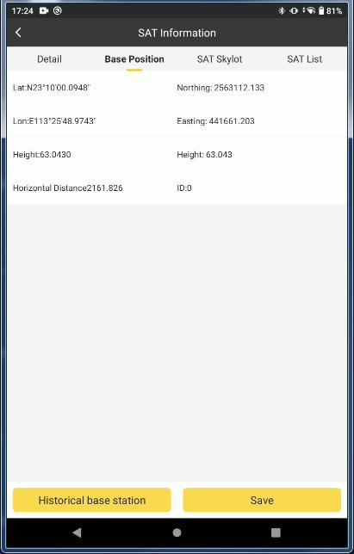

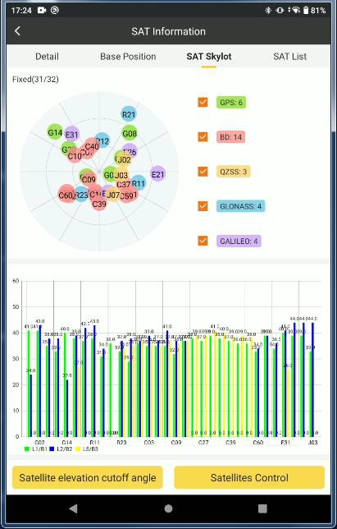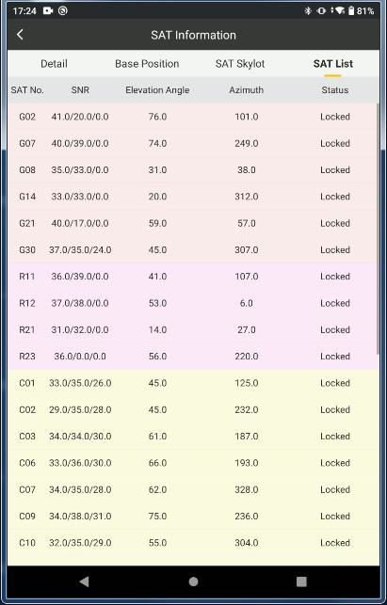

## Function section

There are four main section on the bottom: Project (*Chapter 3*), Device (*Chapter 4*), Survey (*Chapter 5*), Tools (*Chapter 6*)

# Chapter 3 Project

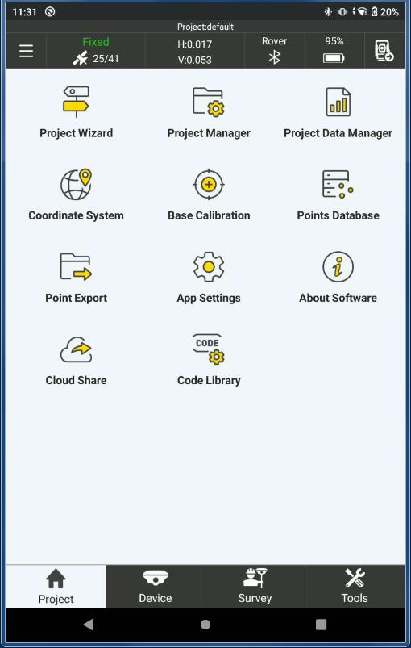

## Project Wizard

Project wizard is a quick workflow to start working by survstar, it contains the Project (Project Manager, Coordinate System), Device (Connection, Rover/Base/Static mode and datalink), Survey(Point Survey, Point Stakeout, Line Stakeout) configuration, Click the “Options” to change the configurations.

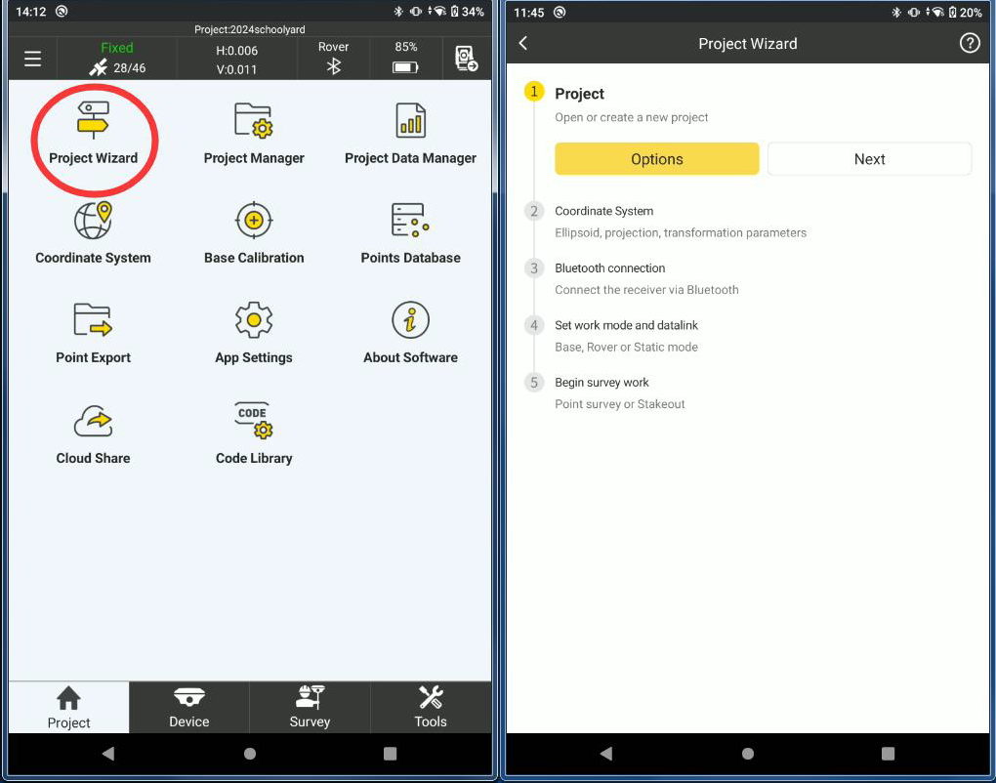

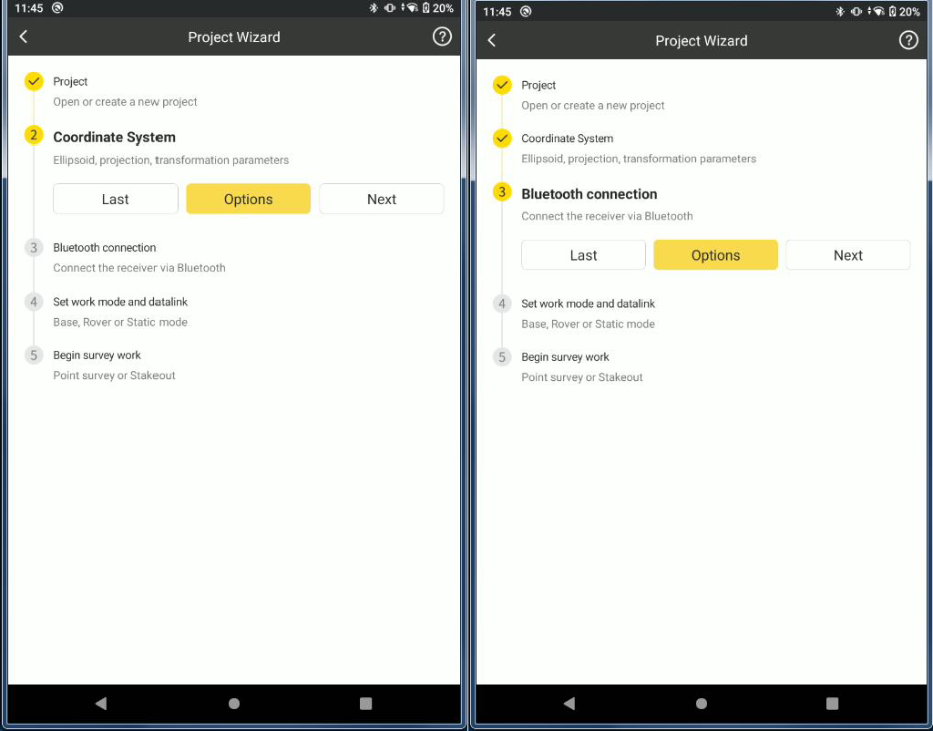

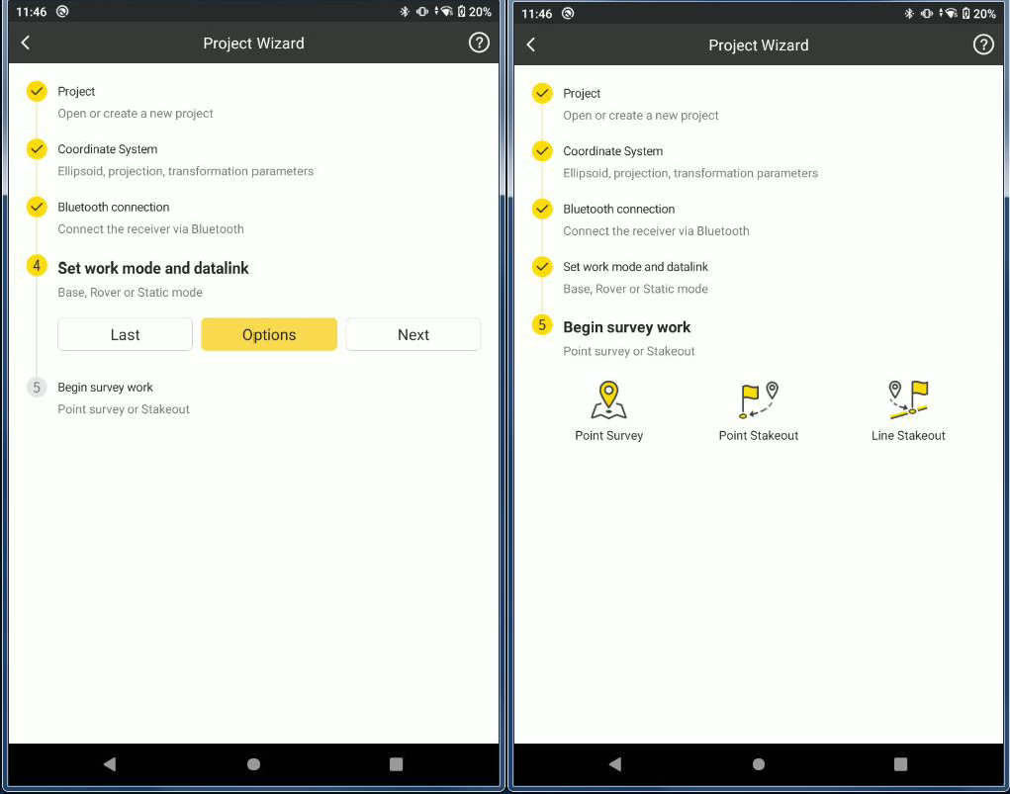

## Project Manager

Project Manager defines the title of a project, and where the project folder store. You can choose and check the data on the previous project, or create a new project file.

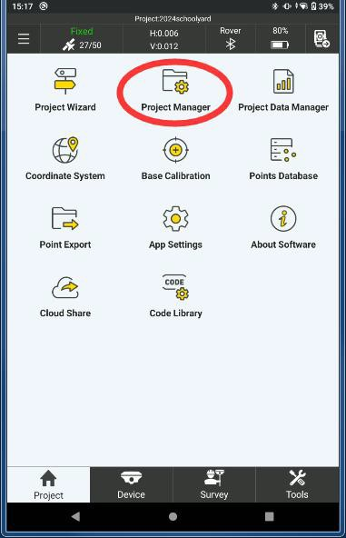

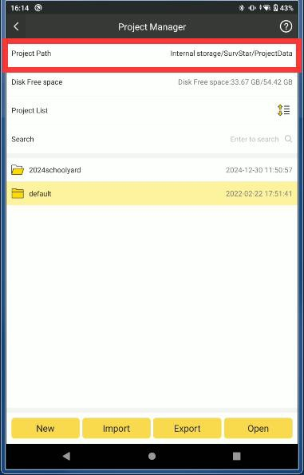Projects we created are saved in the default directory of controller: Internal storage/SurvStar/ProjectData.

## Search Project

In Project Manager-Project List, we can search projects.

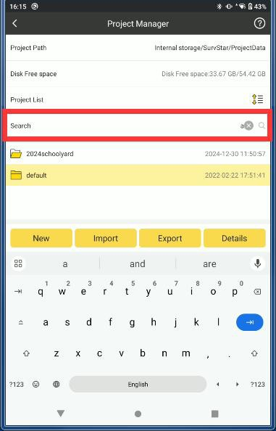

## Open Project

Choose the project, Click Open, then the project selected will be opened.

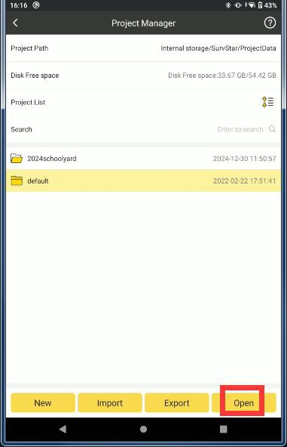

## Delete project

Long press for 1 second, the toolbar below will display delete button, click Delete, and this

project will be deleted.

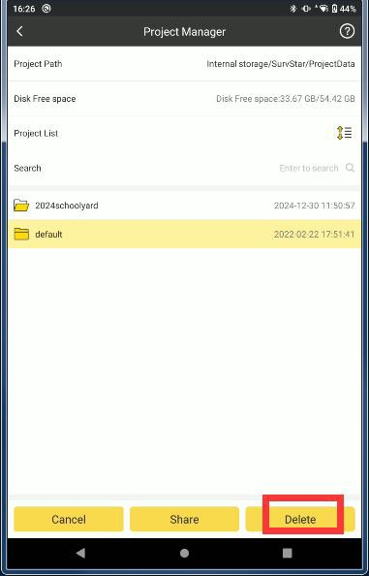

## Create new project

When we run SurvStar, we need to create a project and define basic information such as project name, operator and coordinate system type.

Click to create a new project,

New

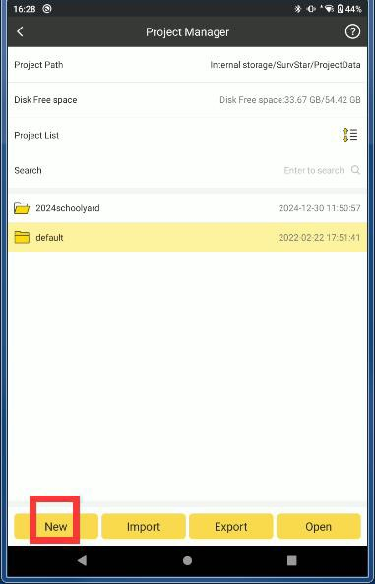

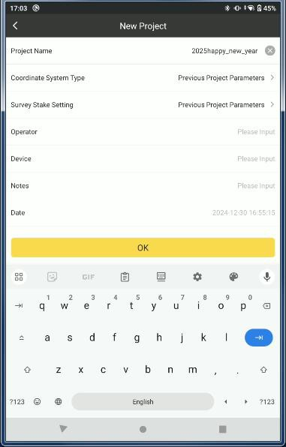Input the Project Name, project name doesn’t not support “space”, supports numbers/letters/-

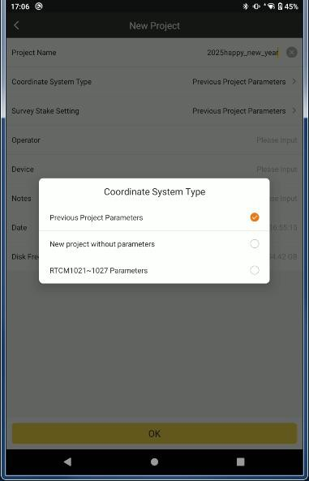Coordinate system type: Previous Project Parameters (use the same coordinate system parameters in previous project), New project without parameters (no projection and ellipsoid parameter, you need to set it on SurvStar-Project-Coordinate system later), RTCM1021~1027 Parameters (if select this one, then the Coordinate System parameter in SurvStar will not be used, SurvStar will use the coordinate system parameters which received by NTRIP CORS with RTCM1021~1027).

## Import Project

If projects from other controllers are copied into survStar/ProjectData, we can open them directly; if they are copied into other directory, we can import them by loading their project file (*.configure).

Click in Project Manager.

Import

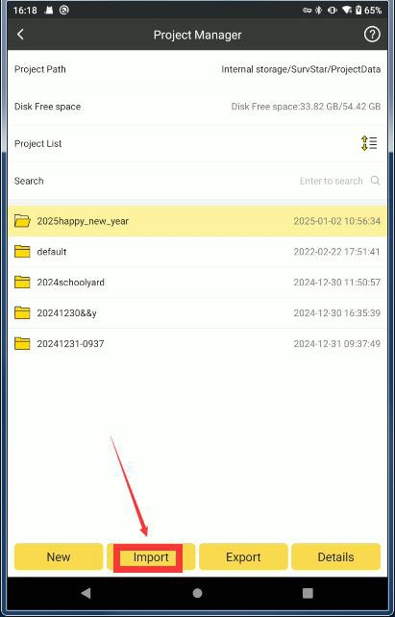

Find the target project folder, choose the project file (*.configure) saved before, and click OK. Then the project will be opened.

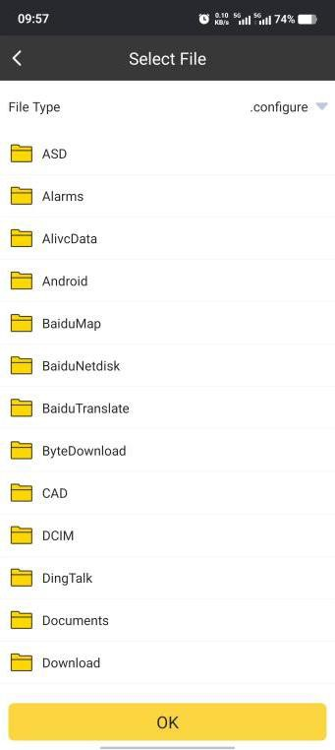

## Export Project

Click in Project Manager.

Export

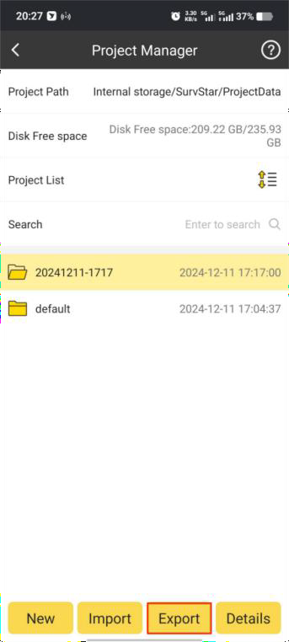

Choose the directory we want to save the project. Click OK. Then the project will be saved.

## Project Details

Choose the target project, and Click Details.

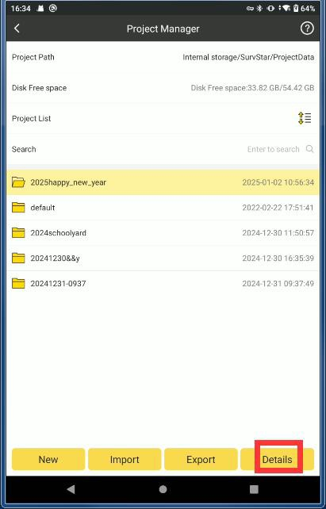

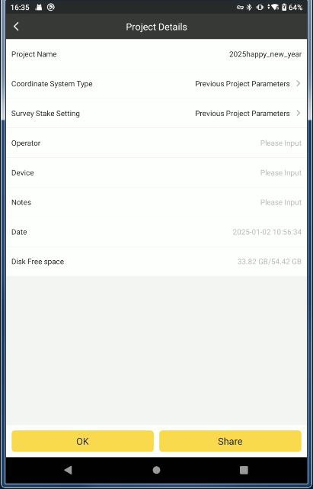2.We can find relevant project information, such as Project Name, Coordinate System type etc.

## Project Data Manager

With that function we can manage the surveyed data. We can create, import, delete and change the surveyed data.

New Project Data:

1. Click New.

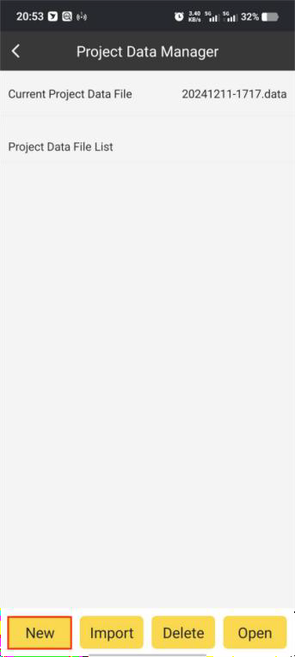

1. Input the name of the new project data and click OK.

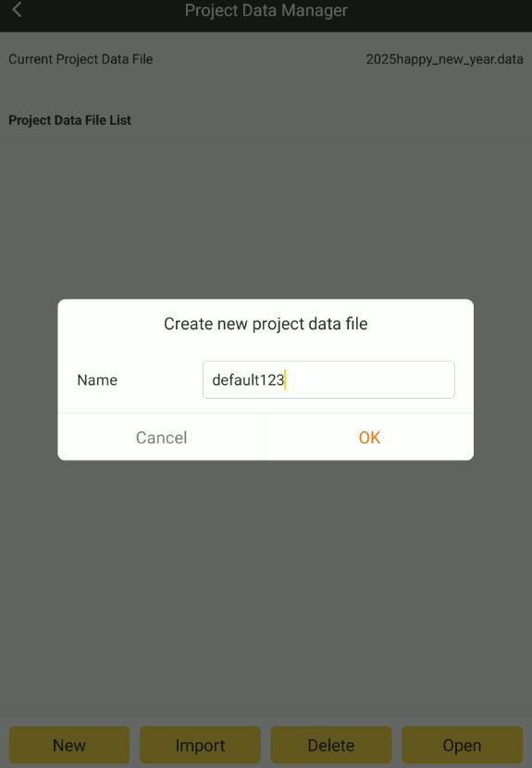

1. The new project data created successfully.

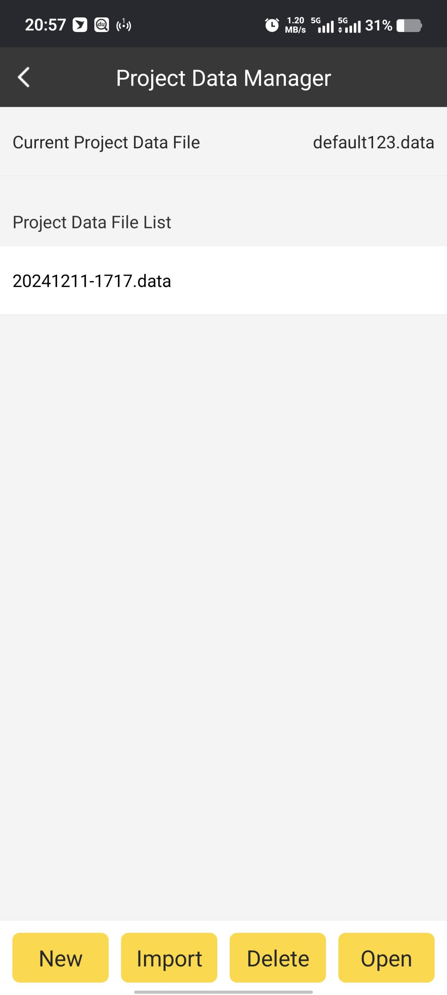

Import Project Data:

We can import the project data from the file (*. data).

1. Click Import.

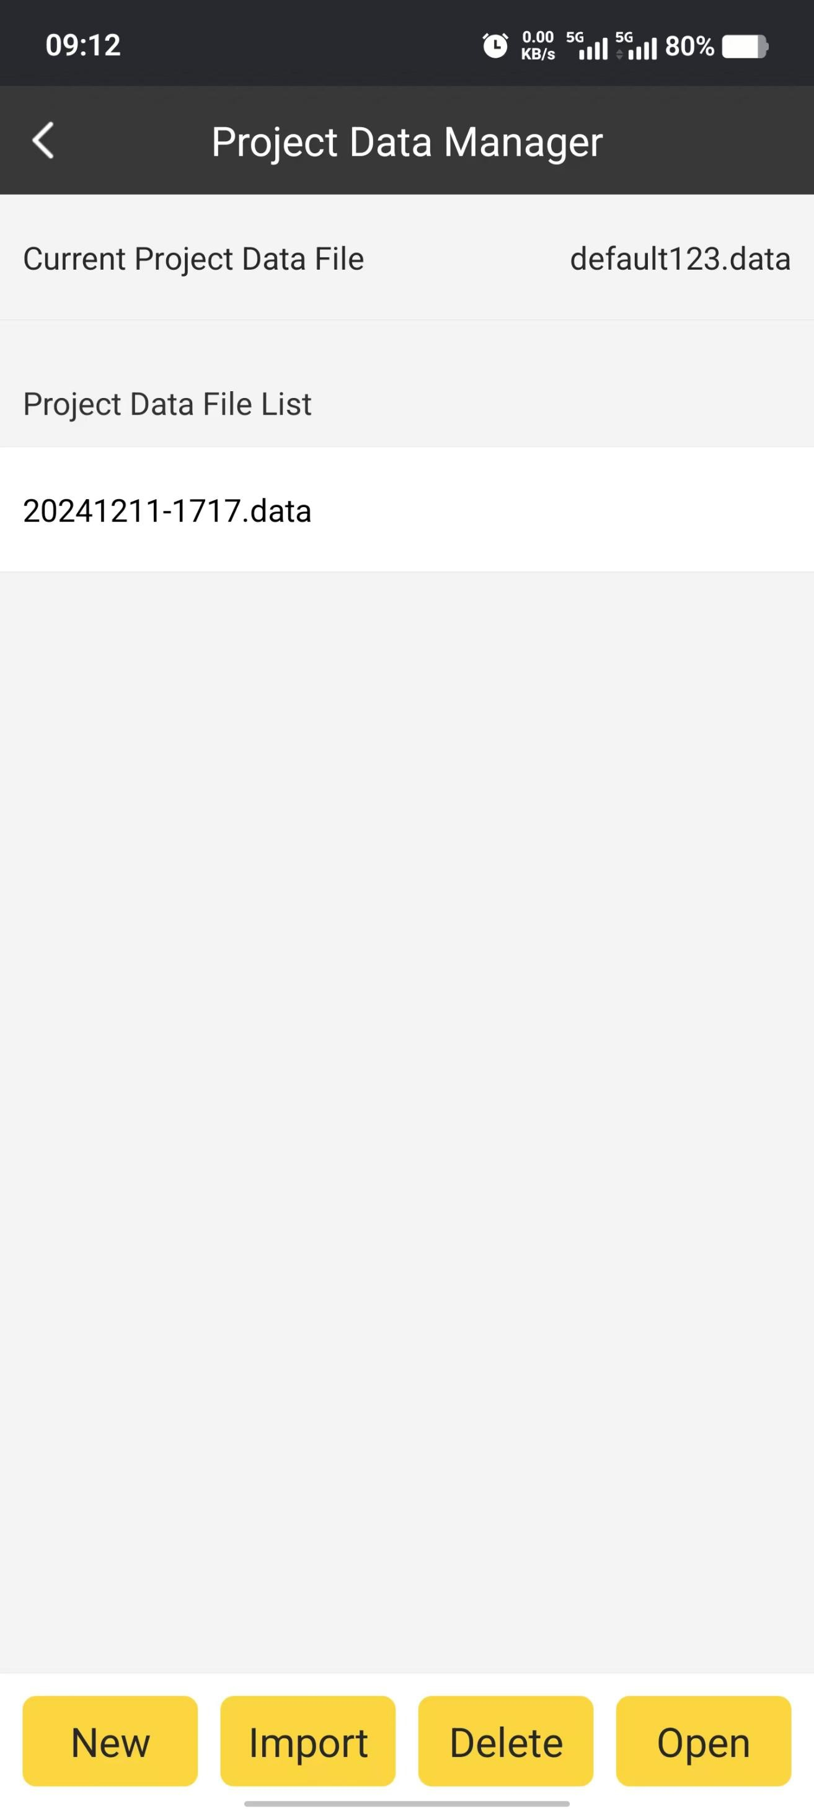

1. Find the correct location of the project data file and choose that file we wanted. Click

OK.

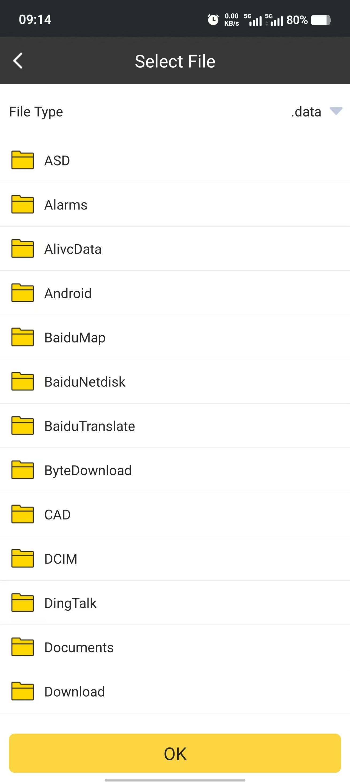

Delete Project Data:

1. Choose the project data we wanted to delete. Then click Delete.

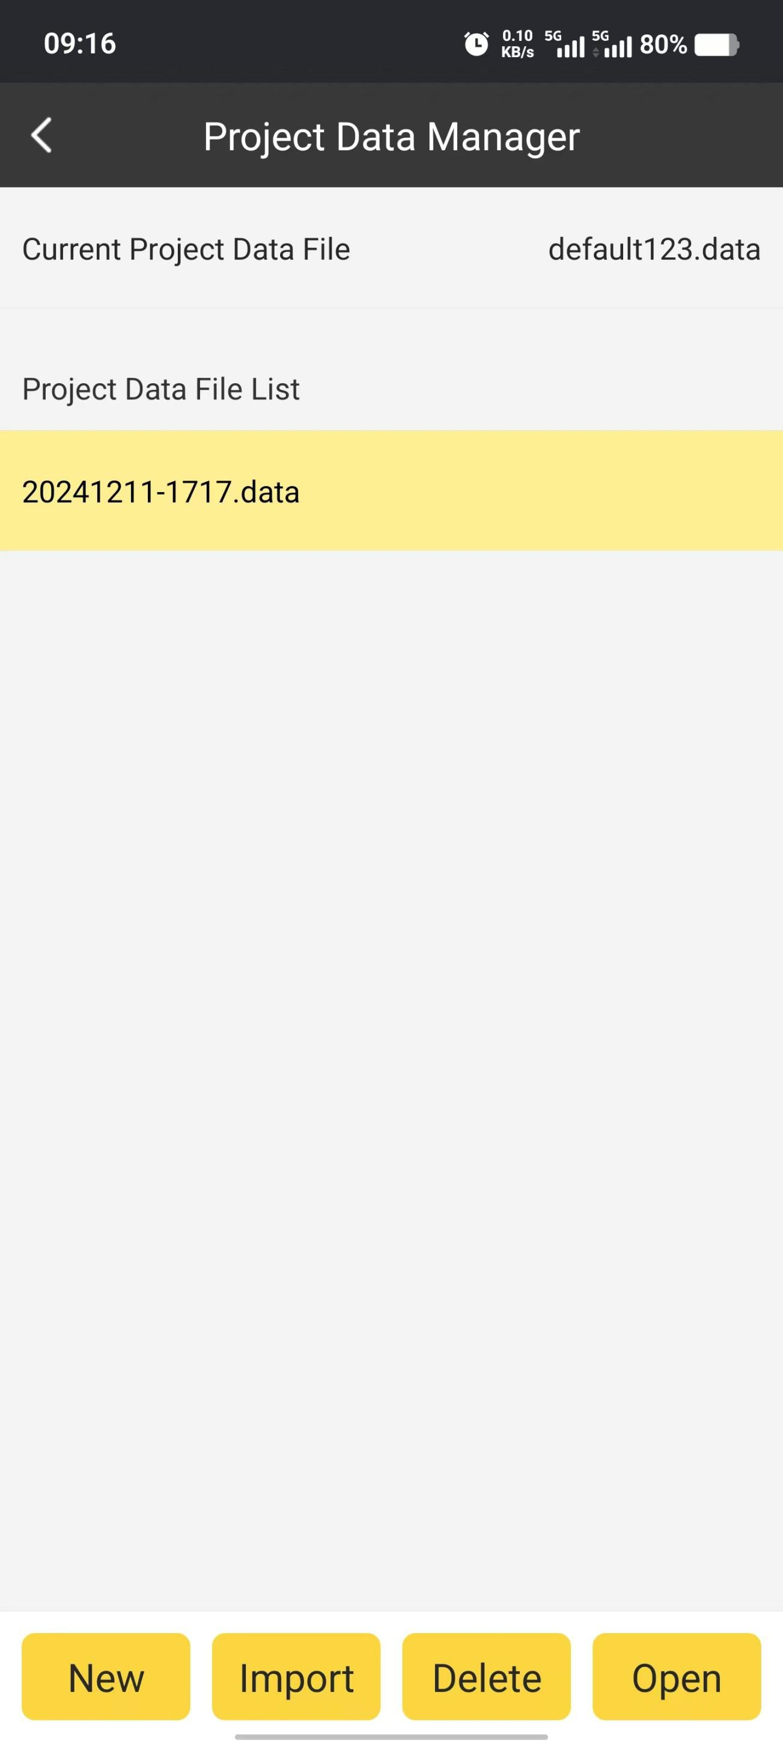

1. Click OK. The project data file will be deleted.

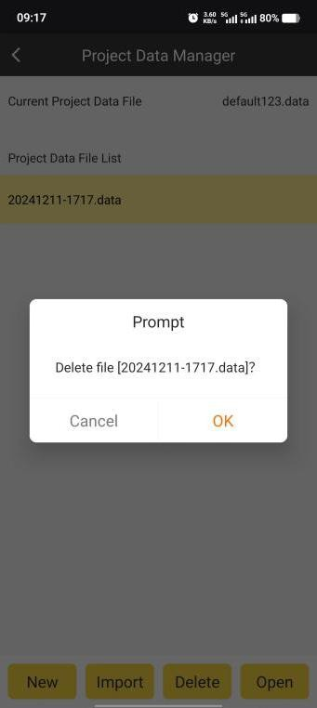

Open Project Data:

1. Choose the project data we wanted to open. Then click Open.



1. Then the chosen project data is opened.

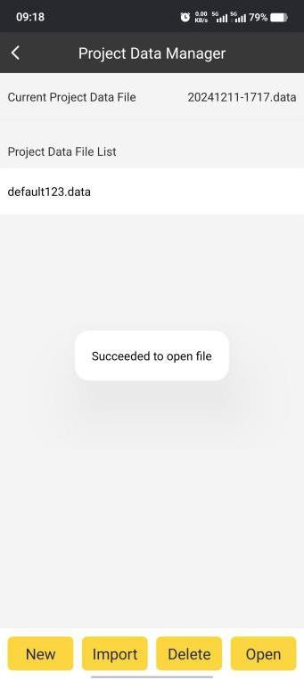

## Coordinate System

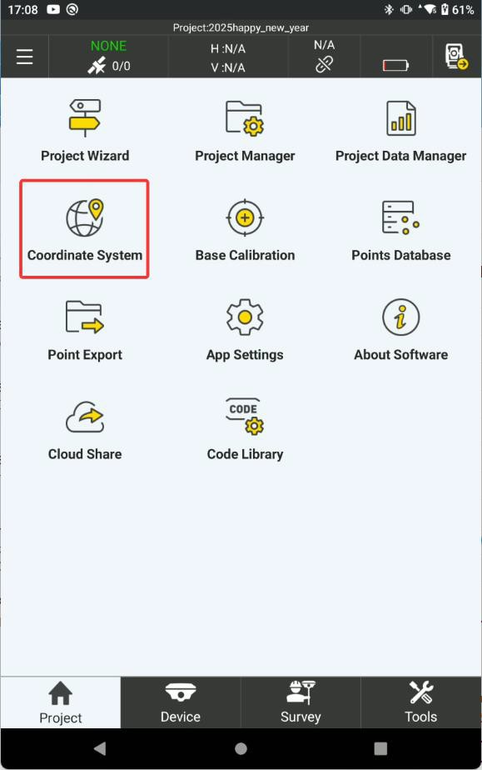

In coordinate system, we can create new coordinate system by defining the name, ellipsoid, projection, 7 parameters, 4 parameters, height fitting parameters, vertical adjustment parameters, plane grid file, geoid file and local offsets.

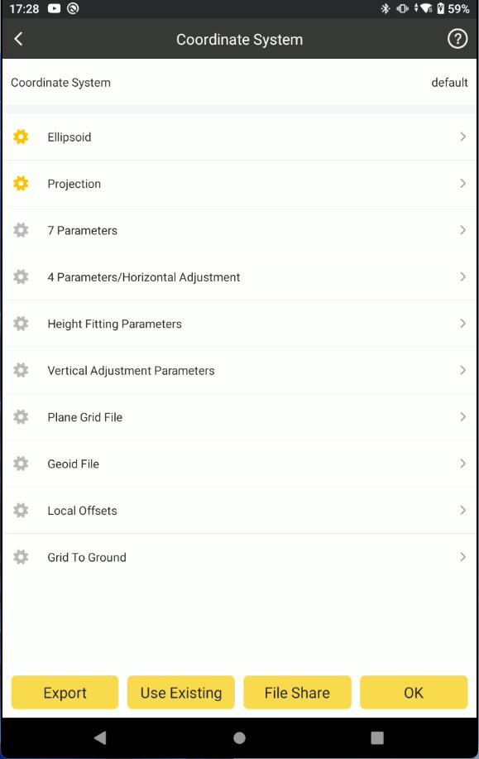

Ellipsoid:

1. In Ellipsoid, we can define the existing Ellipsoid for current project.

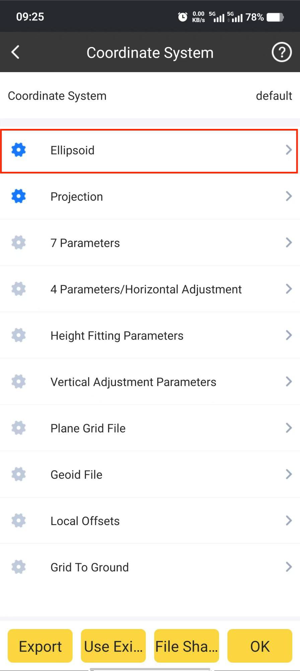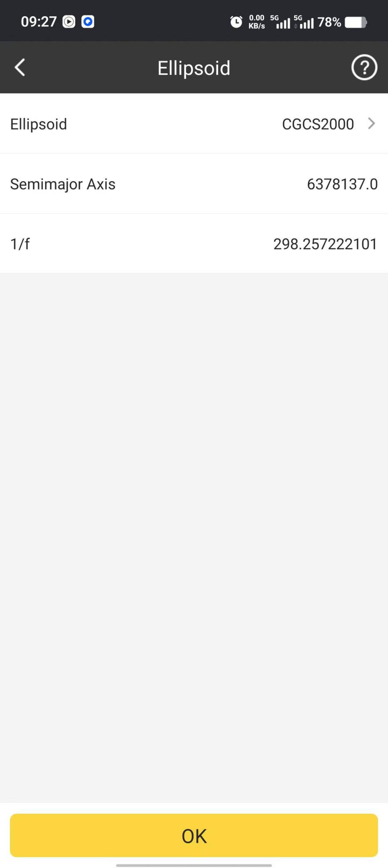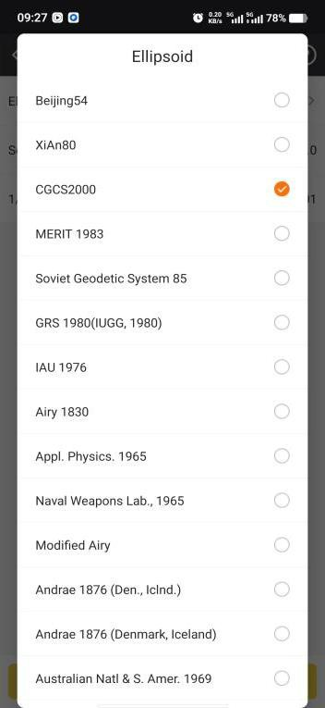

1. Also in User Define, we can define the ellipsoid by inputting Semimajor Axis and 1/f parameters.

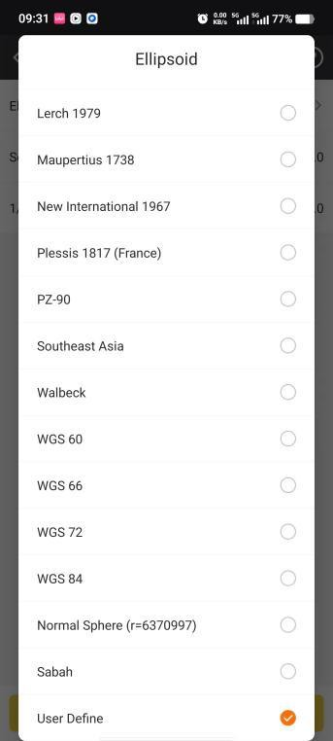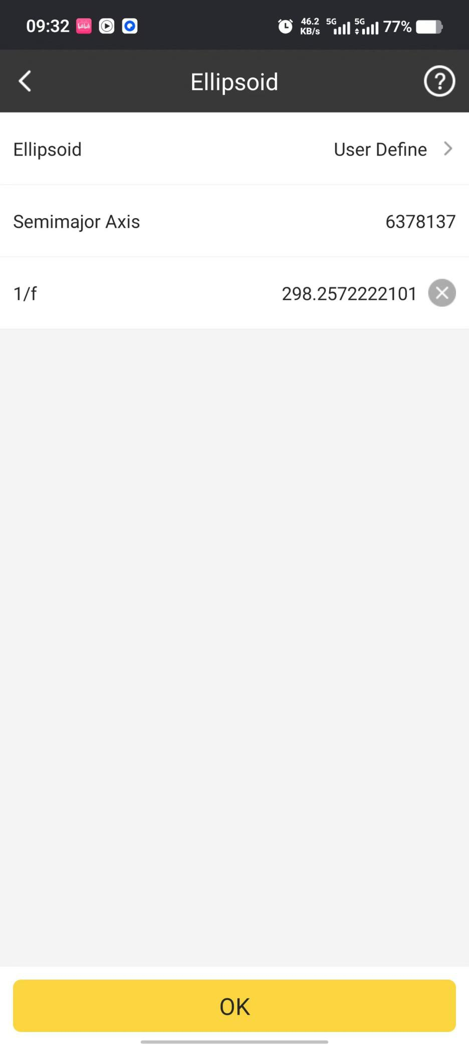

Projection:

In Projection, we can define relevant projection parameters such as Projection Mode, Central Meridian, Latitude of Origin and so on.

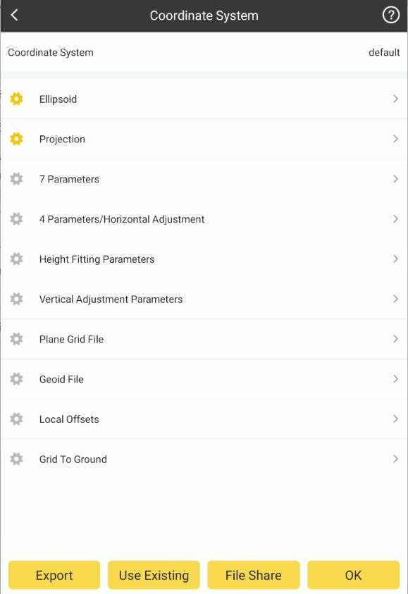

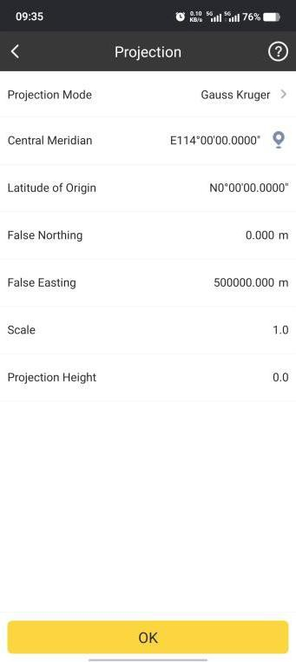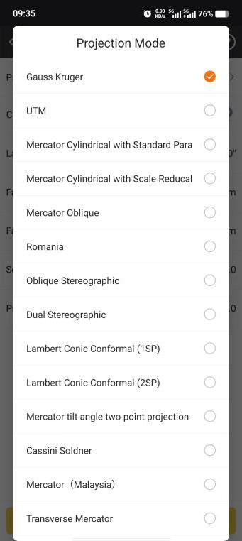

Note: We can acquire Central Meridian of current position by clicking . Coordinate Parameters:

Also we can define 7 Parameters, 4 Parameters, Height Fitting Parameters, Vertical Adjustment Parameters and Local Offsets.

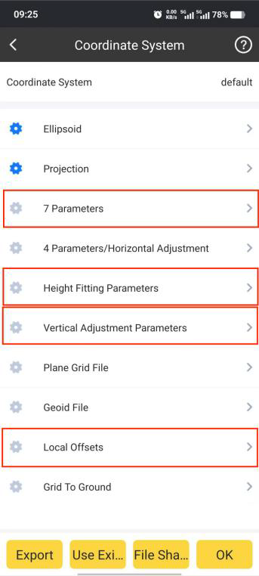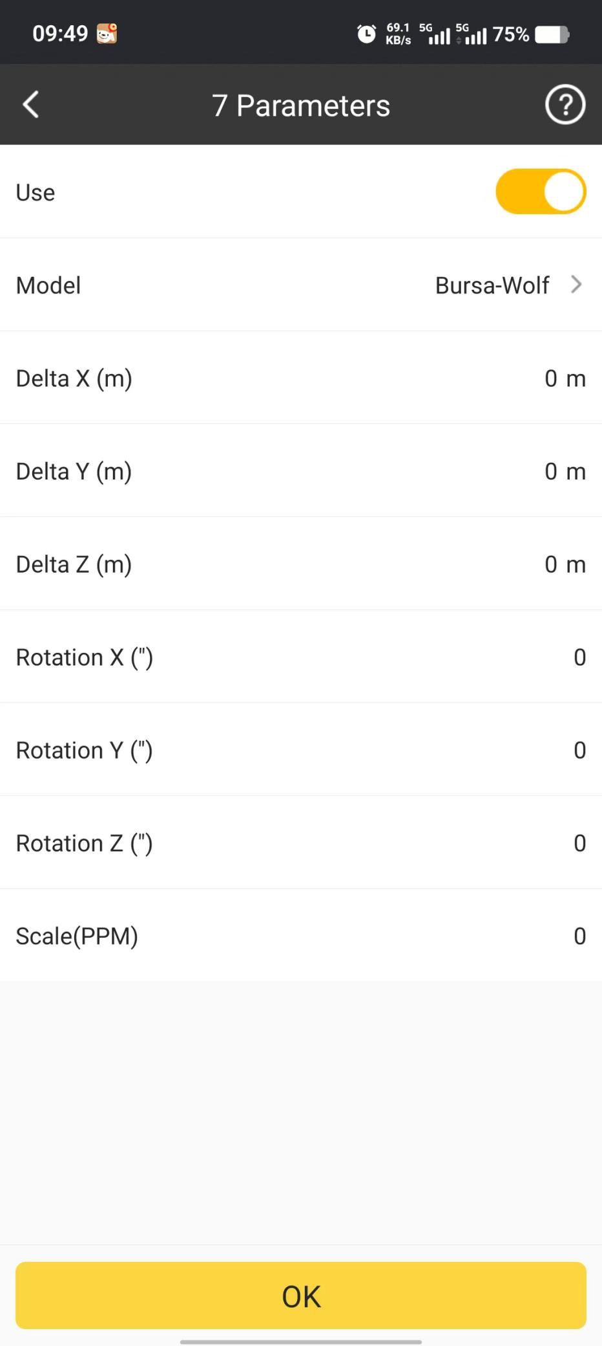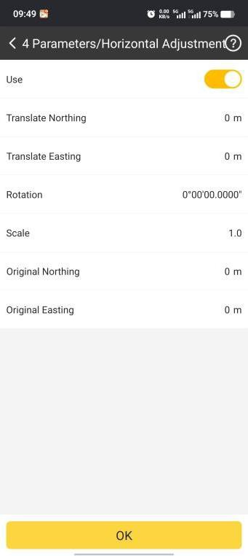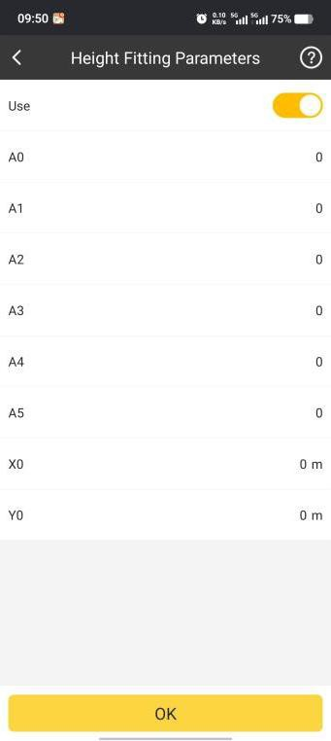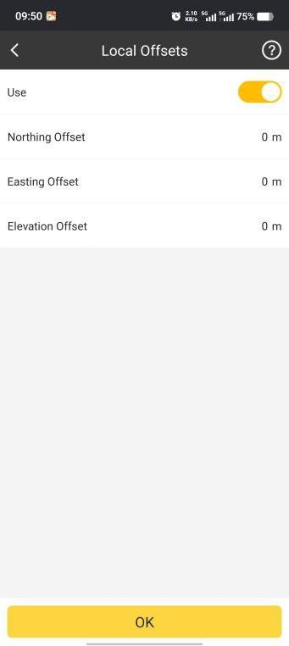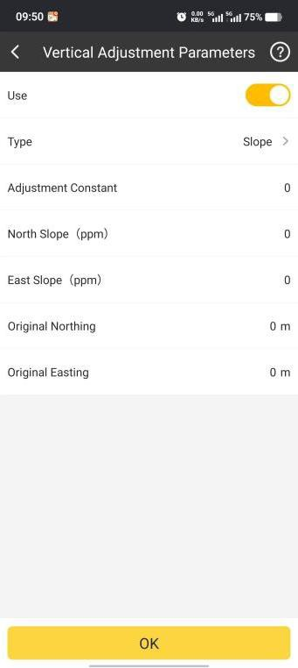

If the function is enabled, the icon in front of it will turn to . Plane Grid File:

In Plane Grid File, we can add *.GSB format file to adjust plane coordinates.

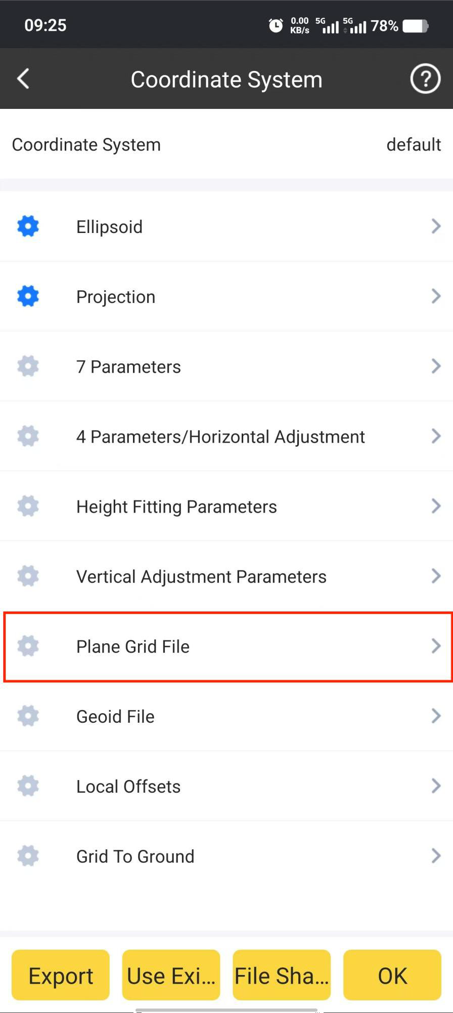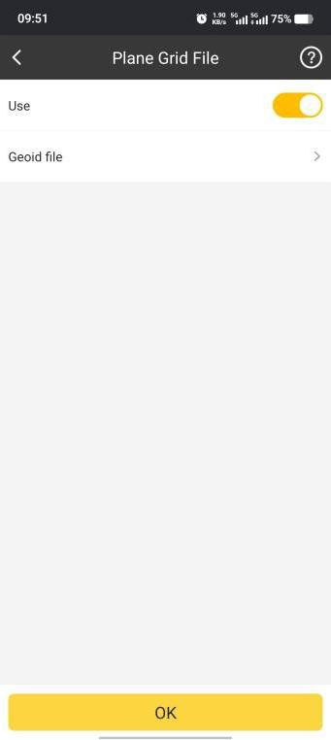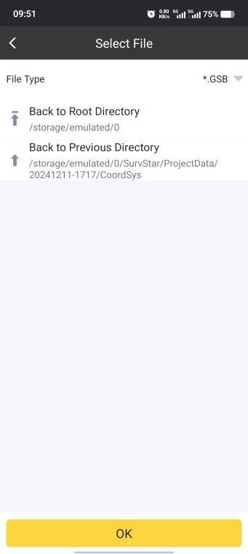

Geoid File:

In Geoid File, we can add *.SGF or *.GGF format file to adjust elevation coordinates.

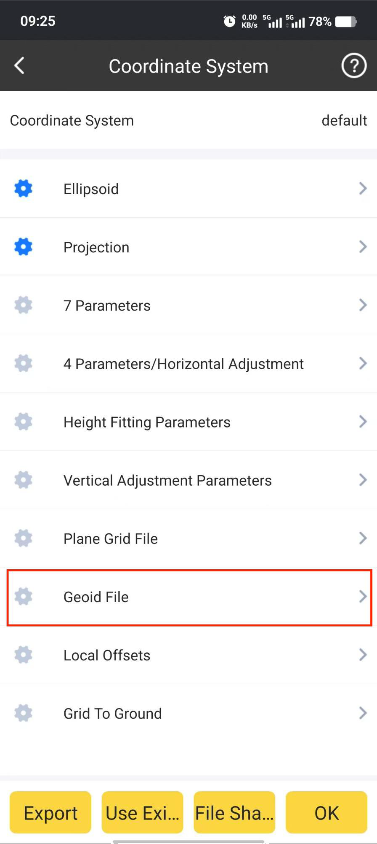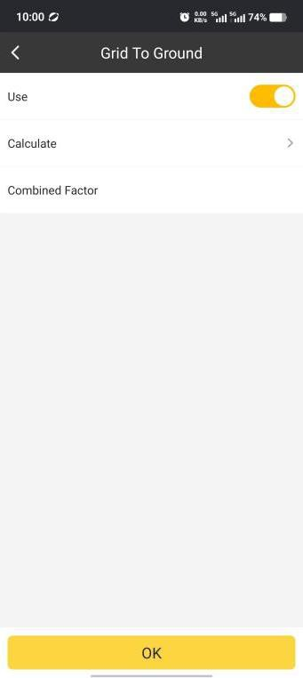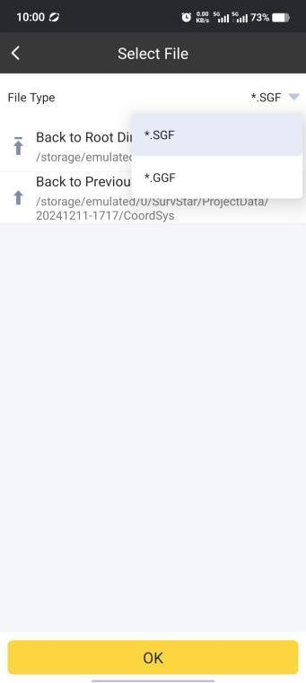

Use Existing File:

We can click to select and apply the existing predefined coordinate system or

Use Existing

use the coordinate system file (*.xml).

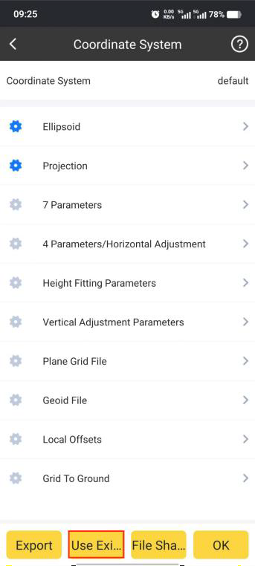

Click Local Storage, find the coordinate system file (*.xml) and click it, the coordinate

system will be applied.

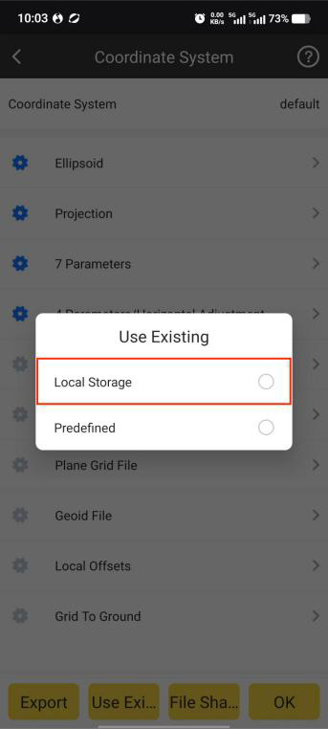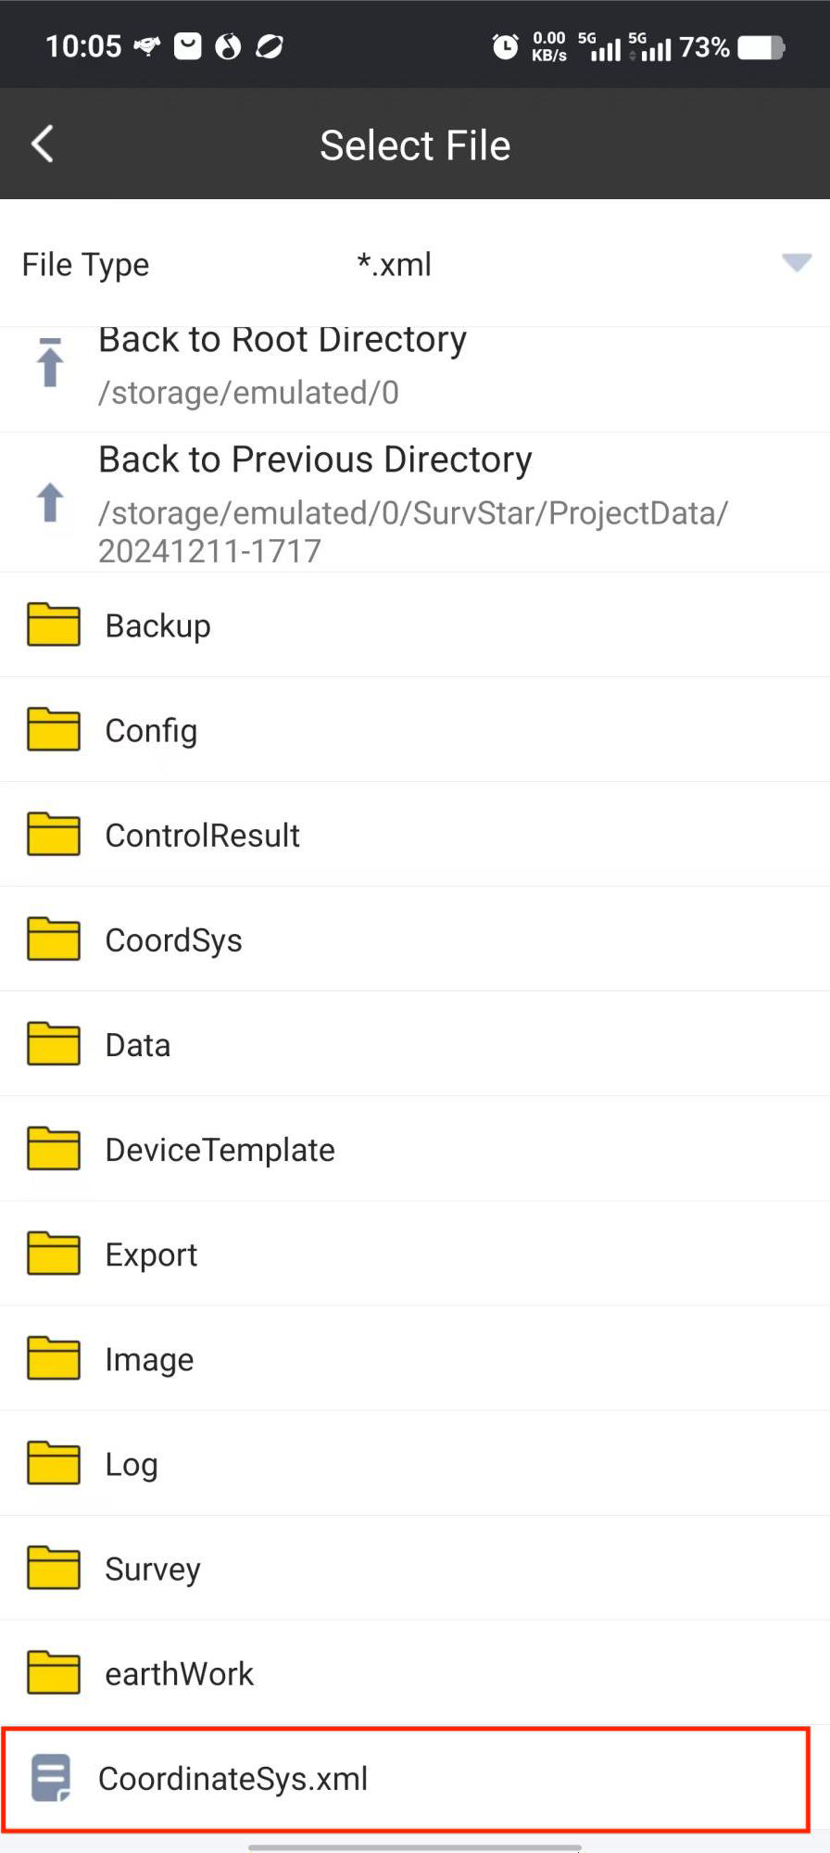

Click Predefined, then click and select the country or region (Alphabetical) where

Country

the needed coordinate system is located.

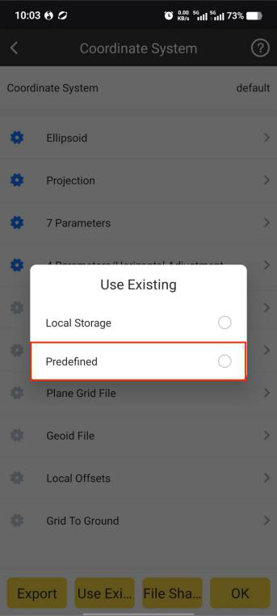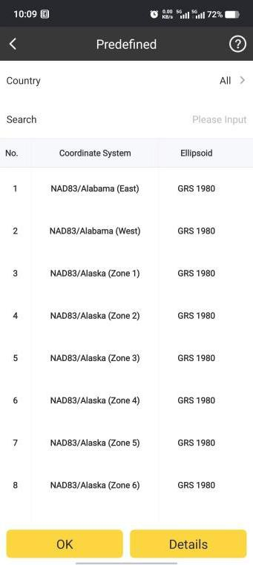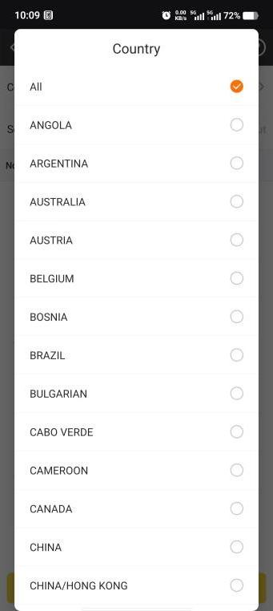

Then select the needed coordinate system and click to apply it, we can click to

check its information.

OK

Details

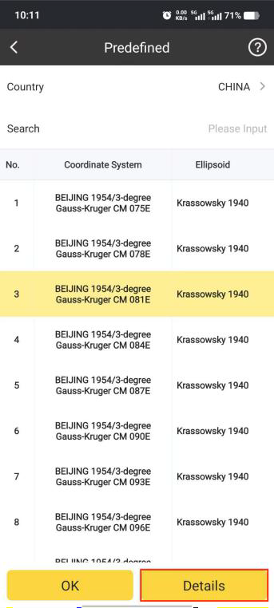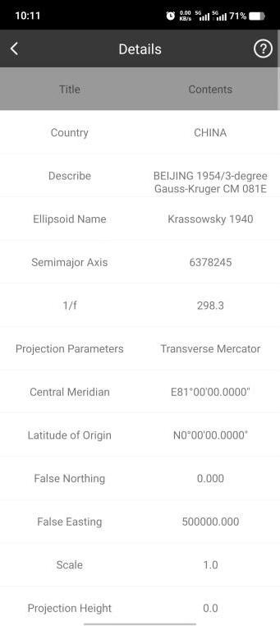

We can also search coordinate system with keywords in Search bar.

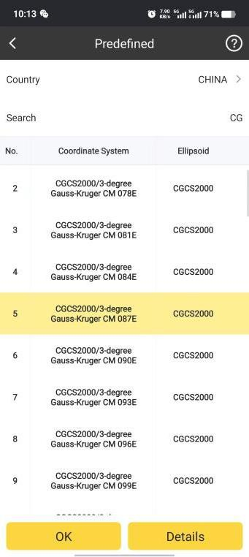

Export:

If we need to save the coordinate system in file, we can click Export, input File Name, select the path to save it and click OK, the coordinate system file will be exported.

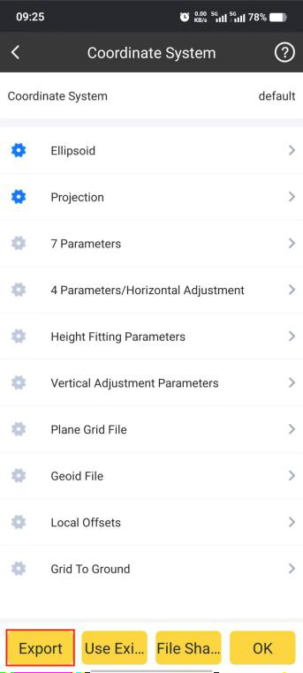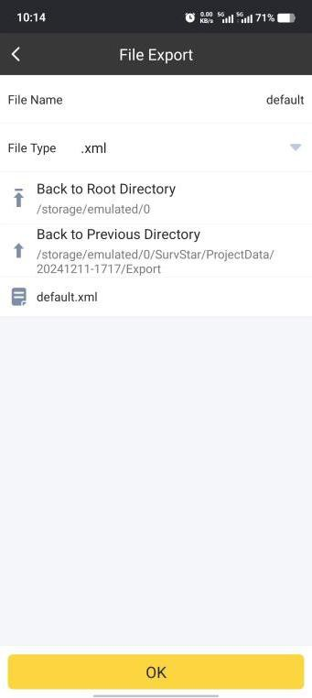

## Base Calibration

We can calibrate the base coordinate using this function.

There are two ways to calibrate: one is Base on Known Point Calibration, set up base on a known point, and when rover gets fixed solution, input known point coordinates to calibrate; the other is Base on Unknown Point Calibration, set up base on an unknown point, when rover gets fixed solution, put rover on a known point and known point coordinates to calibrate.

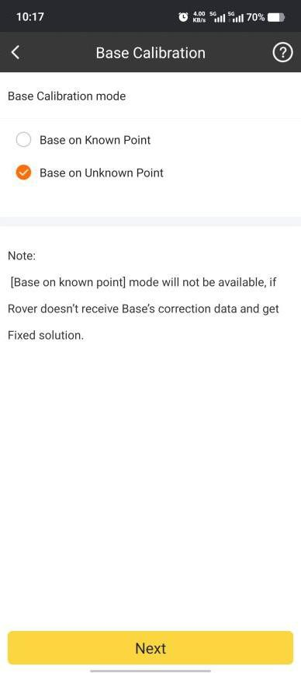

Base on Known Point:

Set up base on a known point, after rover gets fixed solution, we can start do the calibration.

1. Choose Base on Known Point, and click Next.

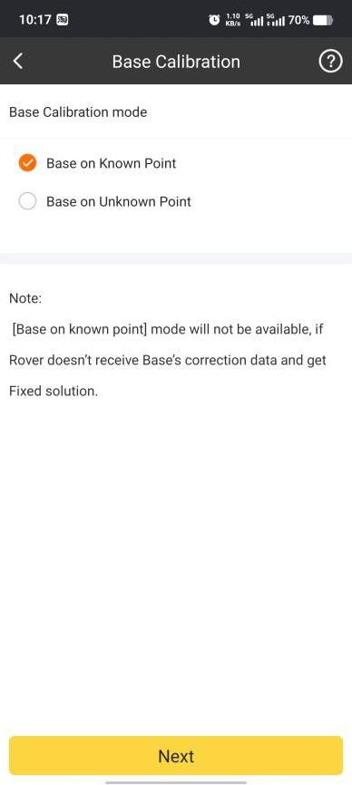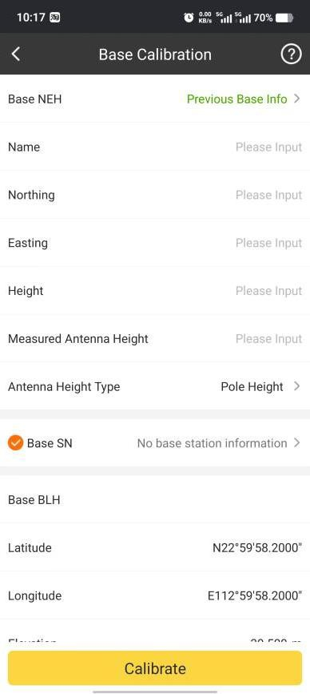

1. In this page, we can click to find the historical base station information.

Base NEH

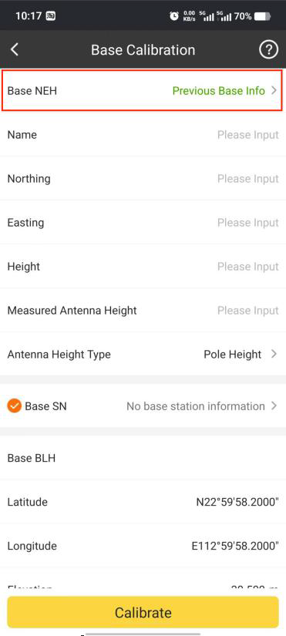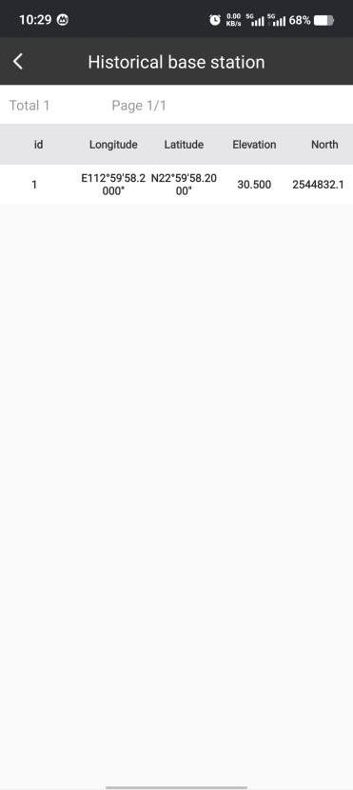

1. Find the right historical base station, and click Choose, then the relevant coordinates

information will be applied.

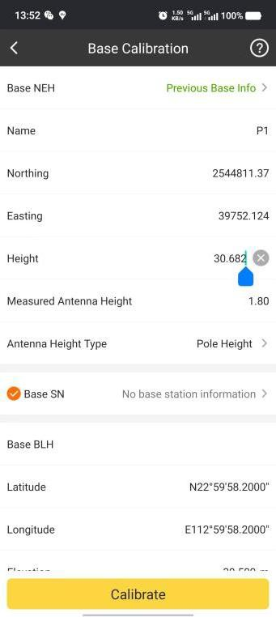

1. Also we can input base information manually.

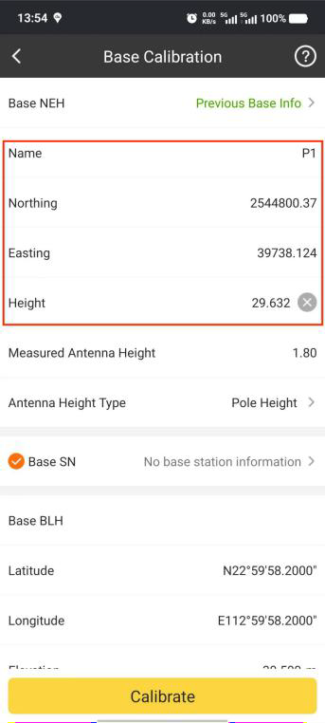

1. Then we can select right antenna type and input relevant antenna height.

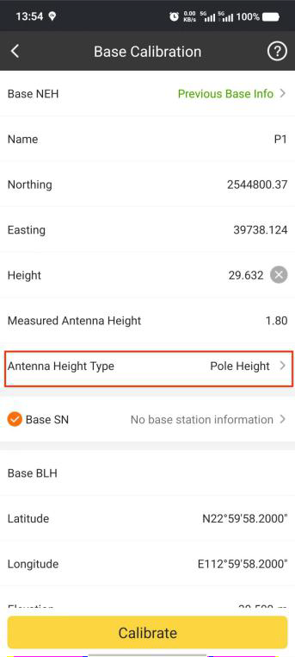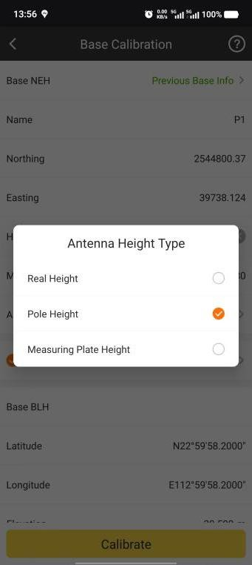

1. Click and then there will be a popup to show the calculation results. Click OK

Calibrate

then the results will be applied.

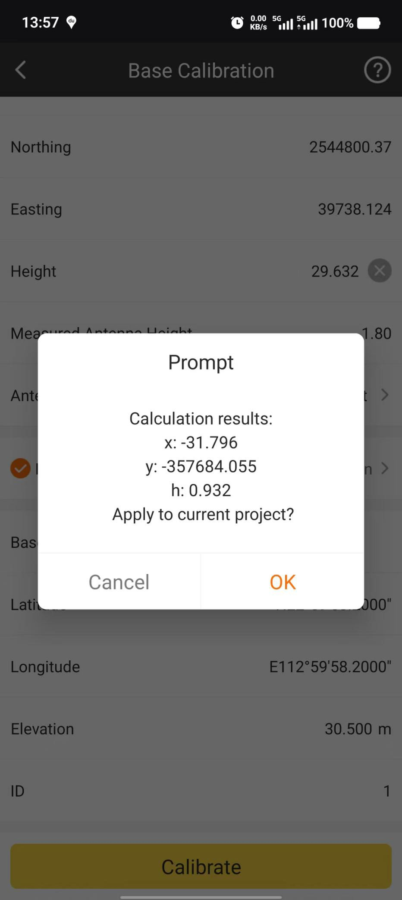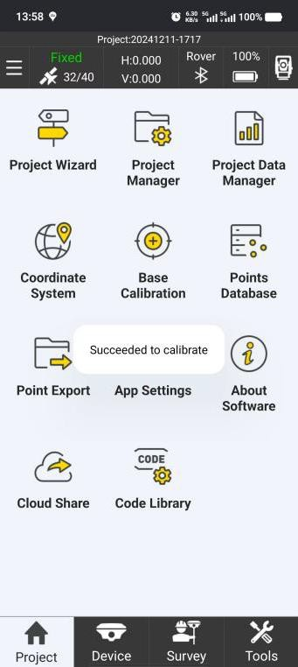

1. And then in SurvStar, we can go to SAT Information, find the base position has been changed.

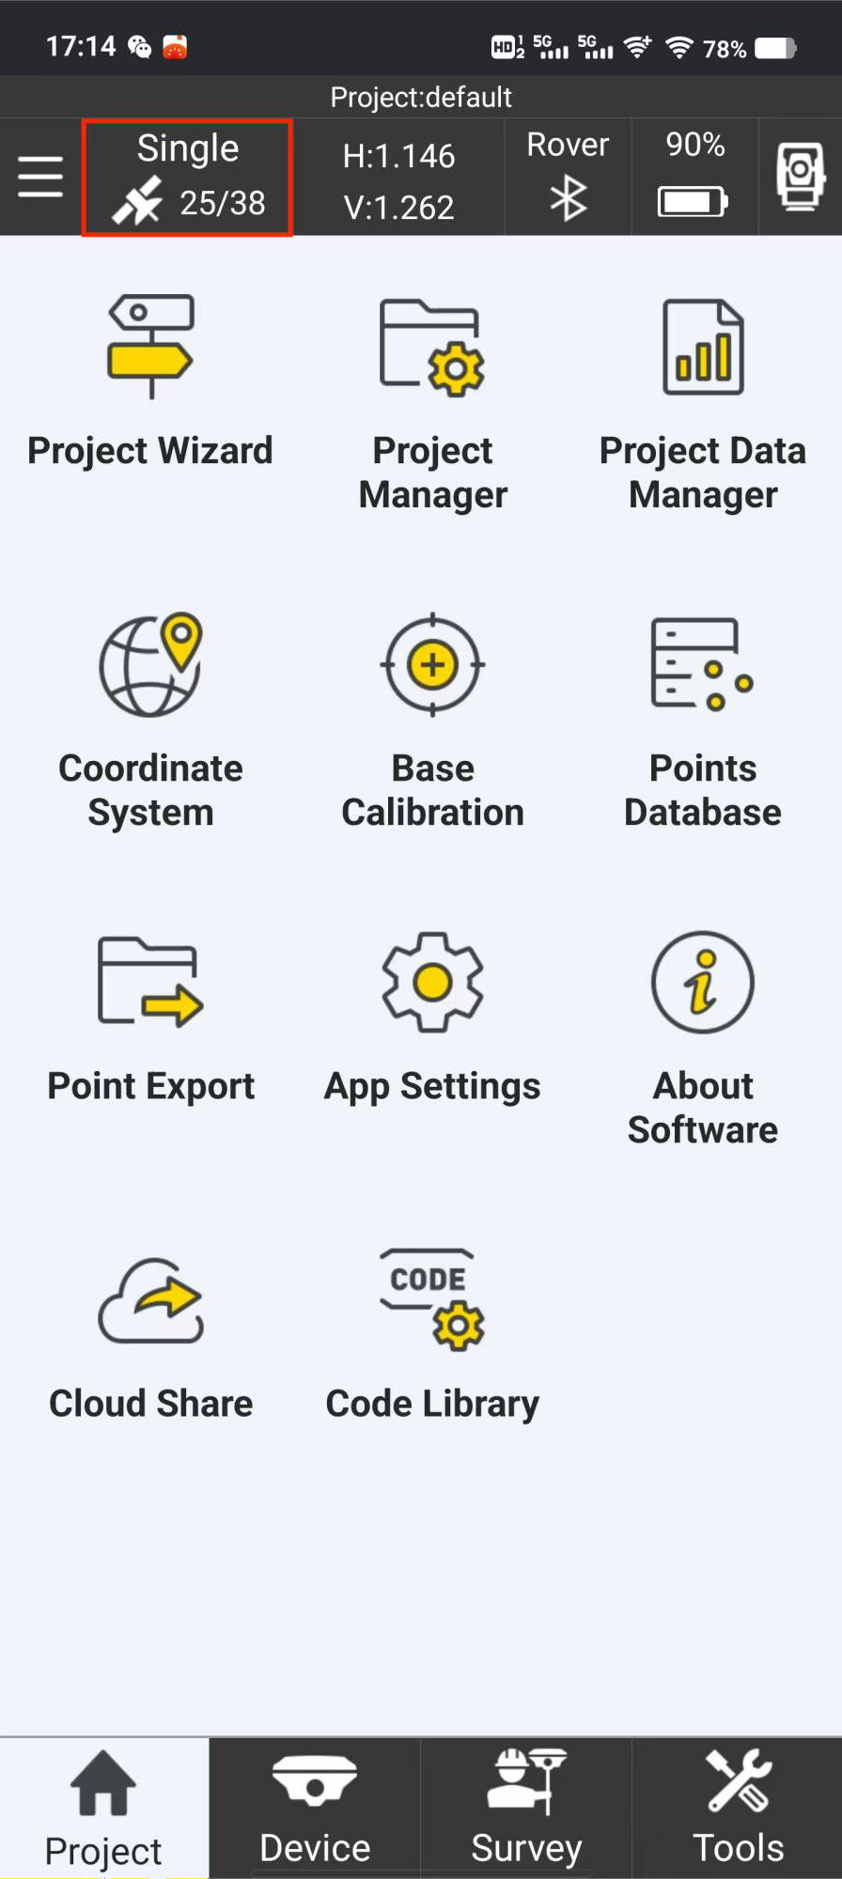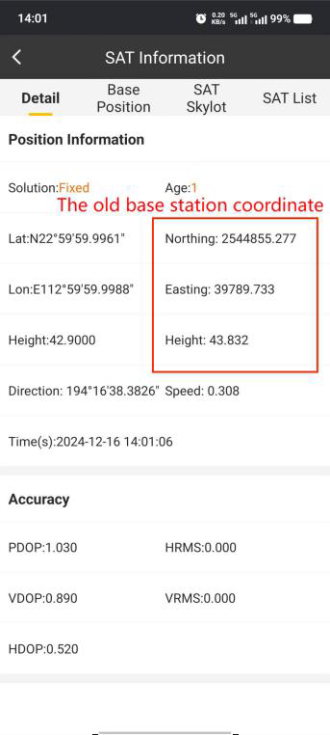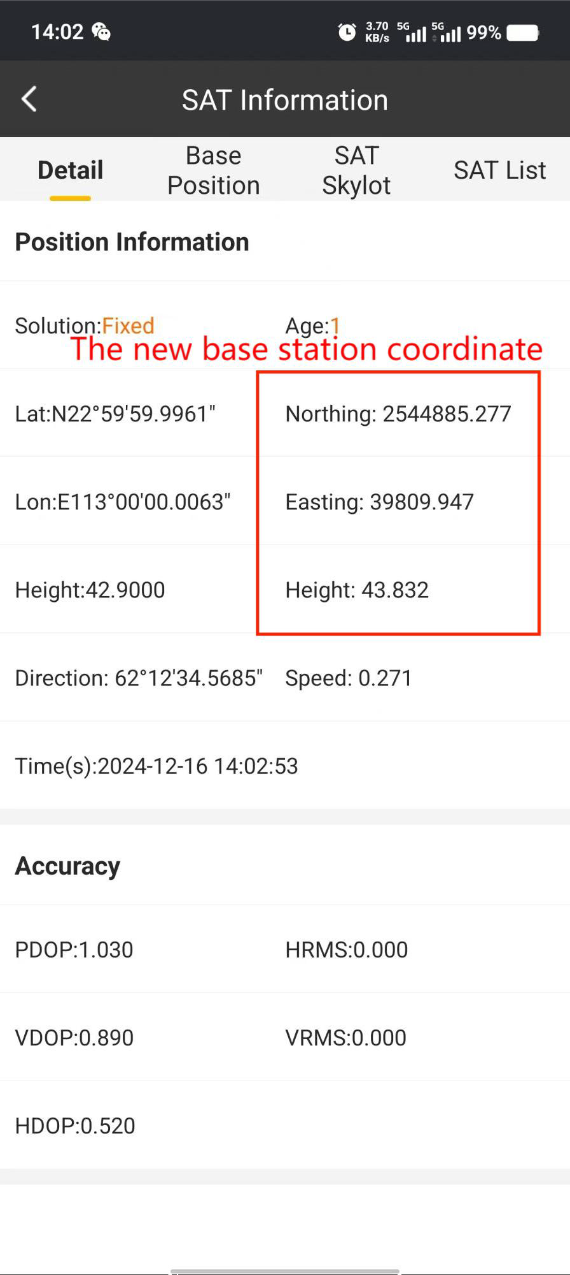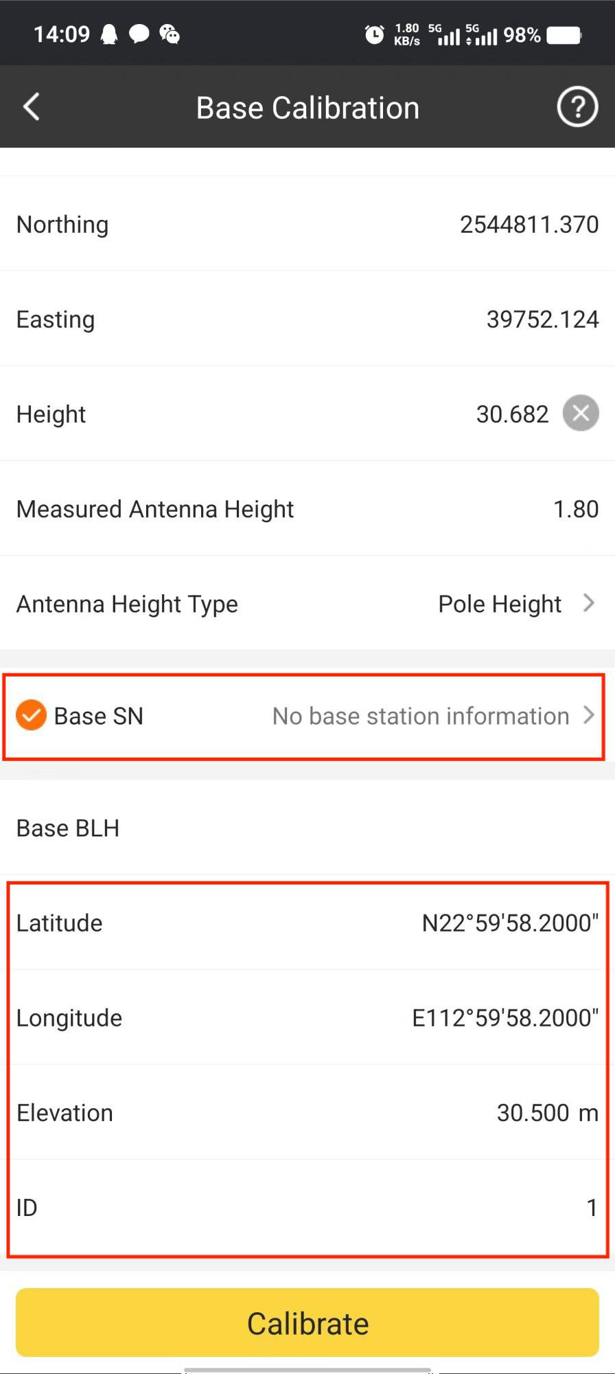

Base on Unknown Point:

Set up base on a unknown point, after rover gets fixed solution, we move rover on a known point and then start calibration.

Choose Base on Unknown Point. And Click Next.

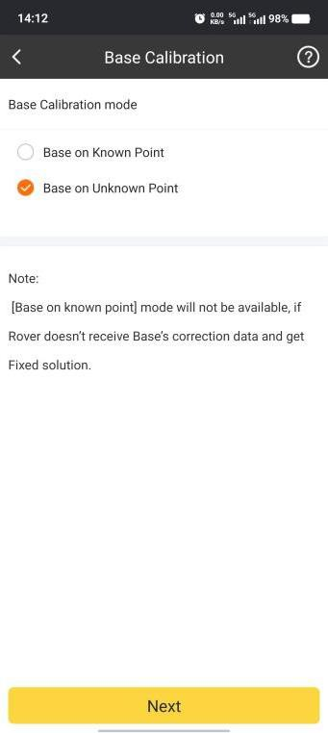

1. We can input the known points coordinates by selecting it from data base (if it is in the Point Data base).

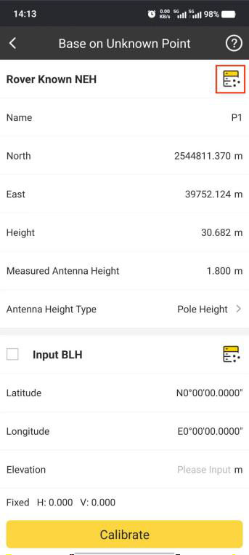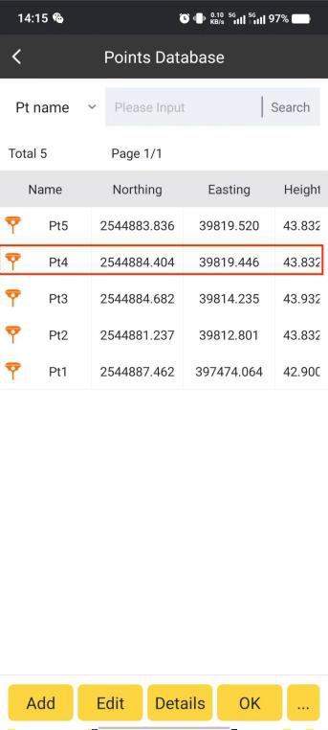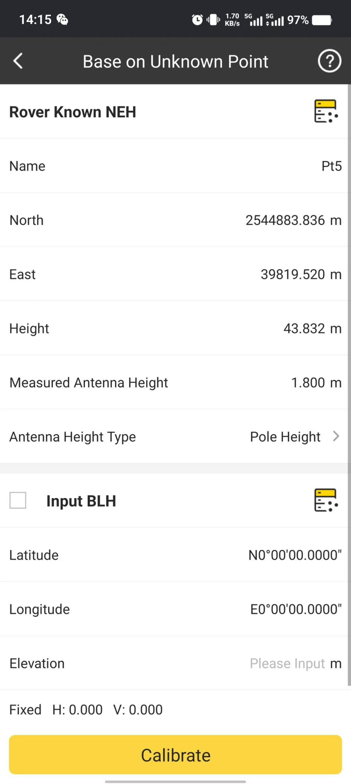

Or we can input NEH information manually.

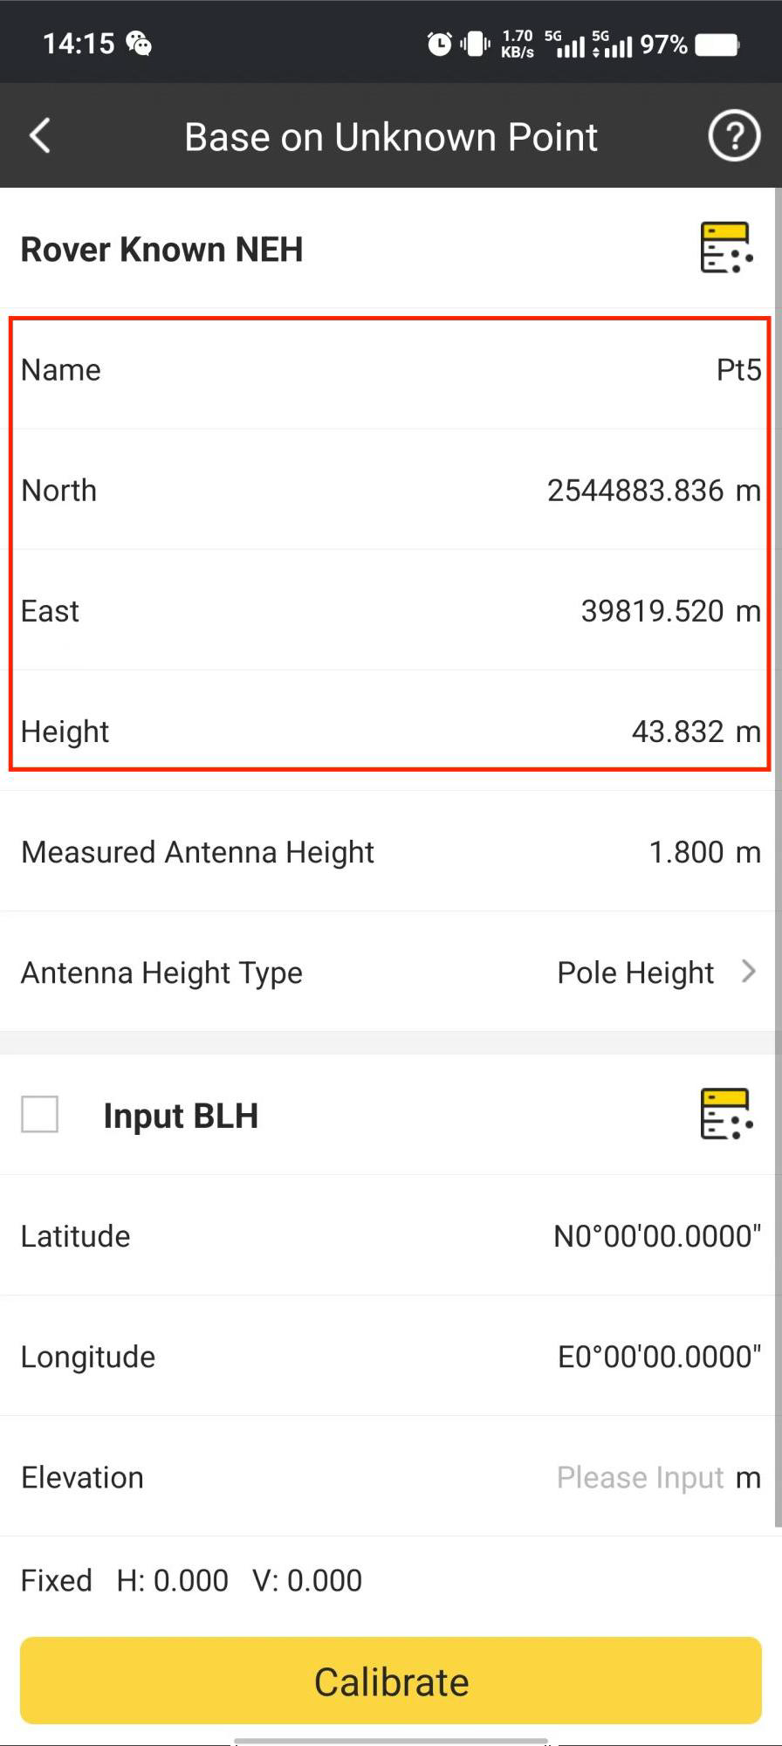

1. Then we can select right antenna type and input relevant antenna height.

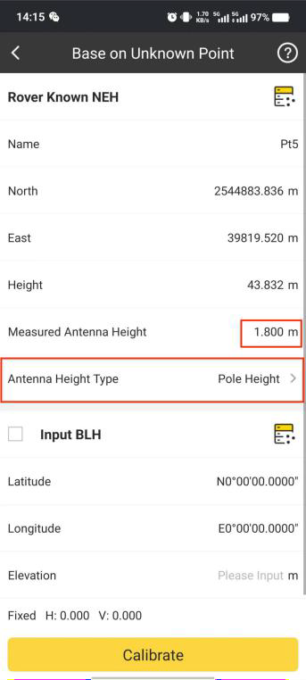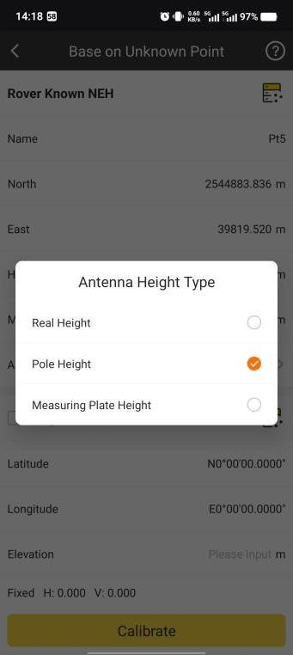

Then click to calculate the calibration parameters.

Calibration

Note: we can acquire current position’s BLH automatically here. if ReadFrom GPS(average count) is enabled, then SurvStar will collect current position’s BLH for 5 times and take the average value.

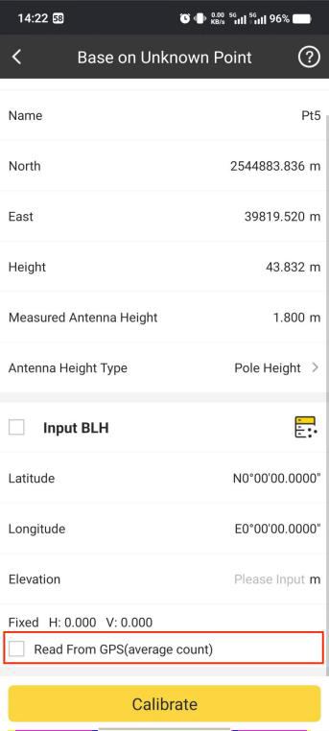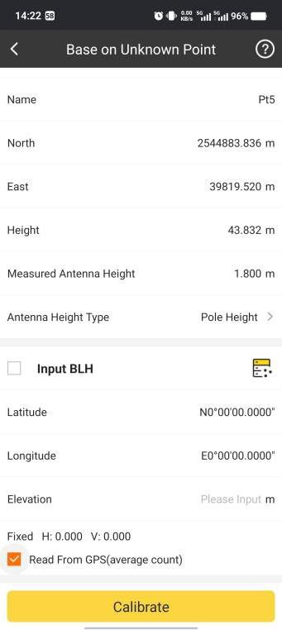

It will show the calculation results, and click To apply the result.

OK

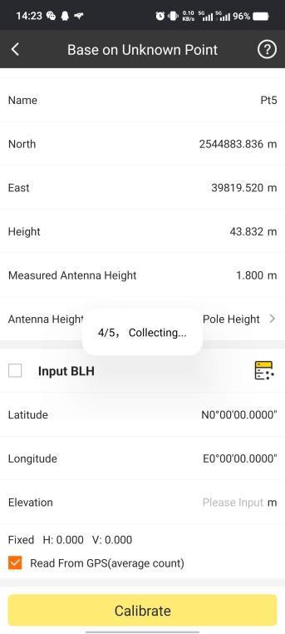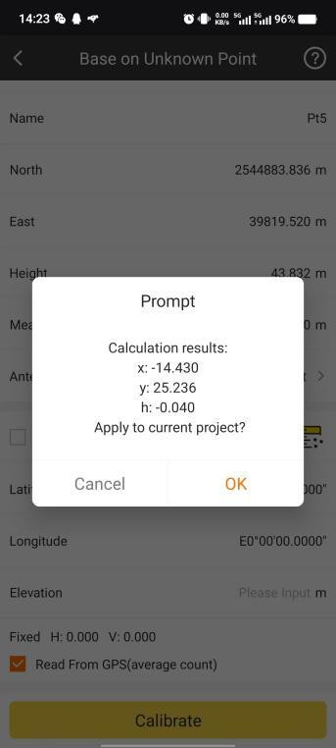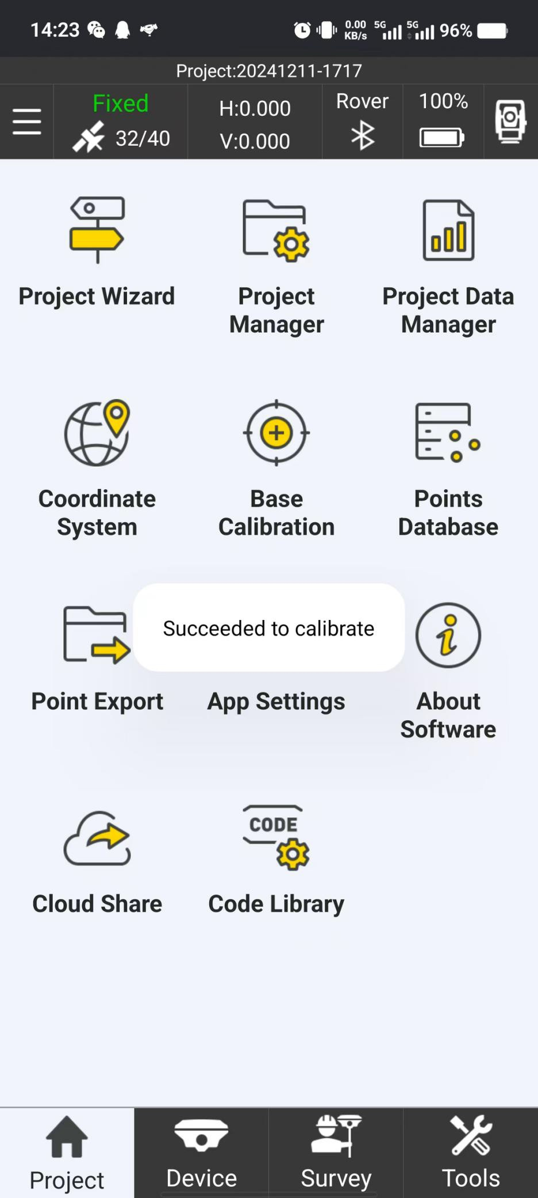

Note: if we enable Input BLH here, we can input current BLH manually or get it from Point Database directly.

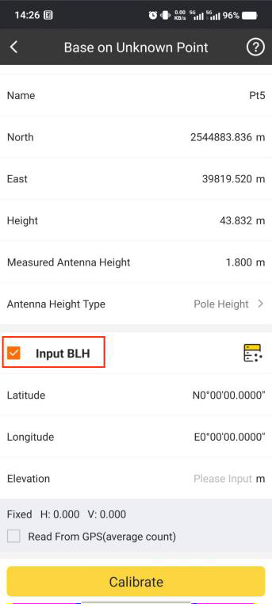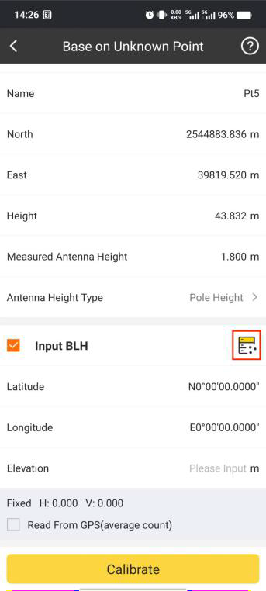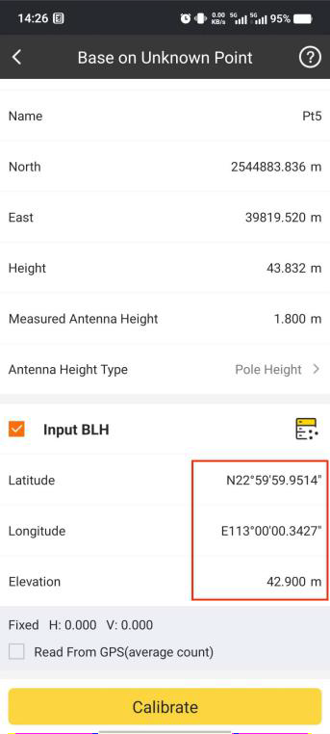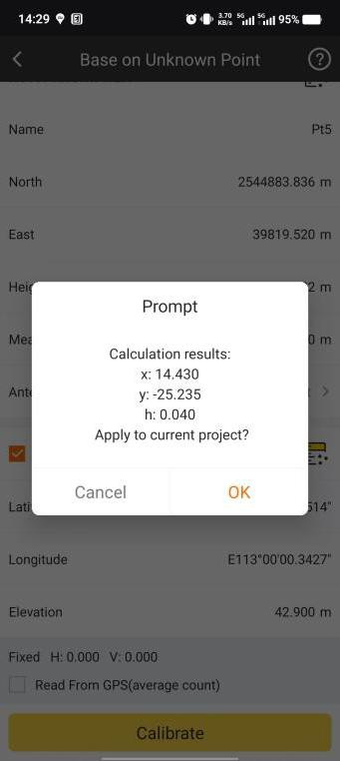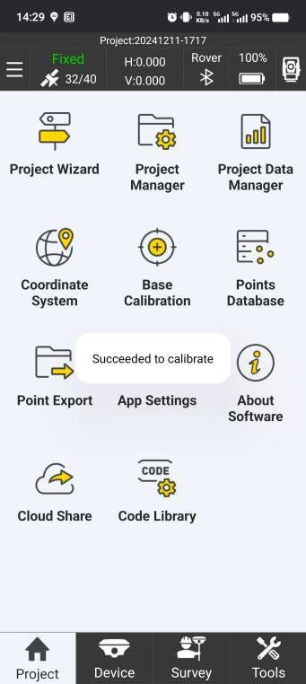

And then in SurvStar, we can go to SAT Information, find the base position has been changed.

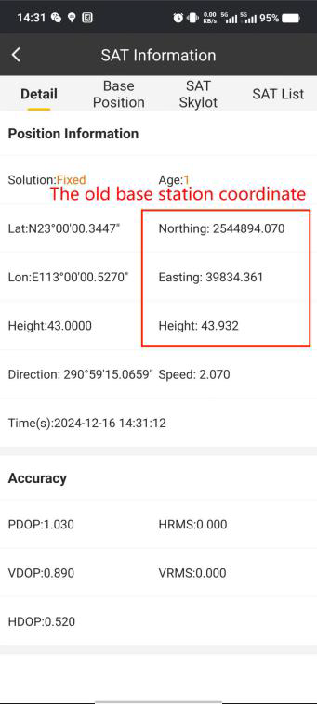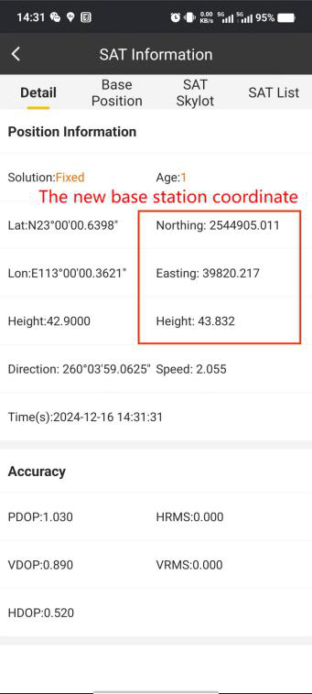

## Points Database

In Points Database, we can manage points by Add, Edit, Check Details, Import and other operations.

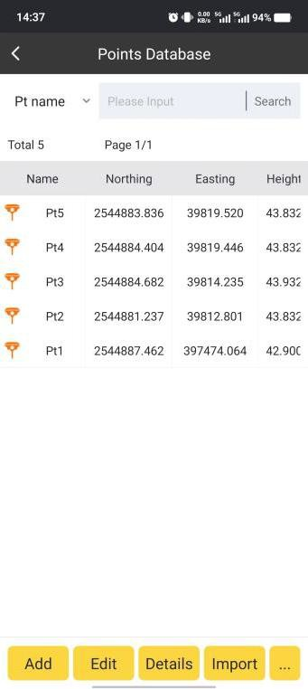

Add:

Click Add, we can input points coordinates manually here and add it to the Database.

Firstly, we need to define the Point Name.

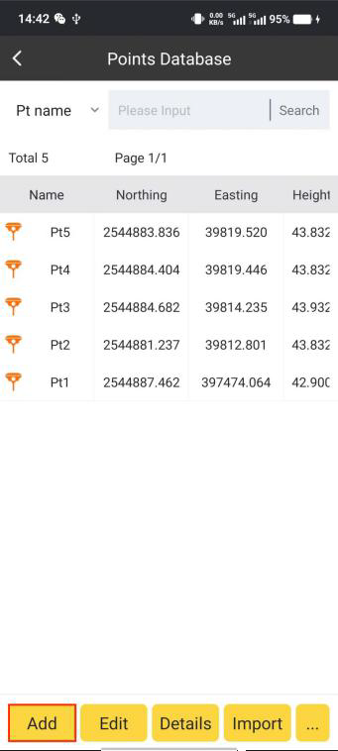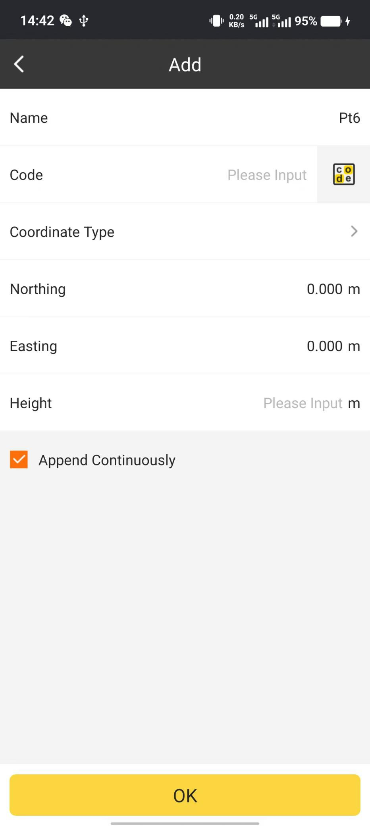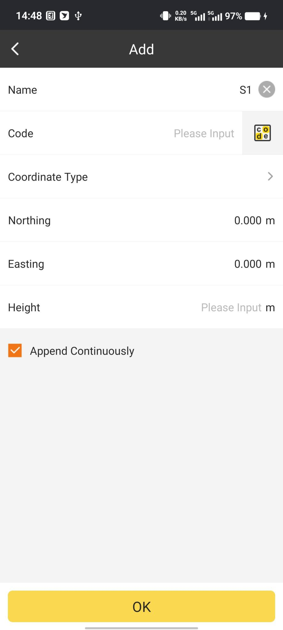

Then the Code:

If we don’t need Code property, we can leave it blank.

If we plan to attach Code property to the point, we can input code directly.

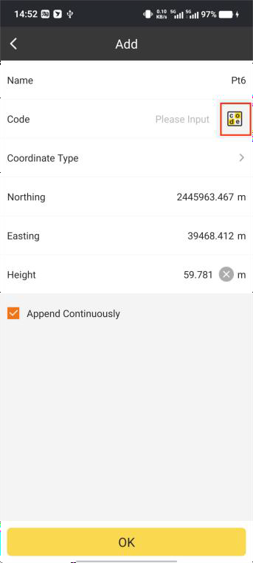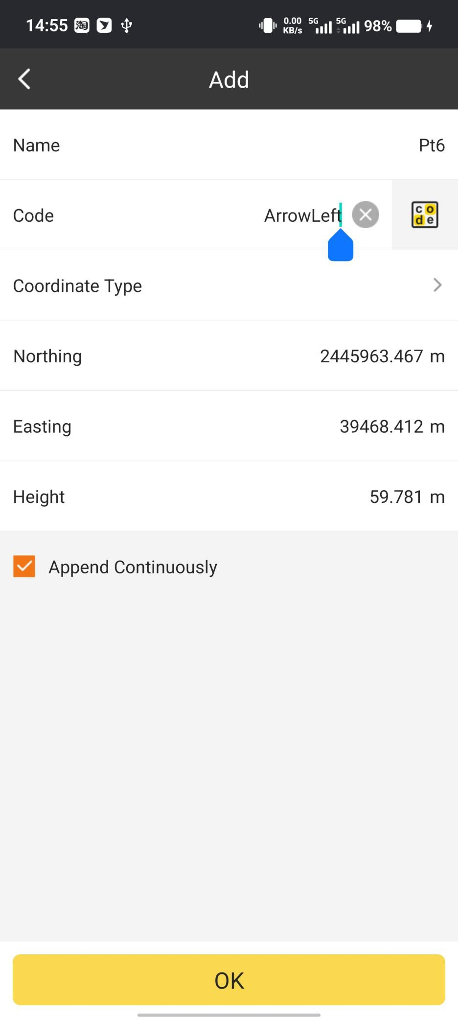

There are predefined codes in the data base, by searching and selecting, we can try to find the code we need.

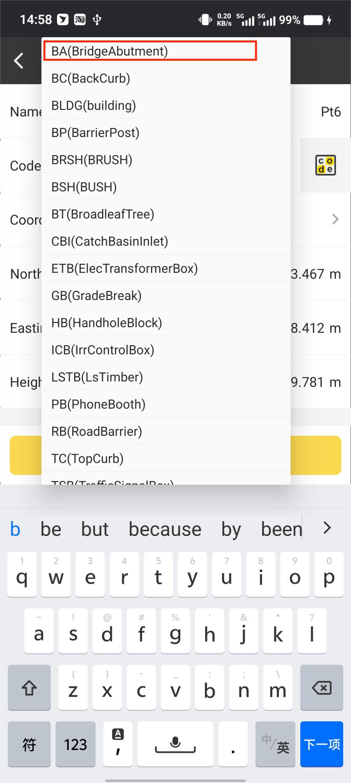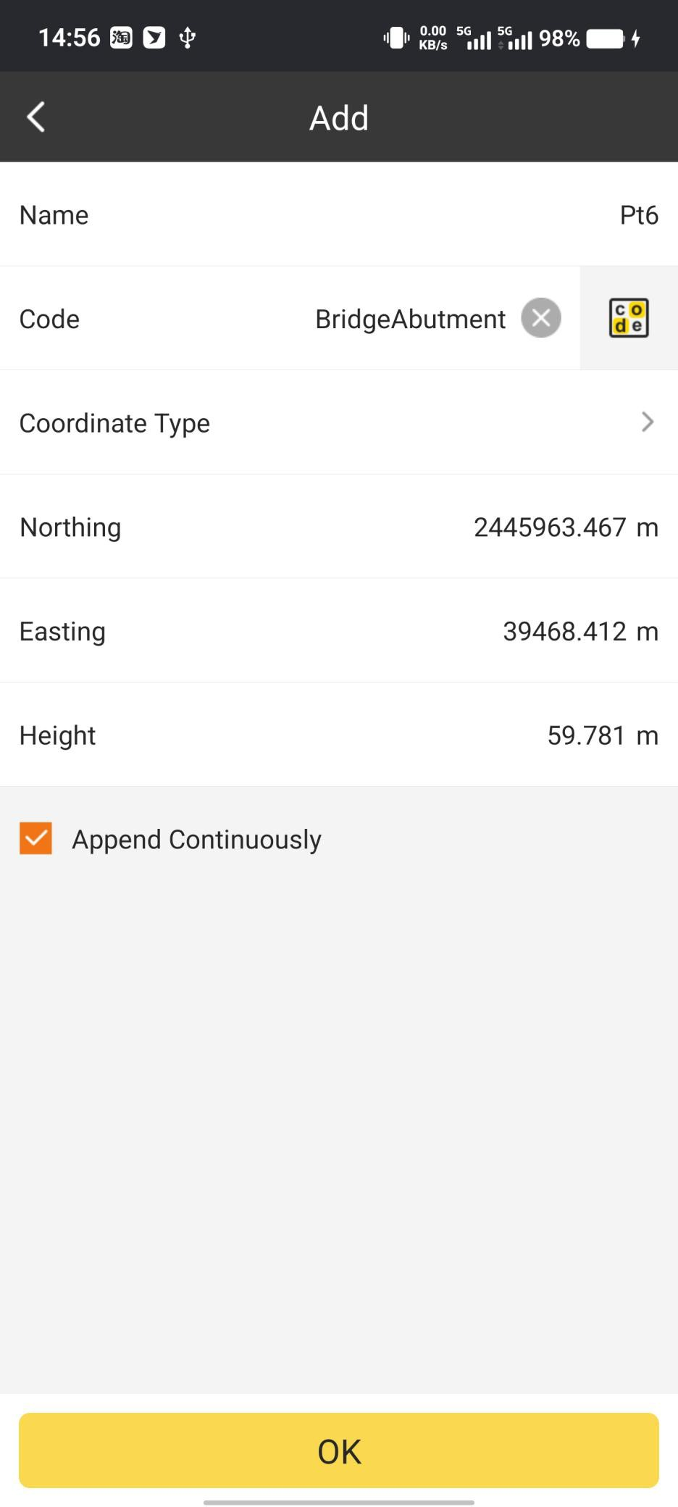

If we want to check the predefined code data base, we can click the icon to access.

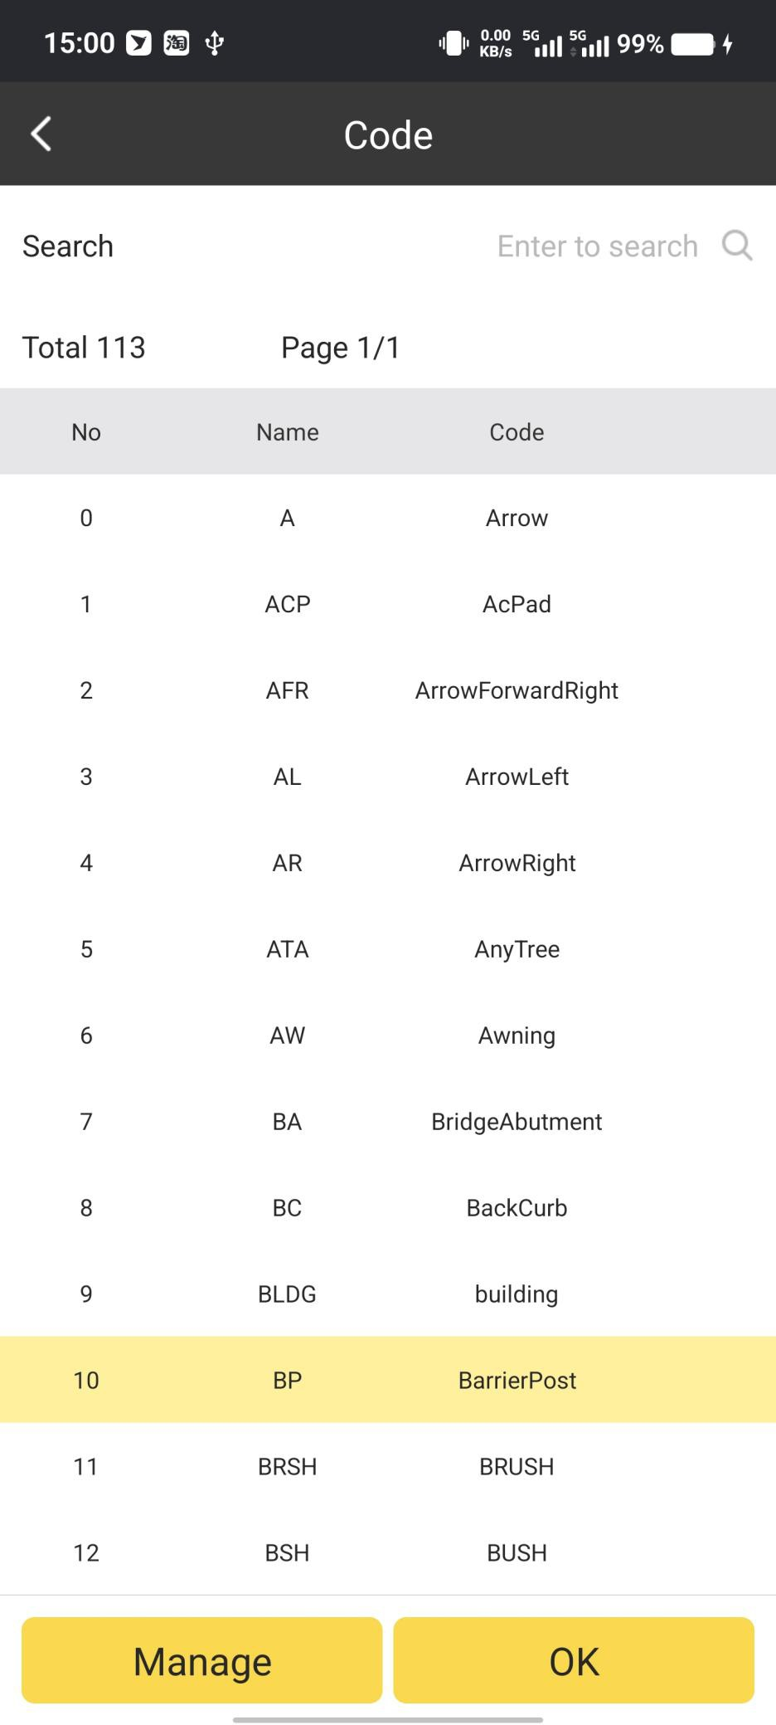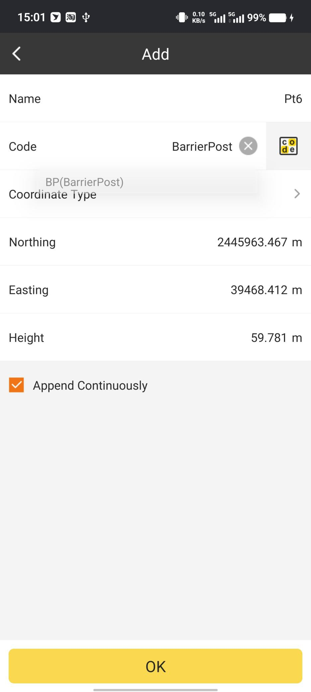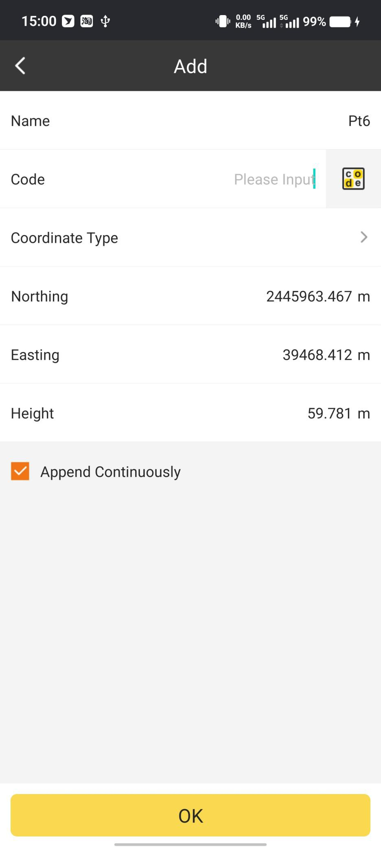

In Manage. We can manage the code database. It includes Add, Edit, Delete, Choose and

Import. Click to add a code library. We can create the code we need.

Add

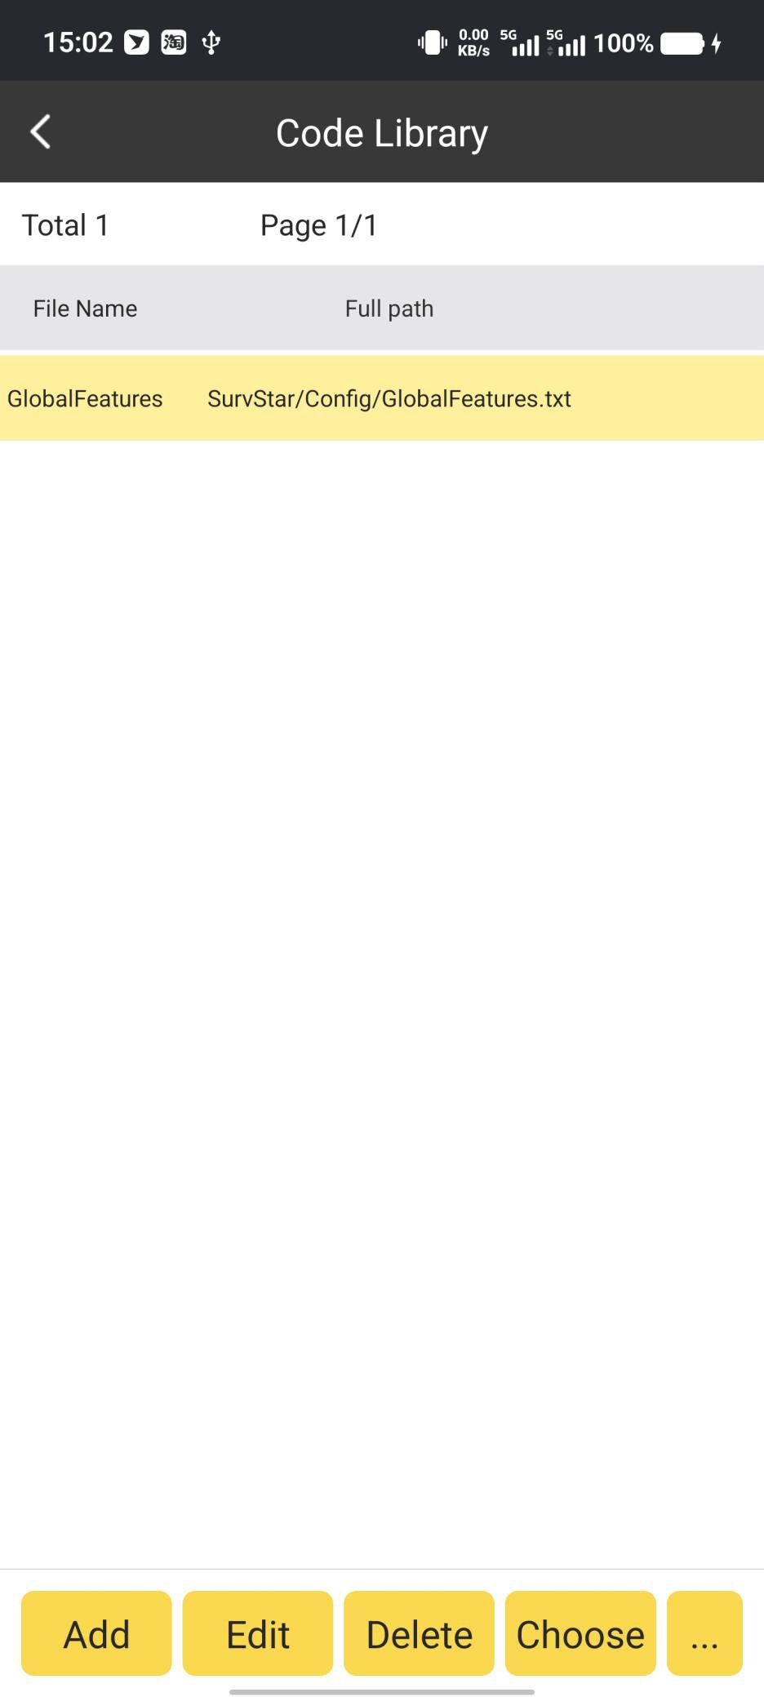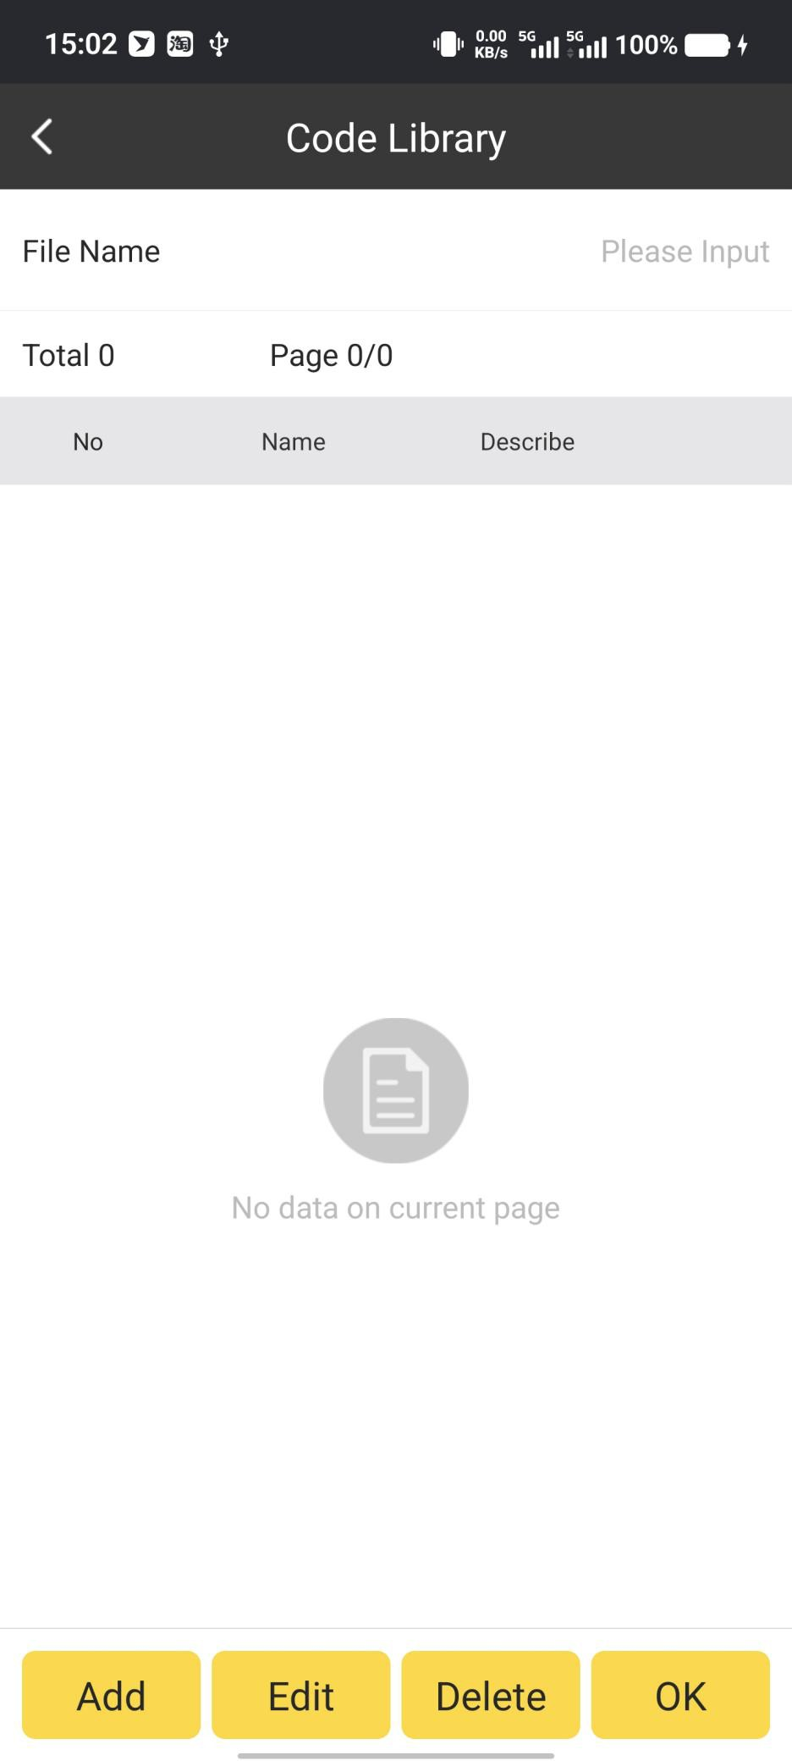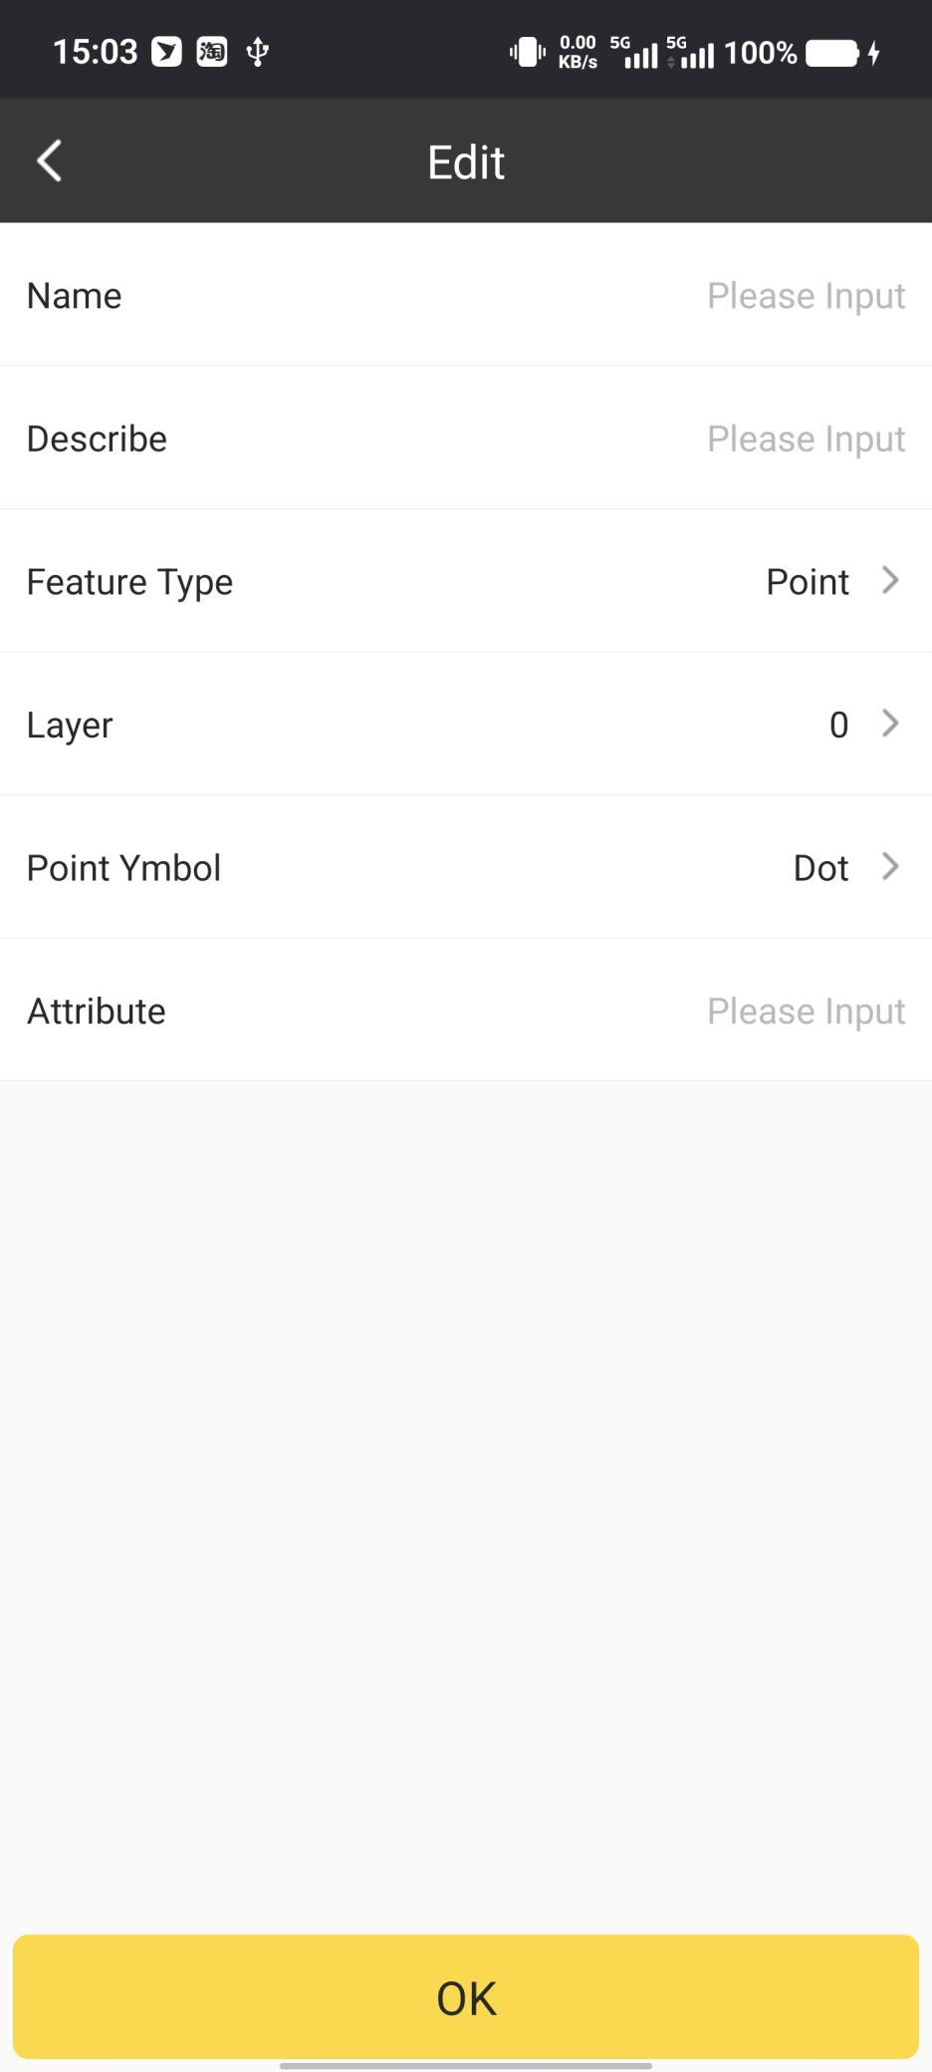

Then we need to choose the Coordinate Type. There are two types: NEH and BLH.

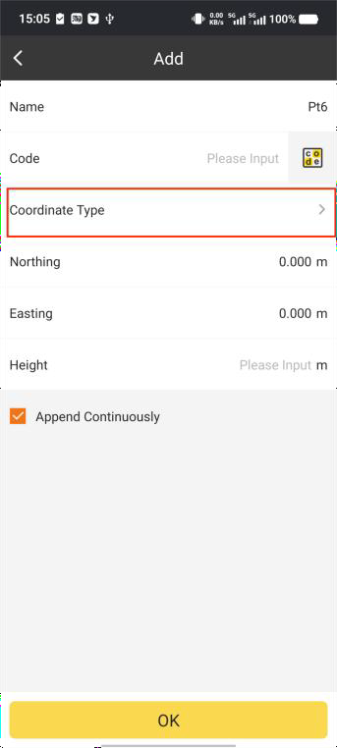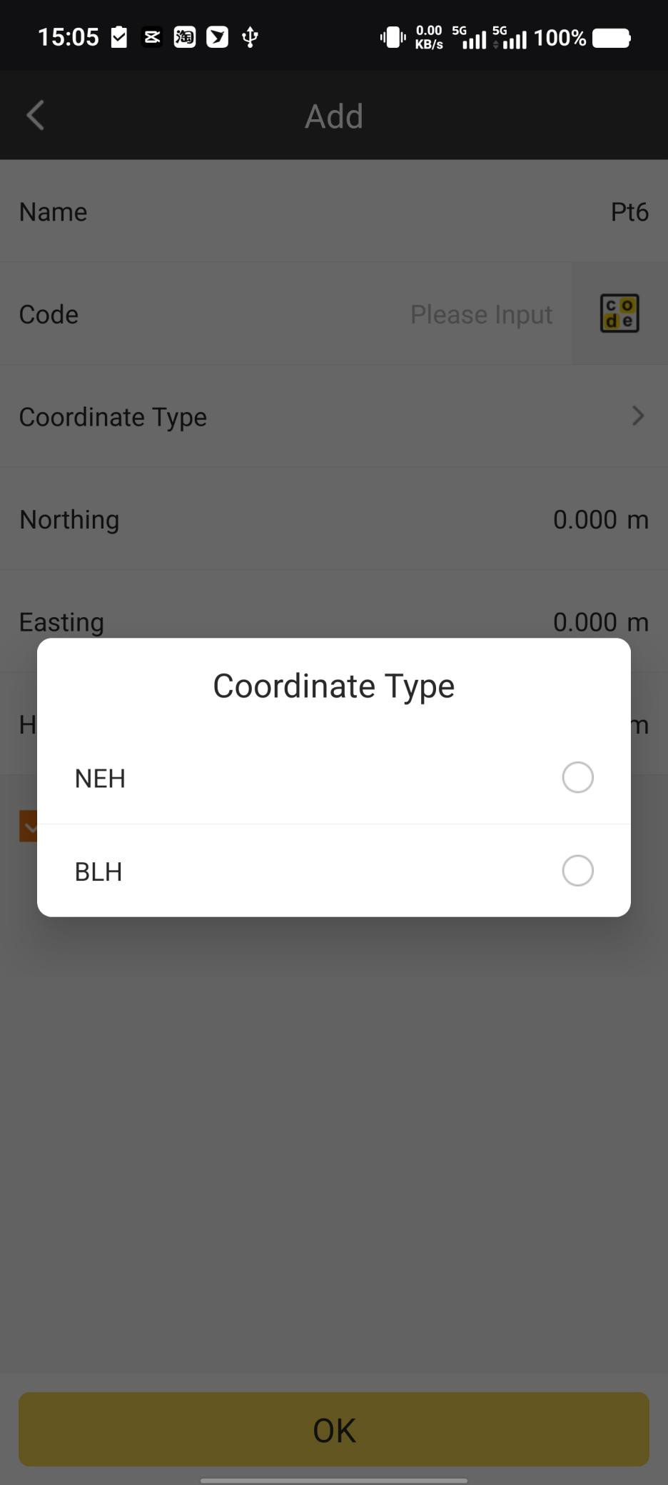

Then we can input the coordinate of the point.

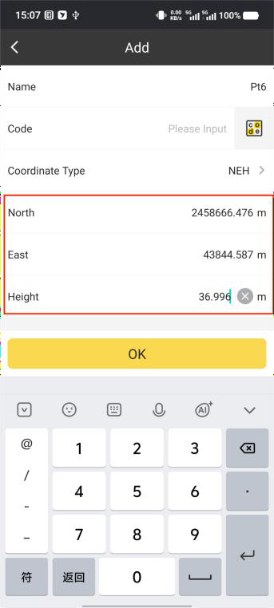

Click OK. The new point is created in point database.

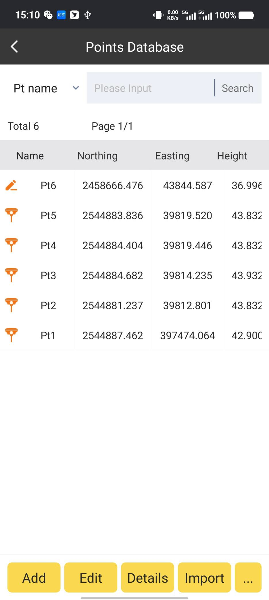

Edit:

Select the point we want to edit and click Edit. We can edit the coordinate, code and name

of the selected point.

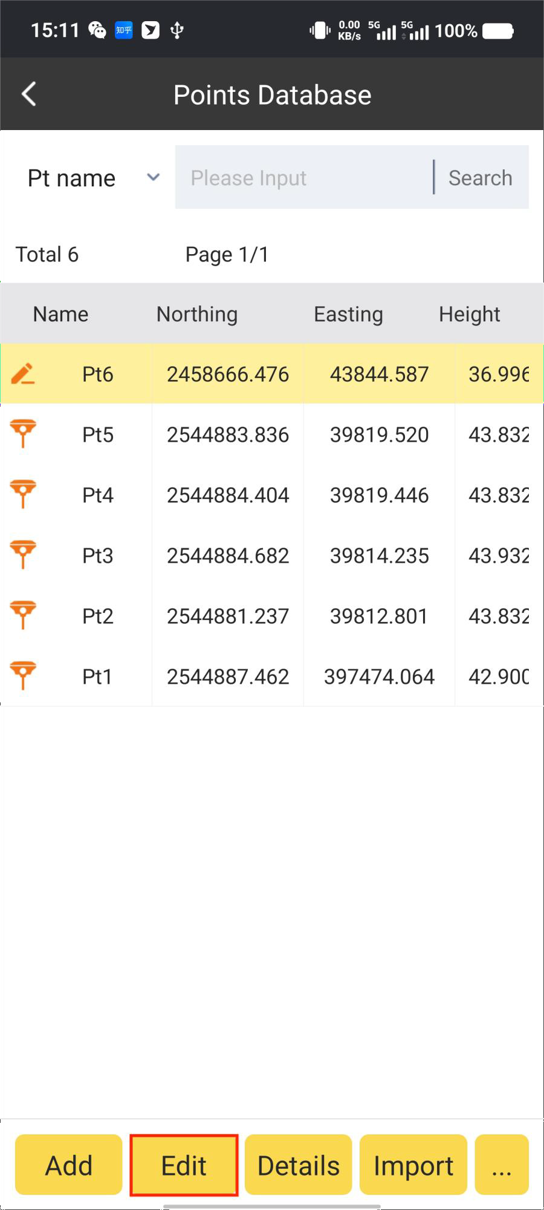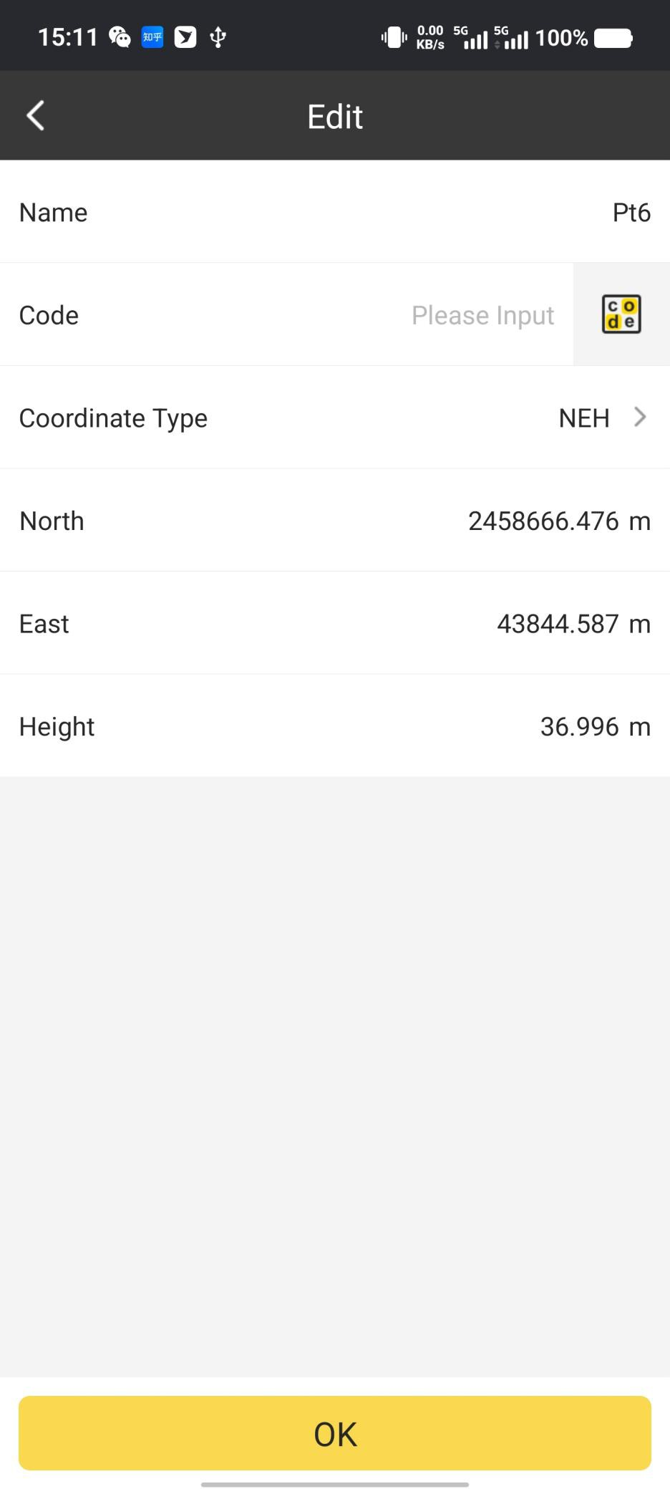

Note: for Survey Points and Stakeout Points, we can only edit Point Name and Code.

Details:

Select the point we want to check and click Details. We can check the details of the

selected point.

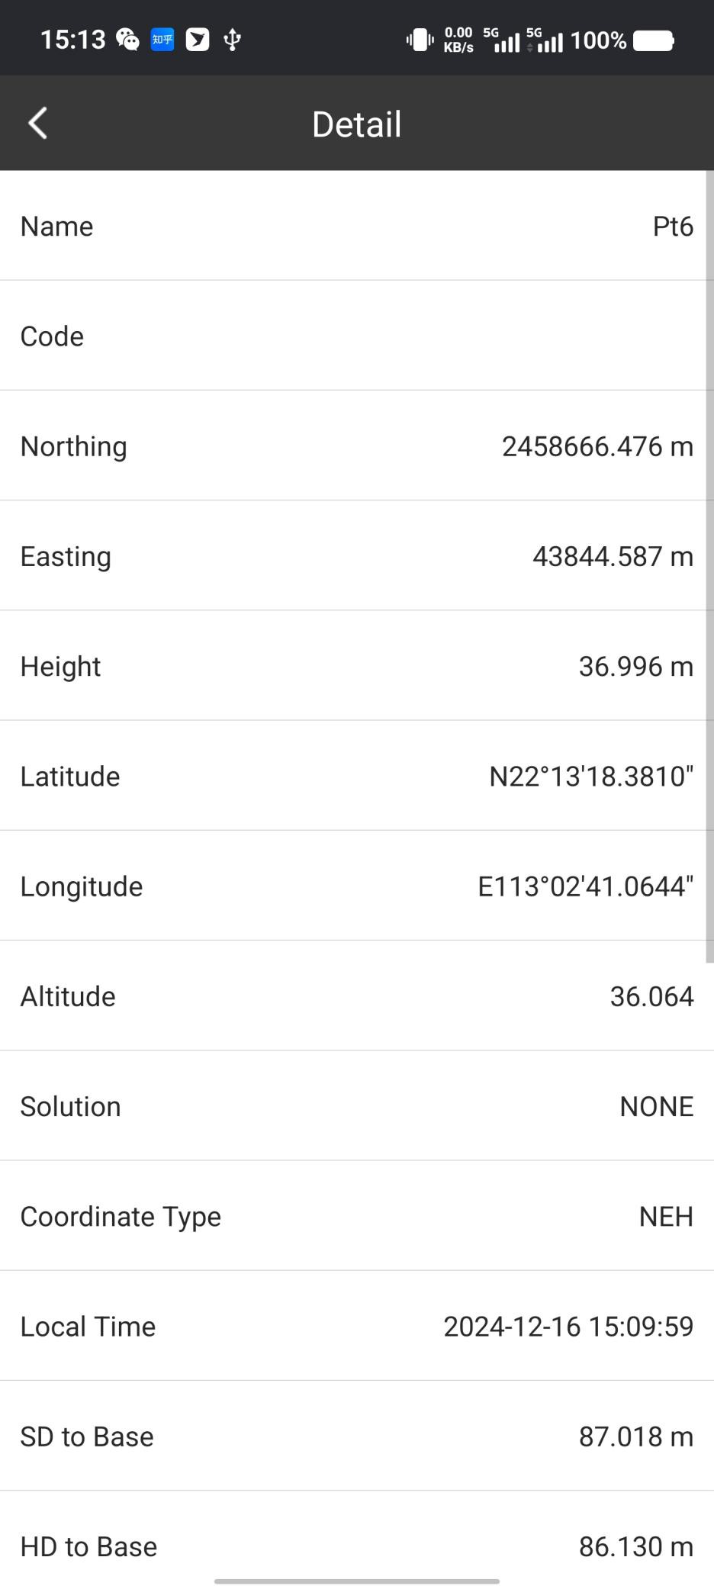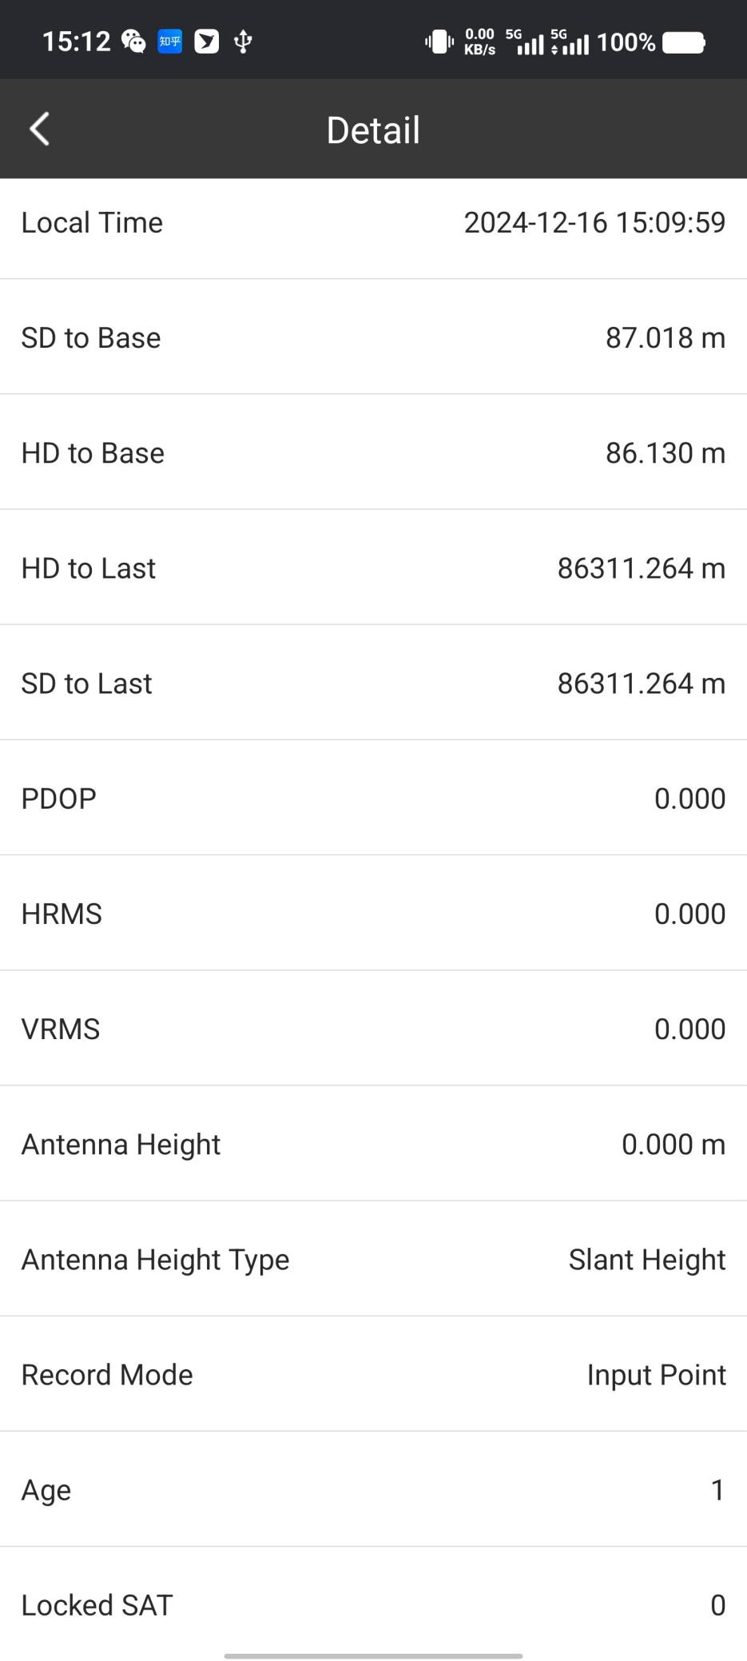

Import:

We can import points to Points Database Directly. When we import file, in Format Manager, we need to select the Import File Format, Point Type and Files Directory, then we can find the target file and load those points to Point Database.

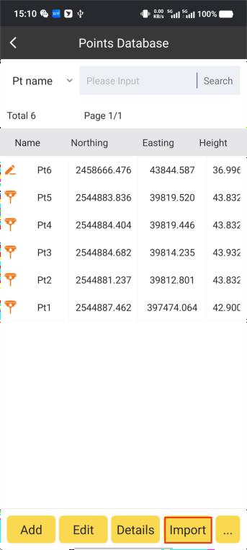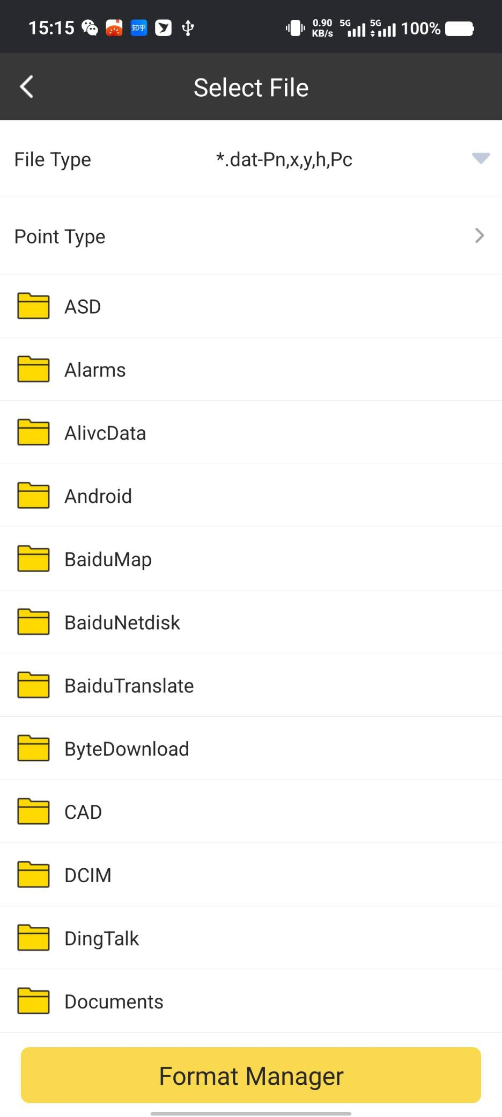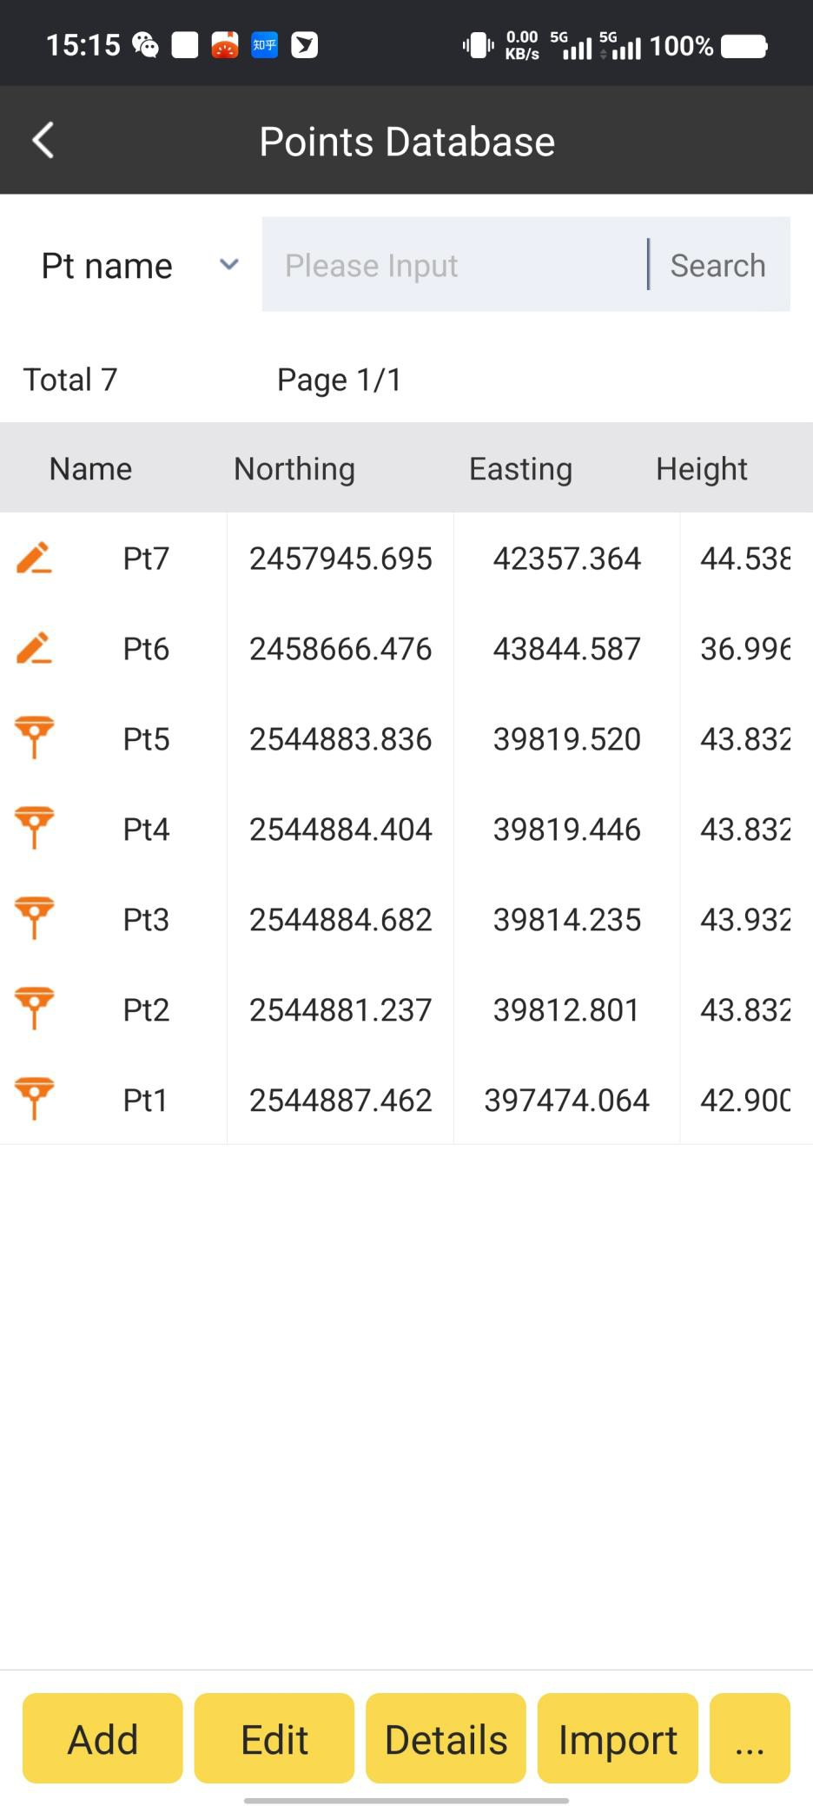

In Format Manager, we can define the imported file’s format and contents. Then when we import files to SurvStar, we just need to get the relevant format file, and import it directly.

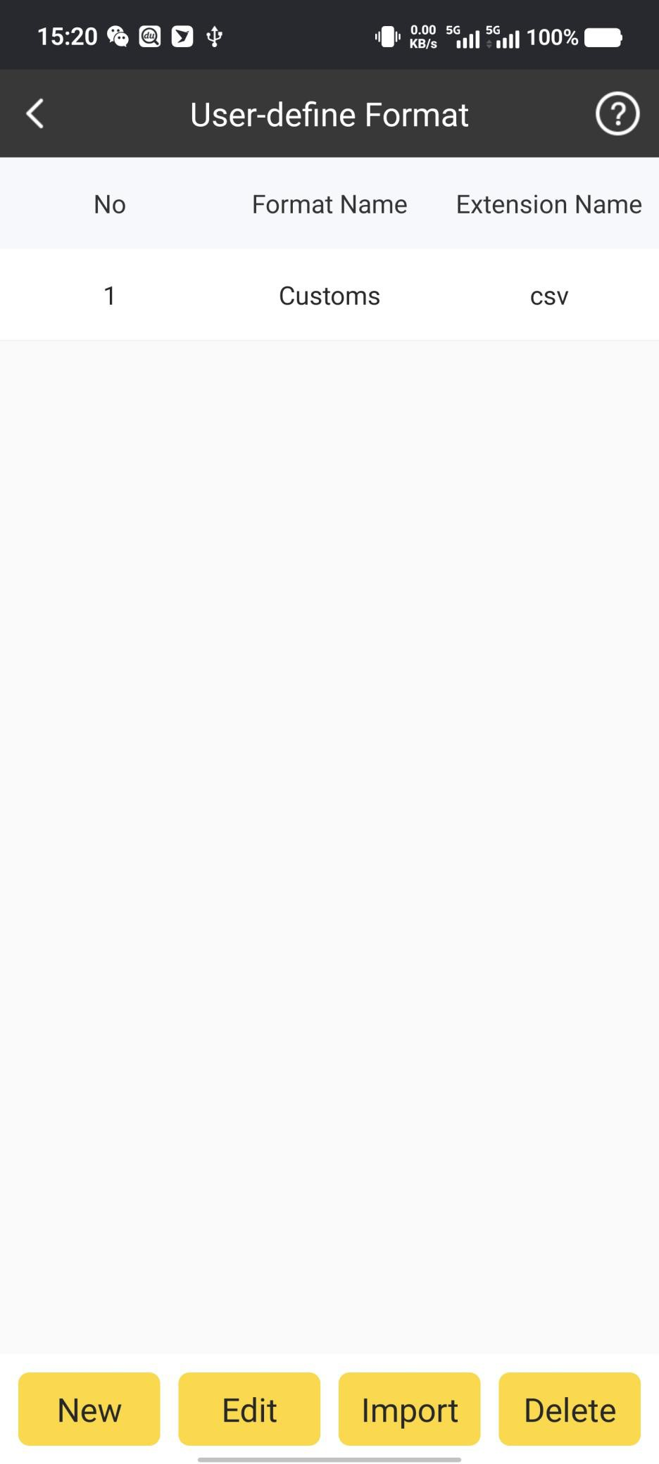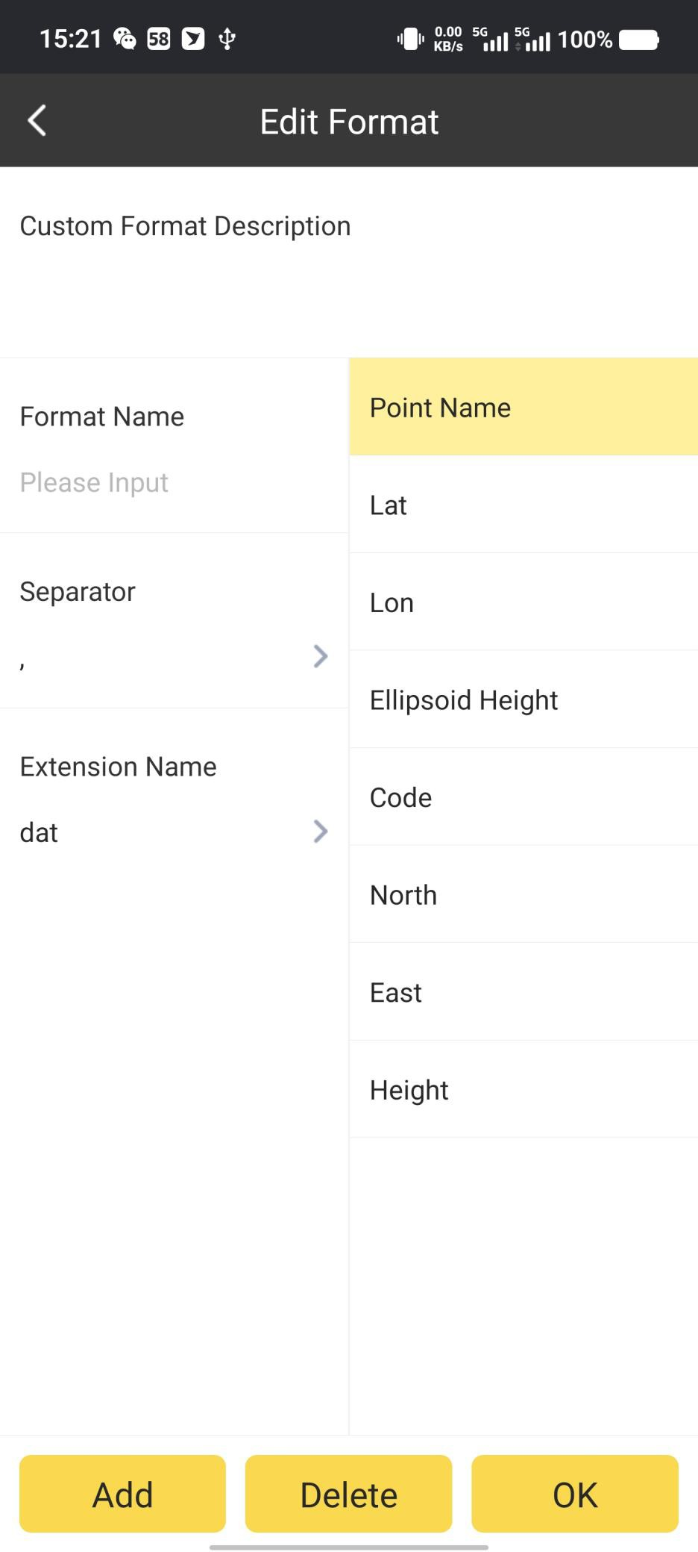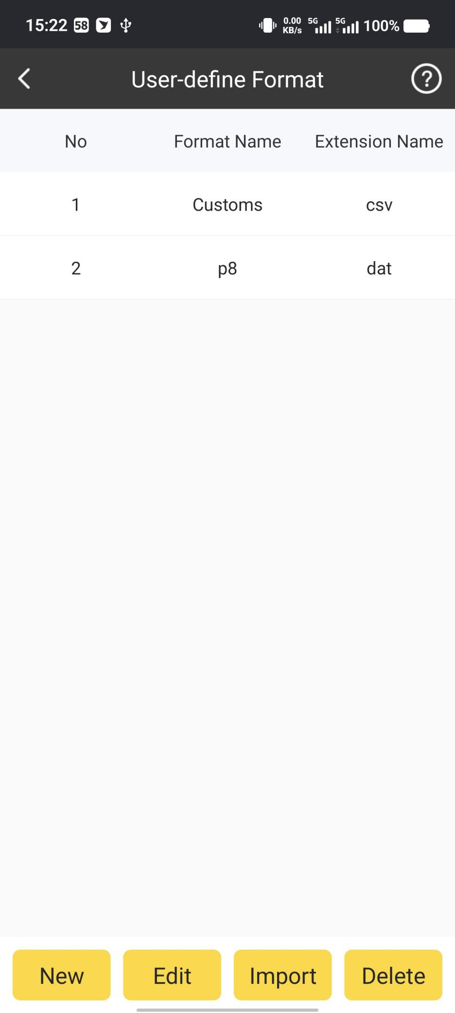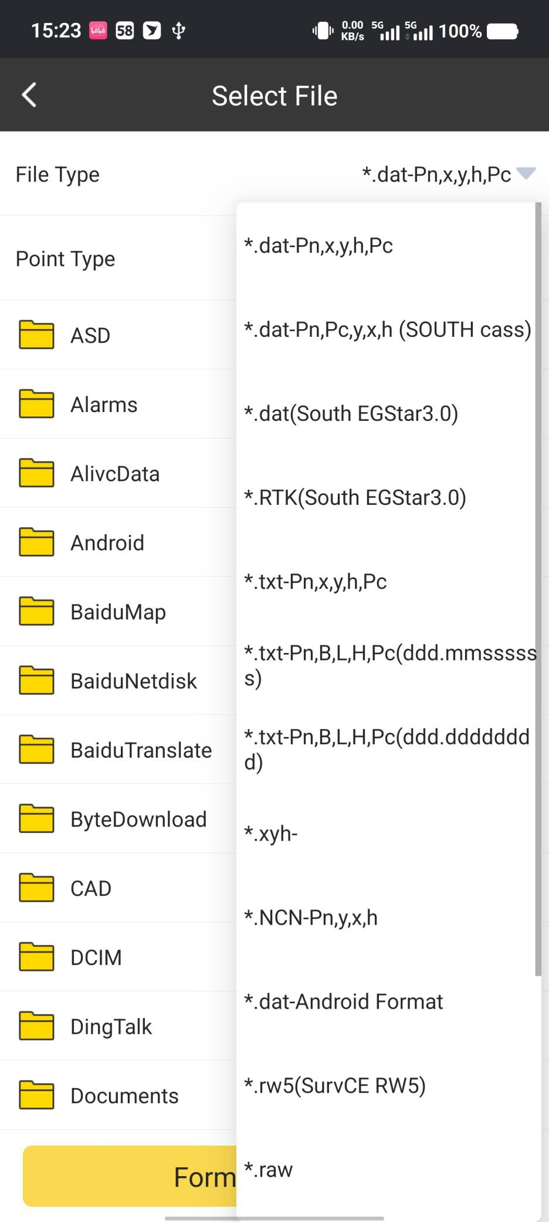

Options:

Besides basic, Add, Edit, Details and Import functions, by Clicking

in the right of the

…

tool bar. Then we can use the other function as Delete, Filter, Recover, Share, Export and Refresh.

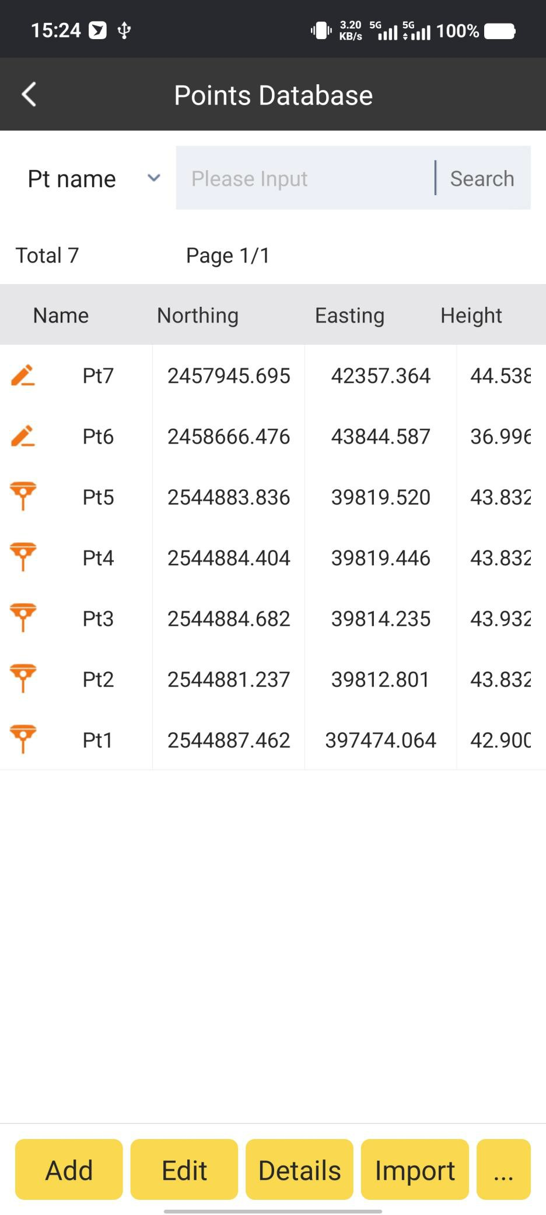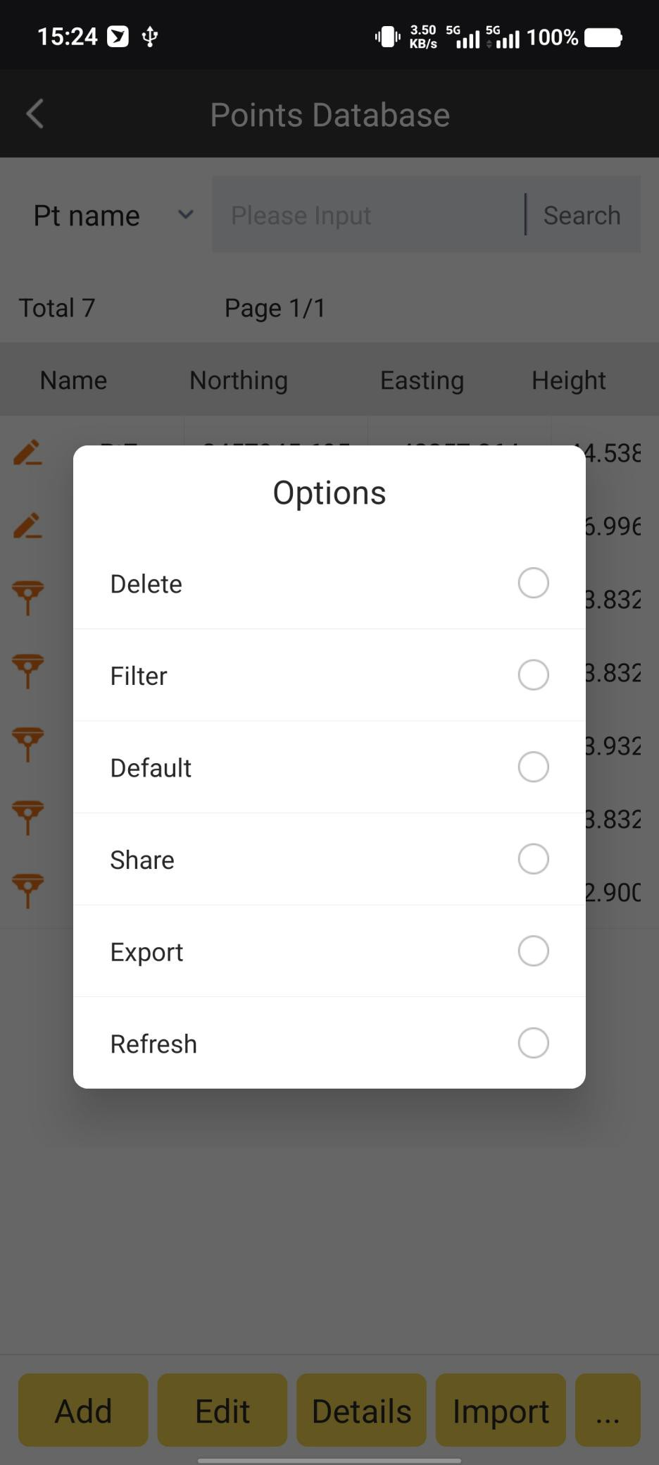

Delete:

We can delete the points selected.

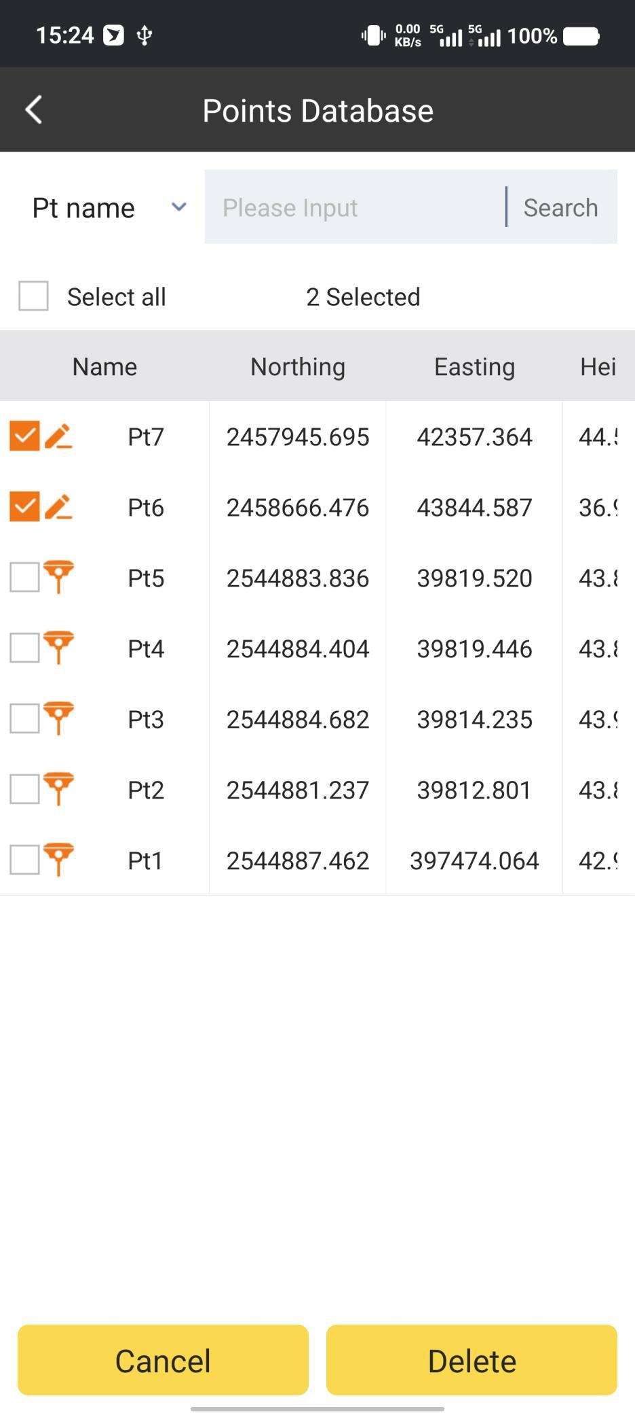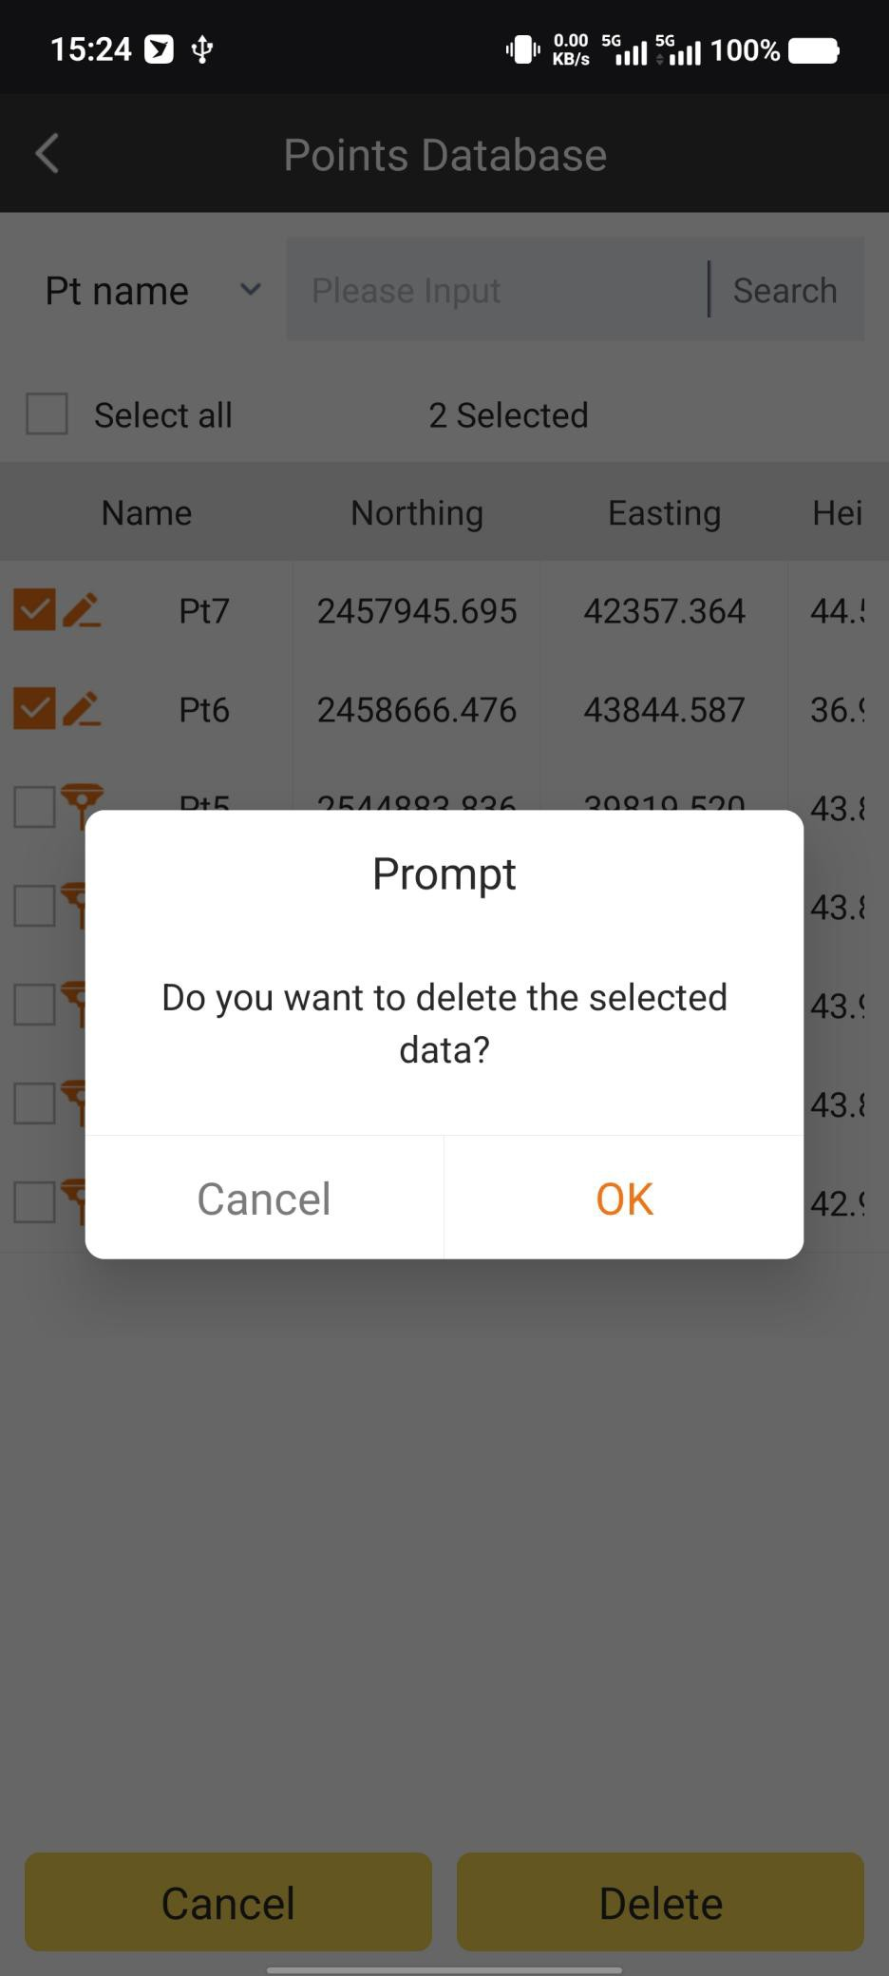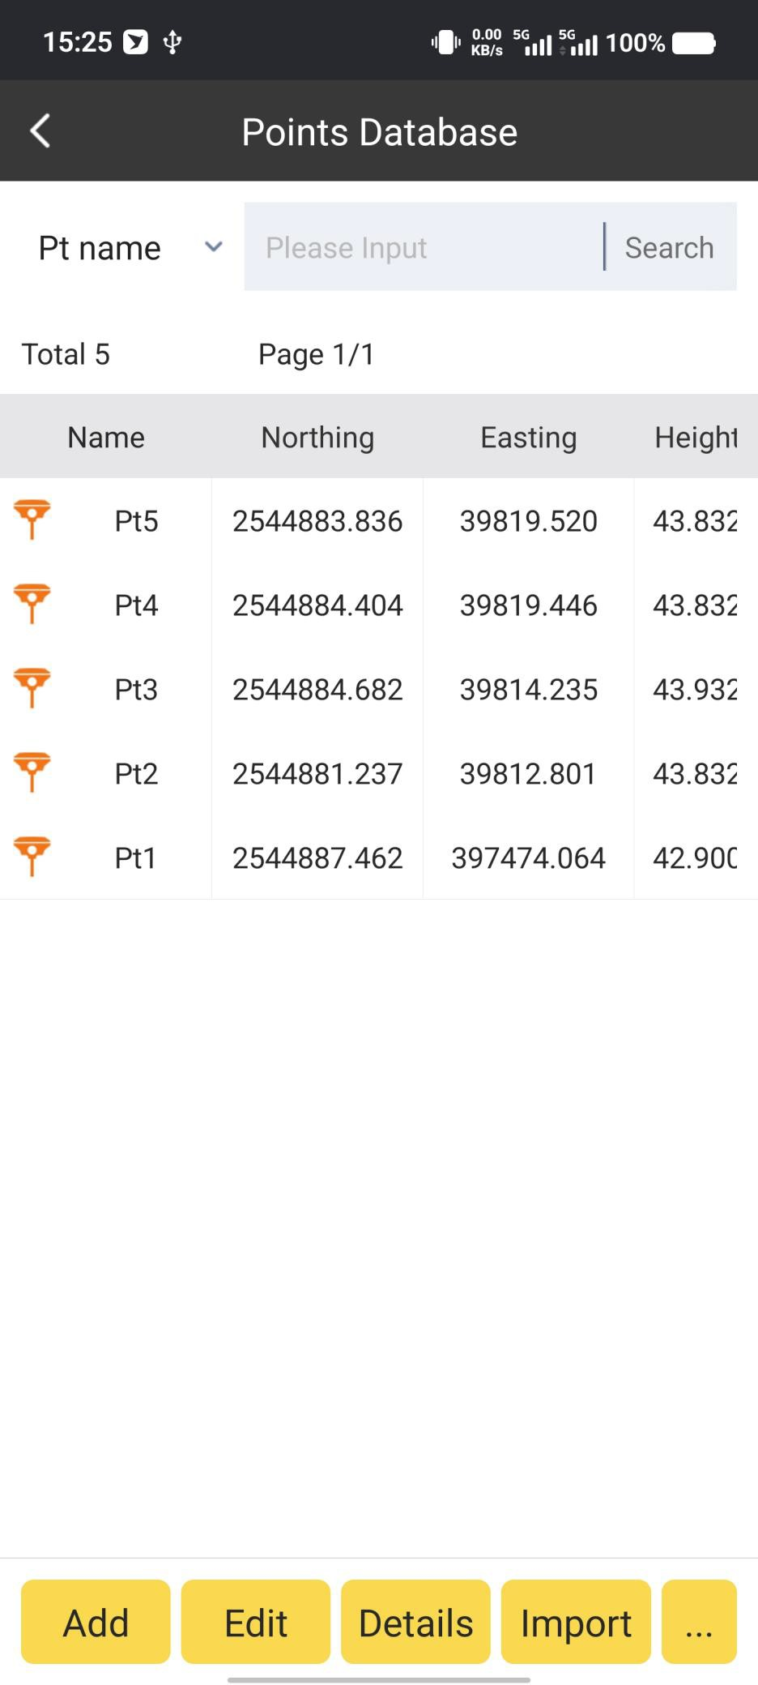

Filter:

We can let Point Database filter and display the points (Survey Point, Input Point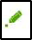 or Stake Point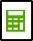) we need automatically.

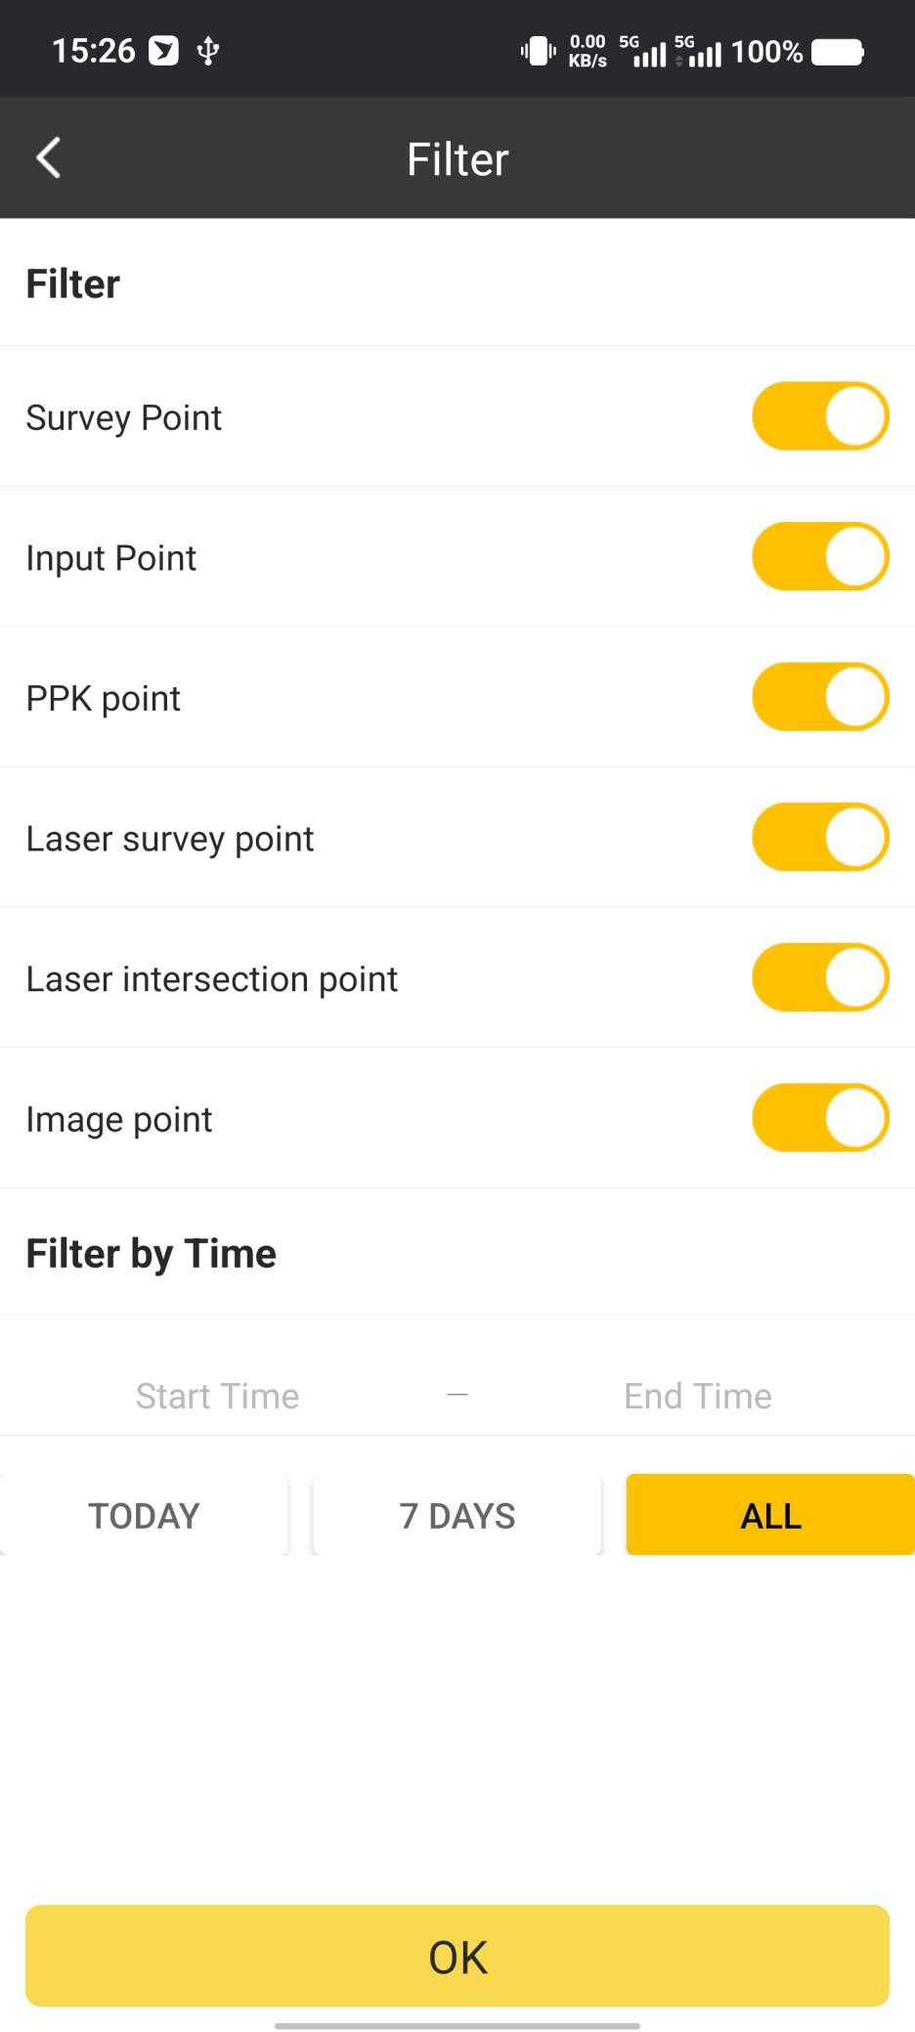

Default:

If we delete some points by mistake, we can recover them here.

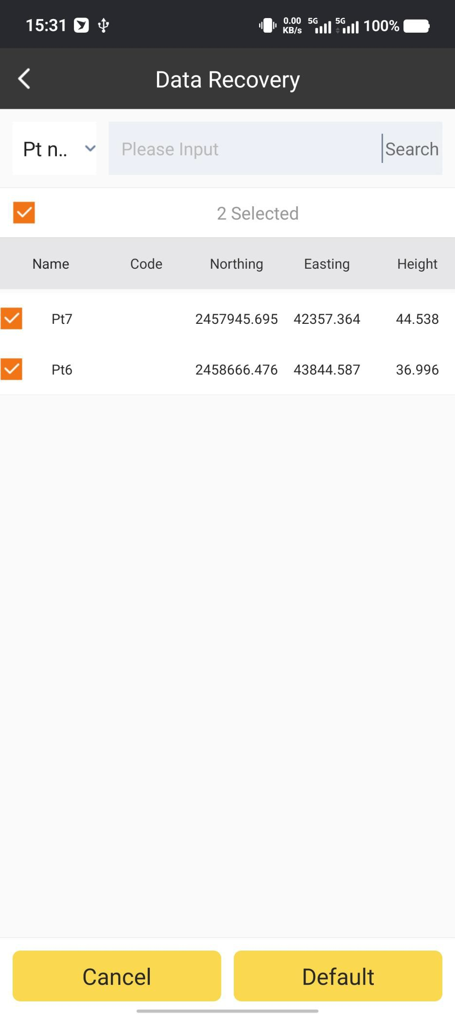

Share:

We can share the points to other users by QR code or Text format.

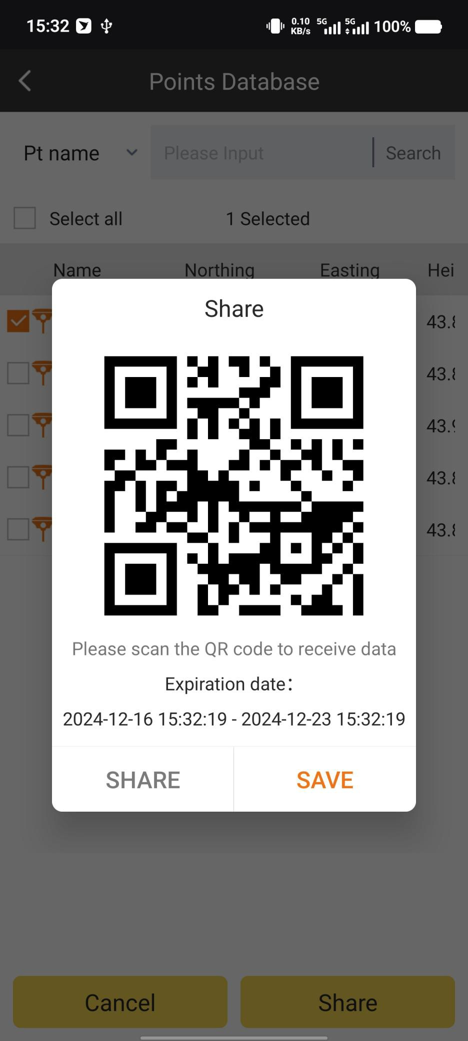

Export:

We can export data file in existing formats or self-define formats.

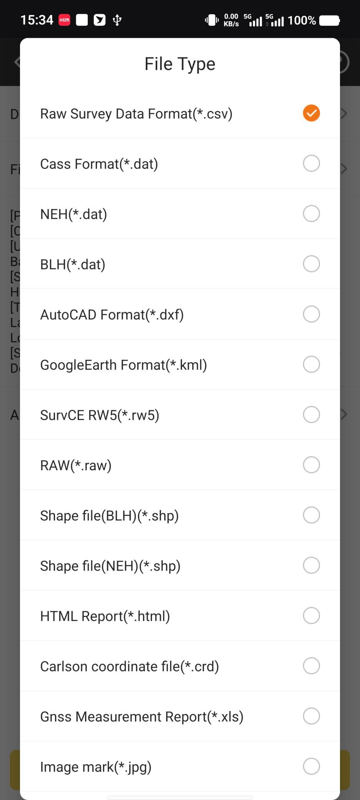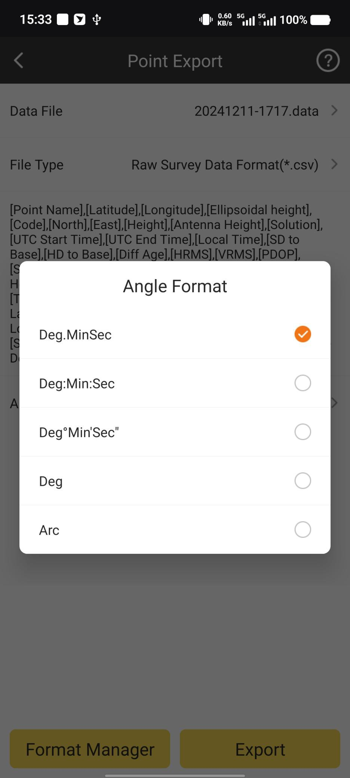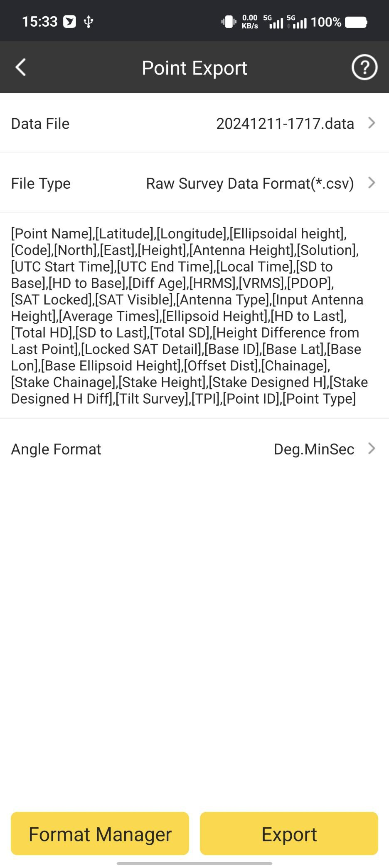

Select the export file path and click Export.

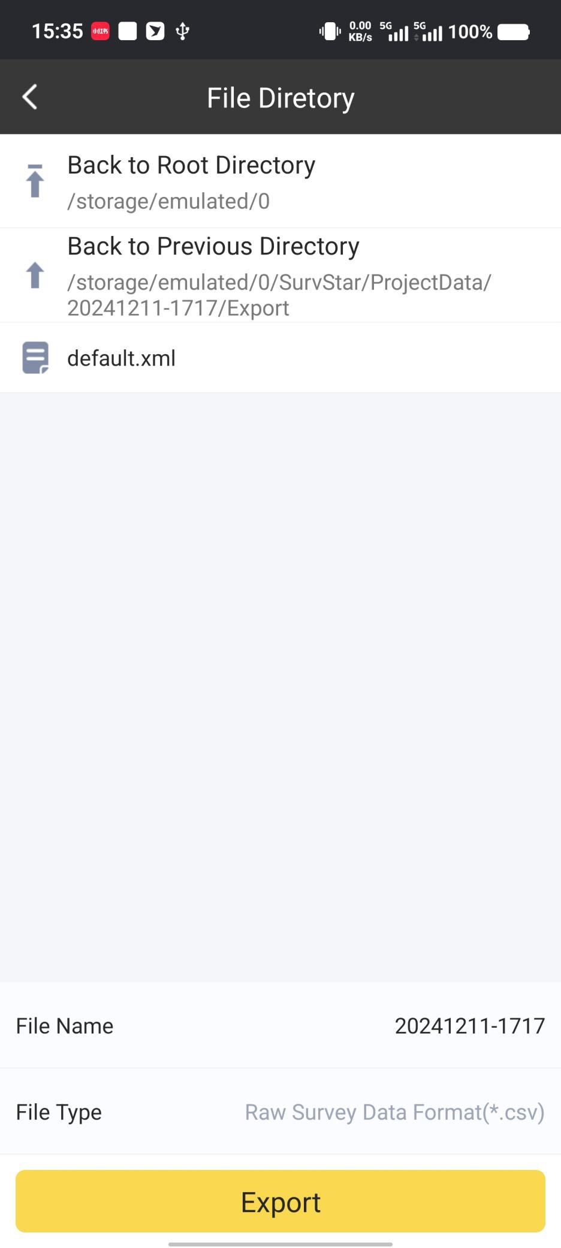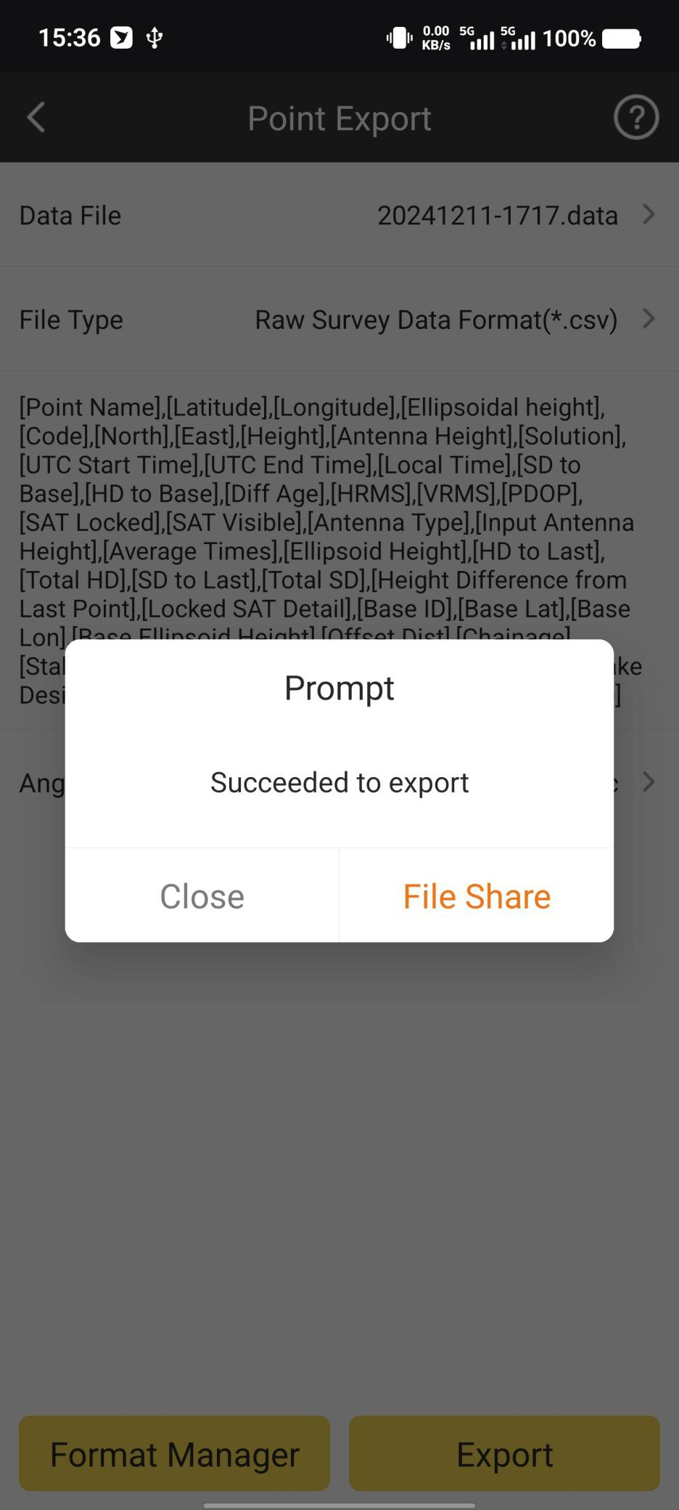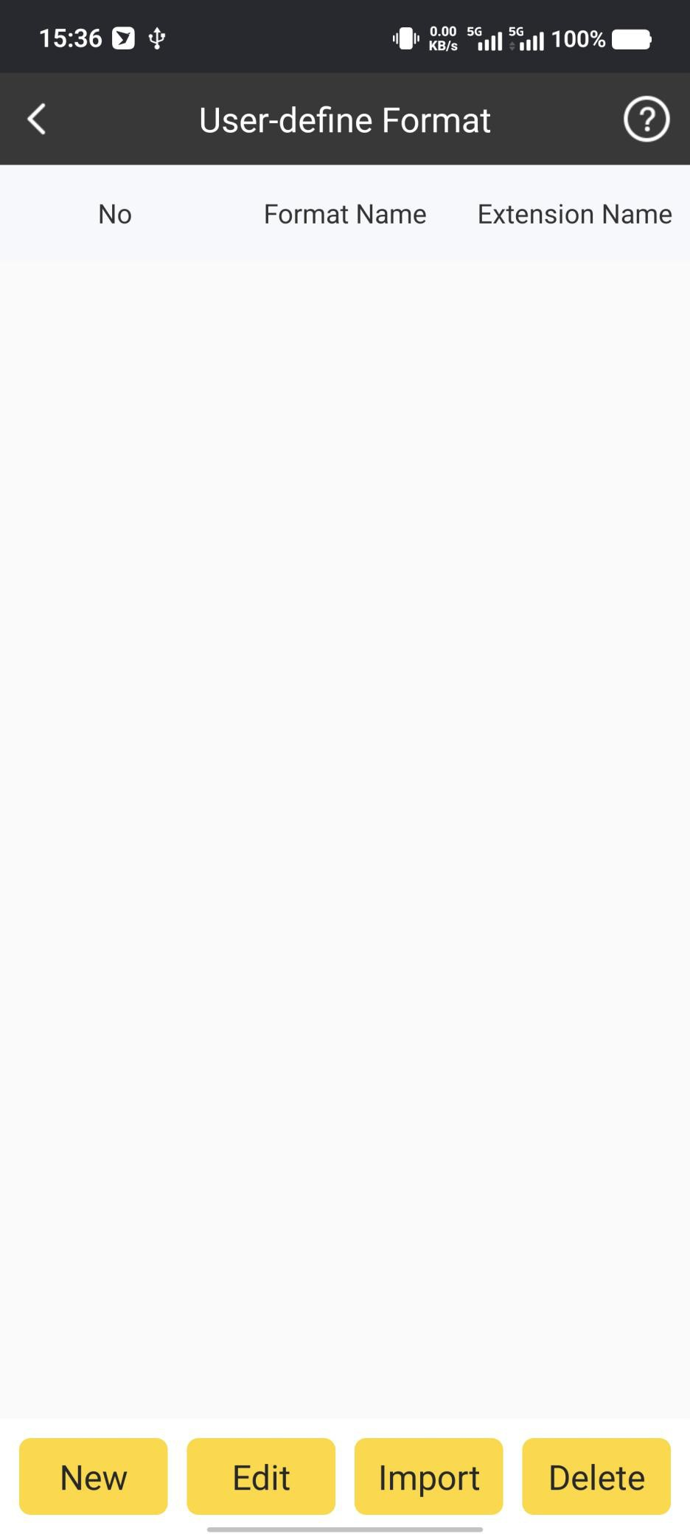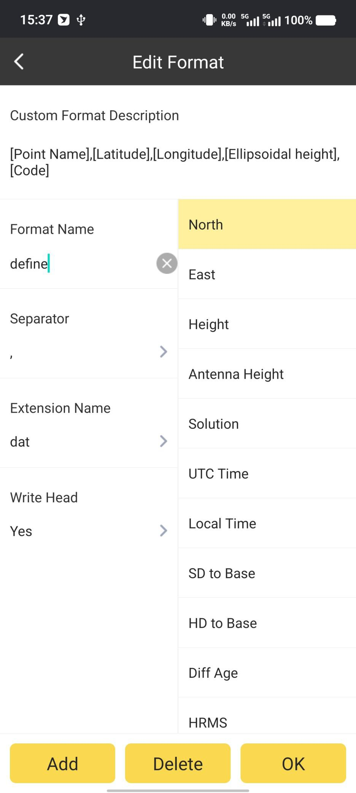

Refresh:

Click Refresh, we can apply the new Coordinate system parameters to the points in

database.

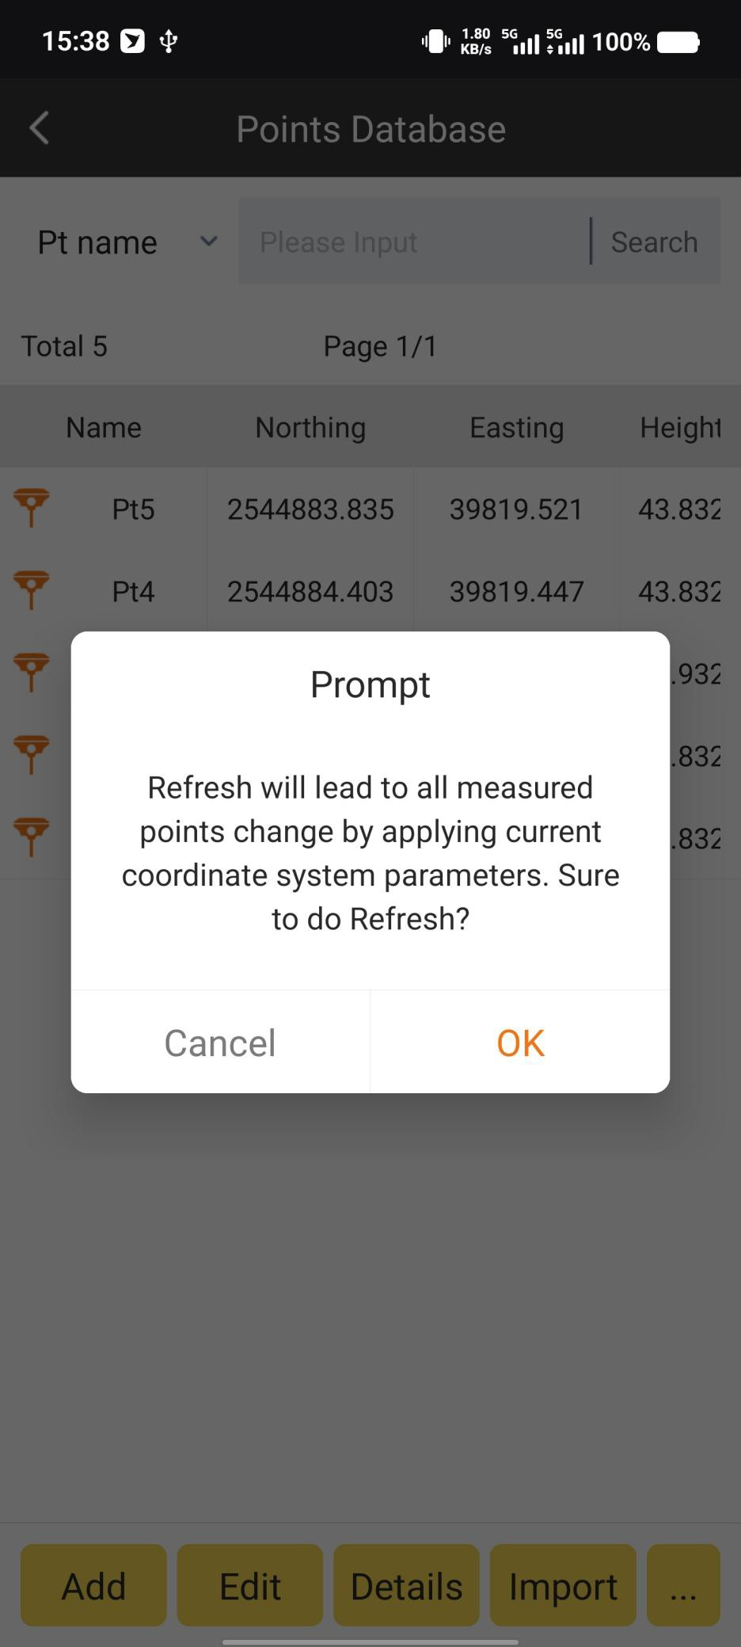

## Point Export

It is the same config as Point Export in Points Database.

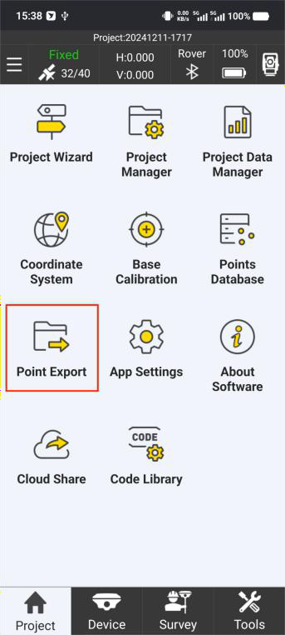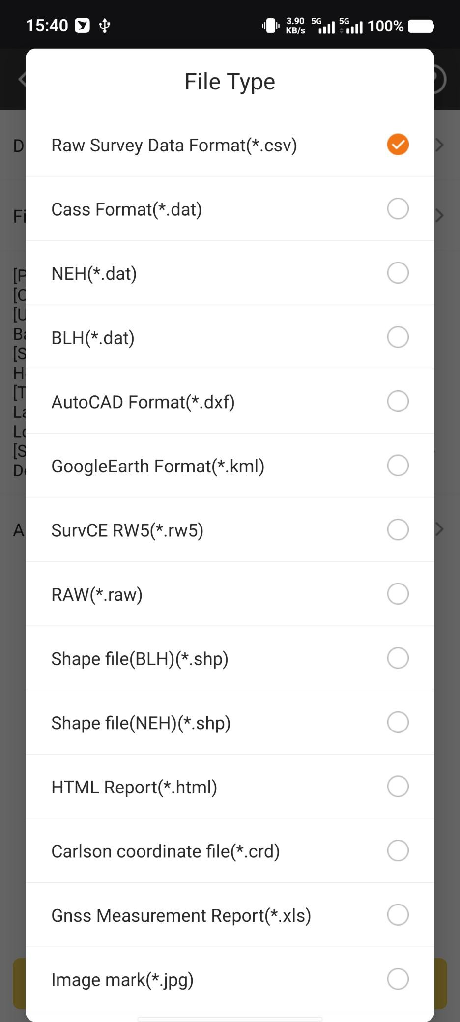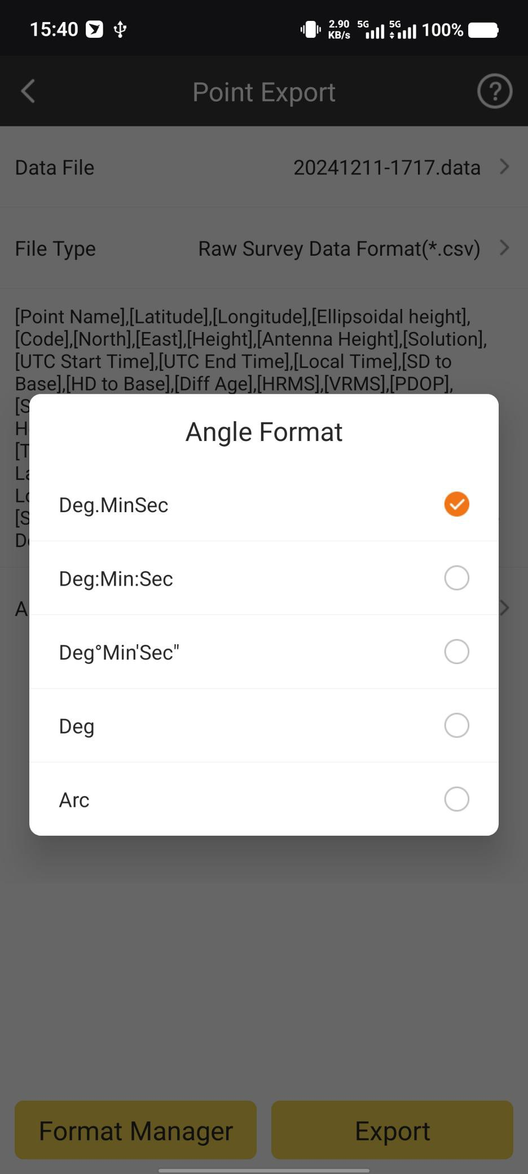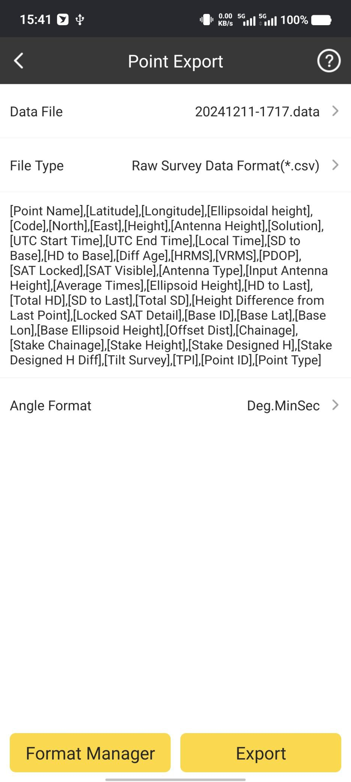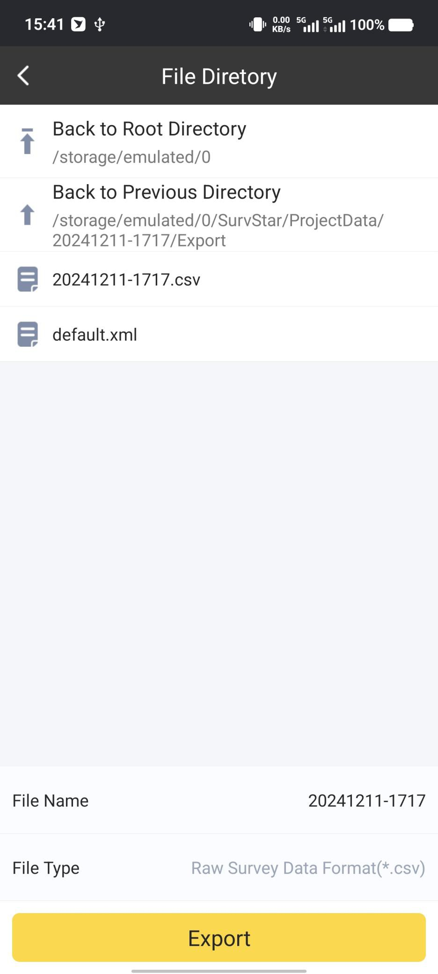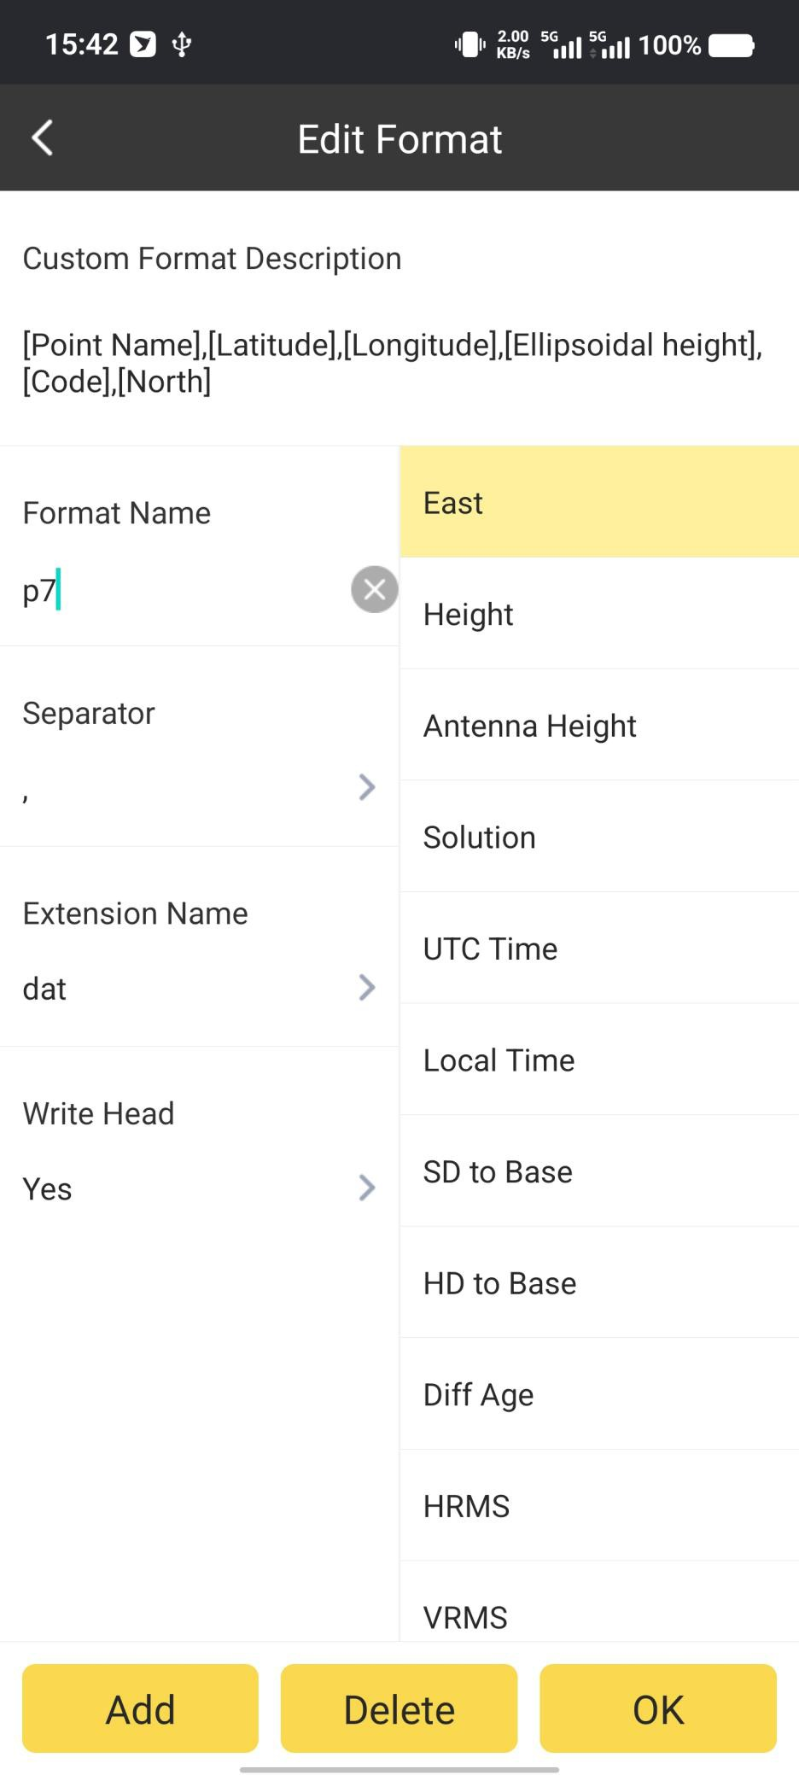

## APP Settings - RTK

In APP Settings, we can do basic configurations (such as General config, Point Save Settings, System Settings and Display Settings) for SurvStar.

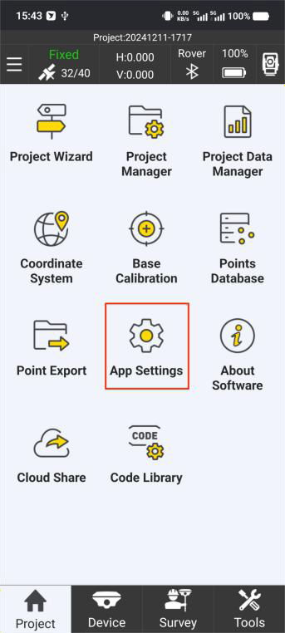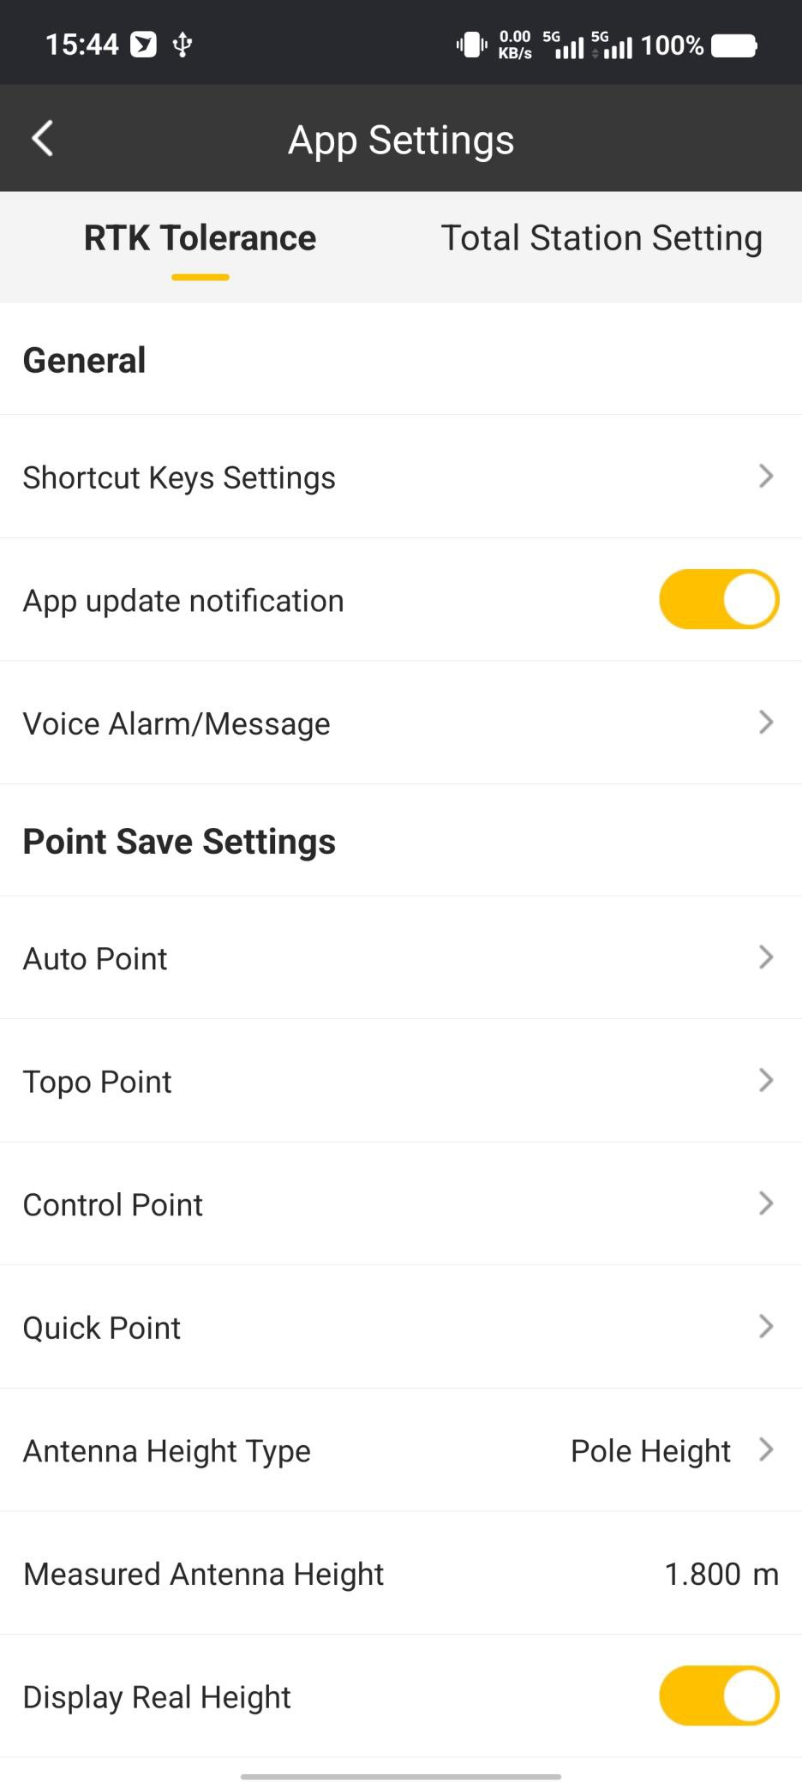

In General Config, we can set App update notification and App Voice Alarm.

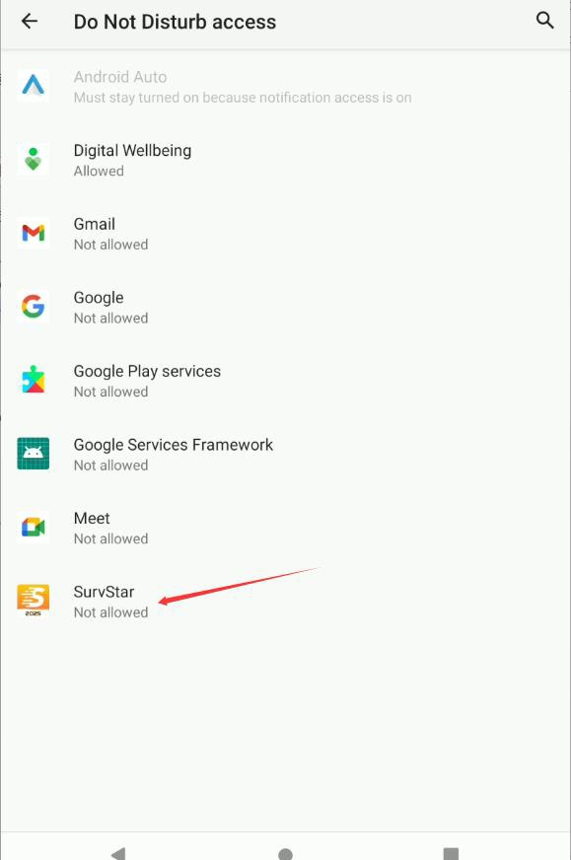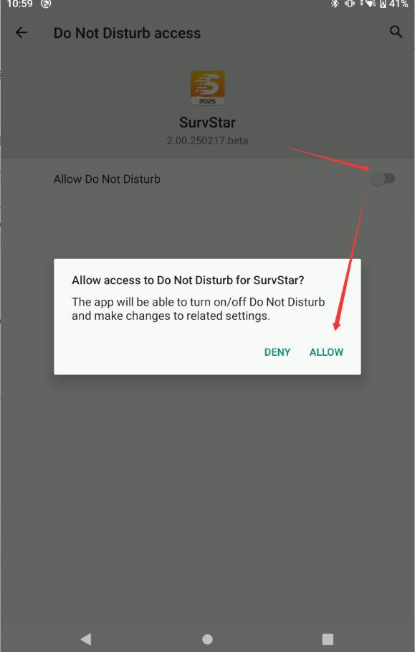

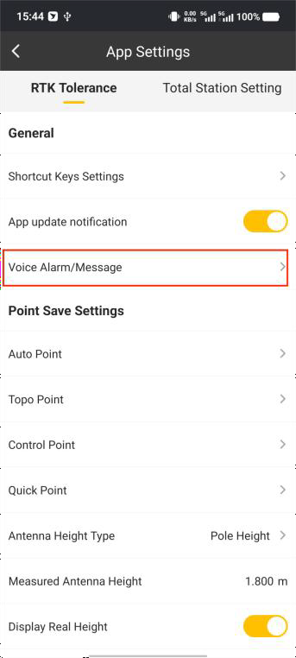

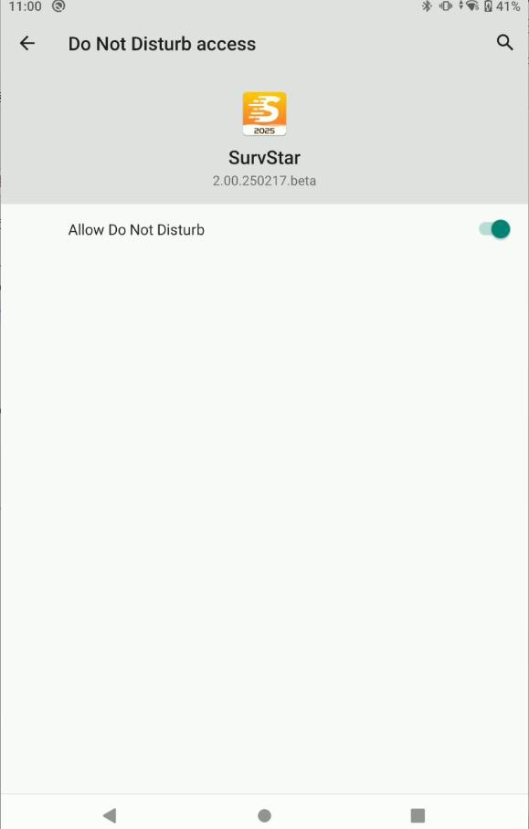 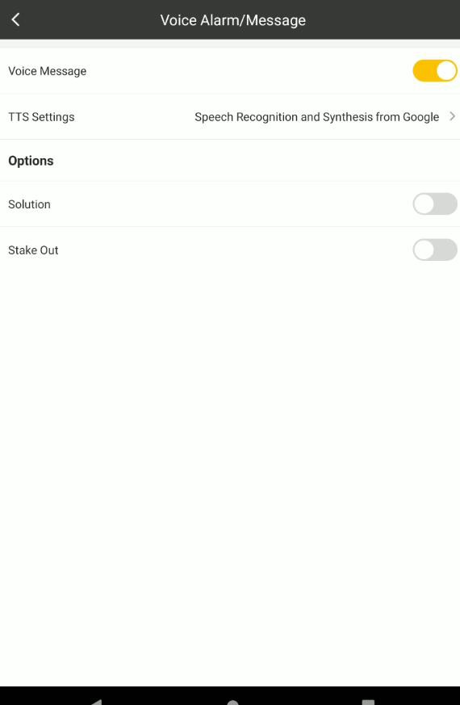

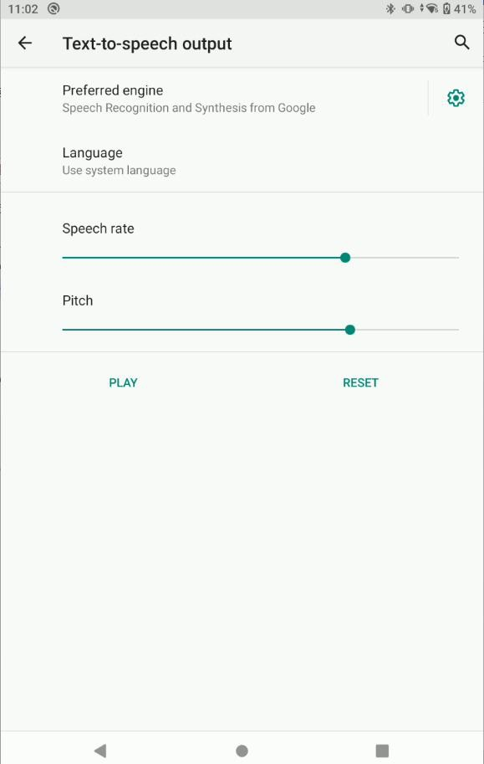

In Point Save Settings, we can set Point collection limits and parameters, Antenna Height, mask angle and so on.

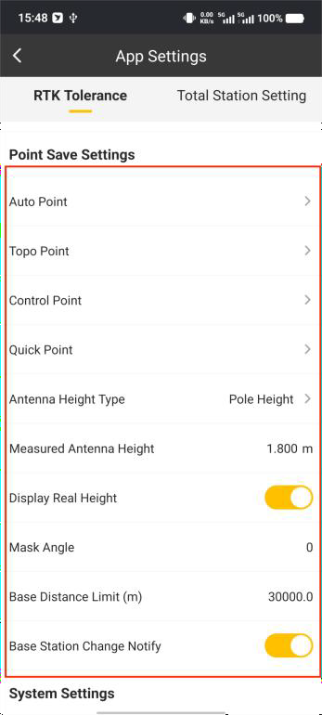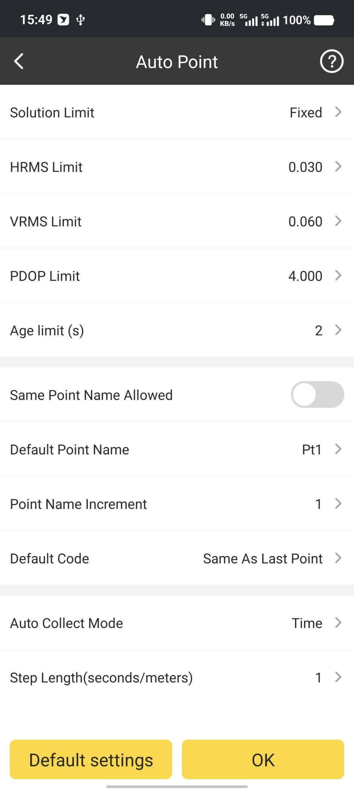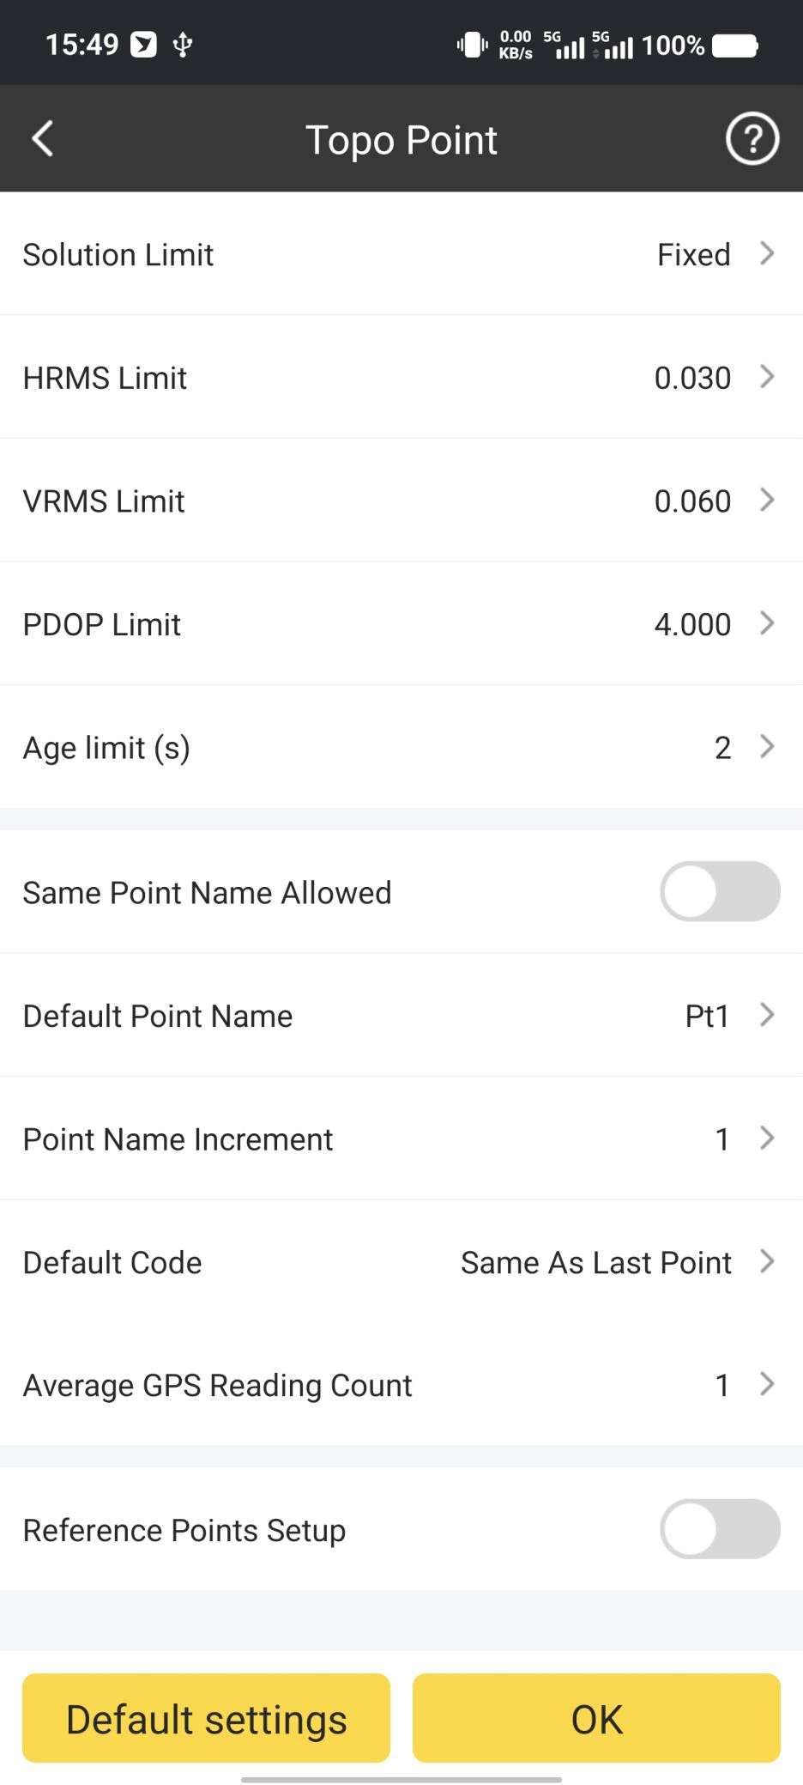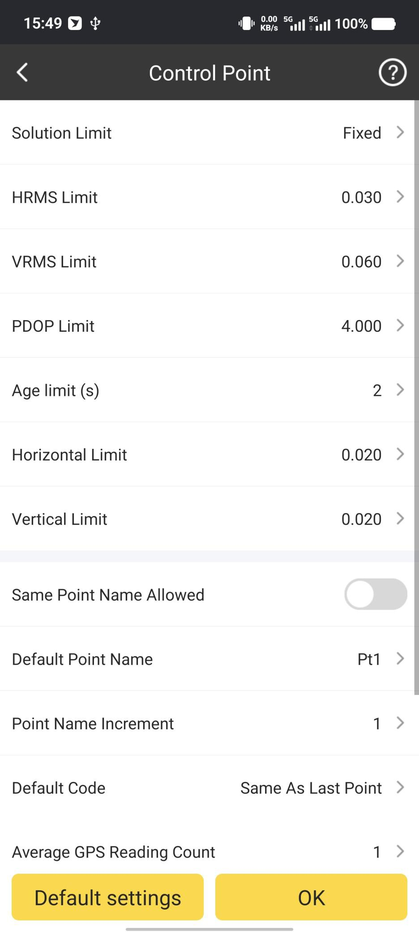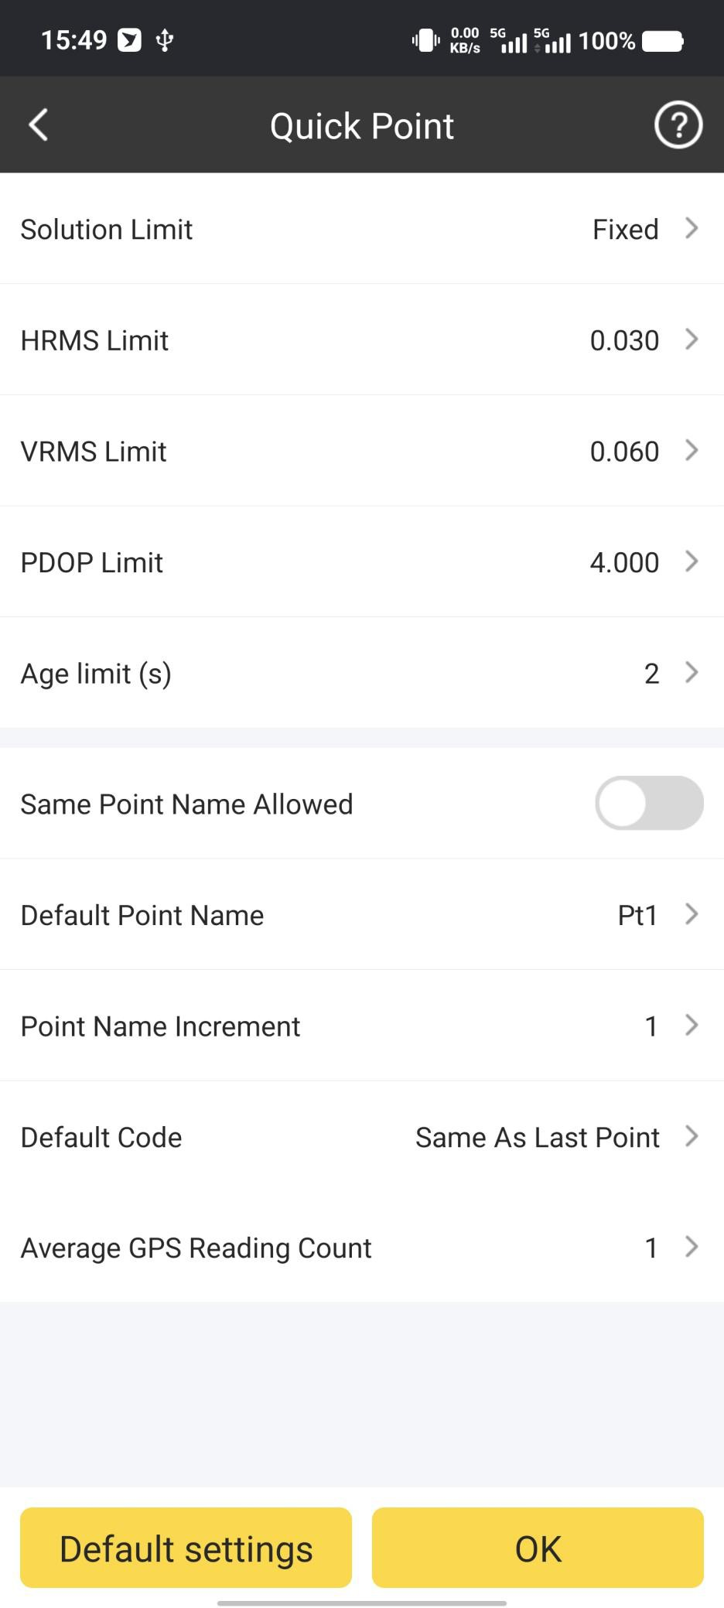

In System Settings, we can set the Time Zone, Length Unit, Length decimal,Angle Format, Angle decimal,Textcoding, Language,Screen display orientation.And set RTK backup

on/off.

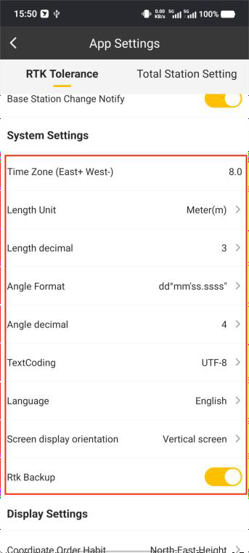

In Display Settings, we can set the Coordinate Order Habit, Point Display Limit, Positive Direction,Restart Positioning. And set Fake Point Detection , link points with same code and Voice Control on/off.

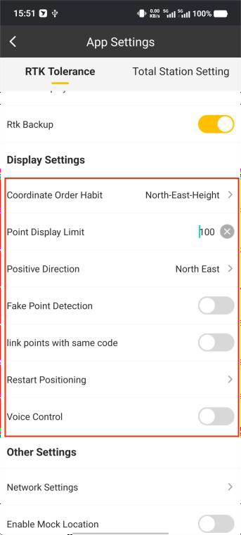

## APP Settings – Total Station

By clicking this, we can set the settings of SurvStar. It contains RTK and Total Station Settings.

In Prism Prediction, we can set the waiting time after the prism lost and what the total station will do next.

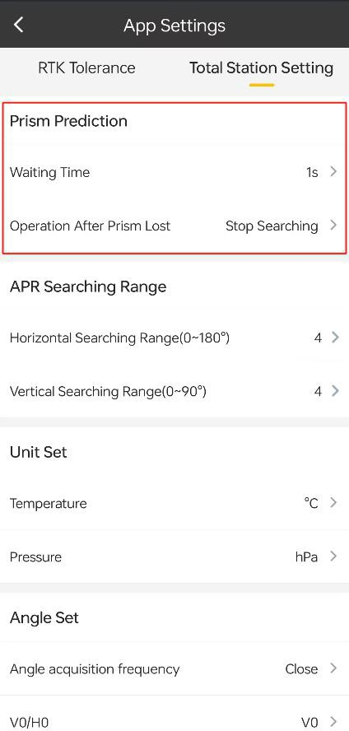 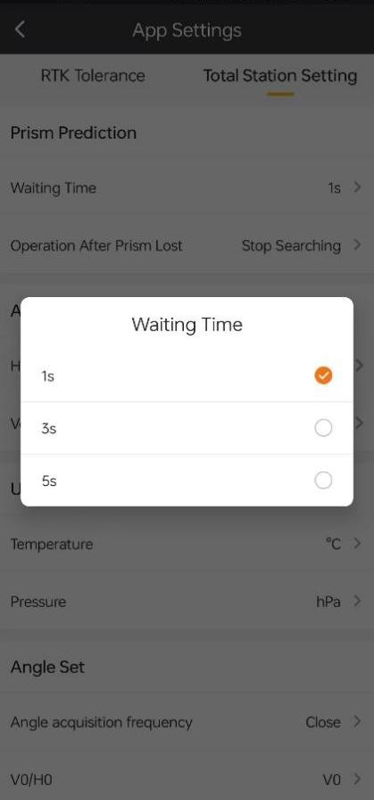

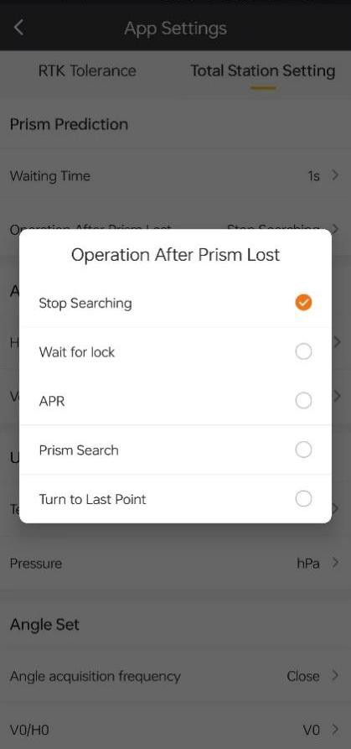

In APR Searching Range, we can set the horizontal and vertical search range.

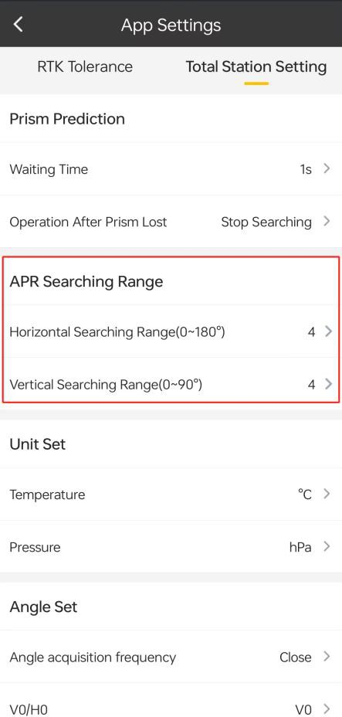

In Unit Set, we can set the units of temperature and pressure.

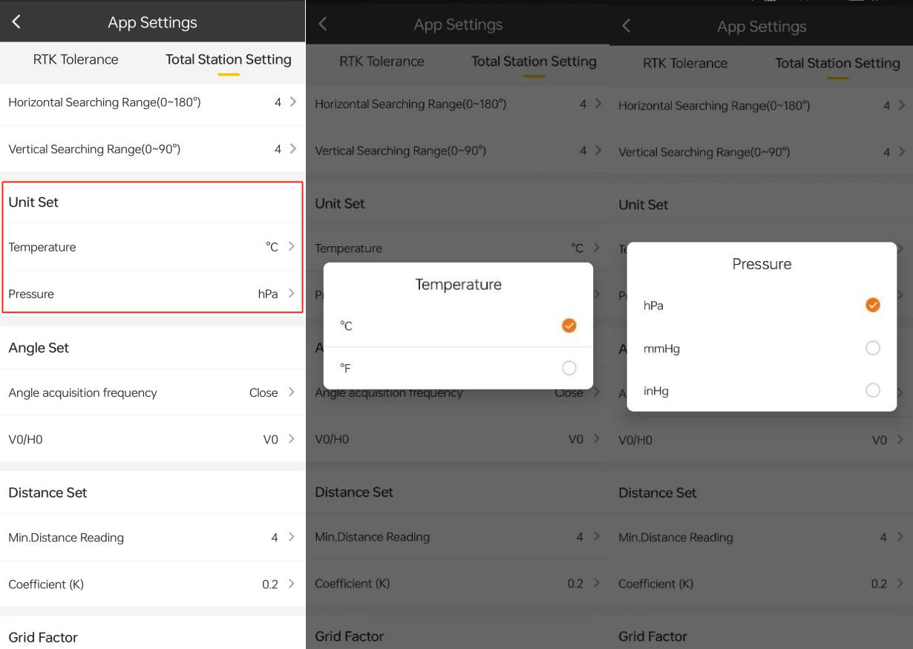

In Angle Set, we can set angle acquisition frequency and V0/H0.

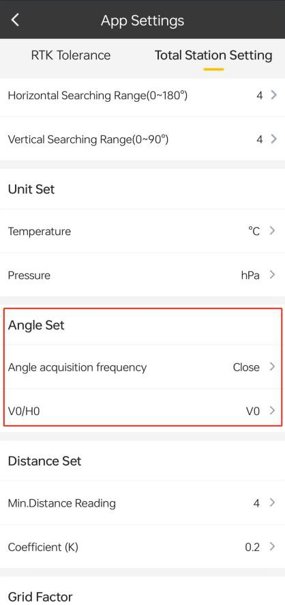 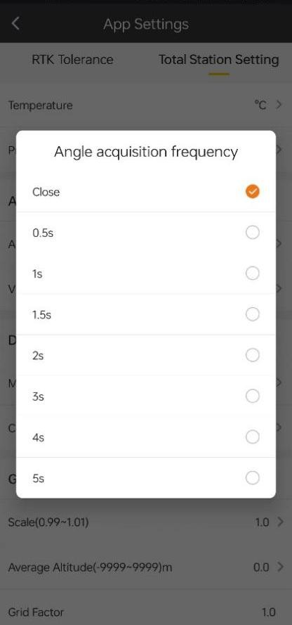

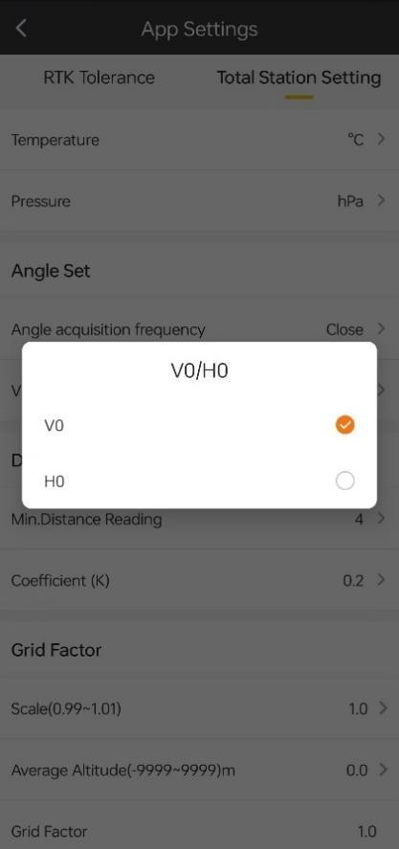

In Distance Set, we can set min. distance reading and coefficient.

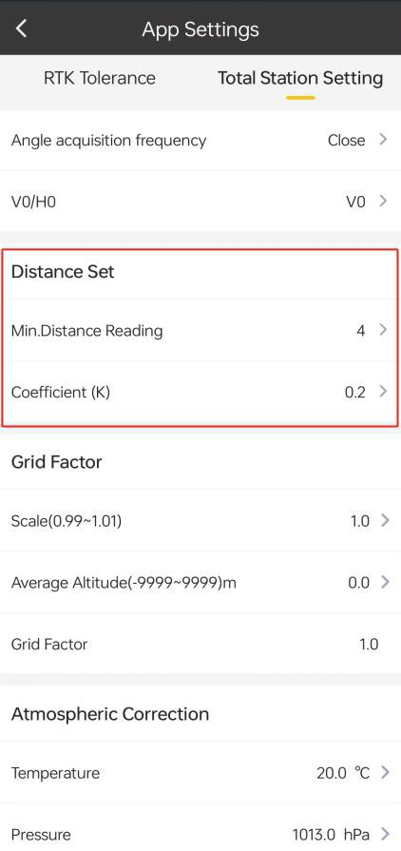 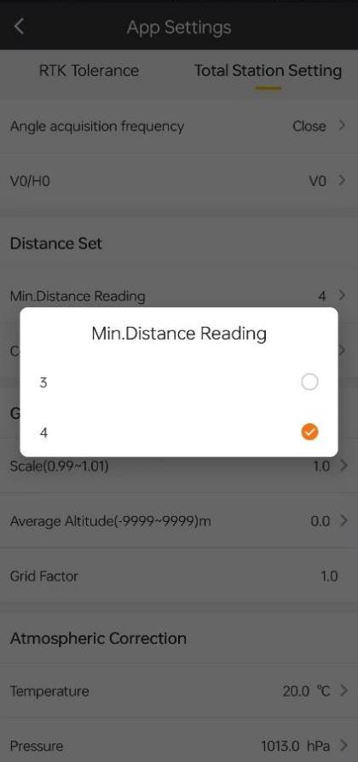

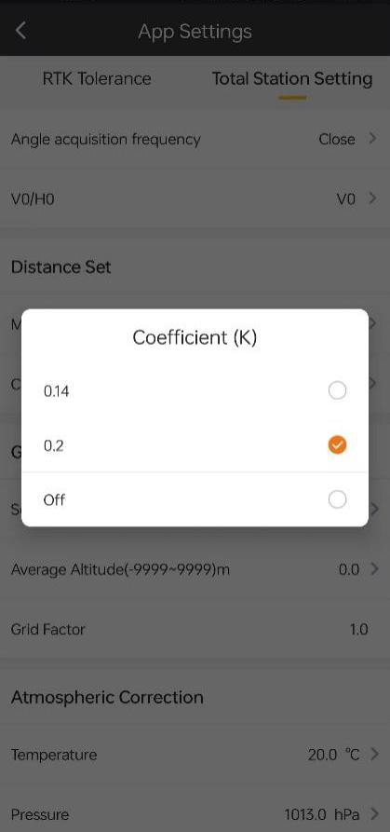

In Grid Factor, we can set scale and average altitude.

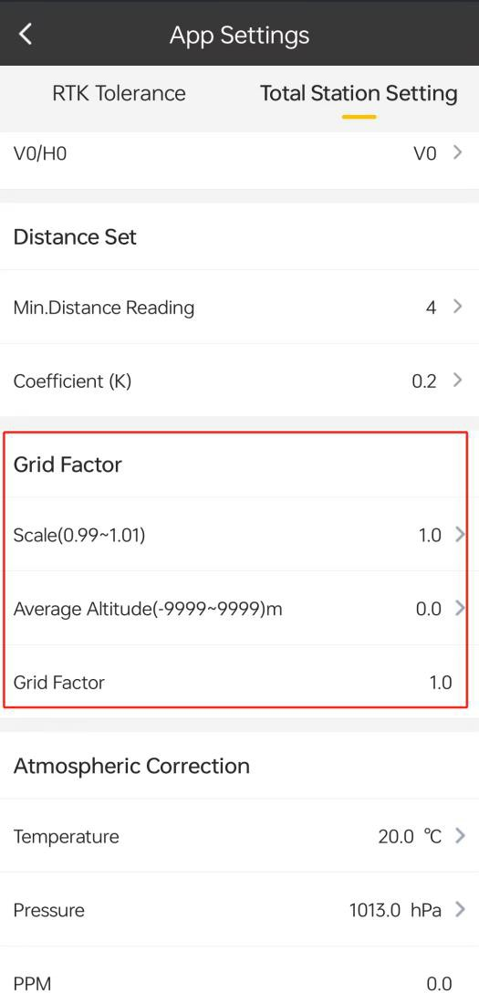

In Atmosohric Correction, we can set the correction of temperature and pressure.

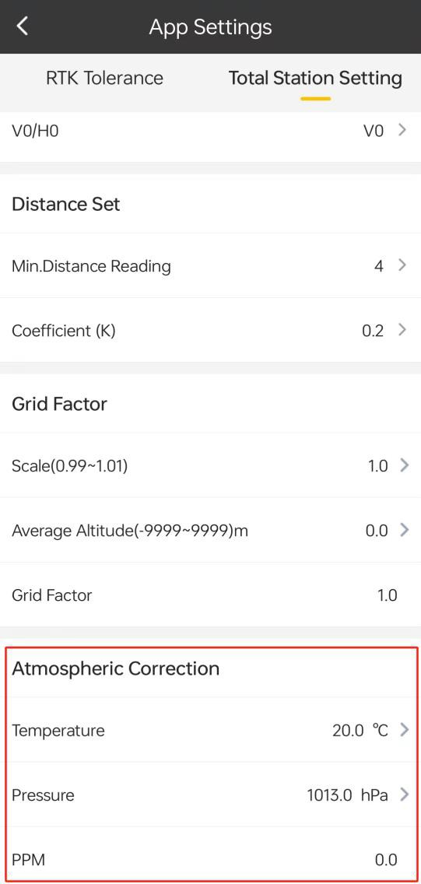

## About Software

By clicking this, we can check the version of SurvStar, register the SurvStar and check new version manually.

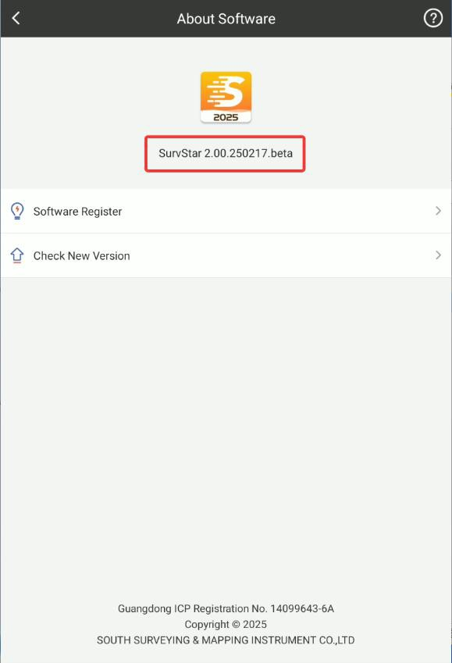

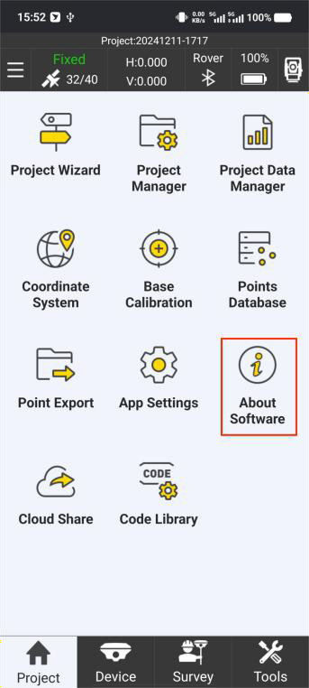

Software Register:

When we get the register code, we can click Software Register, input the code in the bar,

and click Activate.

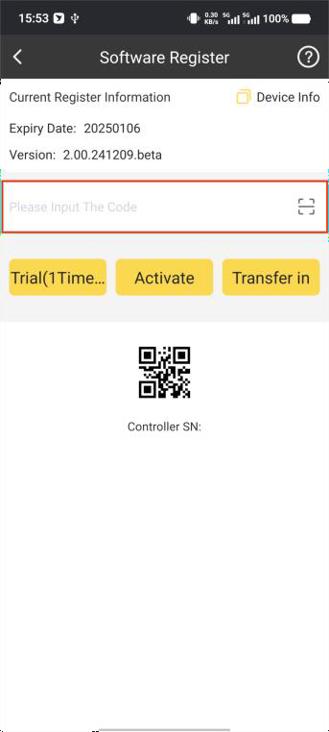

We can also check the information about the Register ID, Controller SN a, Expiry Date and PID.

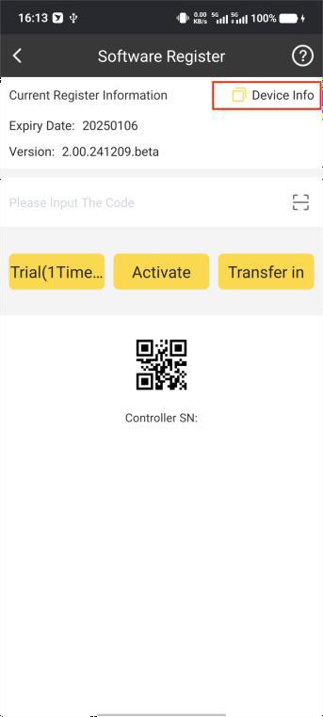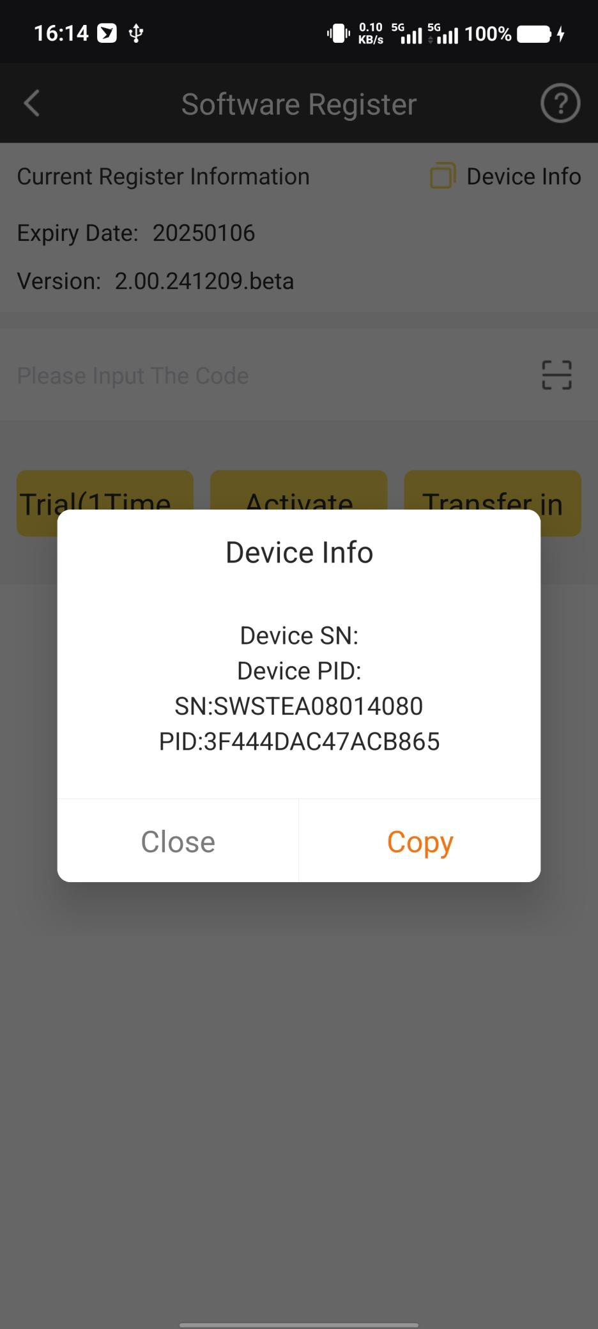

We can click Check New Version to see if there is update or not.

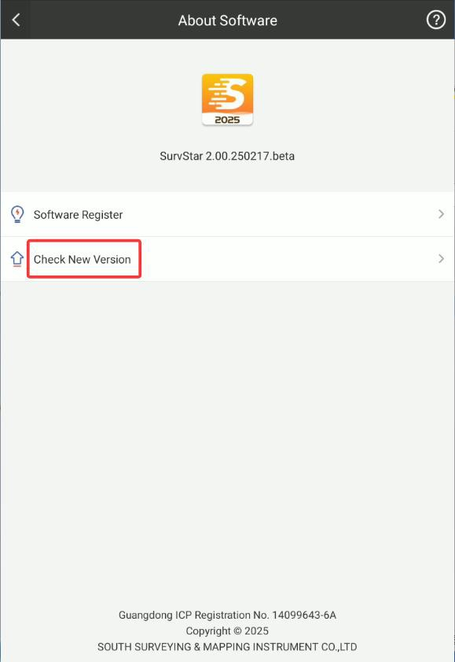

# Chapter 4 Device - RTK

## Communication

It is used to connect and communicate with receiver.

Click Device->Connection or tap the 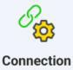icon in the top to enter this interface.

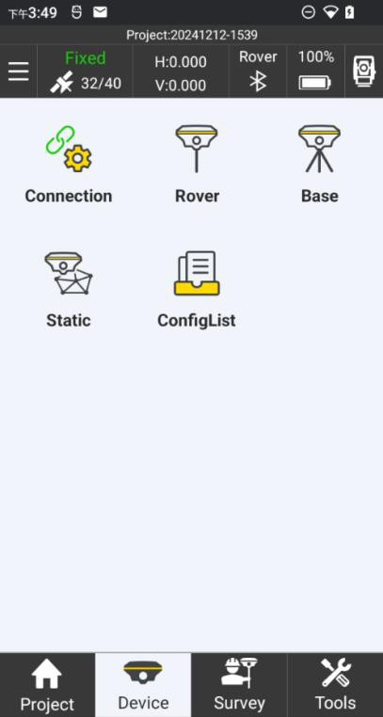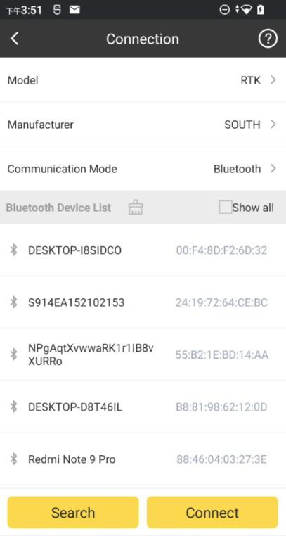

Select Model

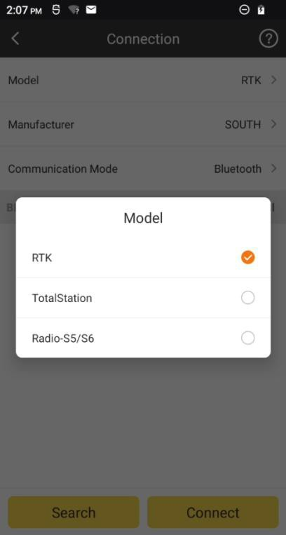

Set the correct Manufacturer.

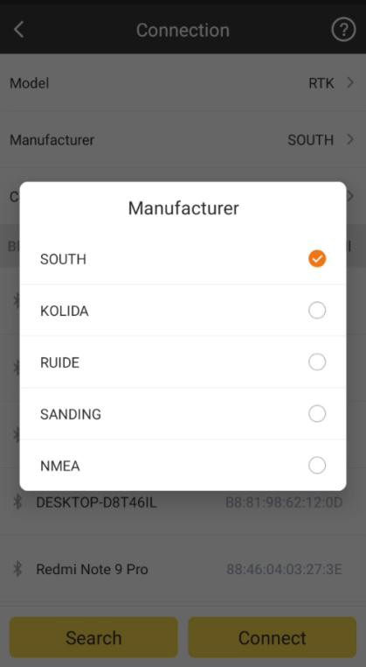

Select the Communication Mode. There are four kinds of Communication Mode: **Bluetooth**: connect receiver by Bluetooth. It is the most common used way to connect the receiver.

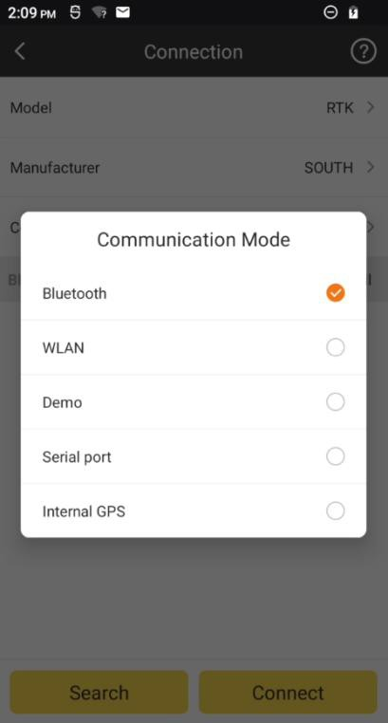

1. Click to detect the Bluetooth devices around us

Search

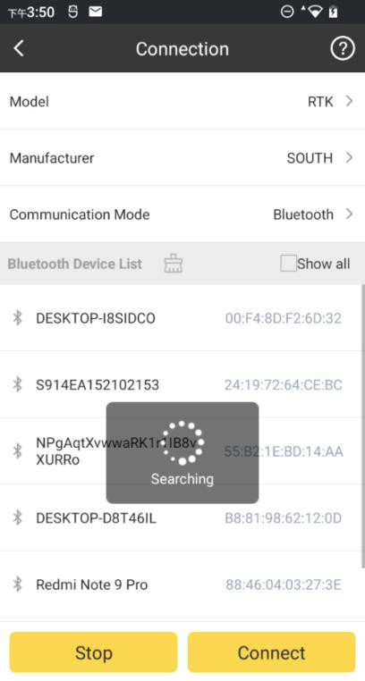

1. Select the receiver’s serial number, and click to connect receiver. The chosen

Connect

device will highlight with yellow.

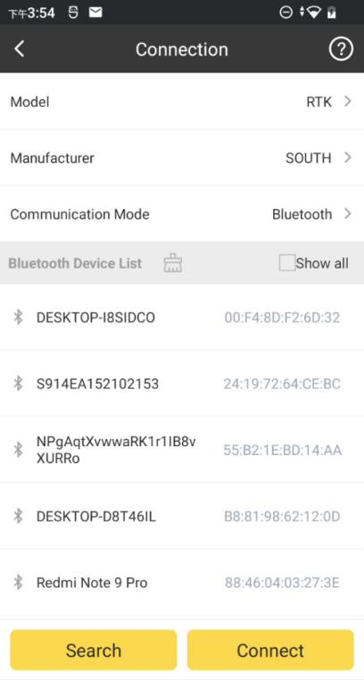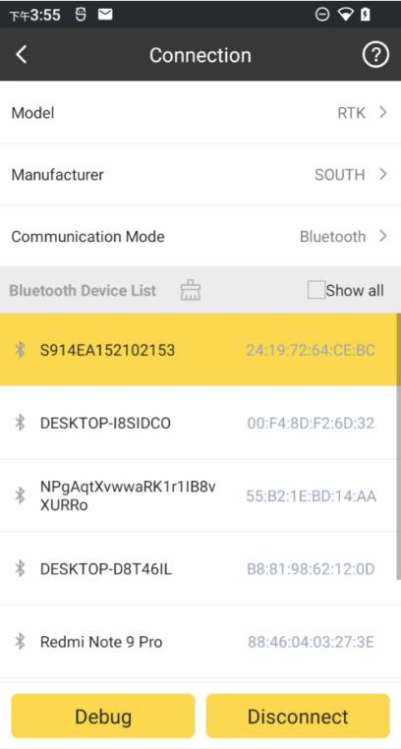

1. In Debug, we can monitor the data stream from the connected receiver.

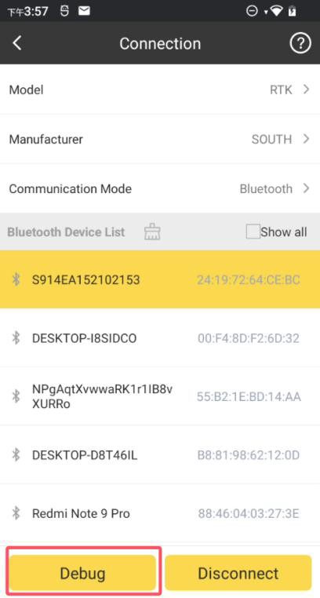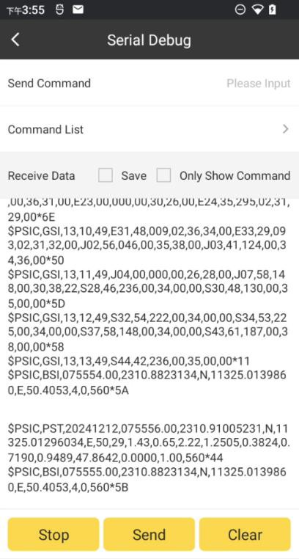

Start\Stop: Start\Stop data stream from the receiver; Send: send commands to communicate with receiver; Clear: Clear contents of the page;

Below are some commonly used commands’ list.

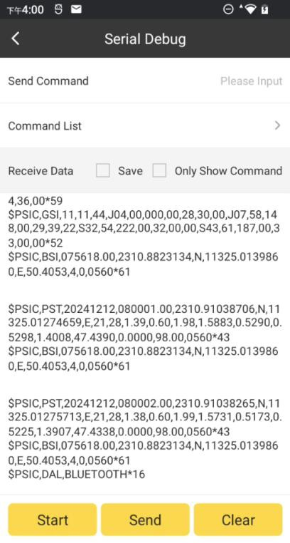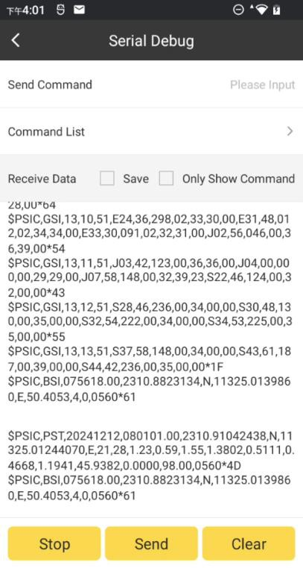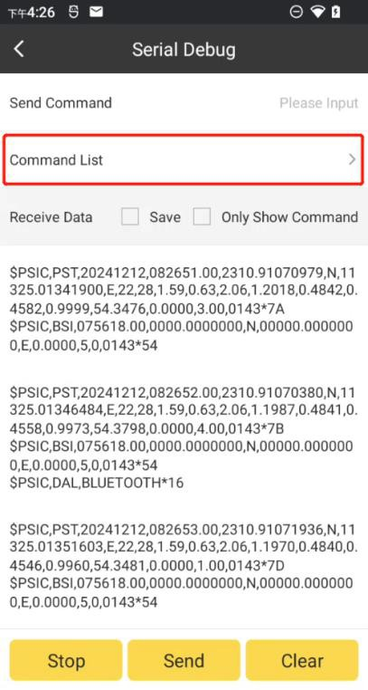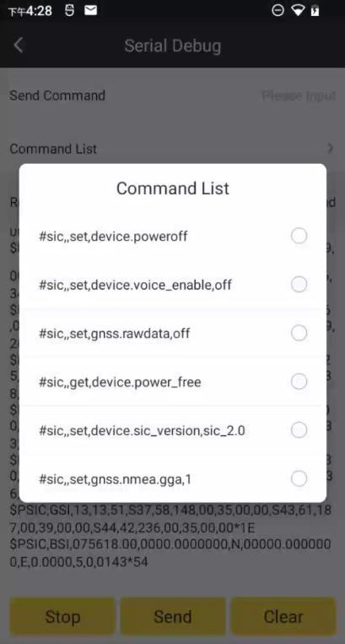

1. If we want to break communication with receiver, we can click Disconnect.

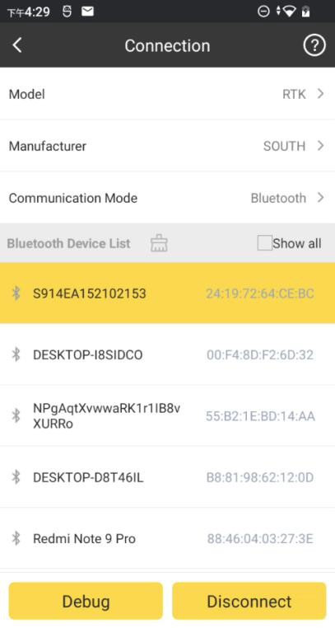

**WLAN**: Connect receiver by WIFI (It only supports the receiver with WIFI and WEB UI; and while connecting the receiver by WIFI, the android controller won’t have access to the internet.)

1. Click the connect.

Device list

bar to enter this page, choose Wi-Fi point name you want to

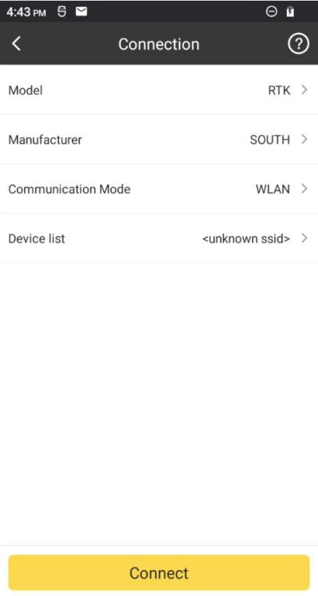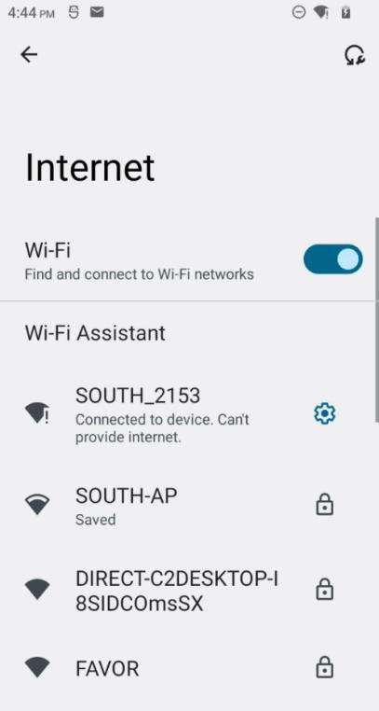

1. Swipe down the screen then click the BACK icon to connect the WLAN of the receiver.

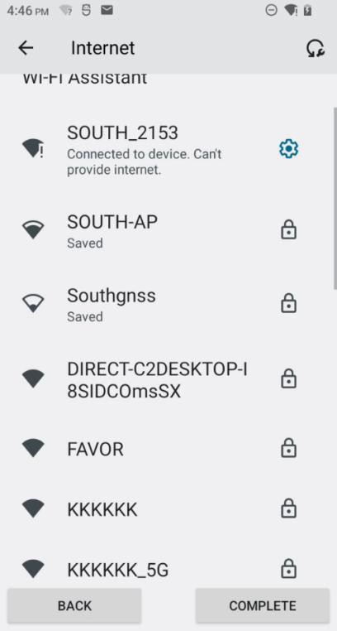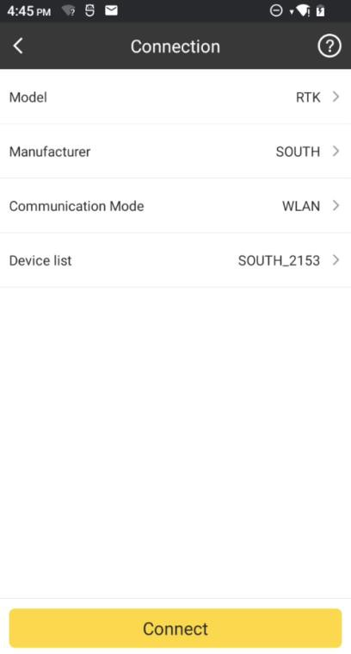

**Demo**: It is a mode used monitoring position to use SurvStar (usually for tuition and test purpose) without connecting real receiver. In this mode, we can define the starting point’s coordinates, receiver moving direction and speed.

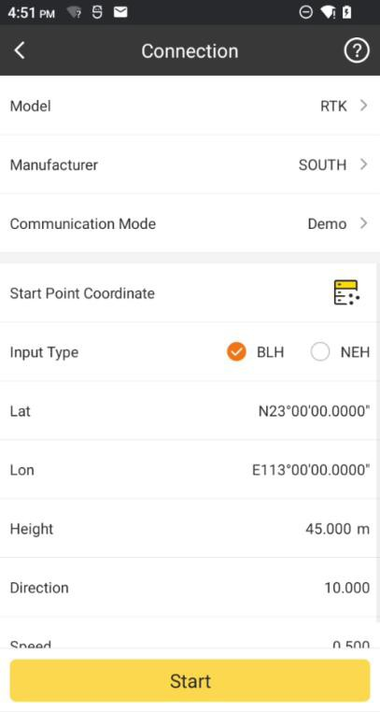

**Serial port**: Connect the receiver by cable (Not used so often)

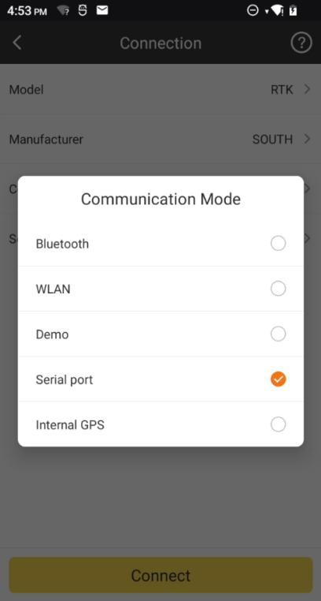

**Internal GPS:** Suitable for device with satellites antenna port, like N80T

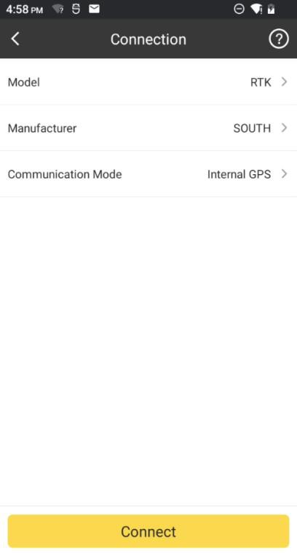

## Rover Mode

In Rover Mode, we can set receiver to rover mode and do some configurations Click Device->Rover to enter the interface of Rover Mode.

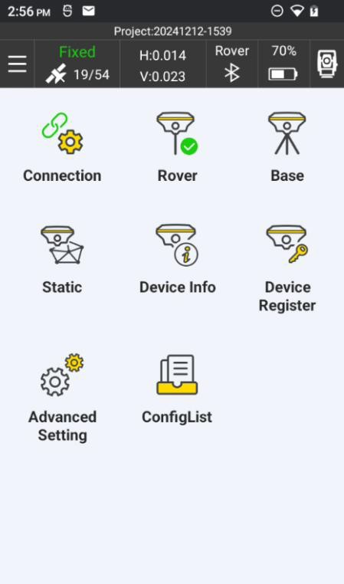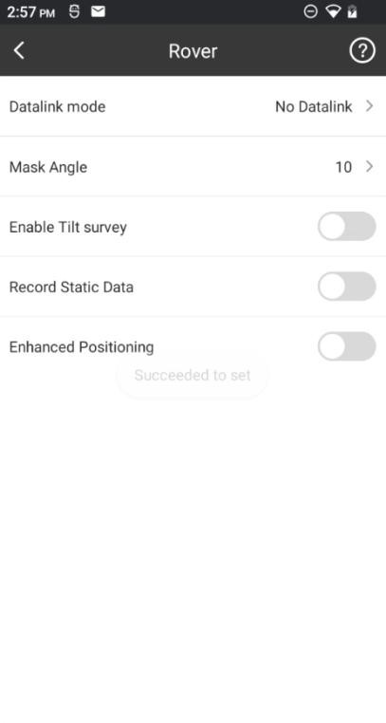

Datalink Mode: set datalink for rover.

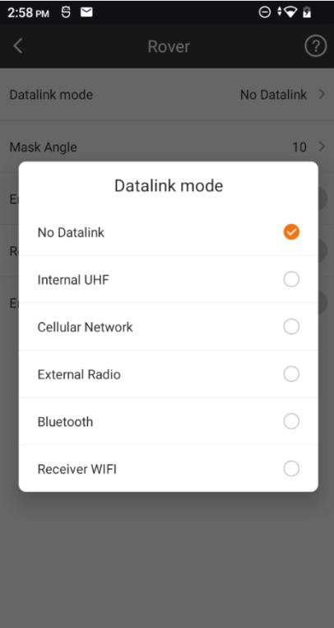

Mask Angle: to setting receiver mask angle, generally, the angle is higher, receive few number satellites, but quality is better. Default is 10.

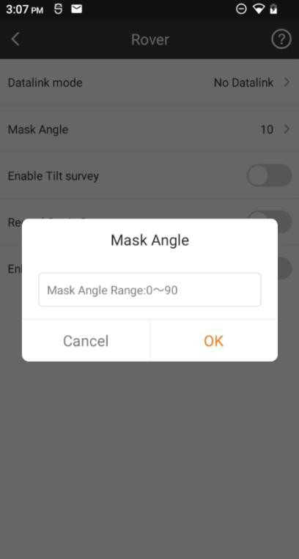

Enable Tilt Survey: by enabling it, we can do E-Bubble Calibration and Magnetic Calibration for IMU sensor.

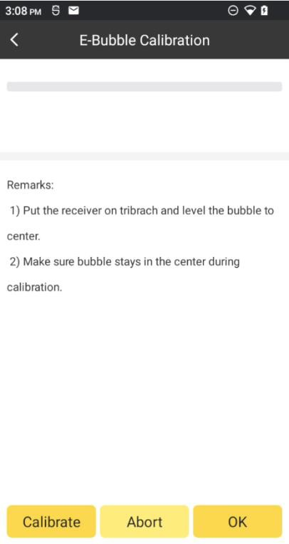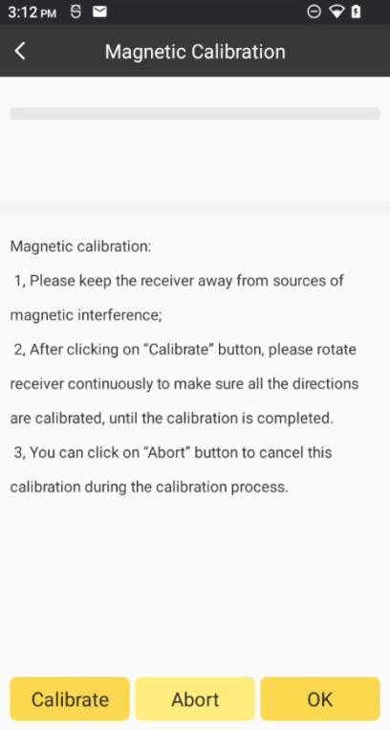

Record Static Data: Enable receiver to record raw data automatically (usually used in PPK mode).

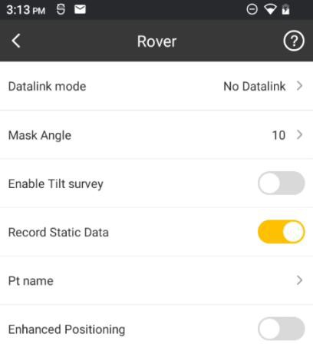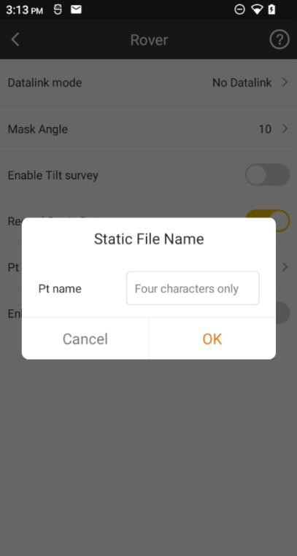

Enhanced Positioning: Improve RTK performance when affected by the ionosphere.

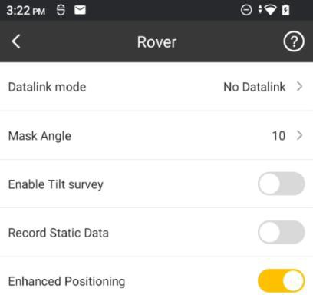

## Rover-No Datalink

In No Datalink mode, rover’s data link is empty, and cannot receive corrections from base.

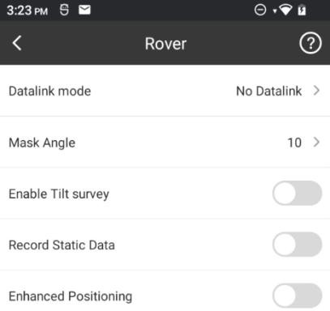

## Rover-Internal UHF

In UHF mode, rover is able to receive corrections from base by internal radio.

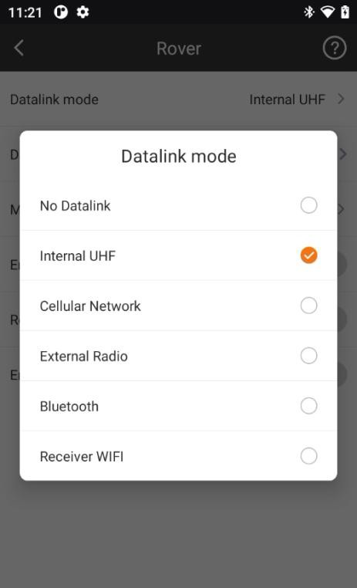

In UHF data link, we can set Channel, Frequency, Power, Baud Rate and Radio Protocol for rover, and you can turn on Radio Repeater if necessary, you can change frequency in Radio channel group. Here will showing base ID when you connect to base, and you can check receiver firmware version in here.

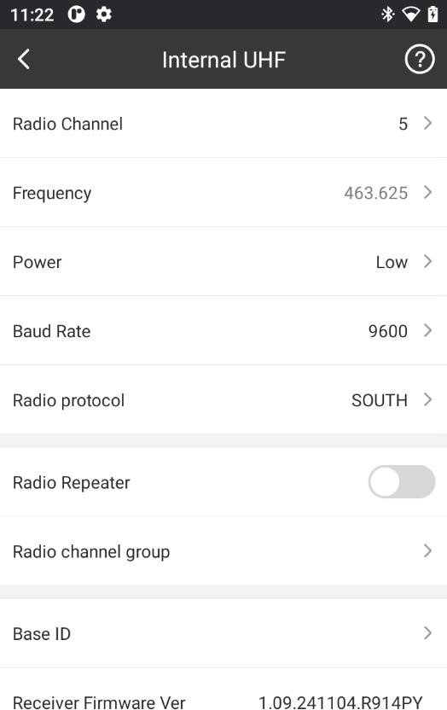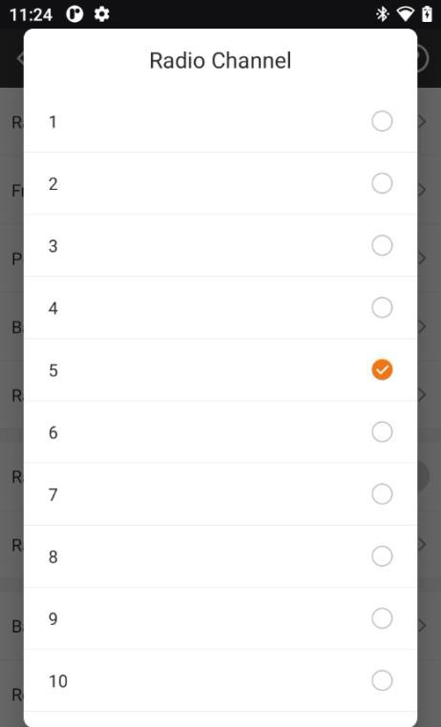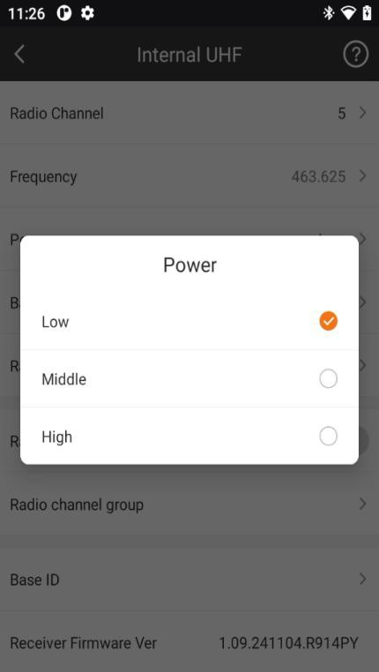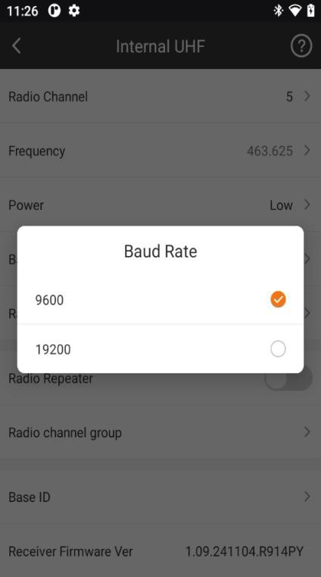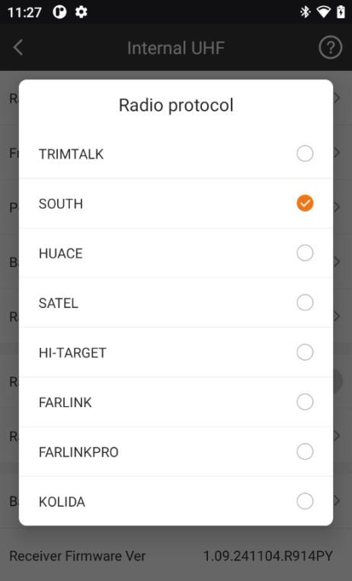

After those parameters above are set the same as base, rover can receive corrections from base and get base information.

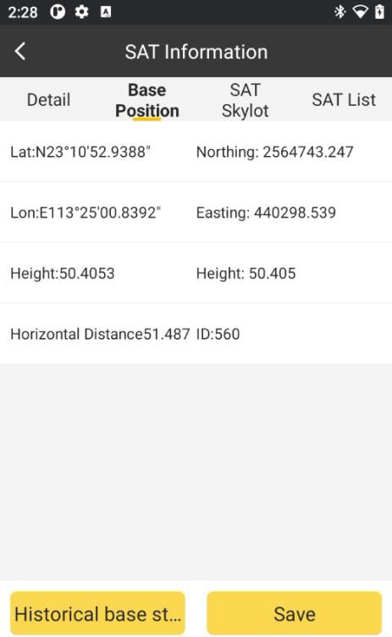

## Rover-Cellular Network

Input SIM card in receiver first, via SIM card to connect network, then choose Ntrip Connection account to log server and get fixed solution.

1. Choose Smart Connect Config and select mountpoint to one button connect network, then you will get fixed one click.

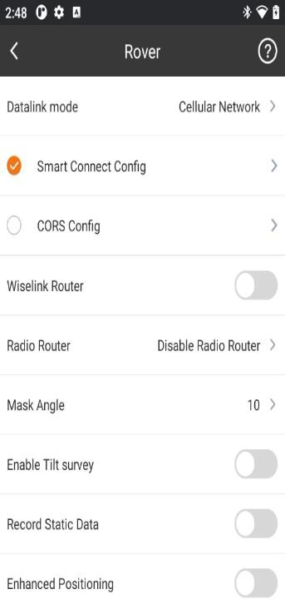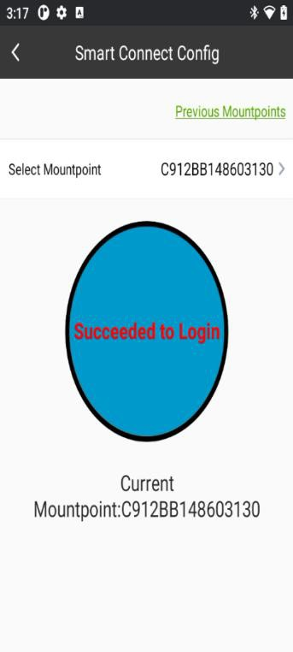

1. Choose CORS config to connect network, add one CORS account, enter IP Port Username and password, then select mountpoint and Mode.

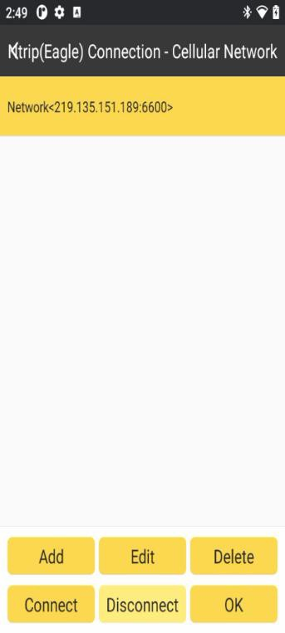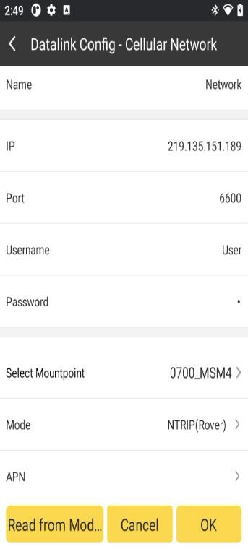

1. Click OK then receiver will be auto log on server.

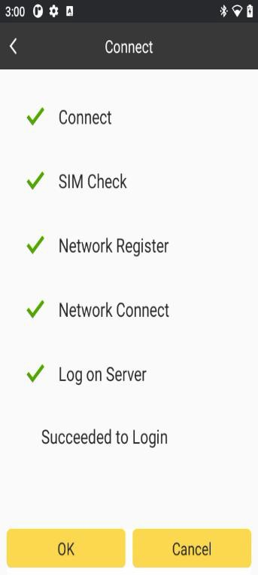

## External Radio

In External Radio datalink, Rover can use external radio to receive radio signal from base.

1. Connect the receiver to external radio.
2. Click the Datalink mode bar, set the receiver to Rover- External mode.

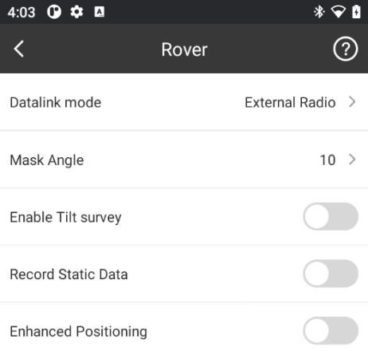

1. Config the external radio the same as base UHF.

note: Configurations on external radio must be done on external radio itself.

## Rover-Bluetooth Data Link

In Bluetooth datalink, we can use controller’s internet to access CORS server and download corrections. (Note: the controller must have access to the internet).

1. Click the Datalink mode bar, set the receiver to Bluetooth mode.

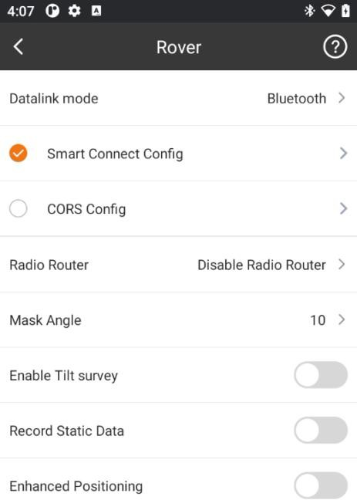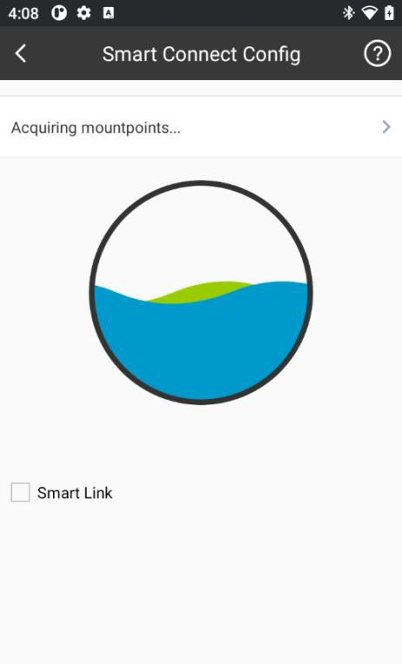

1. Click the bar to enter the Ntrip(Eagle) Connection-Bluetooth page.

Datalink Config

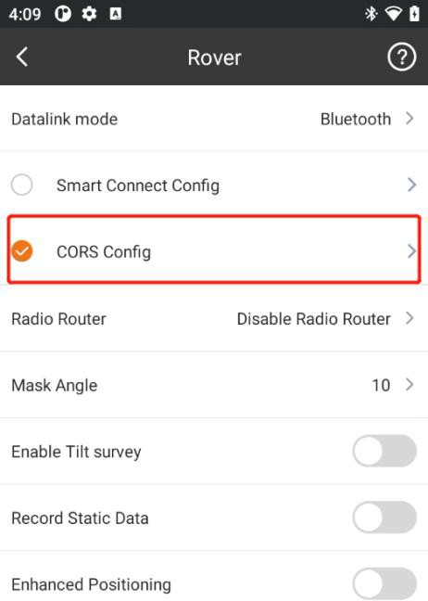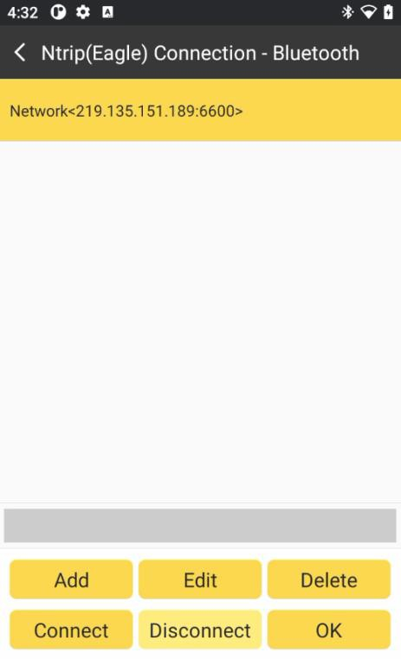

1. Click Add. In this interface, we can define a network config by inputting IP, Port,

Username and mountpoint.

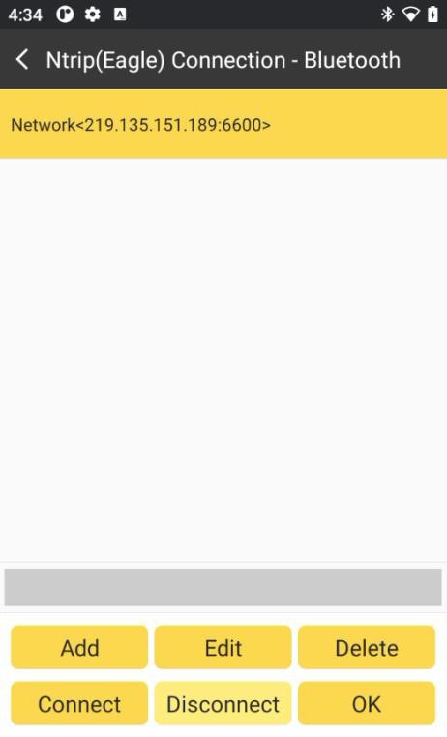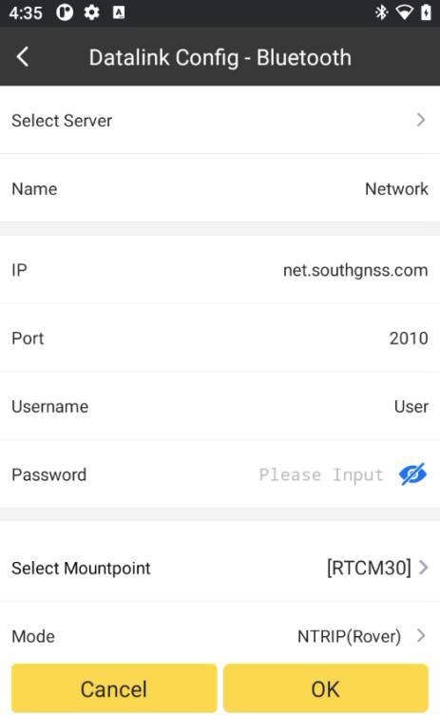

1. In Select Mountpoint, by Refreshing Mountpoints, we can get all the mountpoints available, select the one needed to finish Network config.

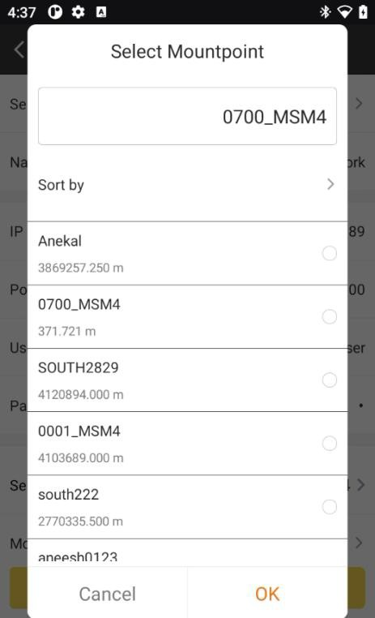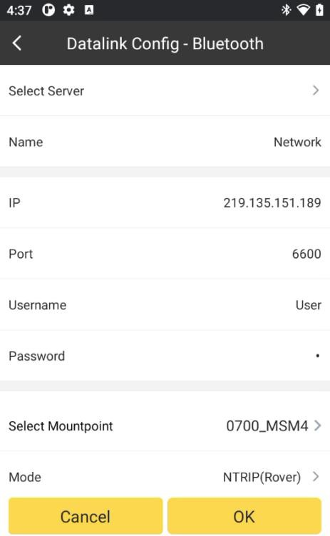

4. Click Connect, and differential corrections from base will be downloaded from the server.

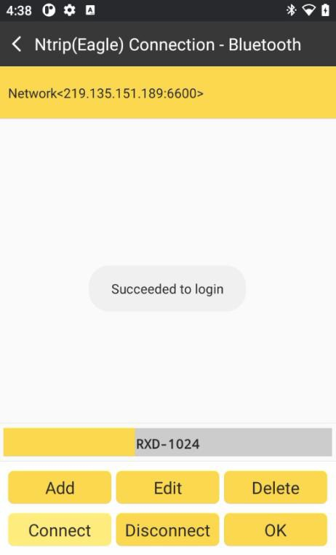

## Rover-Receiver Network

In Receiver Network mode, we must ensure receiver itself has access to the internet, usually there are 2 ways: by receiver’s WIFI or by receiver’s network module.

By WIFI:

1. Click the Datalink mode bar, set the receiver to the Receiver WIFI mode.

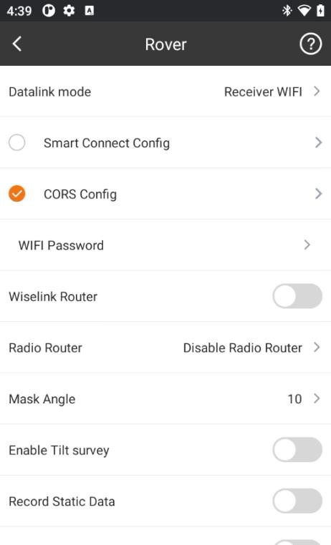

1. Receiver must be able to switch to WIFI client mode and connect to a WIFI hot spot.

Click click

WIFI Password

bar, and click

bar again to connect WIFI network.

Refresh WIFI List…

WIFI Password

to search for WIFI nearby. Then

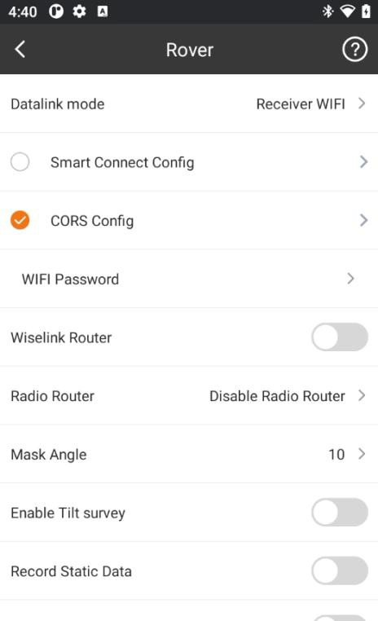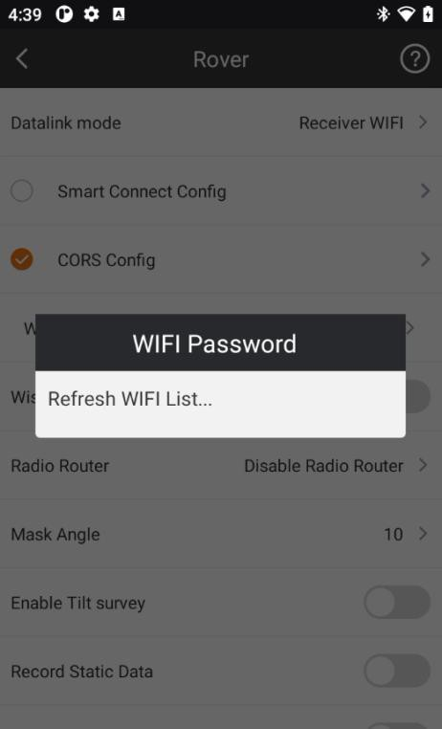

1. Click the bar to enter the Ntrip(Eagle) Connection-Receiver WIFI page.

CORS Config

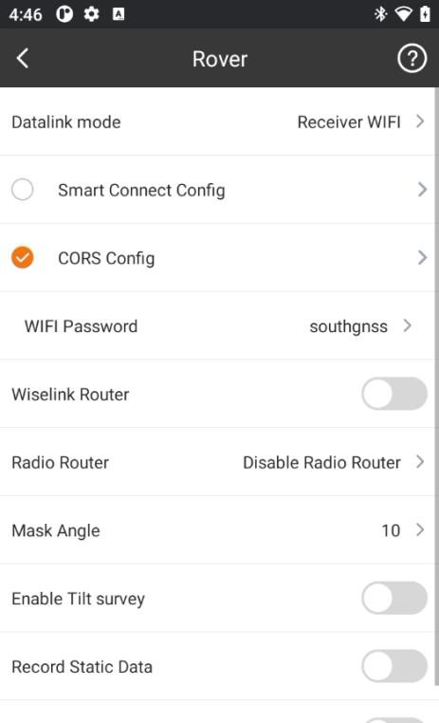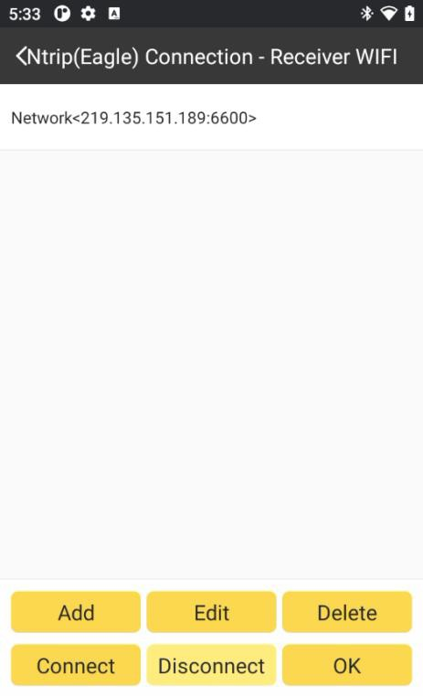

3. Build Network Config and connect (Operation is the same as we do when config

Rover-Bluetooth data link).

## Base Mode

Base Mode is used to start base and transmit differential corrections in UHF, Network, and External Radio.

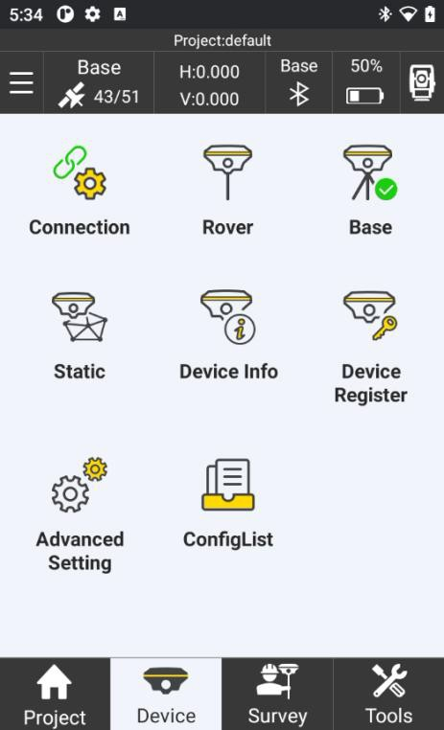

In Base Parameter config, we can set Base Correction Format, Transmit Interval, different Base Start Mode, Antenna Type and Height, Mask Angle, PDOP limit and transmit Data Link.

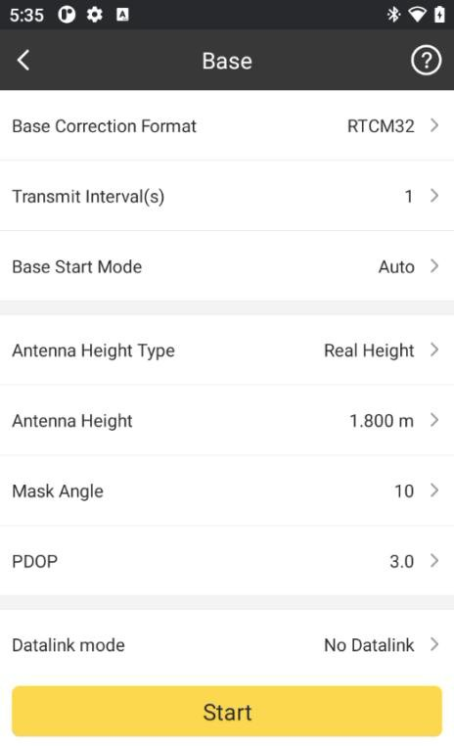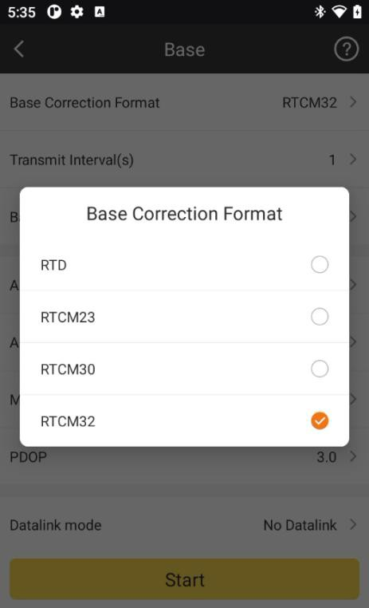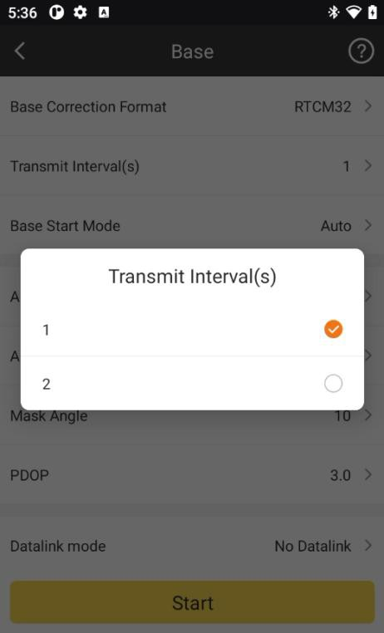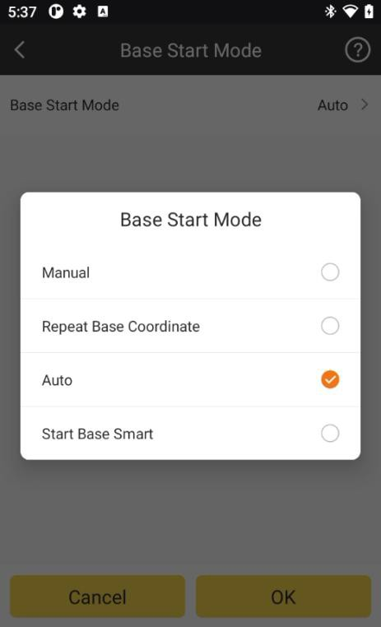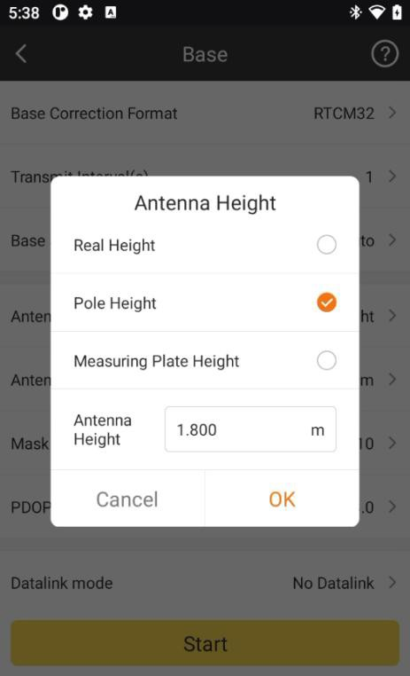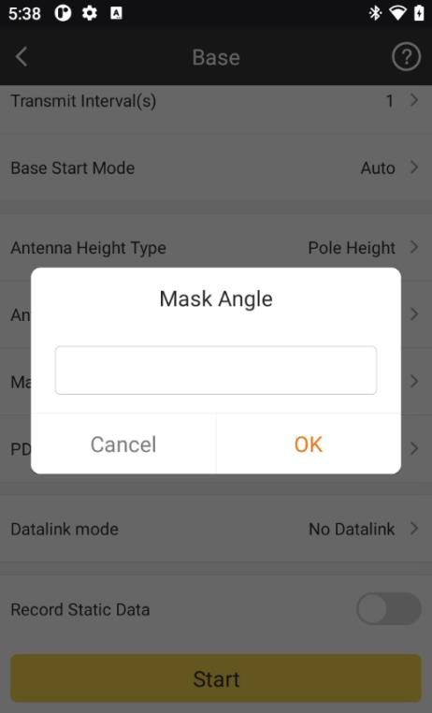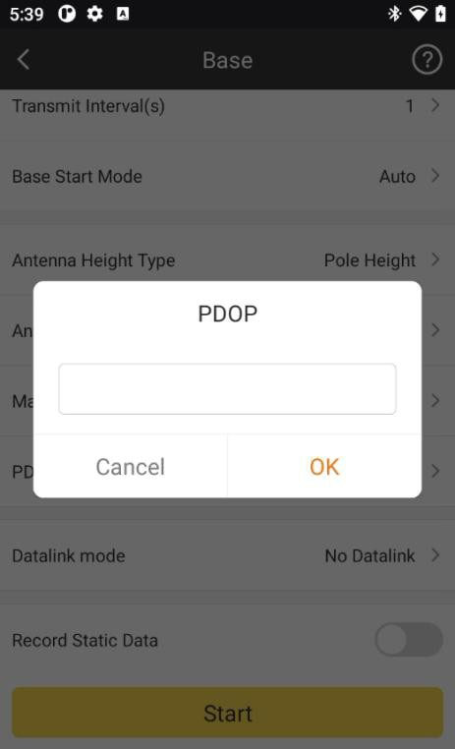

## Base-Internal UHF

In this mode, Base is using its Internal UHF module to transmit differential corrections.

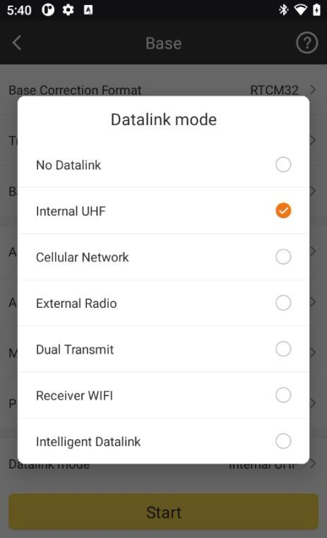

In UHF data link, we can set Channel, Frequency, Power, Baud Rate and Radio Protocol for base.

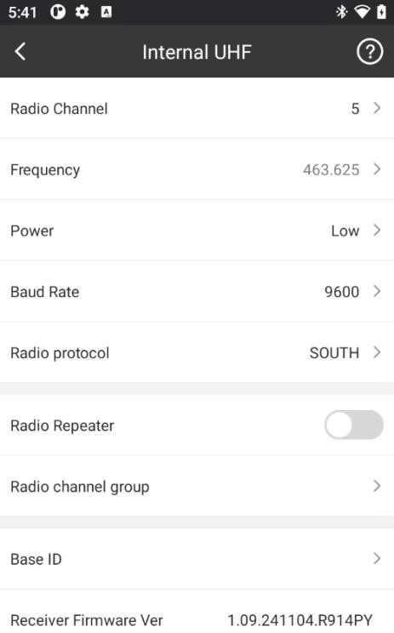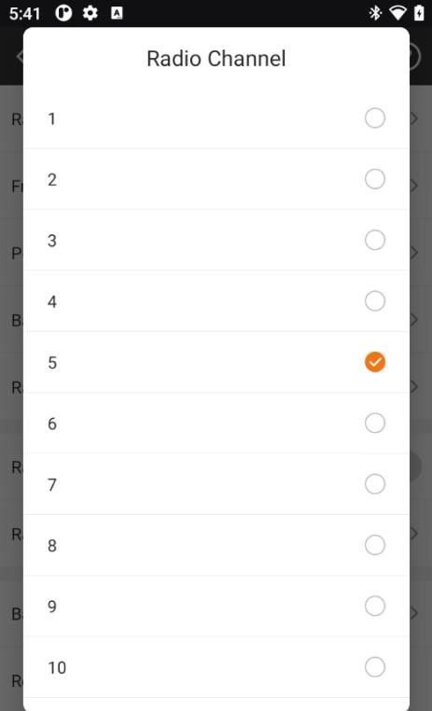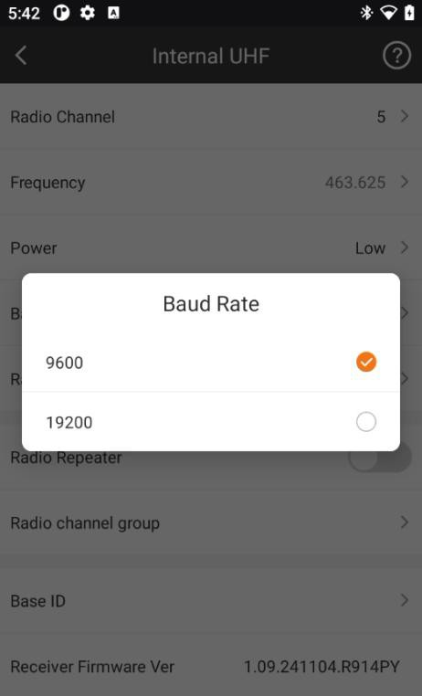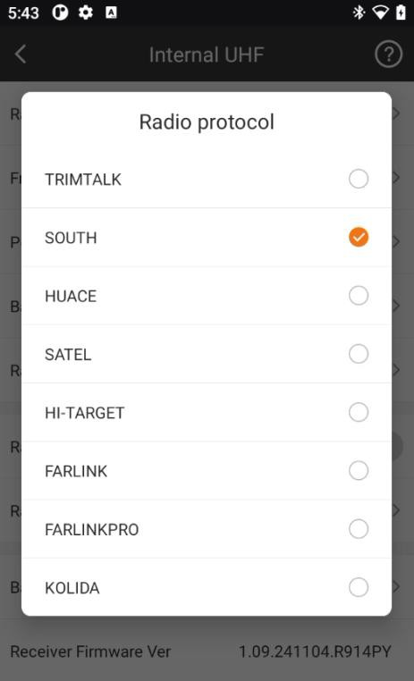

## Base-Cellular Network

In this mode, Base is uploading its differential corrections to CORS server by Network. Then rover can download the corrections and get fixed solution.

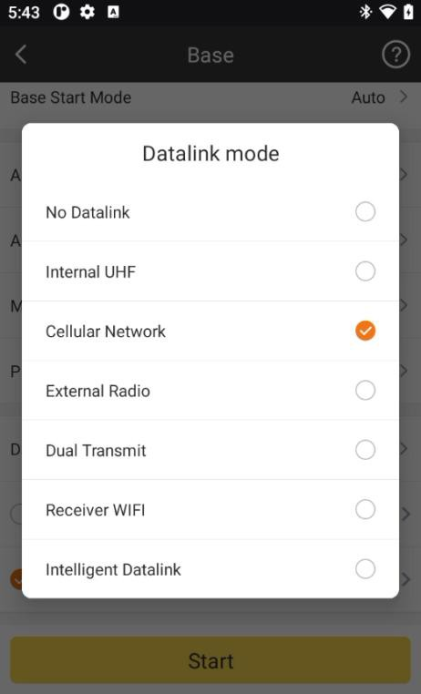

1. Click the bar to enter the Ntrip(Eagle) Connection-Cellular Network

Datalink Config

page.

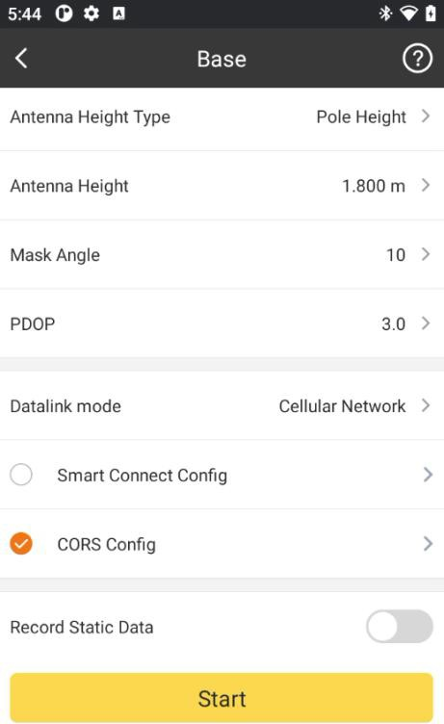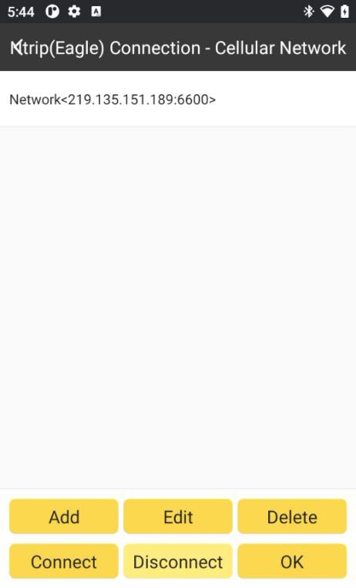

1. Click Add. In this interface, we can define a network config by inputting IP, Port,

Username and Password. If set before, we can click to get them.

Read from Module

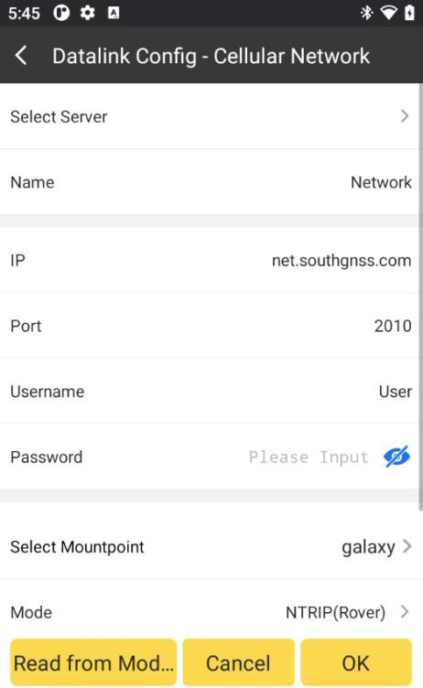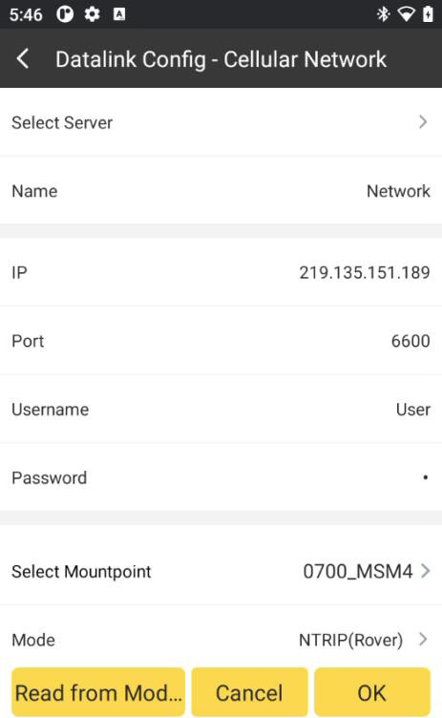

1. Click bar to set the uploading differential corrections’ access points,

Select Mountpoint

which cannot be set already exist in CORS.

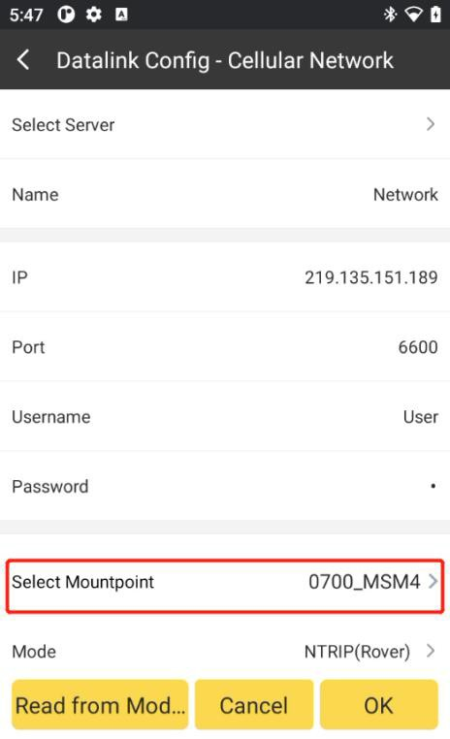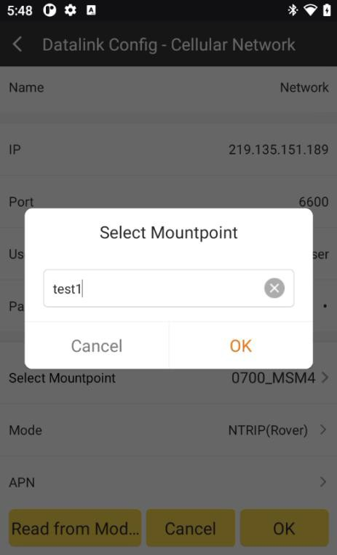

1. Set the Mode as Eagle mode (Base), and set the APN settings.

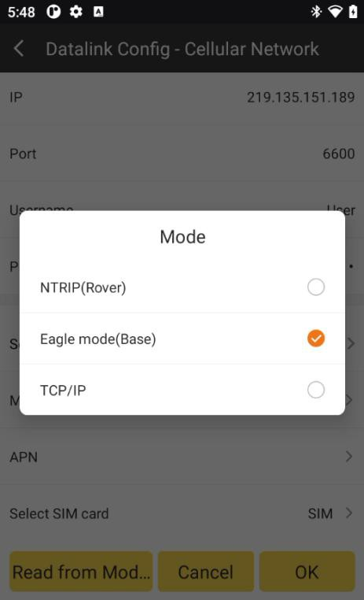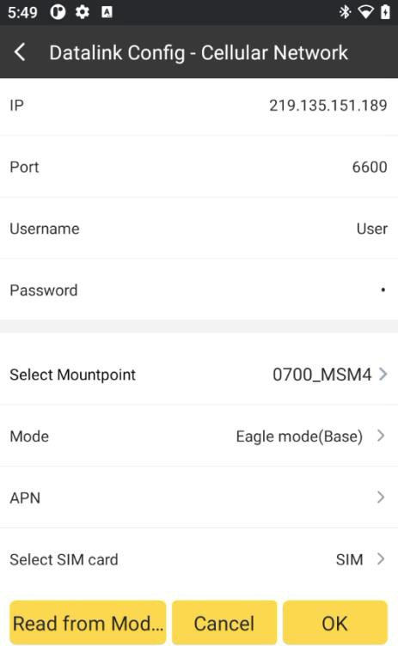

1. Click bar to connect CORS server.

Connect

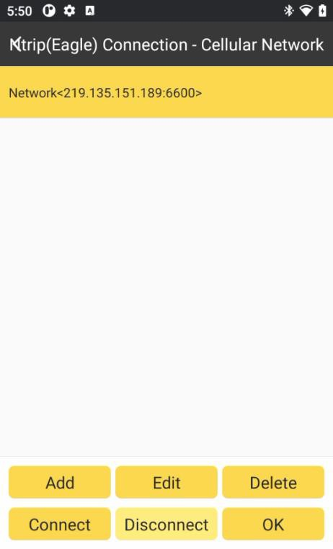

1. Once set, click Start to upload differential corrections.

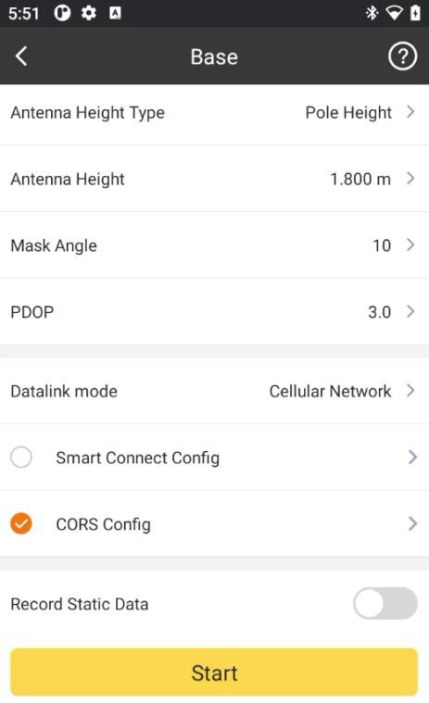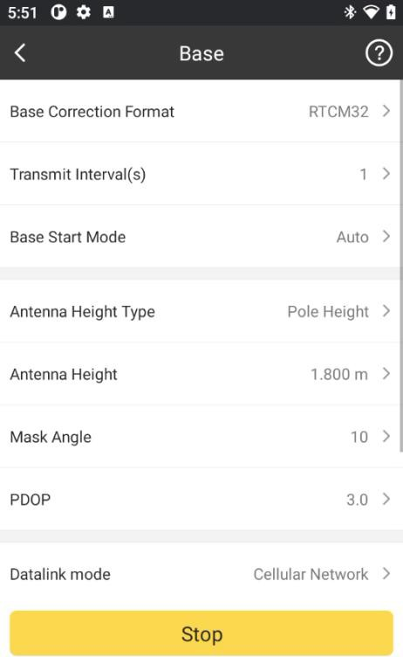

## Base-External Radio

In this mode, Base is using External Radio to transmit differential corrections.

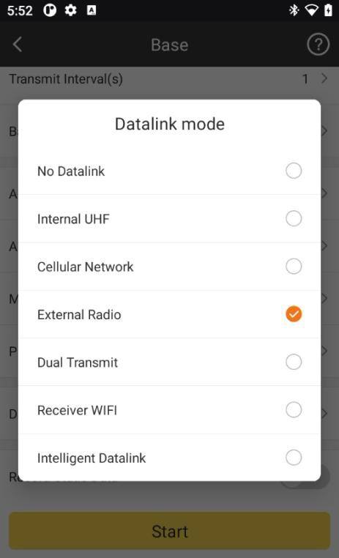

## Static Mode

When we need to use receiver to do static work, we can go to SurvStar-Device, set receiver into Static Mode.

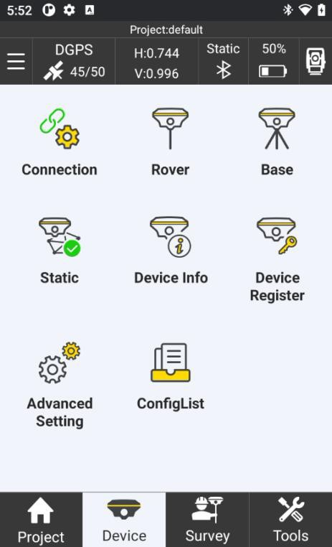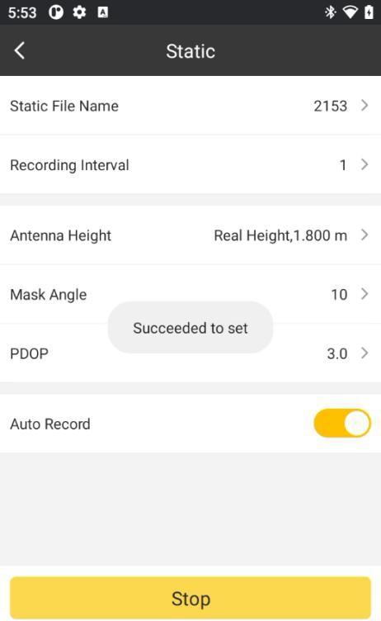

In Static Mode, we need config Static File Name, Recording Interval, Antenna Height and Type, Mask Angle, PDOP limit and Auto\Manual Record.

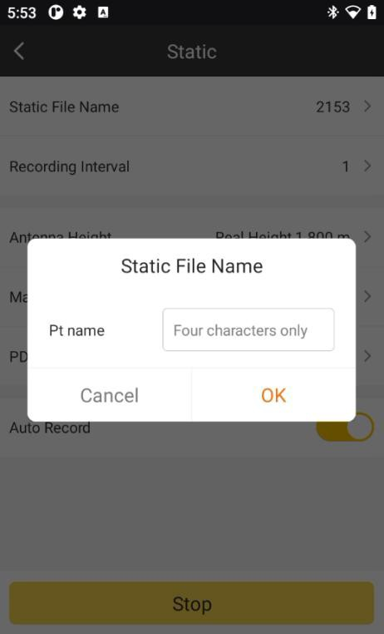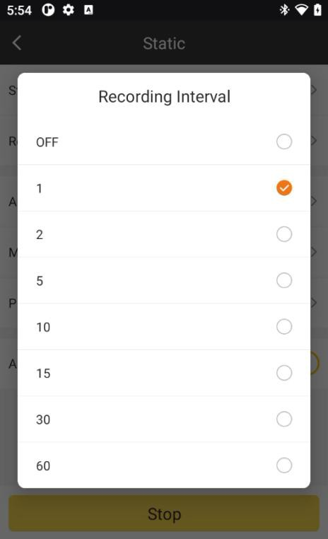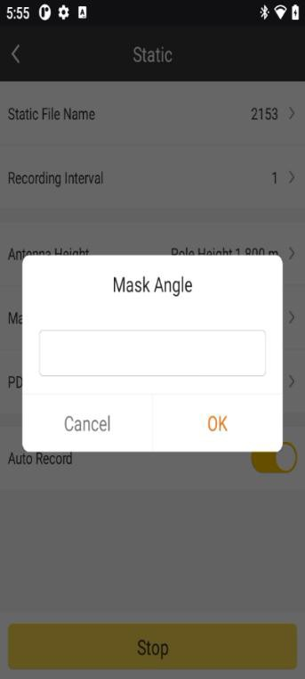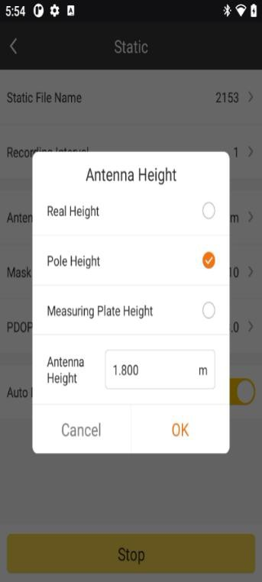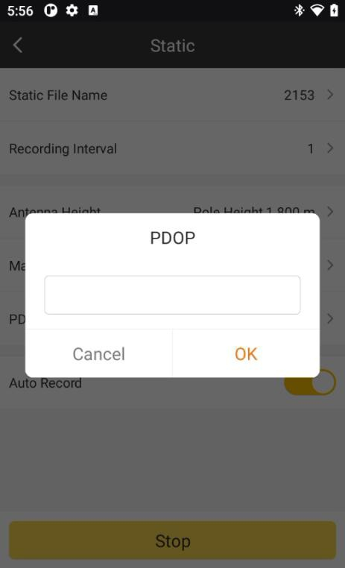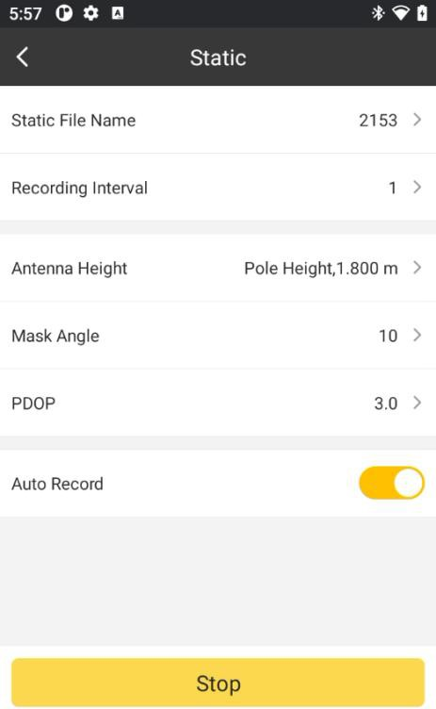

## Device Info

In this sector, we can check the information of the device. It includes Receiver Model, Receiver SN, Work Mode, Datalink, L1 Offset, Antenna Radius, Temperature of the device, Battery Status, Memory, Receiver Firmware Version, Expiry Data, OEM Board SN, OEM Board Firmware Version, UHF Module SN and UHF Module Firmware Version.

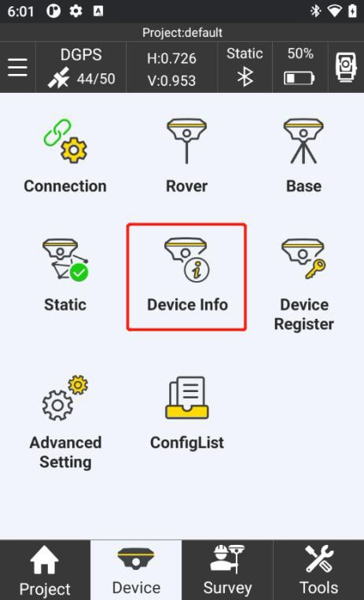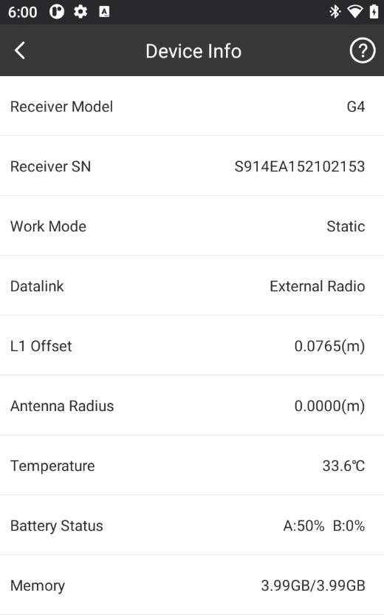

## Device Register

In this page, we can check the device registration information and register device. Click

will copy the receiver SN. Input the registration code in the bar, and click Register,

Copy

then the device will be registered. We can also click to scan the QR code to register.

SCAN

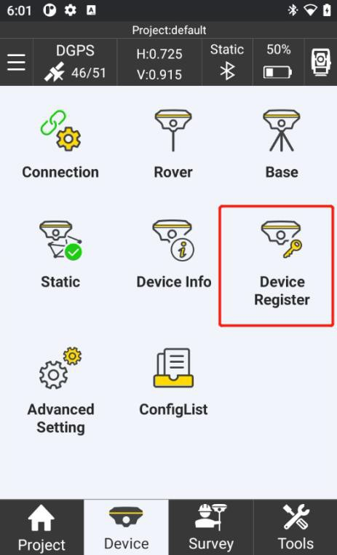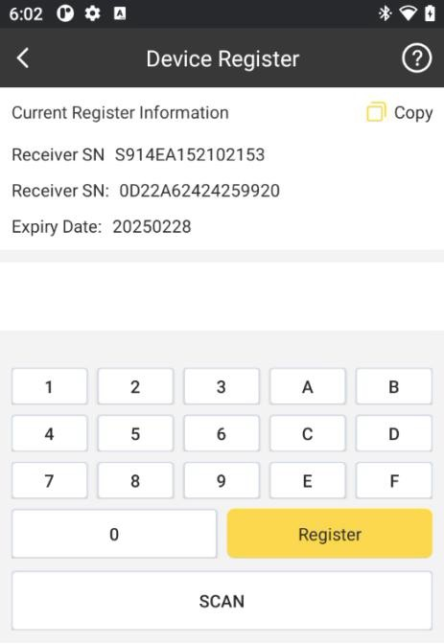

## Advanced Setting

## Receiver Advanced Setting

In this page, we can control weather track one satellite system and set the settings of the receiver. We can set the Voice of the device, Language of the device, Clean Ephemeris, Self-check, Restore to Factory Default and Dynamic PPP and so on.

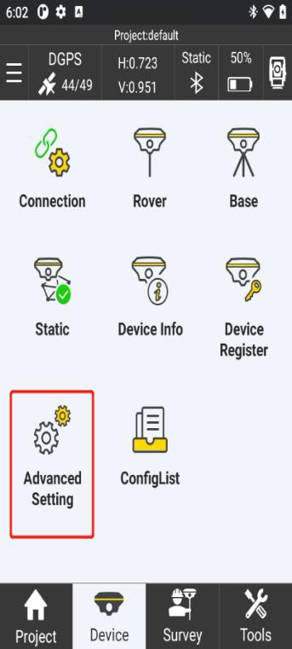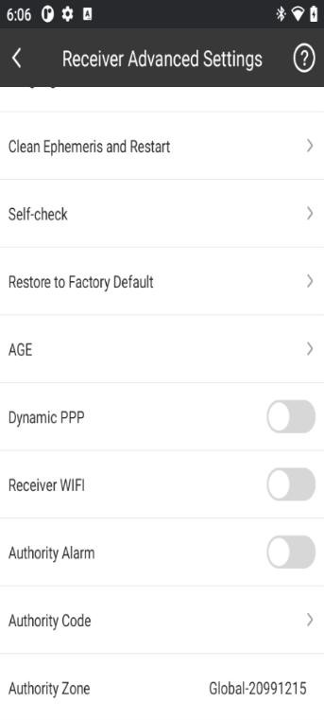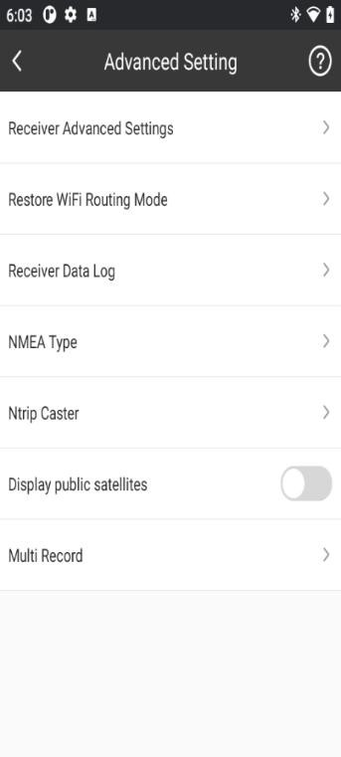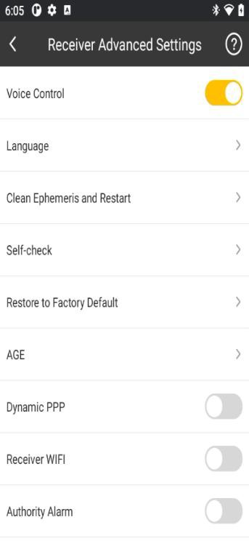

## Other Advanced Setting

Restore WiFi Routing Mode: Setting Restore WiFi Routing to reset WiFi routing. Receiver Data Log: Record receiver system data to check receiver status.

NAME Type: Choose NAME type that you want to export.

Ntrip Caster: Enter access point and port and receiver IP, and then, our receiver can acquire differential data broadcasted by another RTK base via Wi-Fi.

Display public satellites: Default turn off.

Multi Record: You can choose channel and file type to record receiver data, and then you can set collect interval and record interval.

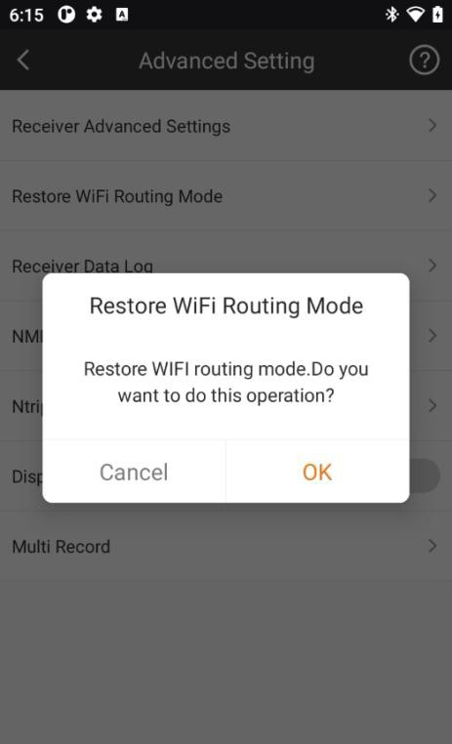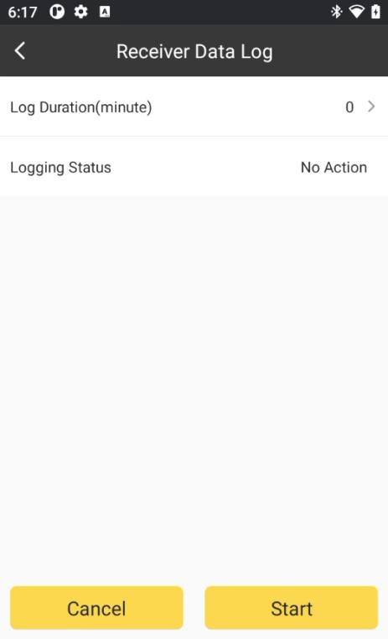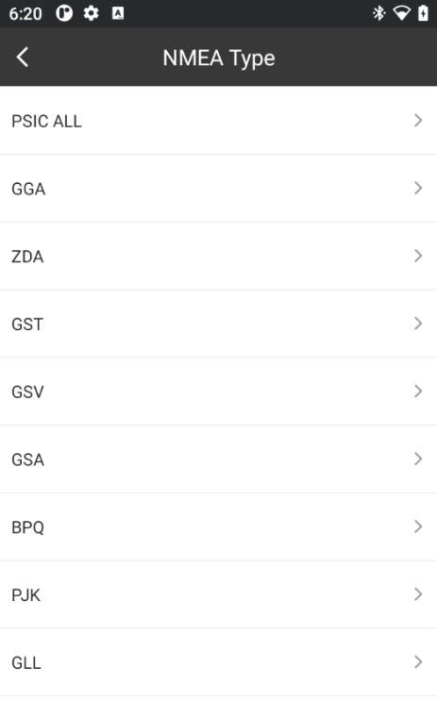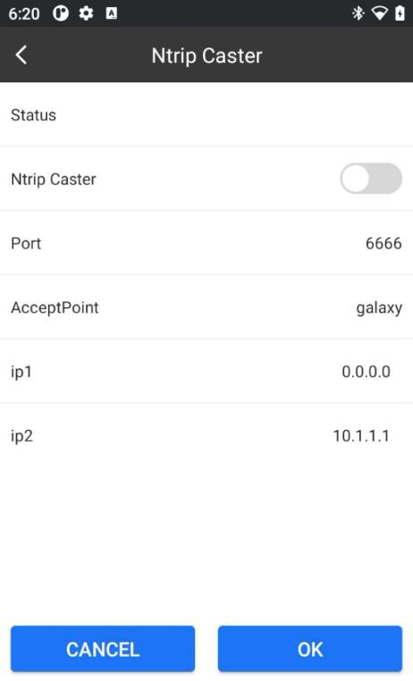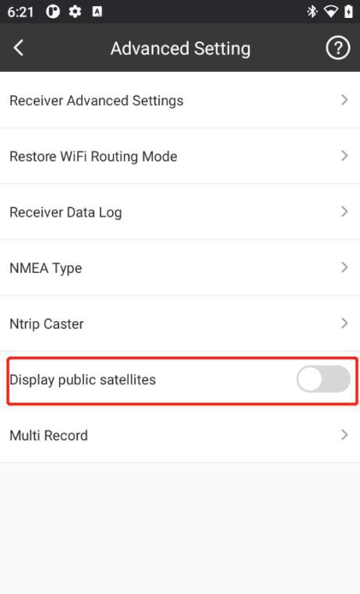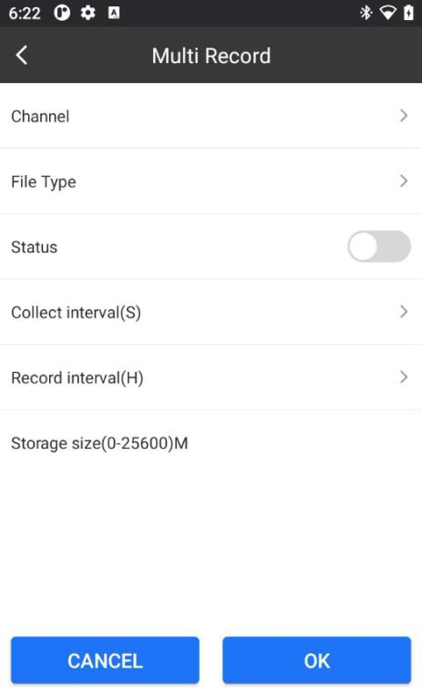

## ConfigList

You can one-click setup datalink for in rover or base mode.

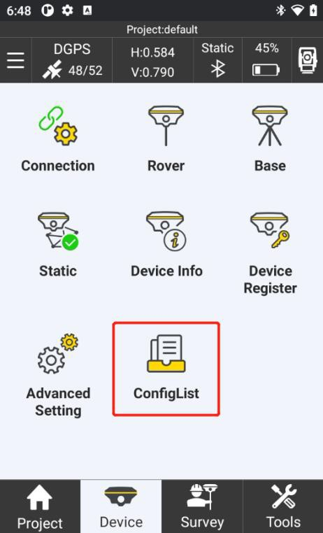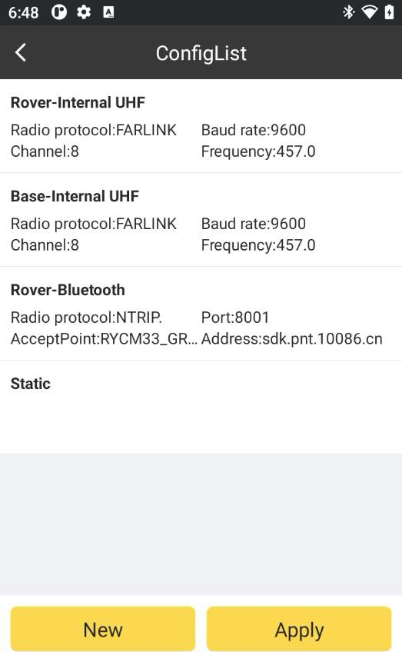

Click new button to add a configlist, you can set working mode and different settings in different datalink mode.

Such as rover mode and Internal UHF datalink.

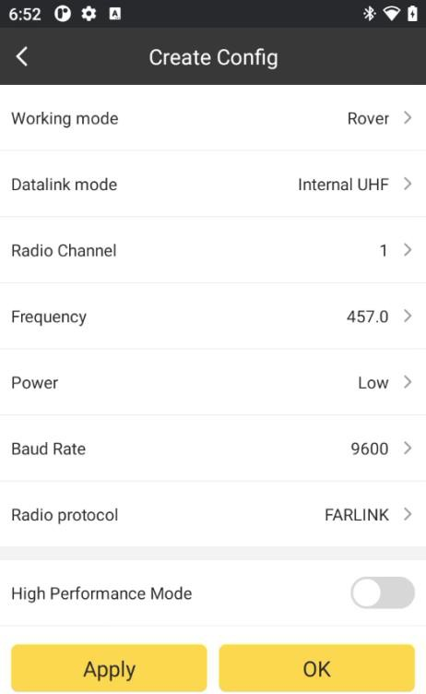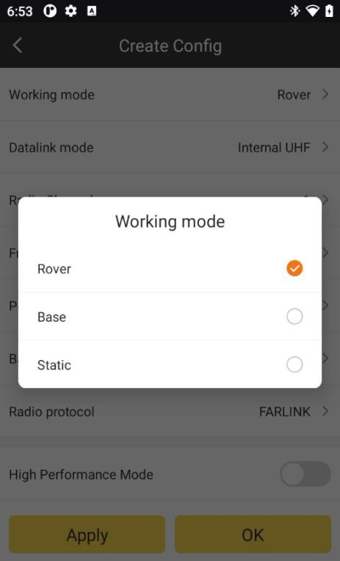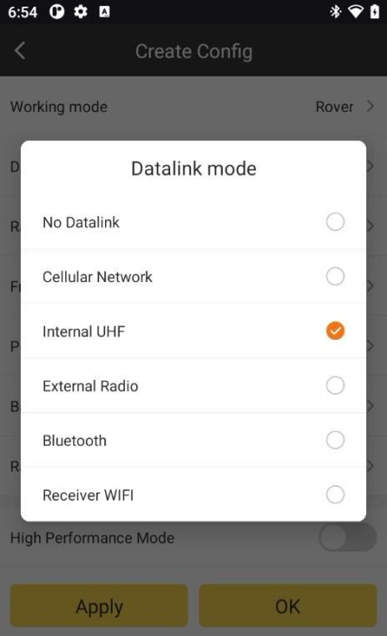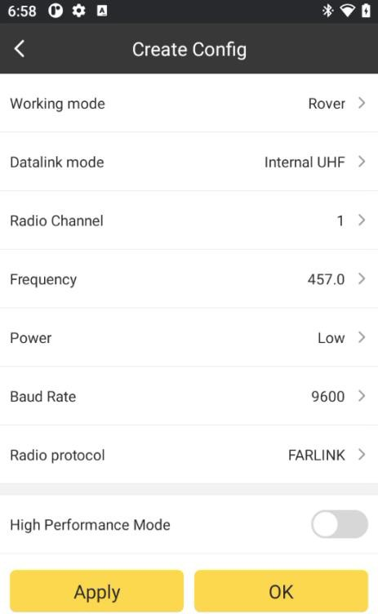

Base Cellular Network mode

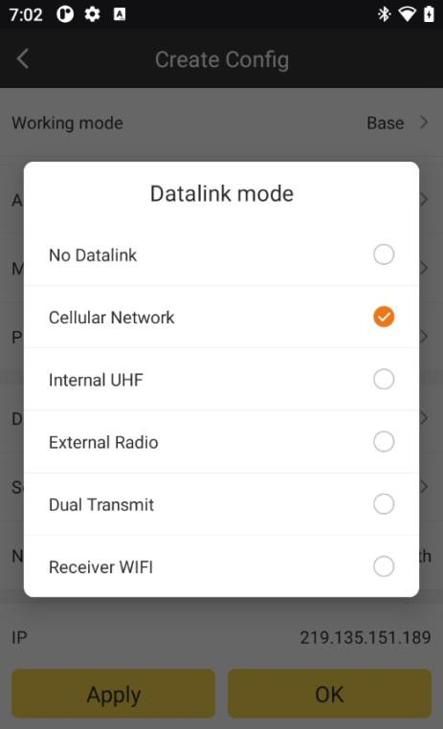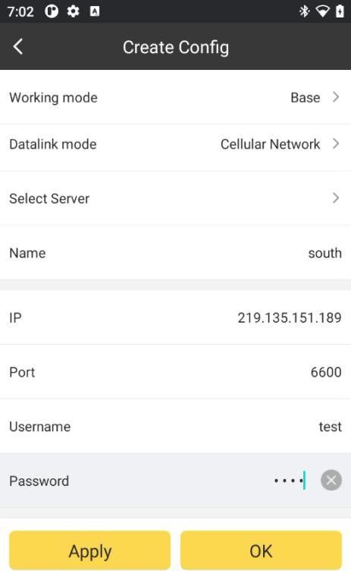

Click OK when you successful create Config, then click Apply, you can great use this ConfigList to use your receivers. Swipe right you can delete or eidit this Config.

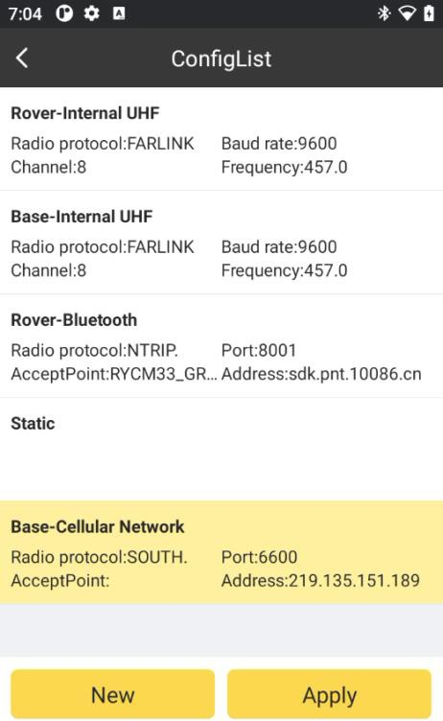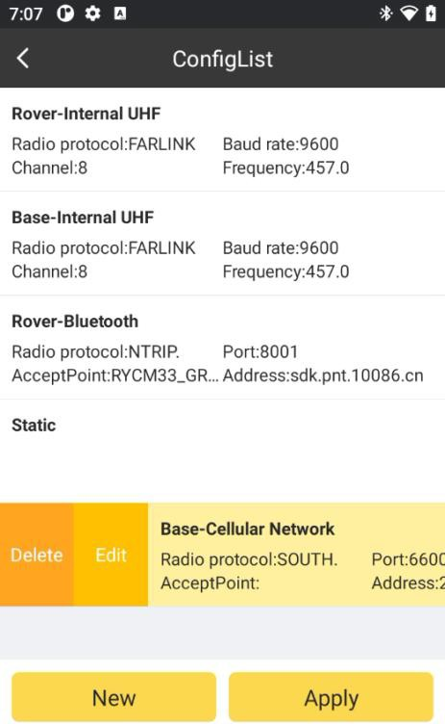

# Chapter 5 Device – Total Station

## Connection

If you need to connect a robotic total station to a device such as a handbook or tablet, first open TServer on the onboard side.

Click Device->Connection to enter this interface.

Select the model of device needed, equipment model. If you need to connect to a total station, the software only supports Bluetooth communication mode.

Search

for nearby Bluetooth devices, when a Bluetooth device with the same name as the total station serial number appears, select the device and click

connect.

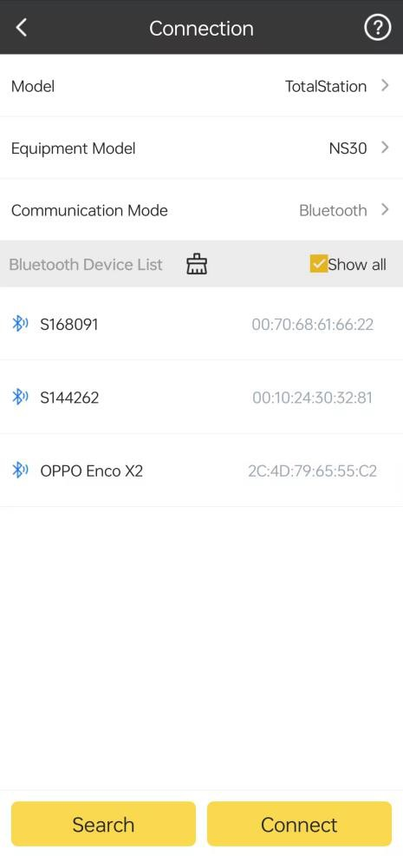

Click to monitor the data stream from the connected receiver.

Debug

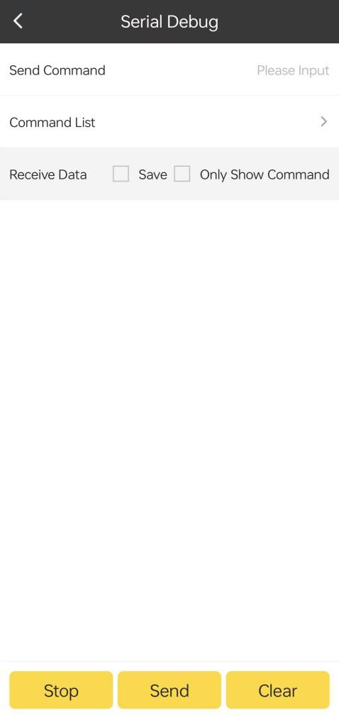

Click or to stop/start the data stream from the receiver.

Start

Stop

Input the commands at the Send Command bar, and click the commands to the receiver.

Send

to send the

Click to clear the contents of the page.

Clear

There are some useful commands in the Command List bar.

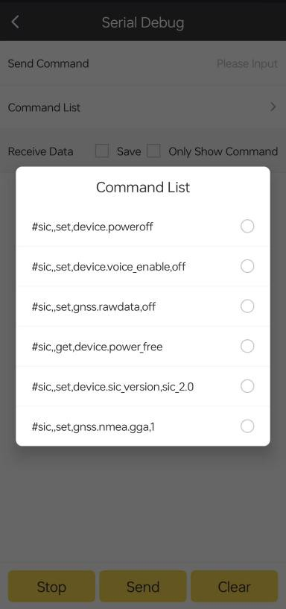

Break the blue tooth connection with the receiver by clicking Disconnect.

## Instrument Station Setting

Click Device->Instrument Station Setting to enter this interface.

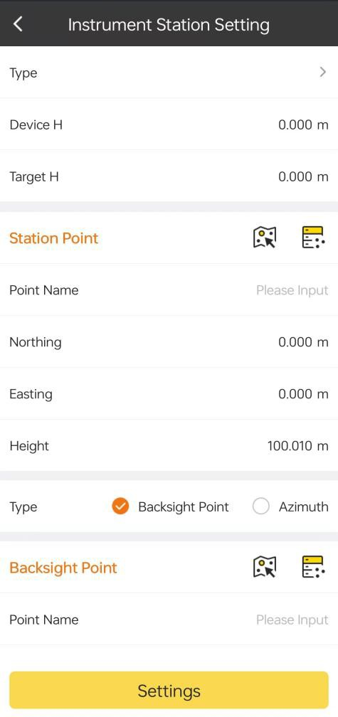

We can choose

or Resection.

Known point

Known point: First enter the instrument altitude and the target altitude. Known points can be obtained in three ways.

Map Select: Click on the  icon to open the chart selection interface. If there is a measured point on the map, click the right arrow icon, long press the green arrow in the middle of the screen, drag the arrow to the position of the measured point, ‘ Survey Point’ will appear on the map, proving that the point has been selected, click OK to complete the point selection.

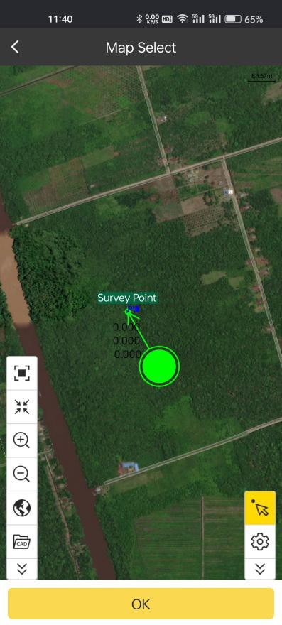

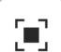:Full map

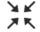 :Go to map center

:Map enlarge

:Map reduce

 :Map settings. Select map layer or background layer. In ‘Map Layer’, there are three types of layers.

Online Map: Offer five online maps or choose ‘no.’

Offline Map: Offline maps are stored in a specified path and can be loaded when needed.

Custom Map: Enter the correct URL for the map.

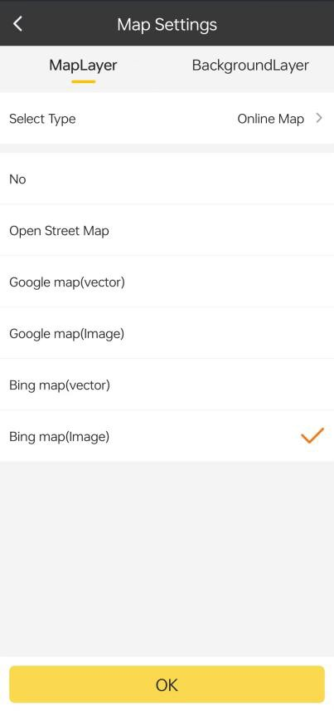 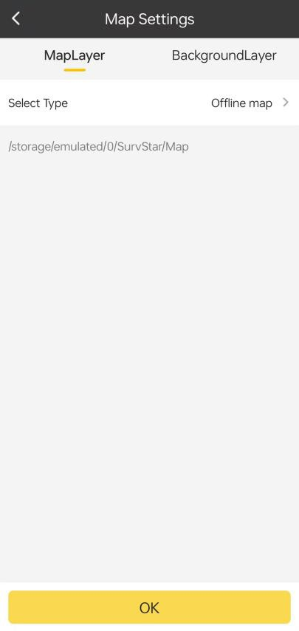

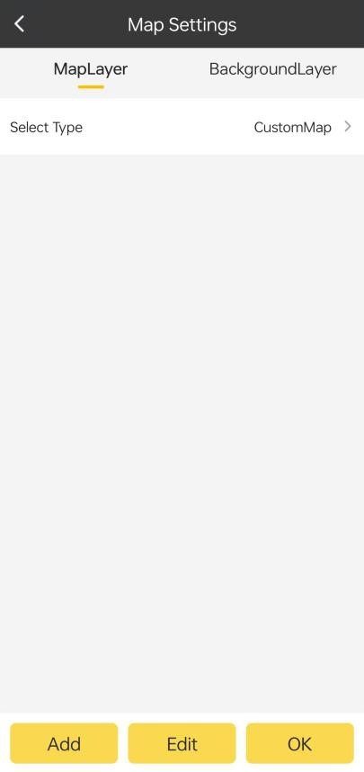

In ‘Background Layer’, store layers in shp, tif, jpg, kml formats under the specified storage path. Select the corresponding layer for adding, editing, moving, deleting and other operations when needed.

: Open CAD. Adding cad files by specified path or full disc search.

: Point selection tool, click the button and drag the green arrow in the middle of the screen to select a point.

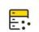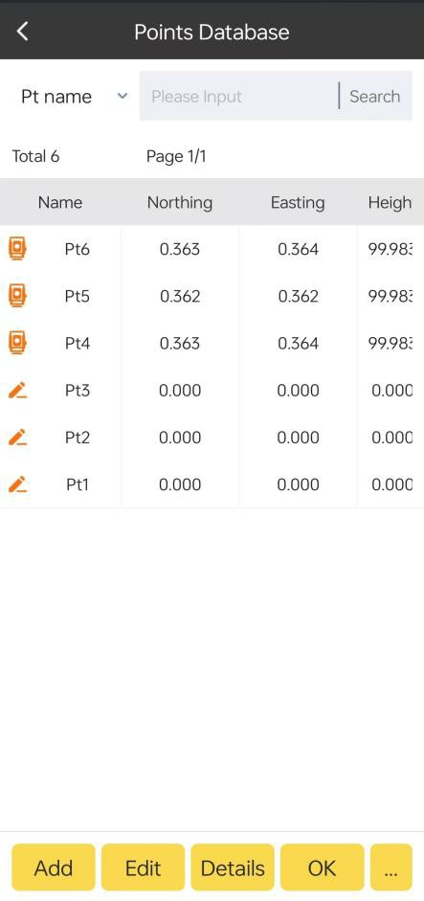Point Database: Select the icon to choose a point from the Points Database, and manage all points by adding, editing, deleting, etc.

Input: Manually enter point name and coordinate information.

The station type consists of two types: Backsight Point and Azimuth.

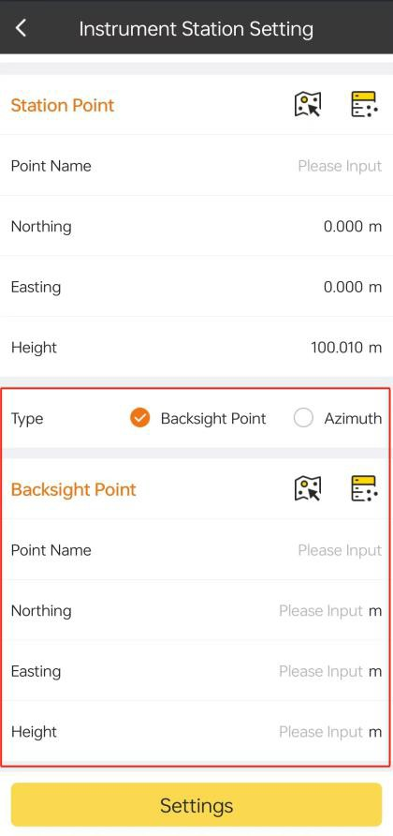

Resection: Set device height and add backsight point.

## BS Check

1. 、Check whether the current angle value is consistent with the azimuth when setting up the station
2. 、Check whether the current backsight point coordinate measurement value is consistent with the existing value.

3、It is necessary to set up the station first to carry out the BS Check.

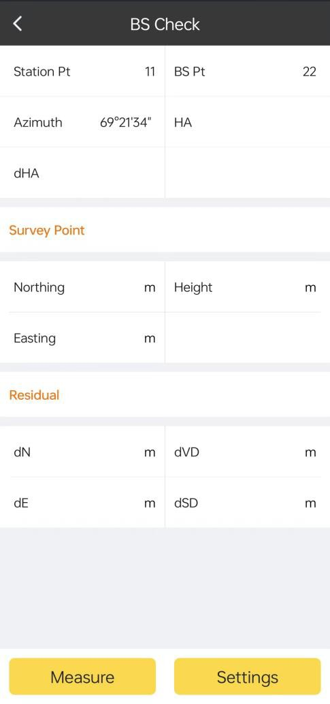

## STN. Ht

The elevation of the current station is obtained by measuring a known elevation point, and the elevation of the station can be obtained by this method if the elevation of some stations is unknown.

In the case that the elevation of some stations is unknown, the station elevation can be obtained by this method.

It is necessary to set up the station in order to set the station elevation.

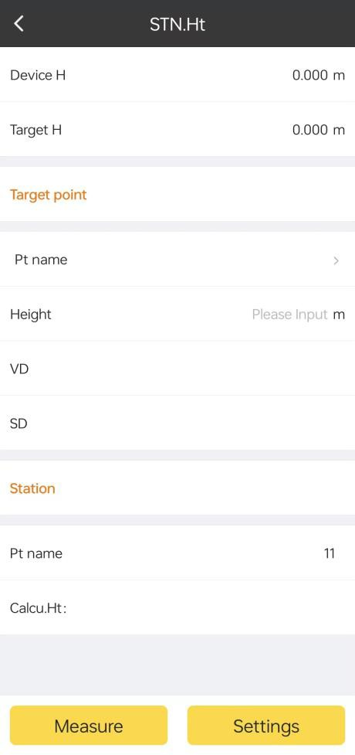

# Chapter 6 Survey - RTK

## Point Survey

By clicking this, we can enter to the point survey page.

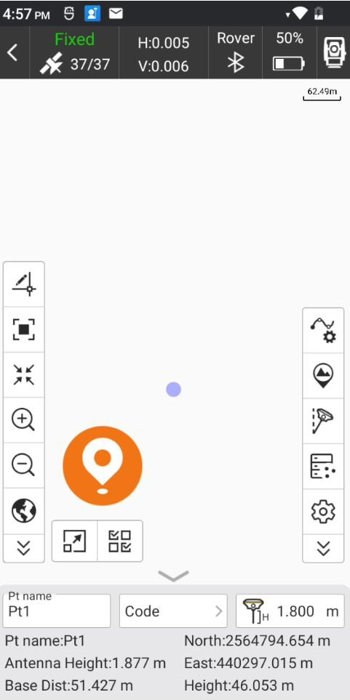

In this page, the icons in upper toolbar describe as follows:

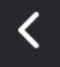: Close/exit Point Survey page.

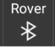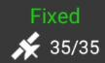 ： Receiver positioning information, pressing to jump to satellite positioning information page.

: Receiver operation mode, pressing to jump to Base/Rover/Static setting page.

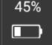: Receiver battery power.

Solution status: includes single, float, dgnss and fixed. Age1: current differential delay is 1.

e.g., Single, 0: current solution is single, and differential delay is 0.

Static, 0: “Static” shows sensor status when the pole tilt survey is enabled, and “0” means that the tilt angle is 0.

H: HRMS, the value represents the horizontal accuracy of current point. V: VRMS, the value represents the vertical accuracy of current point.

35/35: current number of satellites which used to solution, and the total tracked satellites number.

The icons in left toolbar describe as follows:

 Map Display 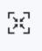 Auto Map Center

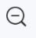 Map Reduce 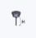 Antenna Parameter

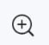Map Enlarge 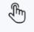 Screen survey

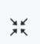 Go to Map center 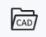 Open CAD

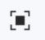 Full Map 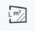 Perimeter and Area

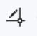 CAD 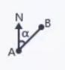Coordinate Inverse

Offset Distance/angle Slope Distance

Angle Calculation 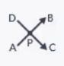 Intersection

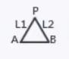Resection Forward Intersection

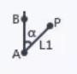Coordinate Traverse 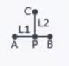Offset Point

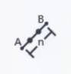Divide Line Equally  Compass

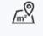Area measure 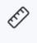Distance measure

Pt, Code, H Display Layer

Show and hide CAD Redraw

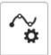The icons in right toolbar describe as follows:

Graphic plot. Point collected by Survstar and then auto plotting with graphic plot.  : set the point type (Topo Point, Control Point, Quick Point, Auto Point,PPK). The following introduces collecting process of all point types.

Topo points: 

The “Average GPS Recoding Count” in record options refers to the number of points which could be consecutive recorded. It means that it could collect one point every time

and this point should meet record limit. When you click  to record the topo point, if the measured point does not meet record limit, there will be a prompt message. If the

measured point meets record limit, the measured point info (HRMS, VRMS, delay, PDOP,

date and time) will be displayed in the screen. Then click to save the topo point.

OK

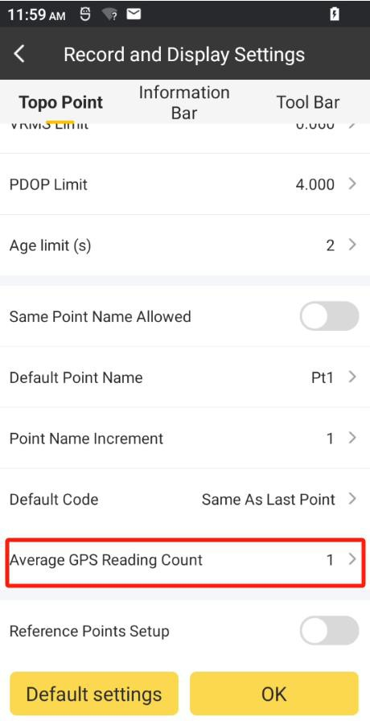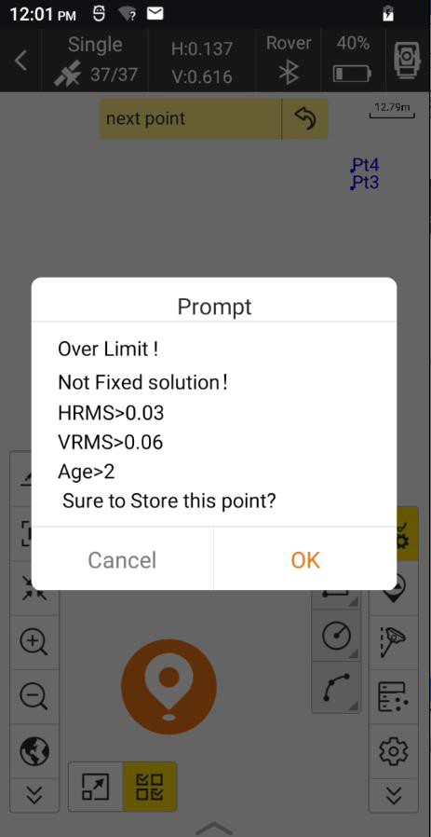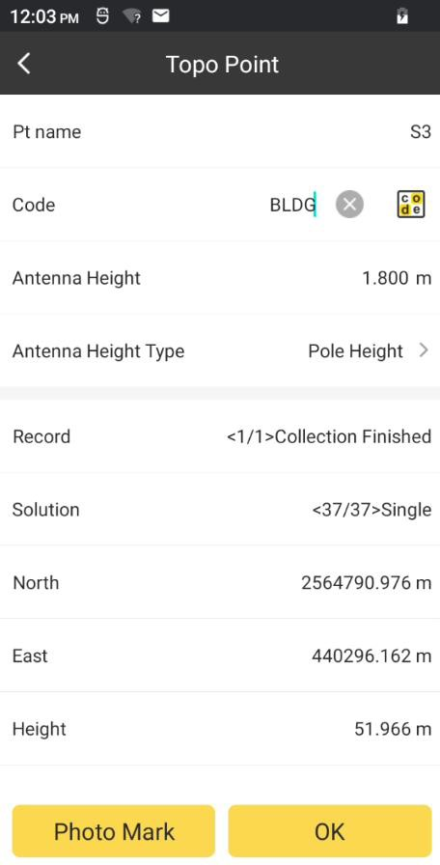

Click Photo Mark, we can make information note on collected points, such as documents,

pictures and graphs

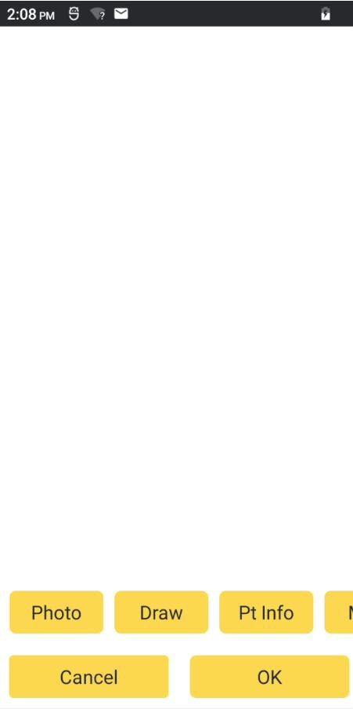

Click Draw, we need to choose the color of the draw line firstly. And we can draw the

shape we need.

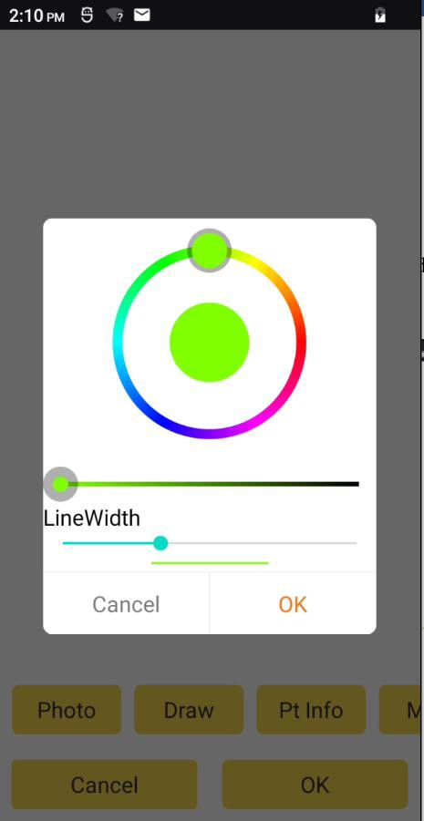 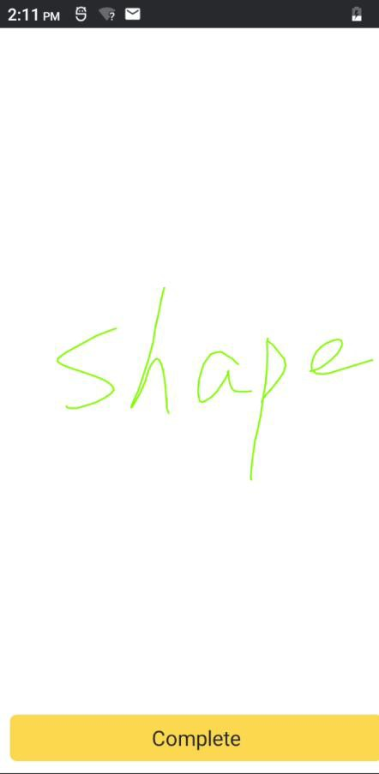

Click Pt Info, we can label the photo information. We can select to on/off Pt name, Code,

North, East, Height, Longitude, Latitude and Elevation.

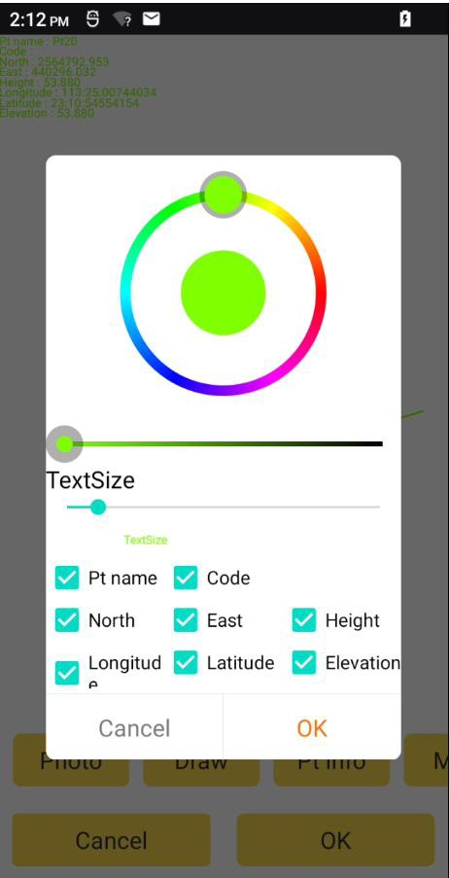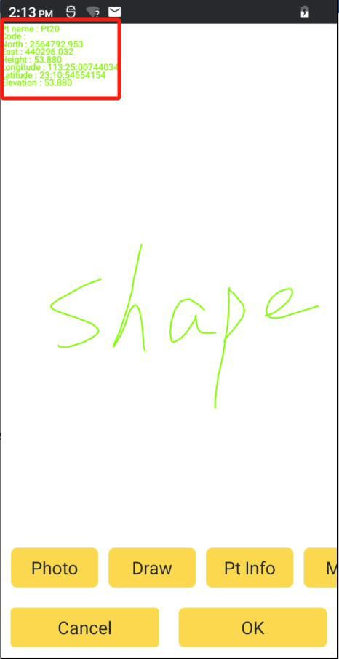

Click and select any drawn shape, we can move it.

Scale

Move

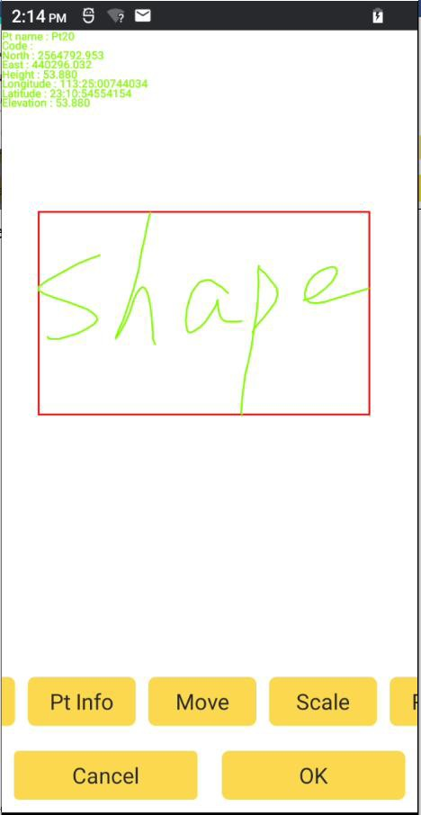

Click and select any drawn shape or photo, we can scale it.

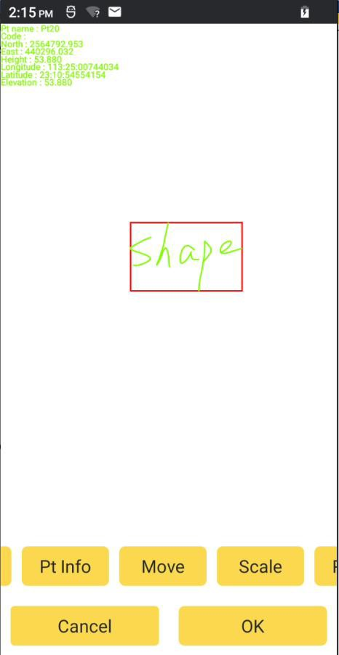

Click and select any drawn shape or photo, we can rotate it.

Rotate

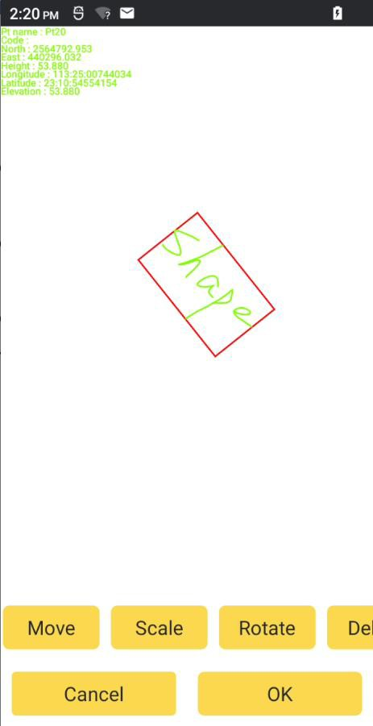

Click and select any drawn shape or photo, we can directly invoke system camera to

take a picture.

Photo

Click and select any drawn shape or photo, we can delete it.

Delete

Click RollBack, it will roll the previous operation back.

Control point: 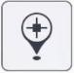

We can set the control point surveyed parameters in Record and Display Settings.

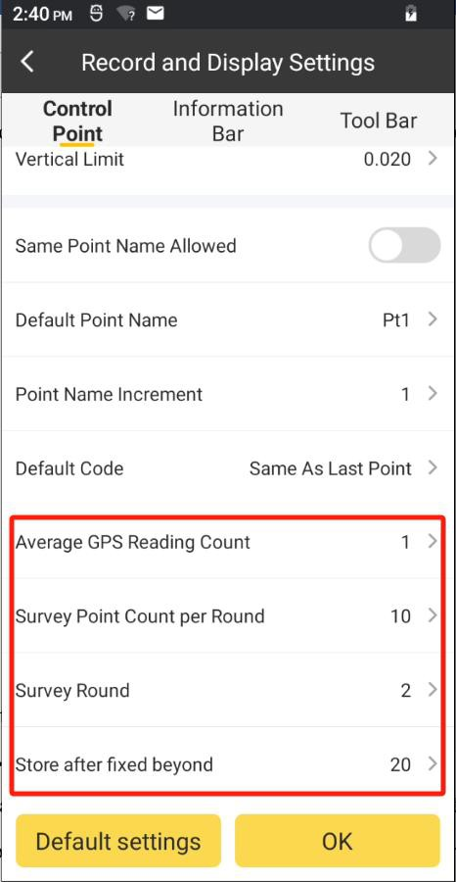

Click  and wait for 20s delay for fixed solution, then it starts to collect data. It records one point every 1s, continuously records 10 points and collects 2 sets of 10 points

(the above data is taken for example according to the control points record settings). When collection is finished, it will output a Control Point Report automatically.

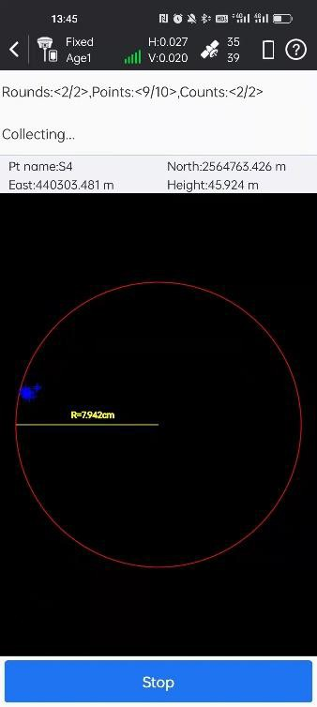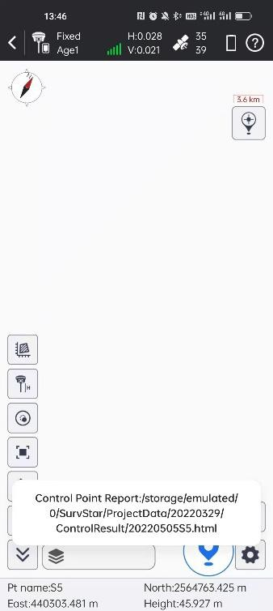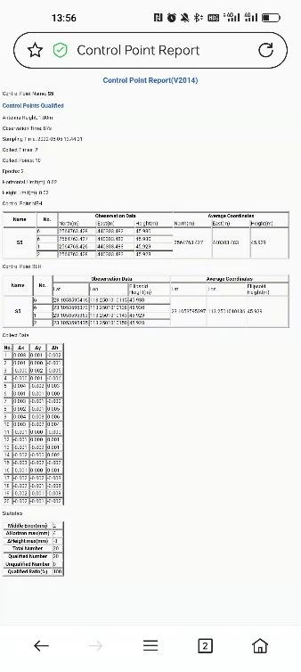

Quick point: 

When you collect quick point, if the measured point meets record limit, then it will finish collection after prompt voice, and there will not show storage page.

Auto point: 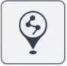

Click and set record parameters, click end the auto points recording.

OK

to start collection. Click again to

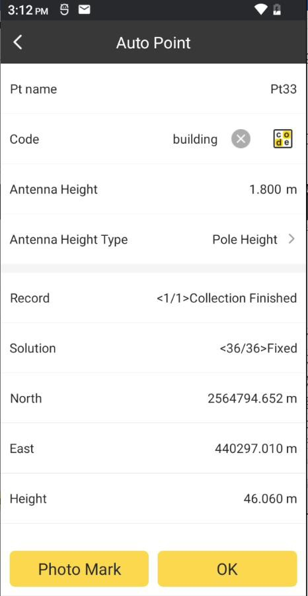 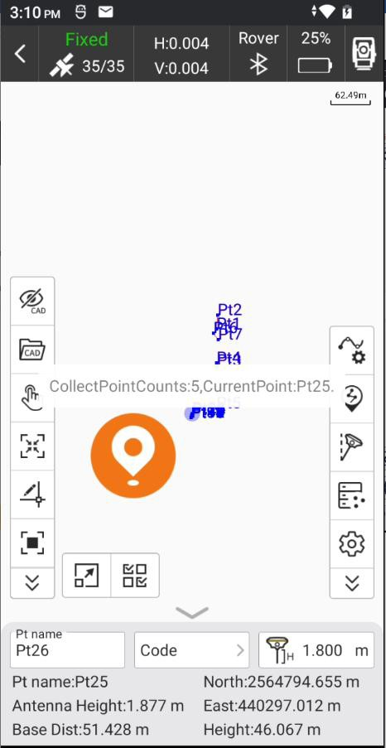

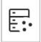Coordinate point database. Points collected by SurvStar are stored in coordinate point database.

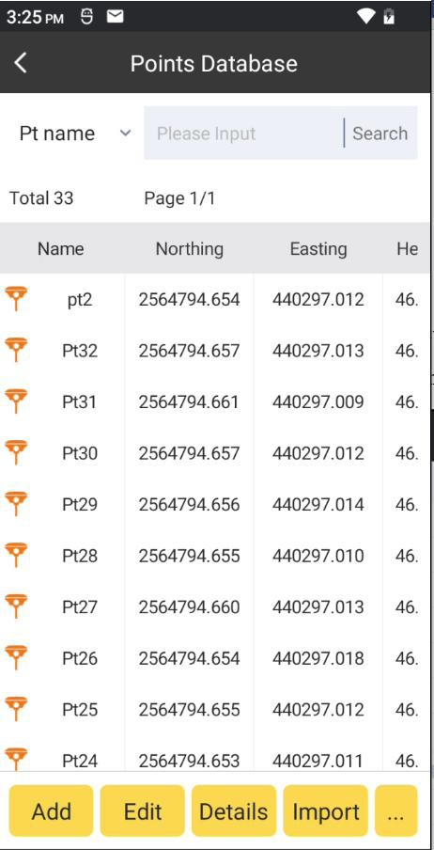

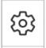Record and Display Settings.

Topo/Control/Quick/Auto Point: settings for display limit of collected points on the basis of set point type that defaults to topo points. It can be Topo/Control/Quick/Auto.

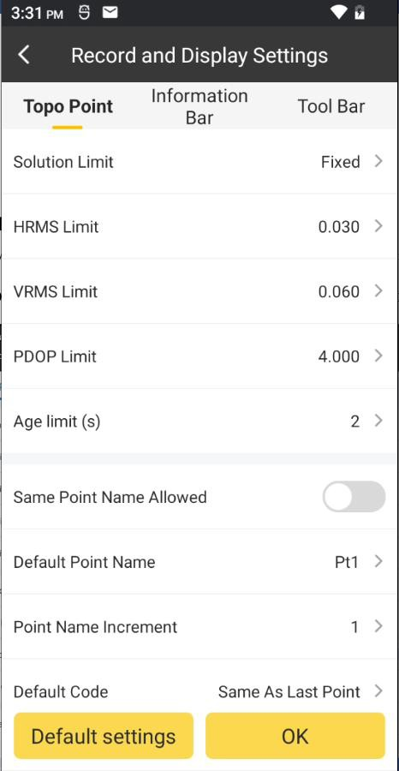 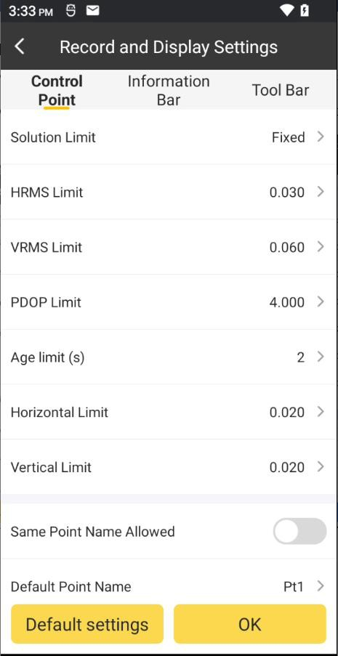

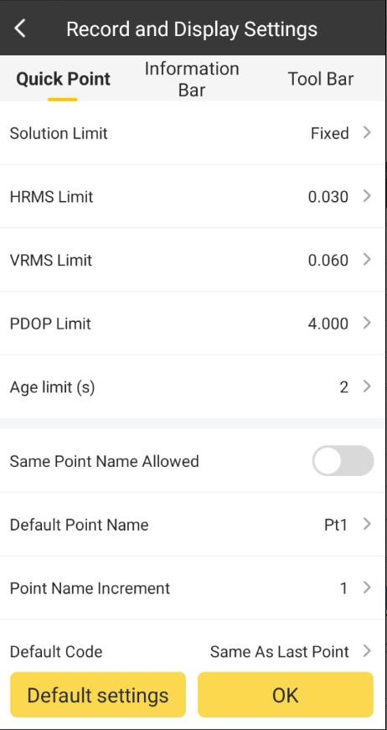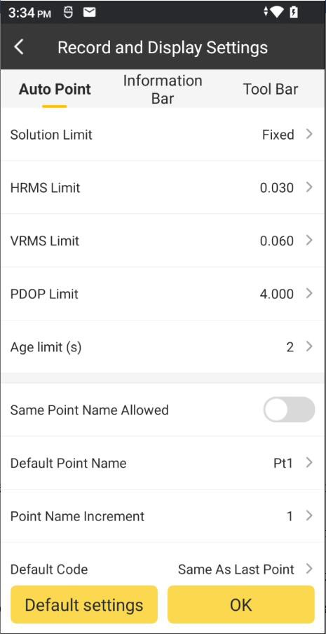

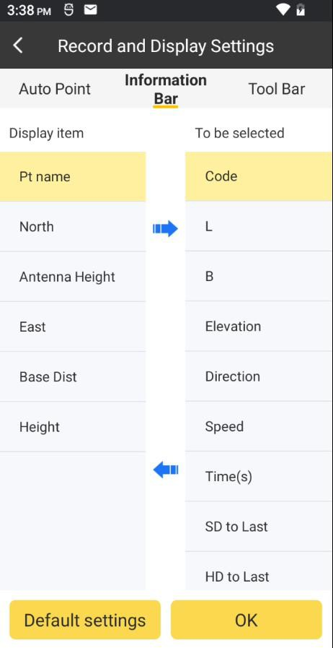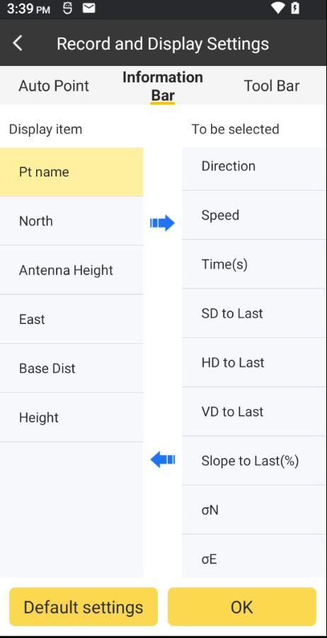Information: it can select the displayed information in the status bar at interface bottom. Select an item in the to be selected list, then click to move this item to the Display item list. In the same way, select an item on the Display item list, and click to move this item to the to be selected list. If click Default settings, the default items will be added to the Display item list, including Pt name, North, East, Height.

Tool Bar: settings what function keys to display in left toolbar in Point Survey interface.

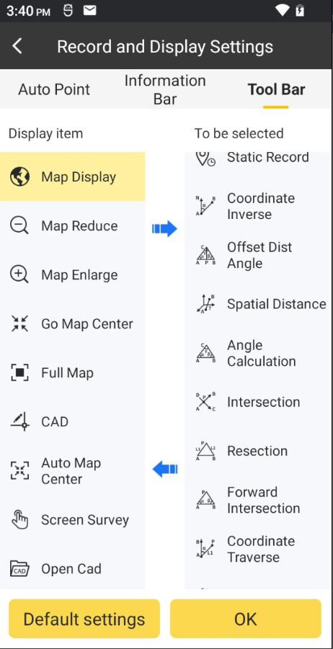

 : Collect point coordinates: this icon changes along with open/close status of tilt

survey. Open tilt survey, it will change to . And if the tilt mode available, it will change to .

## Detail Survey

By clicking this, it will enter to detail survey page. Its upper toolbar information is same as that of Point Survey. Detail Point is a simplified point survey mode, which is suitable for rapid and continuous coordinate survey.

OK

Settings

Click

and set recording limit and click

to return to detail survey page. to Set

Pt name, Code, Antenna Height and Antenna Height Type, click  to complete point collection.

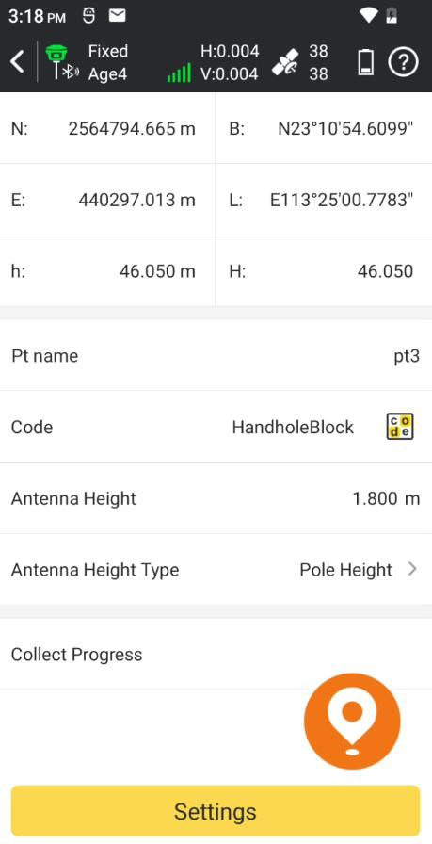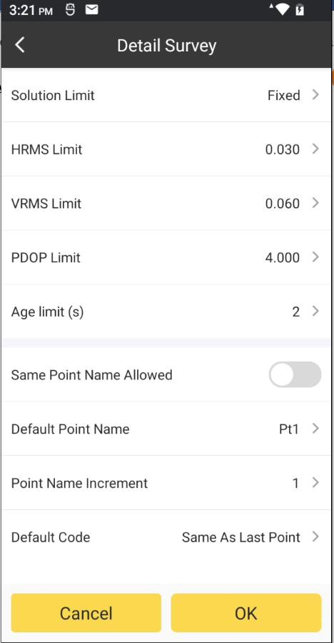

## Point Stakeout

Point stakeout is the process of inputting target coordinate in software and stakeout in field. By clicking this, we will enter to points database. Select any point, and click OK. Then we will enter to the point stakeout page.

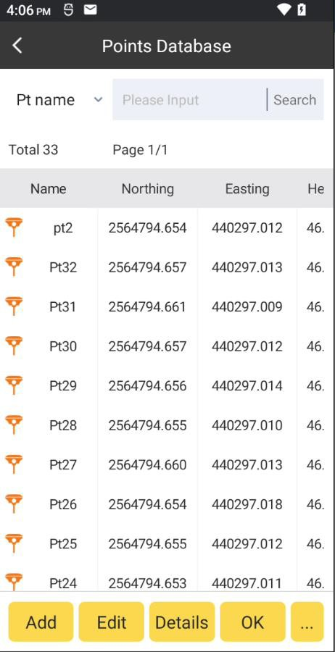 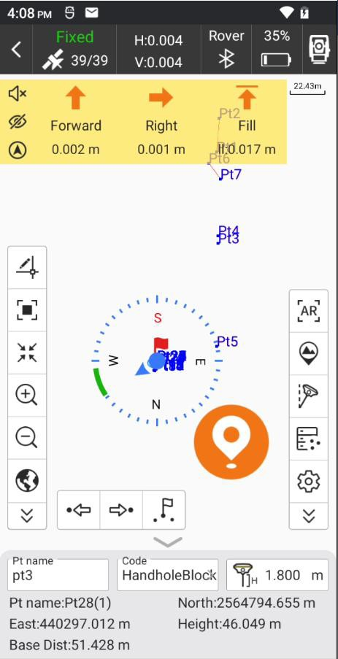

Arrows in top bar describe as follows:

To Forward/Backward: distance that receiver needs to move Forward/Backward from current position to stakeout point. To Forward arrow shows up and to Backward arrow shows down.

To Left/Right: distance that receiver needs to move Left / Right from current position to stakeout point. To Left arrow shows left and to Right arrow shows right.

Fill/Dig: dig in stakeout point position. If the value is positive, perform excavation; if not,

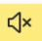perform fill. If current height is higher than stakeout point arrow shows down. If current height is higher than stakeout point arrow shows up.

: open/close stakeout voice prompt.

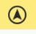: hide or show left arrow bar.

: switch compass mode or distance mode.

This is the distance mode.

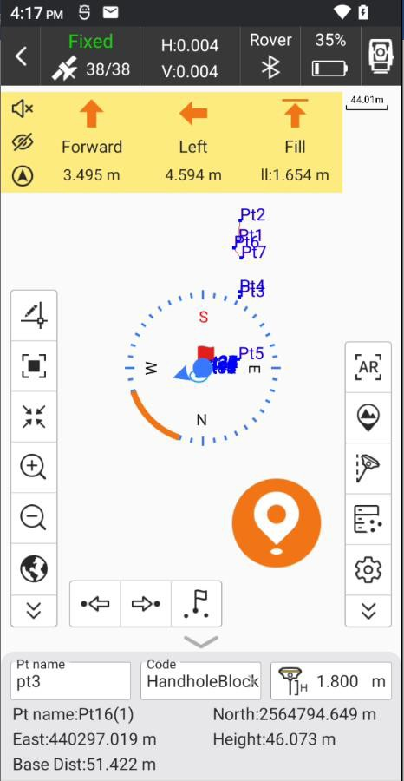

There are two states for compass mode.

**State 1:** Red flag represents target point, blue arrow represents moving direction from current receiver position to stakeout point, green arrow represents the direction from the collector pass and words below represents distance to target point.

**State 2:** In gray/green circle the red flag represents stakeout target, and blue circle represents receiver position. When stakeout distance doubles Prompt Range, it would change state 1 into state 2; when stakeout distance meets Prompt Distance, state 2 blue circle would turn into green.

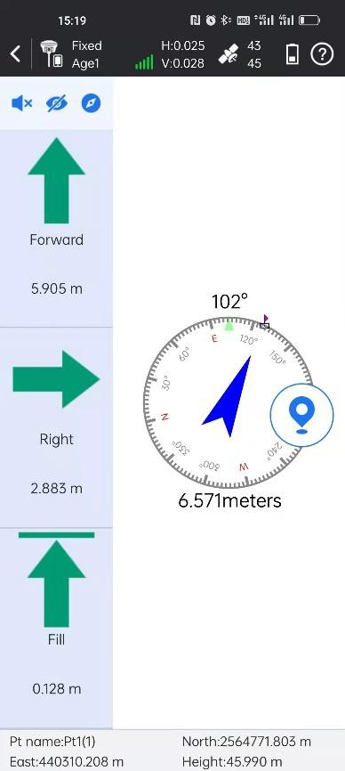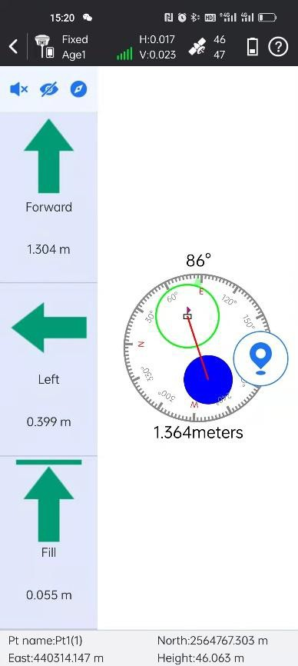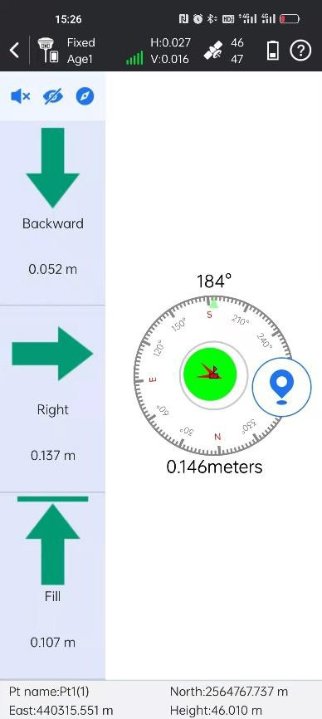

The icons in side toolbar describe as follows:

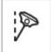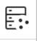: Points database.

: Tilt Survey

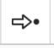: Nearest Point.

: Next Point. 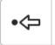: Last Point.

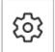: Point stakeout settings.

It can set stakeout settings, including Prompt Distance, Stake Limit, Display Information

(Not Display, Point Name, Code), and Reference Direction (Forward, North); settings for Topo Point, Inform and Tool Bar are the same as that of Point Survey. Click

Default

and it can restore the changed settings.

settings

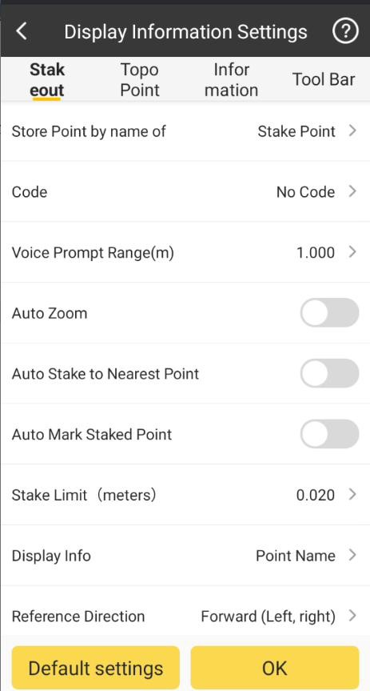

**Prompt Distance**: taking stakeout point as center of a circle and drawing three concentric circles with radii are multiples of 1, 2 and 3 times of the prompt range, area covered by these three concentric circles is prompt range.

Point stakeout steps:

1. Select a point to stakeout in the points database, then click

to enter points stakeout

OK

page. Red flag is target stake point. Circle is current position of receiver. Arrow is direction indicator, indicating the direction of current receiver. When the arrow direction is same with the direction to the target point, please move in this direction, then you can reach the target point.

1. According to left status bar, move from the current point to the stakeout point, and excavate or fill the soil according to the height difference of the elevation.
2. When current point is within prompt range, there will be three concentric circles, which indicate it enters precise stakeout.
3. After you reach the stakeout point, please stake it.

## Line Stakeout

Line stakeout is the stakeout of designed line, including line mileage, left and right offset and elevation control within line. By clicking this, we will enter to Line List. Click Add,

we can add the designed line with Line Name, the Start Point, End Point and Start Chainage. We can also import line file(*.SL).

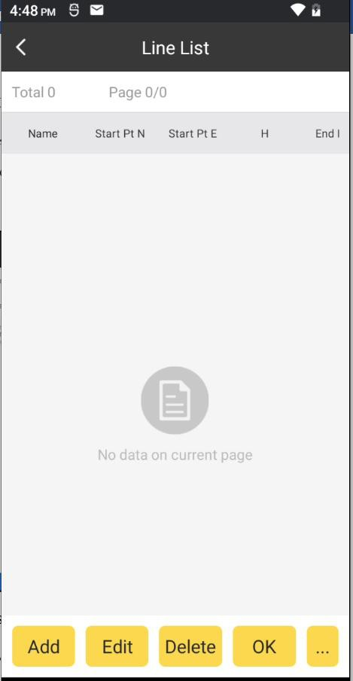 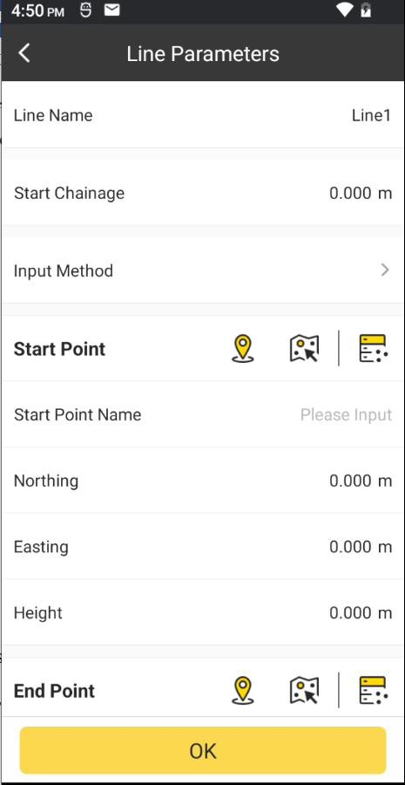 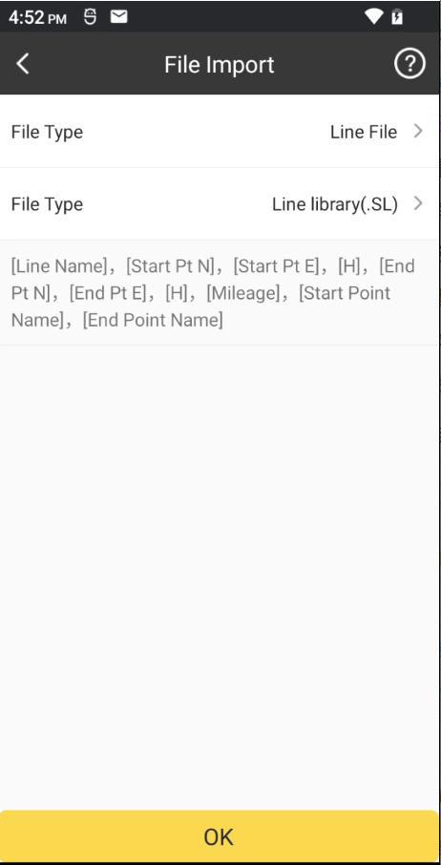

Select any line, and click OK. We can set the settings of stake, it including Chain Pile

Stake On/Off, Auto Stake Nearest Point On/Off, Mileage, Range, Calculating Method and Stake interval. Click OK.

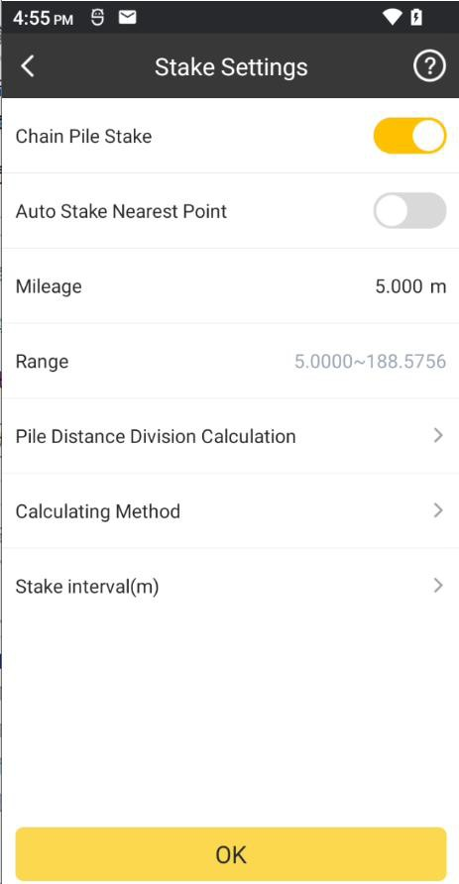

Then we will enter to the line stakeout page.

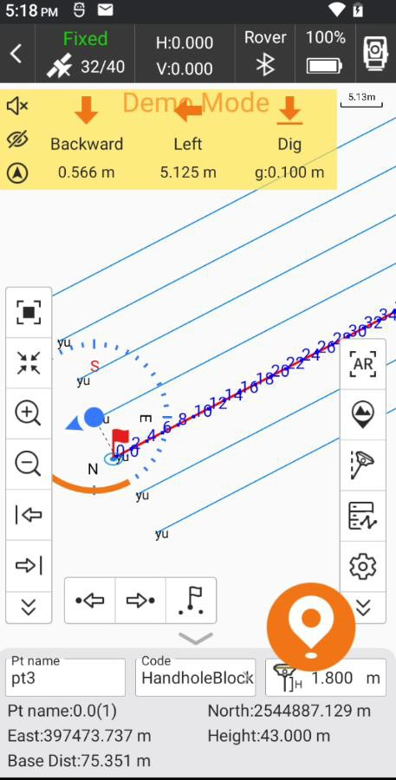

The icons in side toolbar describe as follows:

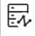: Line List.

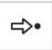: Next Point.

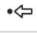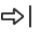: Last Point.

: Next Line. 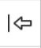: Last Line.

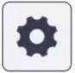: Line Stakeout Settings.

It can set line stakeout settings, including Prompt Distance, Reference Direction (Forward, North); settings for Topo Point, Inform and Tool Bar are the same as that of Point Survey.

Click and it can restore the changed settings.

Default settings

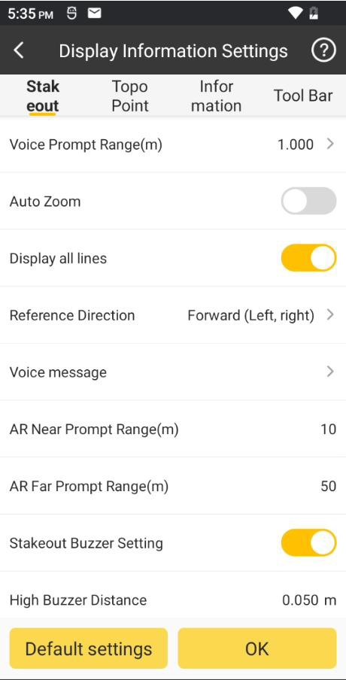

## AR Stakeout

Augmented Reality (AR) stakeout revolutionizes conventional surveying methods by integrating various sensory modalities, including visual and auditory. This approach eliminates the proficiency gap between experienced surveyors and novices by providing real-time visual guidance within authentic environments. Additionally, voice prompts are employed when nearing designated targets. This streamlined process allows surveyors to stake out targets without the need for leveling the pole, relying on visual and auditory

guidance for precise stakeout each time.

**Features:** Users can easily find the target points in real world through real-time images and virtual arrow guidance.

This function must initialize the IMU firstly. After completing the tilt survey initialization, select the point to stakeout, click the [AR] icon on the right side of the screen, and then stakeout points according to the direction and position displayed on the interface. (Note that the direction of the device camera is the same as the direction of the controller)， the

detailed steps are as below.

## WIFI connection

In communication please select WLAN mode, as the picture shown below, switch on the WiFi of your controller, and then let the controller connect to the WiFi hotspot of receiver.

## Datalink settings

Please set the correction data datalink make the receiver connect to CORS to achieve a fixed solution.

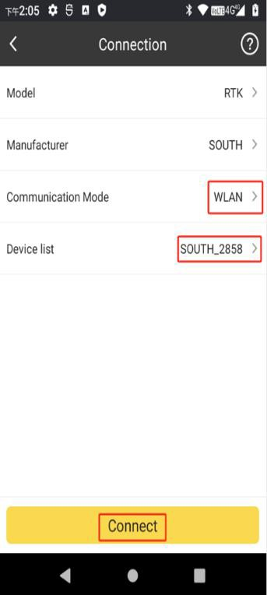 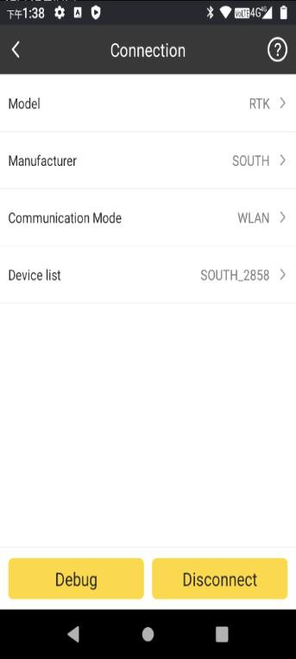 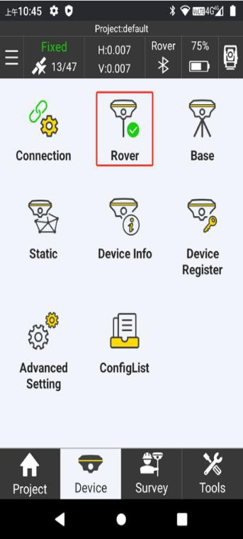

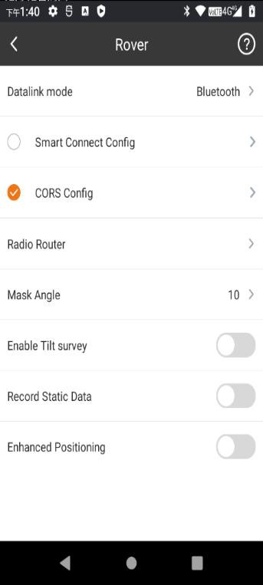

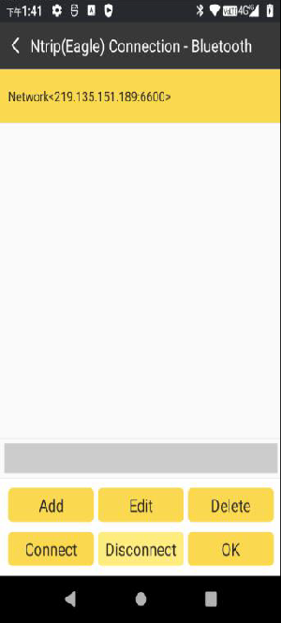

## Point Stakeout

Click the "Point stakeout" function, select a point and turn on the tilt survey function. Shake the device as prompted to initialize the tilt survey. (Note that the pole height is consistent with the actual pole height)

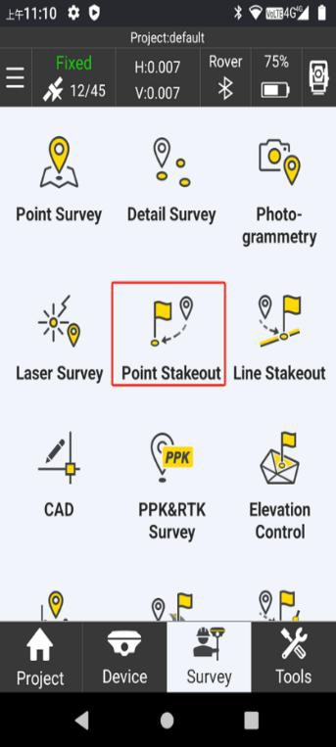 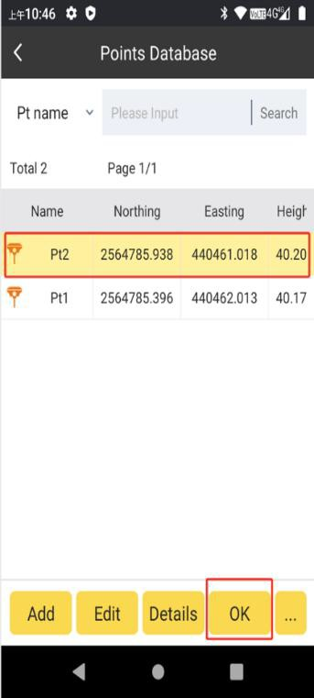

Enable the Tilt survey function, it will prompt you to initialize IMU.

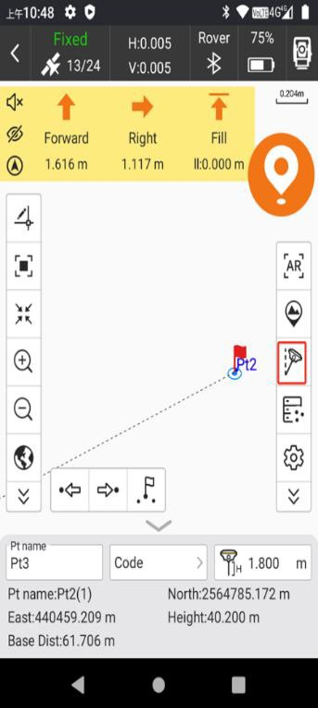

Titl Survey (colour gray denotes not active)

Click it to enable IMU, and

### IMU initializing

According to the prompt to perform operations, 1. please keep receiver still till the next prompt screen, then shake the pole front and forth till you hear the voice “tilt survey is available” at this moment, tilt survey is available. Watch that tilt survey icon is displayed from gray to bright colour.

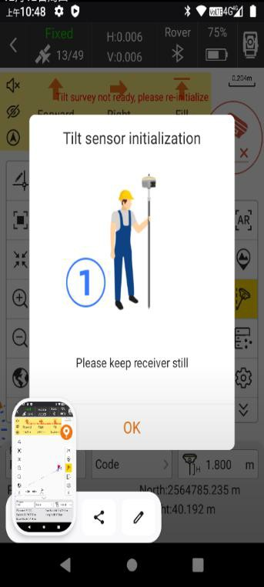 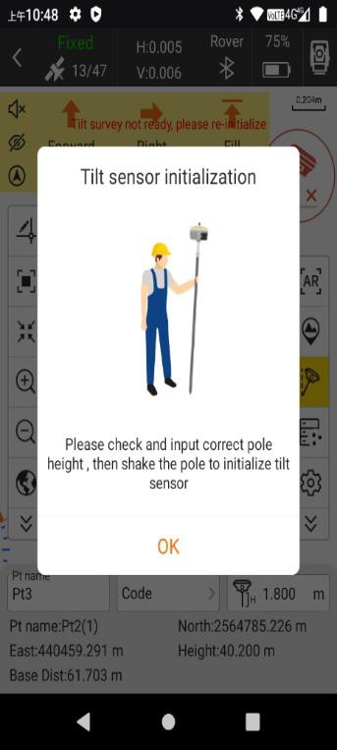

### AR is working

After initializing IMU,users can Enable AR, Click the AR icon to turn on the real scene stakeout.

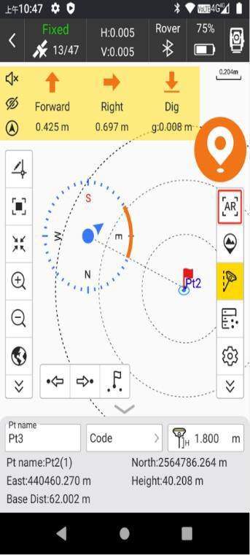 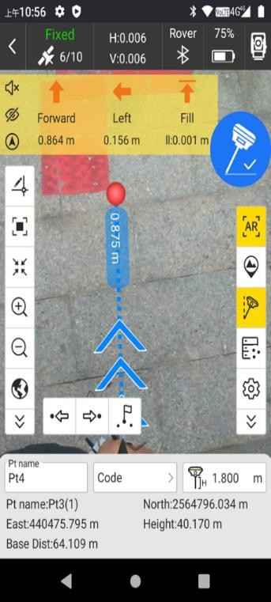

Over 10 meters (default) use the side camera for orientation, after approaching the target point to switch the bottom camera;

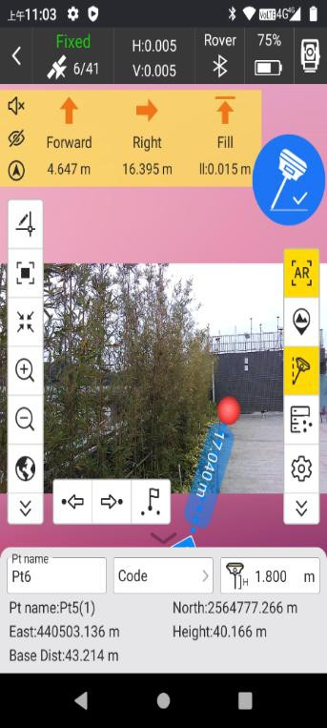  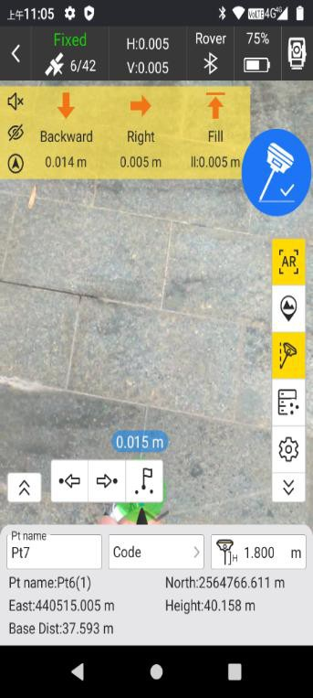

For example: side camera and bottom camera

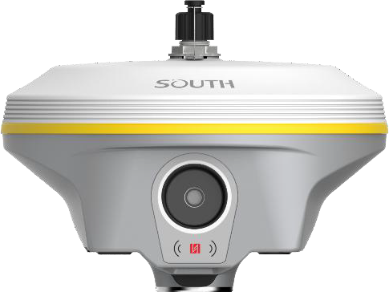

Side camera

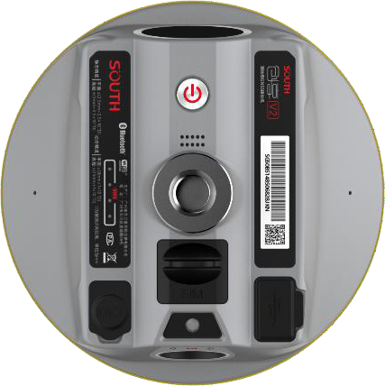

Bottom camera

## Photogrammetry

**Visual positioning** broadens the scope of RTK applications through the synergistic integration of photogrammetry and RTK positioning technologies. With an 8-megapixel

camera, “Fast” IMU and the latest positioning algorithm, Our receiver is adept at capturing and processing images or videos to derive precise coordinates. Therefore, it excels in surveying targets that pose challenges for traditional methods, including intricate corners beneath roofs, obstructed fields, and bridges spanning rivers. This capability enhances surveying versatility, allowing for the efficient and accurate surveying and mapping of locations that were previously difficult to access with RTK surveying techniques.

**When** surveyors have a high-quality internet connection, they can process image data online through the network and cloud servers. Finally to obtain coordinate data for image measurements with 2cm accuracy in just a few minutes. This processing mode balances high accuracy and fast processing speed.

**When** outside the coverage area of internet, surveyors also can achieve offline processing of image data through SurvStar on the controller. This processing mode boosts the fastest processing speed by saving time of uploading image data, providing 4cm accuracy results within 30 seconds, people who care about the data safety, they could consider this offline solution.

**There** are three modes for you to choose from：‘**Takin Photos Mode**’、‘**Taking Videos**

**Mode**’ and ‘**Modeling for Post-processing**’. Use ‘Taking Videos Mode’, keep the target inside the frame, take at least 5 photos around or in a circular motion, with a walking distance of more than 2 meters.

Use ‘Taking Videos Mode’, click to start shooting, keep the target to be measured in sight, walk horizontally or in a circular motion to shoot video for at least 5 seconds, and walk more than 2 meters. Click to end the shoot.

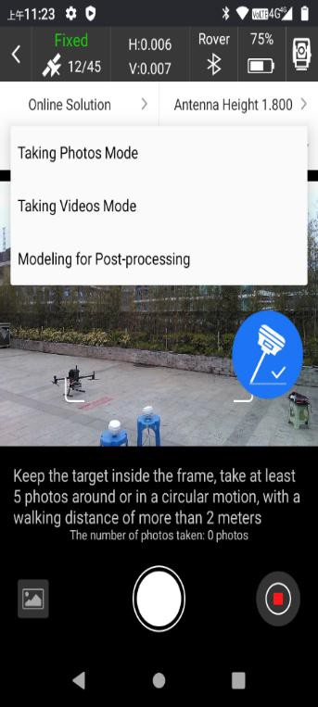 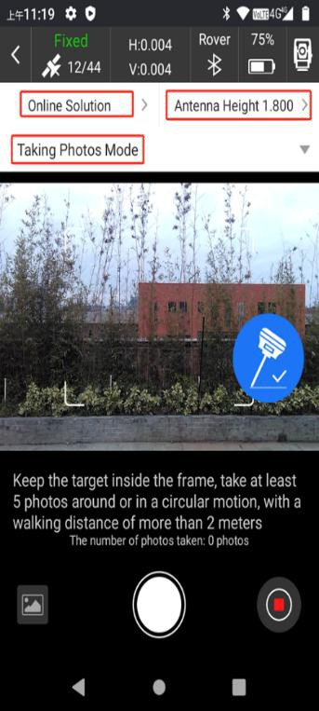

## Online solution

1. Use wifi connection to connect to the device. The device is connected to CORS to achieve a fixed solution.

  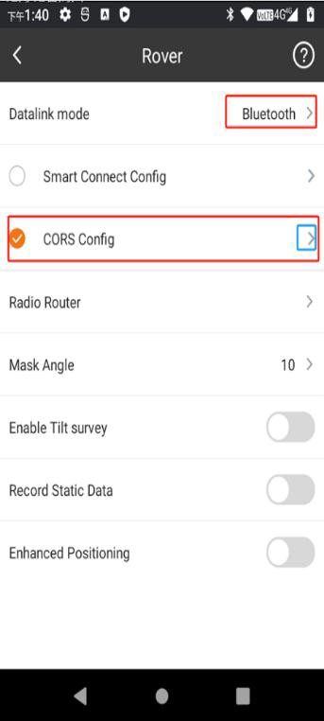

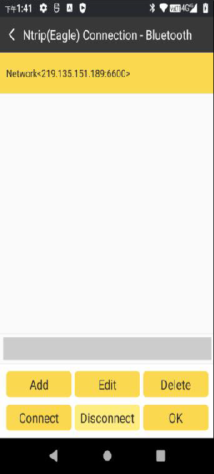

Tips: About the datalink options, if SIM card was installed in controller, users can select Bluetooth, if SIM card was installed in receiver, users can select cellular.

1. Enter photogrammetry, software will prompt you to initialize IMU, please keep receiver still till the next prompt screen, then shake the pole front and forth till you hear the voice “tilt survey is available” at this moment, tilt survey is available. Watch that tilt survey icon is displayed from gray to bright colour. (Note that the pole height is consistent with the actual pole height)

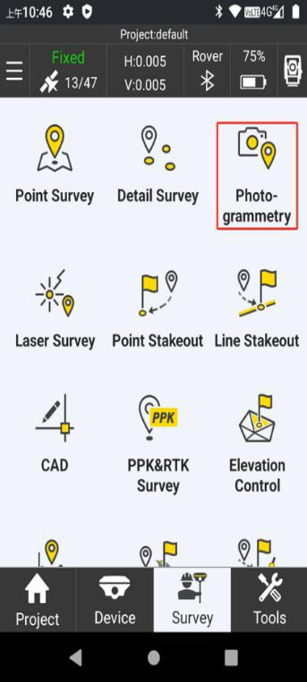 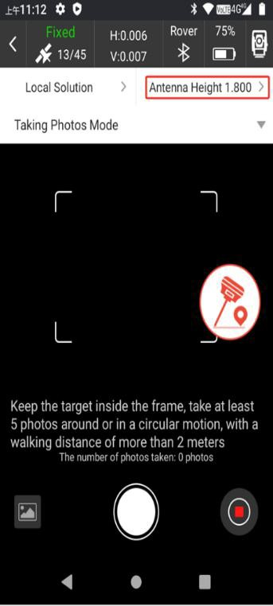 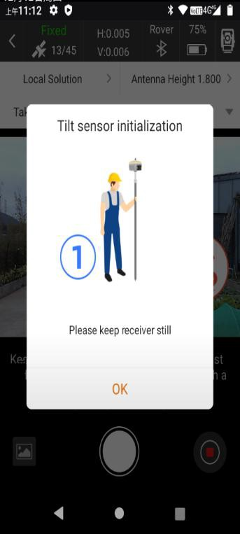

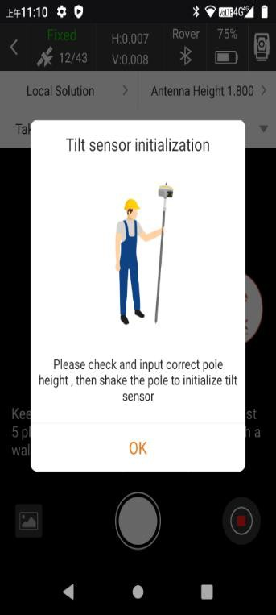

1. There are three modes for users to choose：‘Taking Photos Mode’、‘Taking Videos Mode’and ‘Modeling for Post-processing’.

Use ‘Taking Videos Mode’, click to start shooting, keep the target to be measured in sight all the time, walk horizontally and in a circular motion to shoot video for at least 5 seconds, and walk more than 2 meters. Click to end the shoot. (Photo transfer in progress: The picture taken by the device is being transferred to the controller)

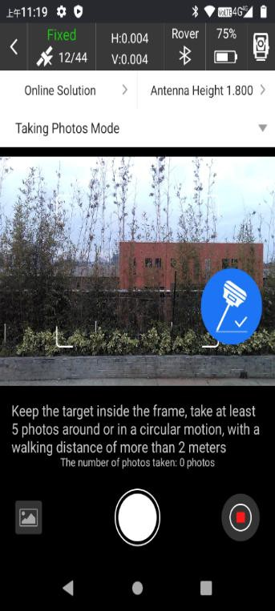 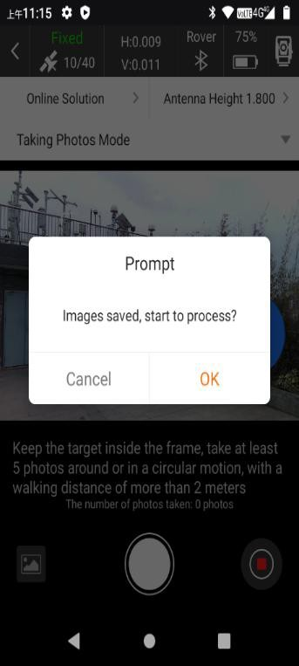

1. Click OK to perform the upload server calculation. (The calculation time is related to the number of uploaded pictures, the more pictures, the longer it takes)

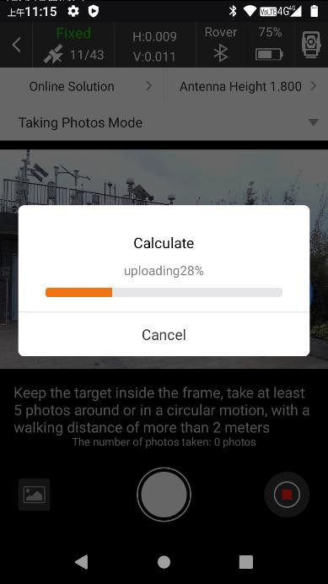

1. After the solution is completed, click OK, select three pictures, select the same target point, you can calculate the coordinates

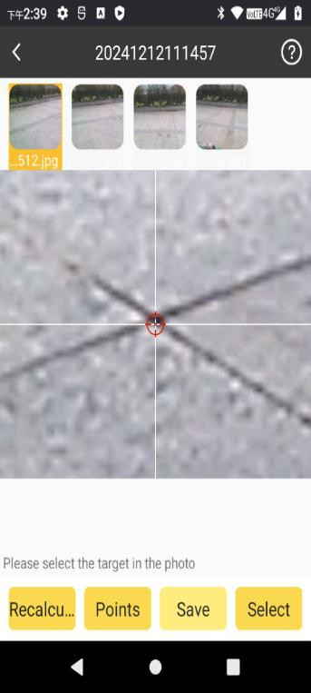 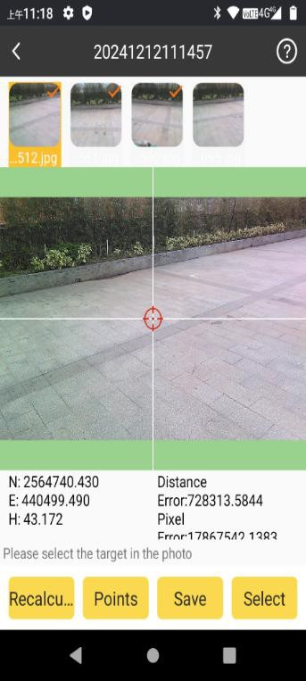 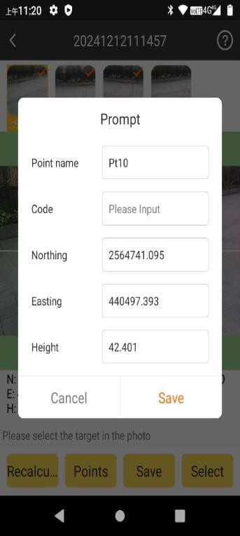

## Local solution:

This feature can be used when the controller or phone without SIM card or cannot access the internet, not need to upload images or videos to the server for processing and calculation. The calculation is done solely by the device's processor, you can use the photogrammetry to be performed normally even in areas without internet access, greatly convenience work in difficult environments.

* + - 1. Photogrammetry when the device does not have Internet access.Click on top left

corner in main page for Photogrammetry, then choose Solution method Location Solution.

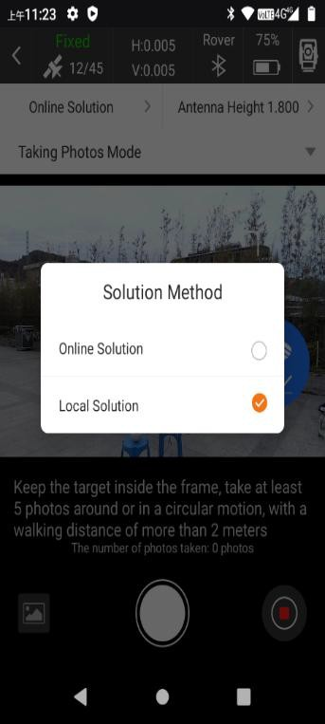

* + - 1. After online solution successful, if you want to local recalculate, choose Select photos to click **Select Points** when enter Image Gallery, click **Local Solution** at the bottom left corner.

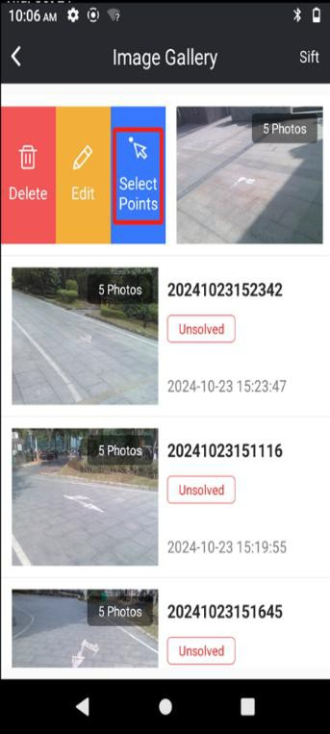 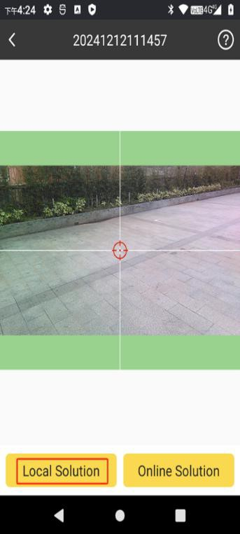 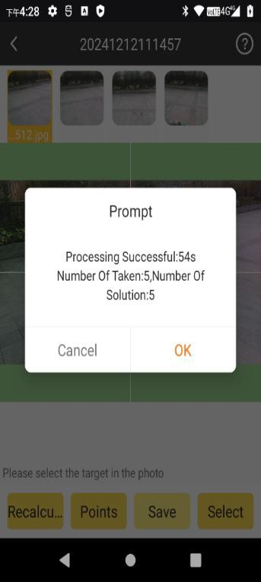

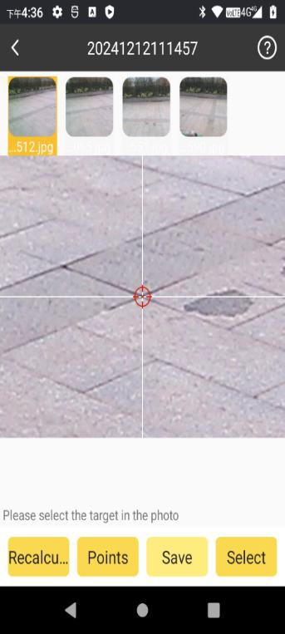

* + - 1. After online solution failed, if you want to if you want to offline recalculate, choose Select photos when enter Image Gallery, then click Local Solution.

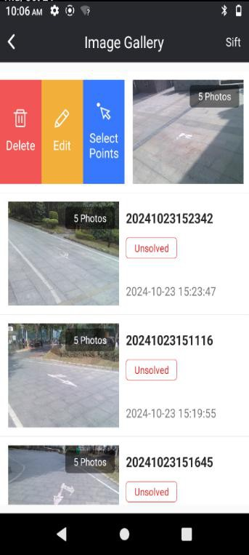  



## 3D modeling

SOUTH's 3D modeling technology are fully utilized and transformed in SOUTH Receivers. The results of image measurements by receiver, can be seamlessly integrated with data outcomes from UAV.

UAV surveys often face challenges of data gaps, leading to incomplete model outcomes. In such cases, surveyors can use SUTH receiver to collect image data on the ground and use SGO to modeling then incorporate it into aerial survey data as a supplement, thereby enhancing the overall model outcome.

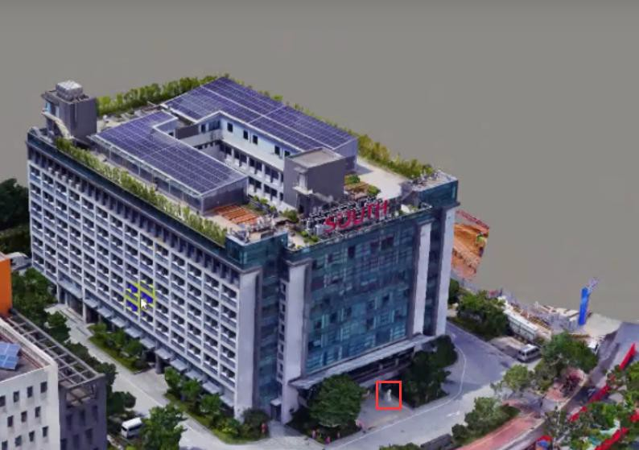

UAV Survey for SOUTH building, Lion statue detail lost

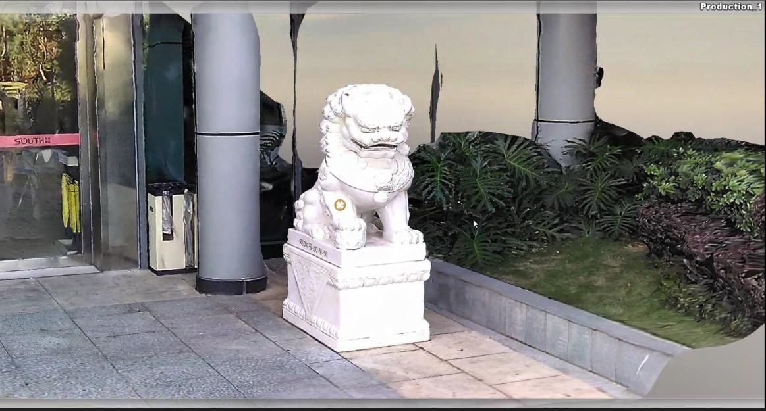

Scan the Lion statue Detailed steps:

* + - 1. New project in SGO. Set the coordinate system parameter which you need.

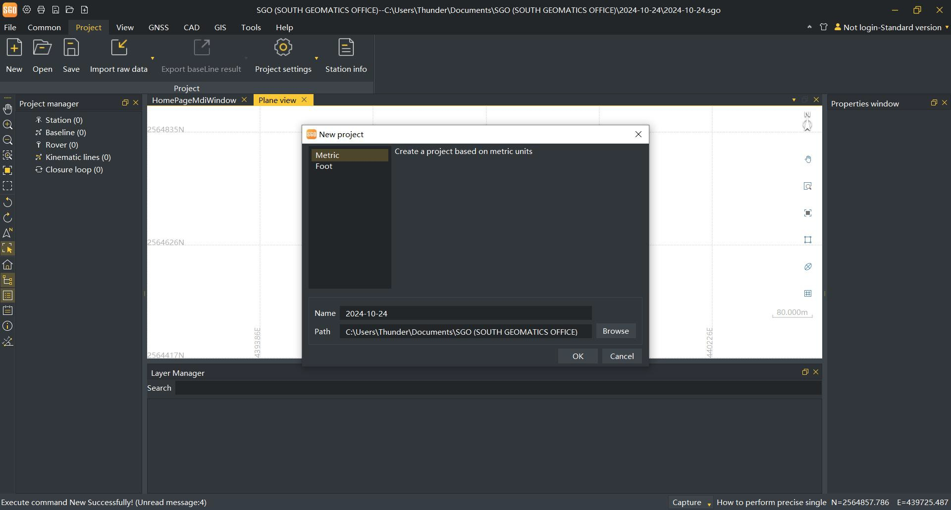

* + - 1. Right-click Toolbar area to choose Modeling manager.

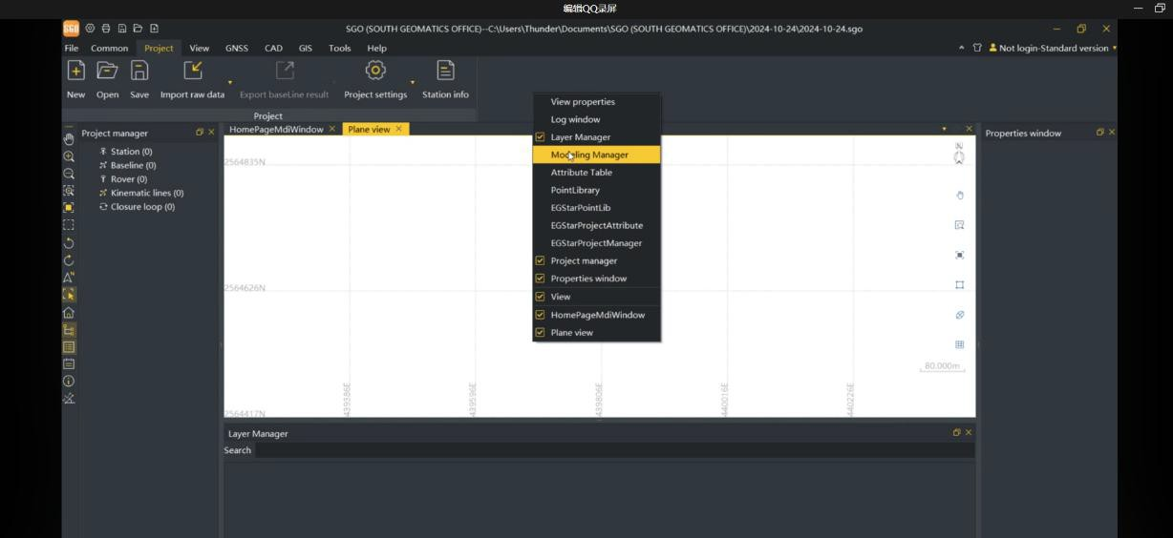

2) Right-click Modeling manager to choose photos folder. In Survstar-projectdata-default.

Or find the photogrammetry images in the receiver disk.

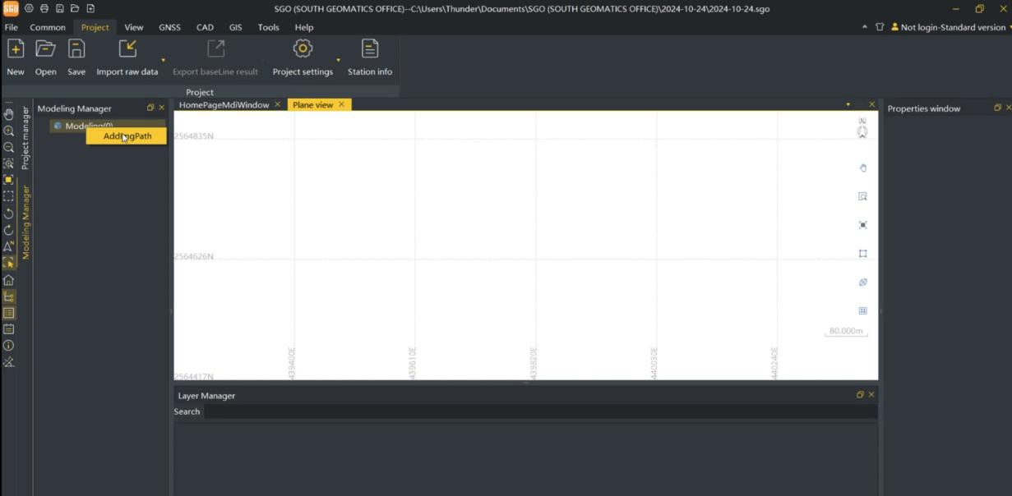

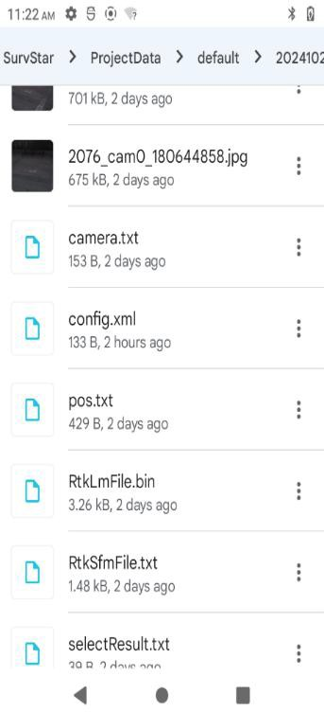

1. Set the parameters and preview photos in Import image group page.

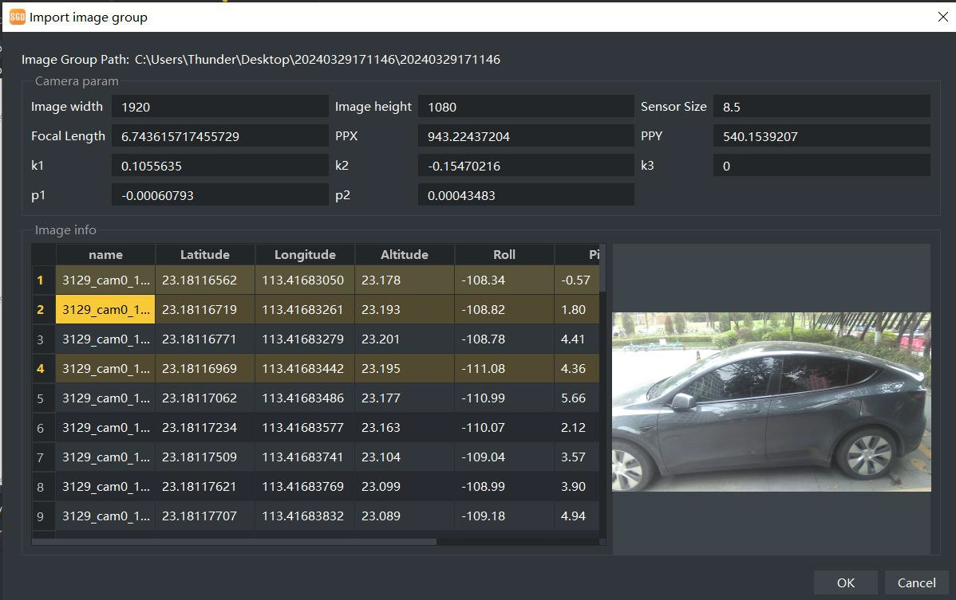

1. Click Modeling when you finished settings.

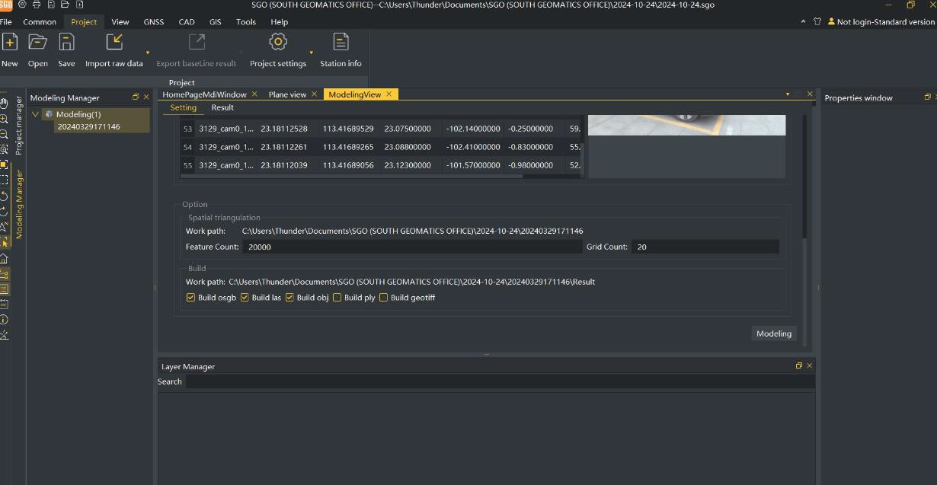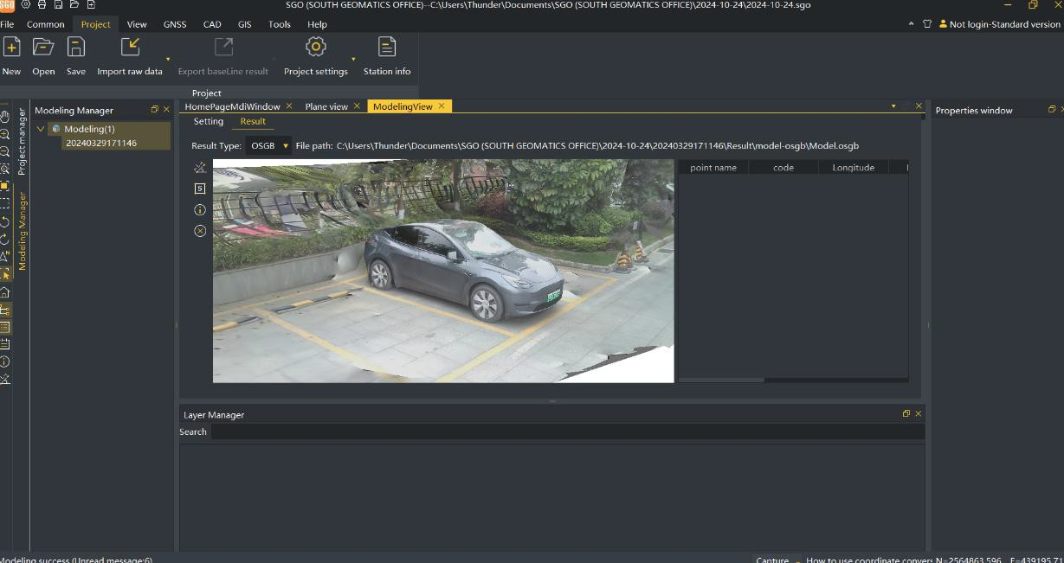

## Laser Survey

**Laser survey** is an instrument that accurately measures the distance to a target by modulating a certain parameter of the laser. Pulse laser ranging involves emitting a brief pulse or sequence of pulses towards the target during operation, with the photodetector receiving the reflected laser beam from the target. The timer measures the time it takes for the laser beam to travel from emission to reception, allowing for calculation of the distance from the rangefinder to the target. Point acquisition is carried out according to the position of the laser point.

Features:

1. **Laser Survey**, It can measure the target point via laser beam in daily survey work, especially somewhere users can not arrived at, such as roads that have been opened to traffic, under eave of buildings, tunnel portal, bridges... semi-occluded area.
2. **Drawing while point collecting,** According to the ground features to select the graphics (line polyline, arc, curve... ) to draw while collecting point in the laser survey function, it can help the users to get the sketch drawing which is convenient for further data process in the next work.
3. **AR,** it can help users to advantageously get the point in Laser Survey function.
4. **Laser Intersection**, It can get the quality result via measuring 2 times or many times on one target point. It can improve the accuracy of measured results.
5. **Laser ranging**, It can measure the distance value between the target and the receiver laser device in door or out door.

Functional main interface.

Drawing while

On or Off Laser

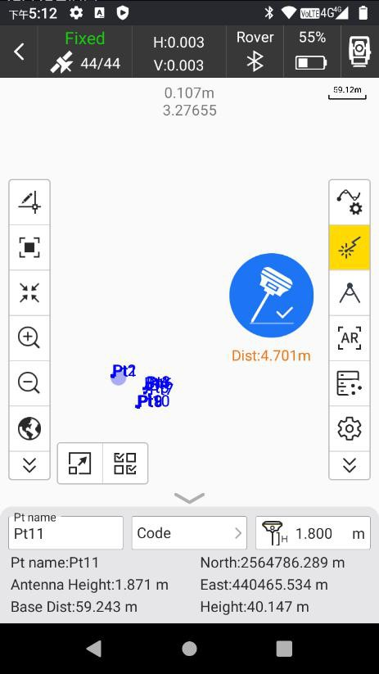

Distance

with

Intersection

AR

**Codes** and **measure method,** the details please refer to the section of Point Survey function.

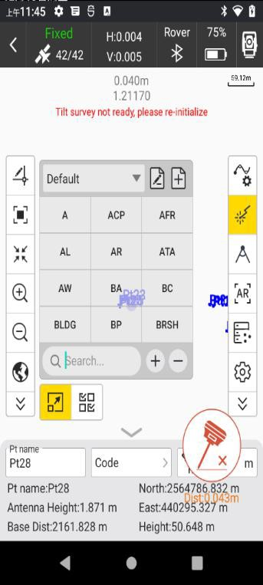 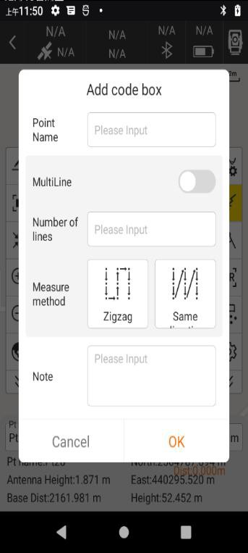

## Laser Survey

Make the WiFi of controller connect the WiFi hot-spot of receiver, choose “Laser Survey” in “Survey”MENU. Set the datalink to make the receiver get fixed solution.

 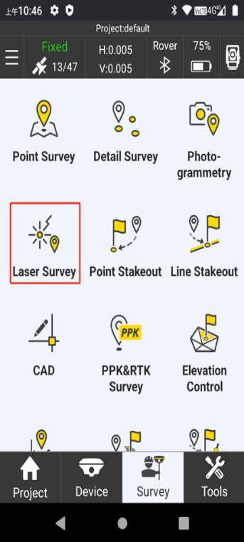

1. According to the prompt screen to initialize the IMU to be available.
2. Turn on laser function,
3. Turn on “AR”. As the picture shown below (According to the demand to switch on/off the “AR”). Start to collect the point, make the center of laser cross hair aim on the target point, click the collecting button to save the point data. Then continue to next collecting.

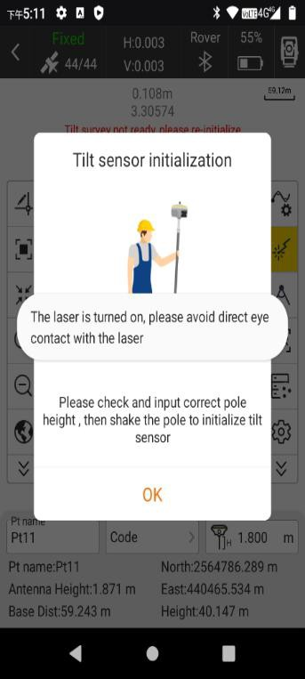 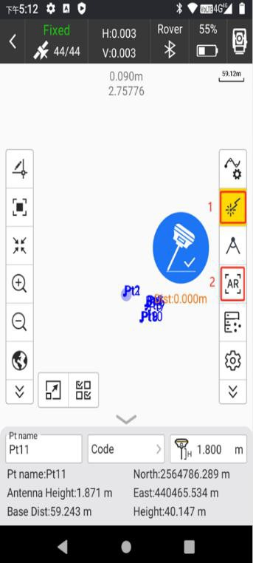

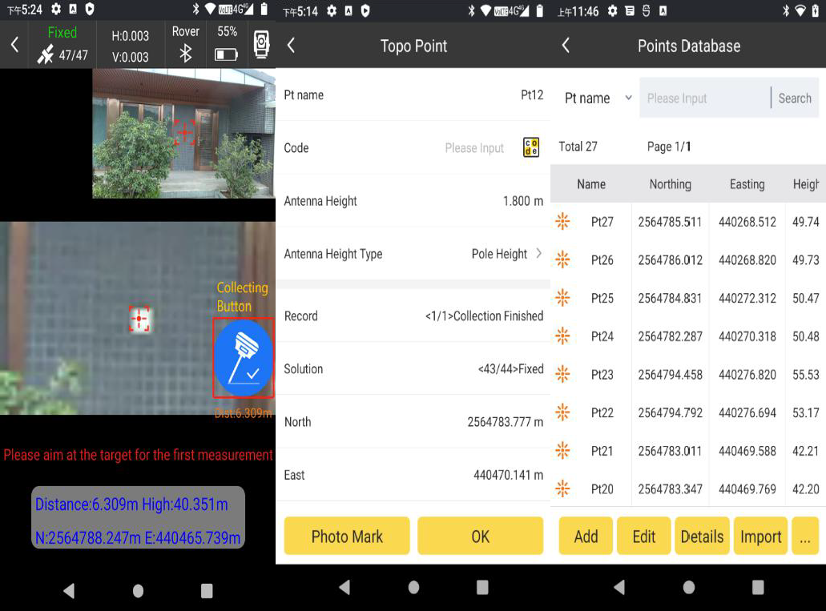

## Drawing while collecting

After initializing IMU, 1.enable laser 2.enable graphics to select the graphics which you need 3.enable AR, start to collect the point, make the center of laser cross hair aim on the target point, click the collecting button to save the point data. Then continue to collect the next point, the points will be connected to form graphics till you completing it.

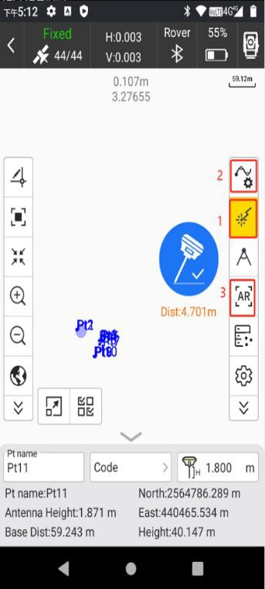 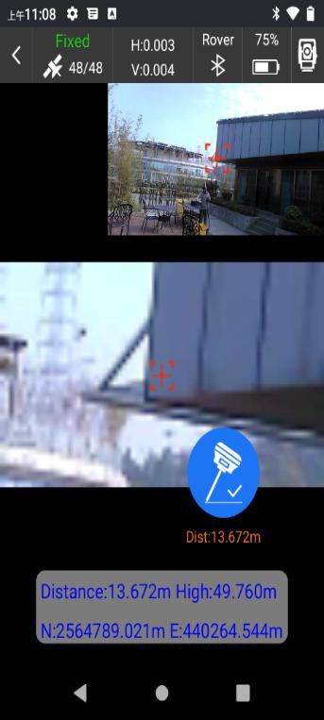 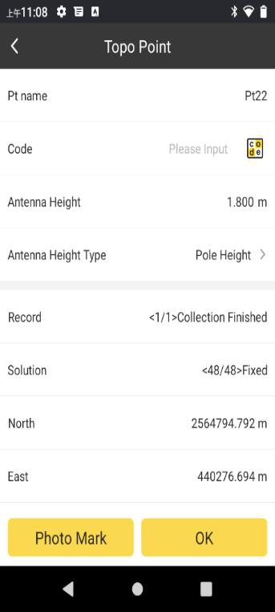

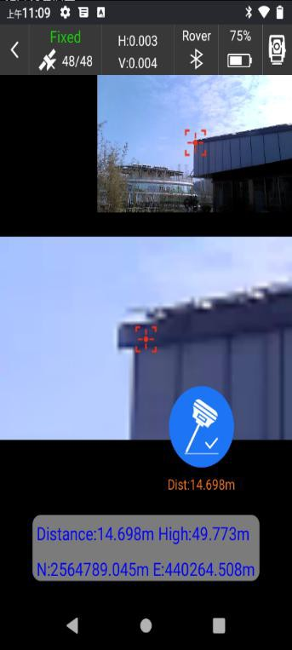 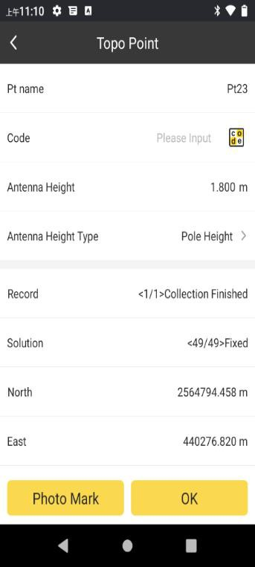 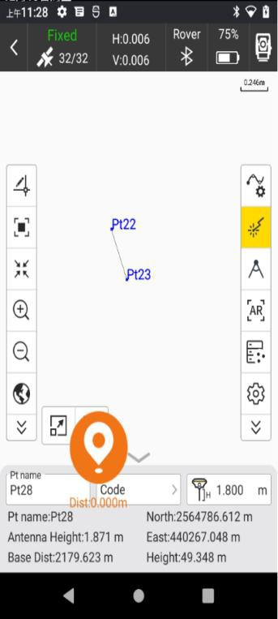

There multiple graphics can be selected

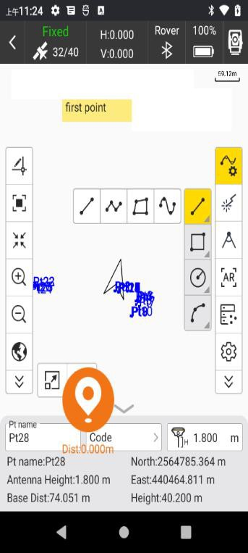

## Intersection function

By intersecting two or more points, you will get more accurate point coordinate. Click the setting menu, choose the intersection method.

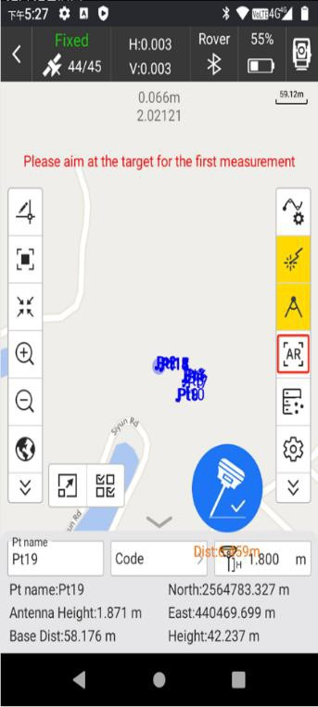 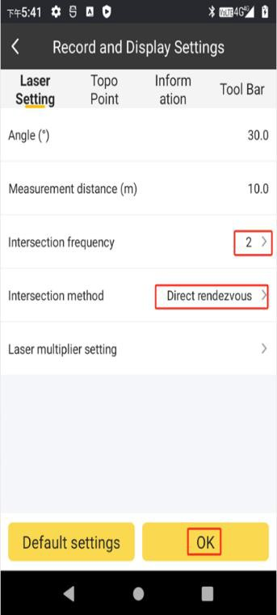

First collecting

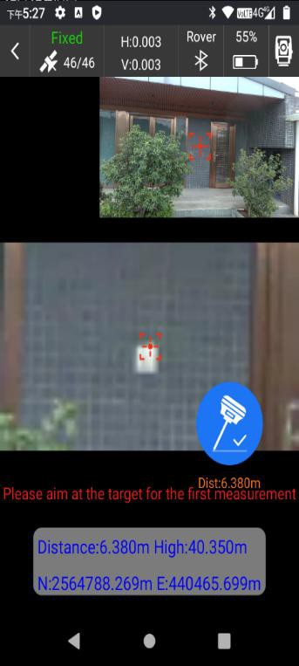 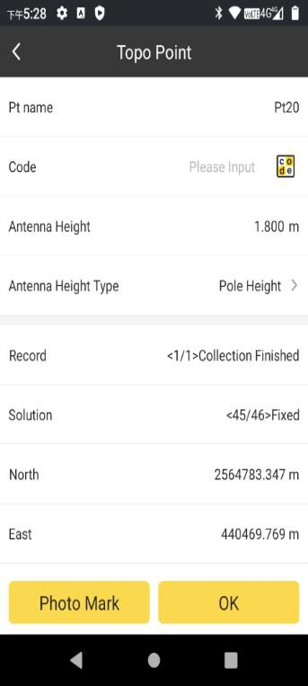

Second collecting

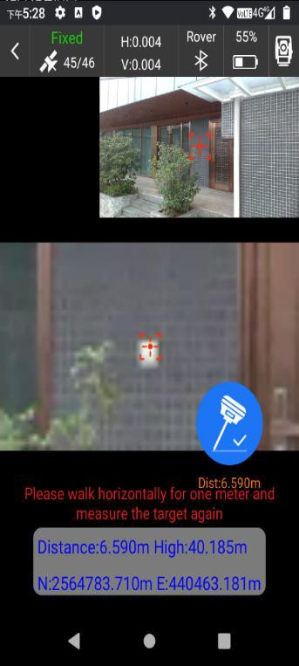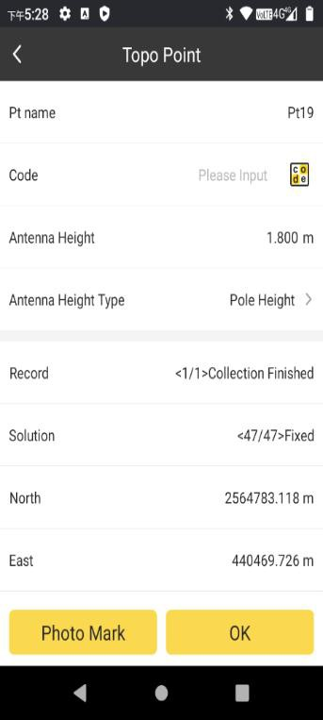

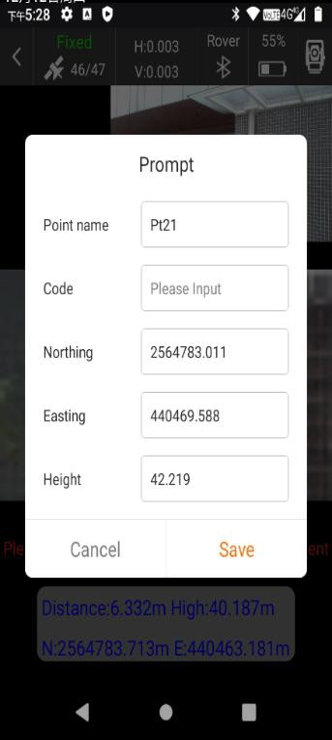Got the result of Intersection，After second collect will calculate the final coordinate of the target point, then save it. As the picture shown below.

Direct rendezvous is when the points are collected, you will directly obtain directly the coordinates of the intersection points.

Point library rendezvous is choose the points in point database, then obtain the coordinates of the intersection points.

## Laser Ranging

Just enable the laser, laser beam will reach the surface of target, it will be reflected, then laser device will measure the distance value between target and receiver laser device, as the picture shown below. Note that this function can be used without tracking satellites.

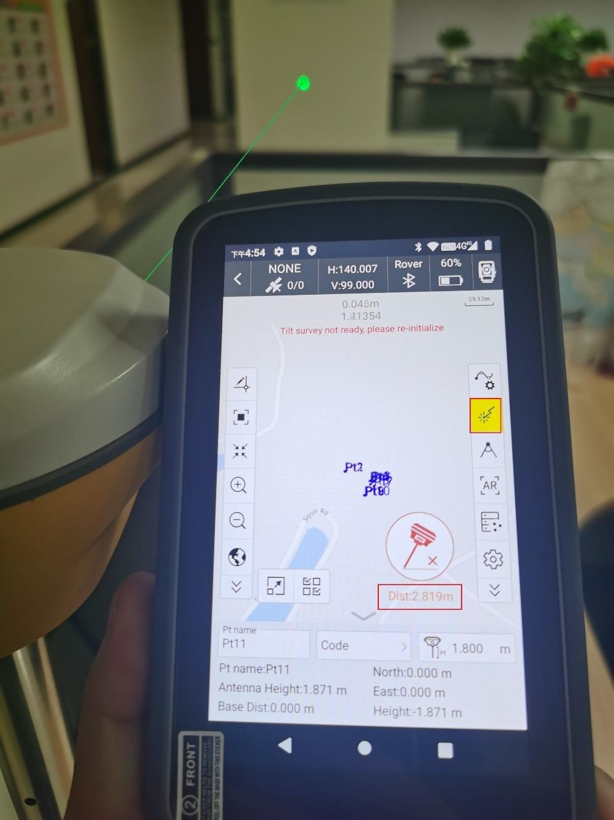

## Code, Survey and Plot 6-8-1 Code library

1. Code library management: support to add, edit, delete, use, import, export code table file;

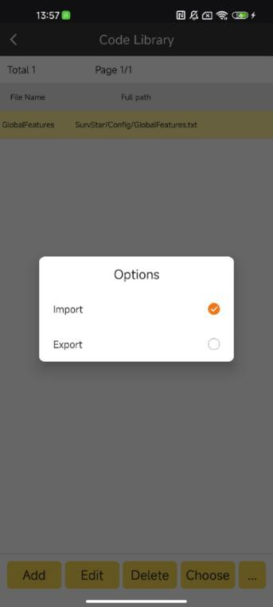

1. Add: support user to add code table and add custom code;

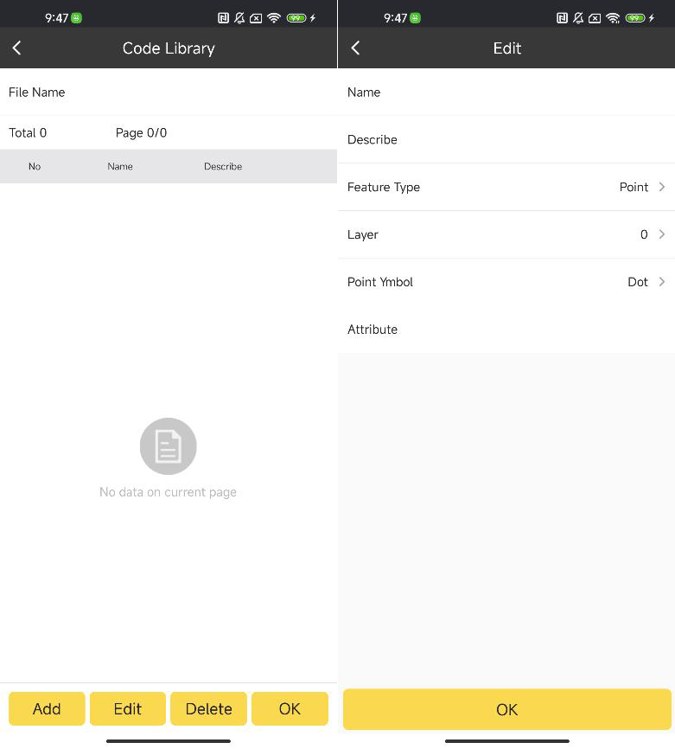

1. Edit: support users to edit the existing code table;
2. Delete: support to delete the code table;
3. Choose: Select the code table to be used, **which will be associated with the code box in the point measurement**, and display when the user adds the code to the code box;

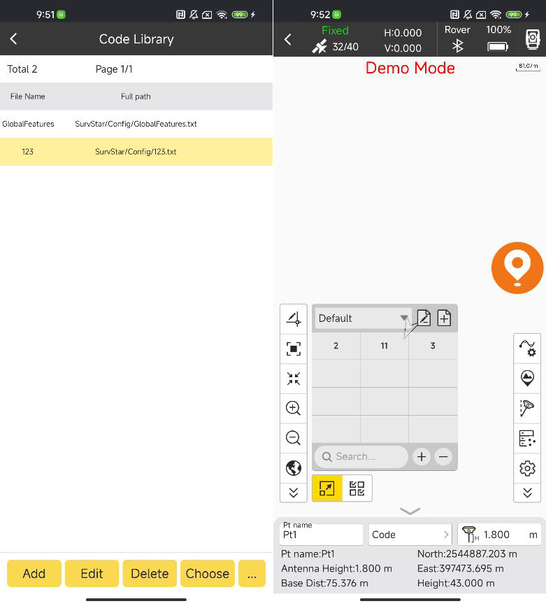

1. Export code file: Support to export TXT/CSV/DAT and other formats code file;
2. Import code file: Support the import of TXT/CSV/DAT and other formats code files, import file format requirements are consistent with the export format;

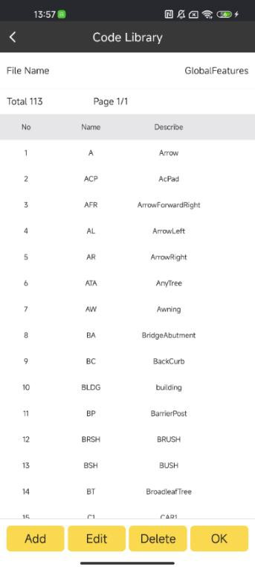

## Code box part

① Associated code library, support user to create a custom code box;

② Code box switching selection and editing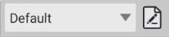; all codes of the current code library are added to the ‘default’ code box and cannot

be modified.

③ Add coding: Select a custom code box, click the blank cell, add code from code library currently in use;

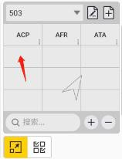

④ Add repeated code: Select an existing code and click Add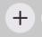(Repeated coding will be numbered to distinguish);

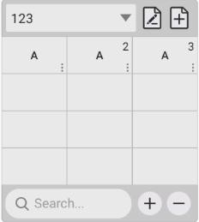

⑤ Delete the code: Select the existing code, click delete  or long press to select the target code to delete;

Code search: Support fuzzy search code;



6

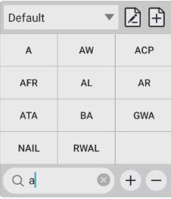

Enable multiple selection code, support the same point to save multiple encoding attributes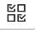;



7

## Graph Part

Support linear measurement such as straight line, multi-segment line, polygon, curve, two-point rectangle, three-point rectangle, two-point circle, three-point circle, three-point arc, etc. Long press to select a type.

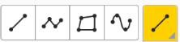

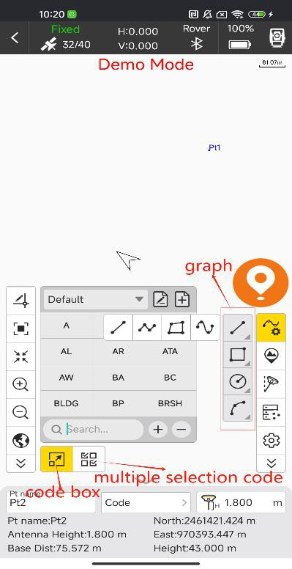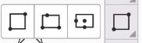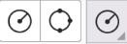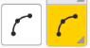

Layer manager

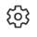Add Layer button in Settings

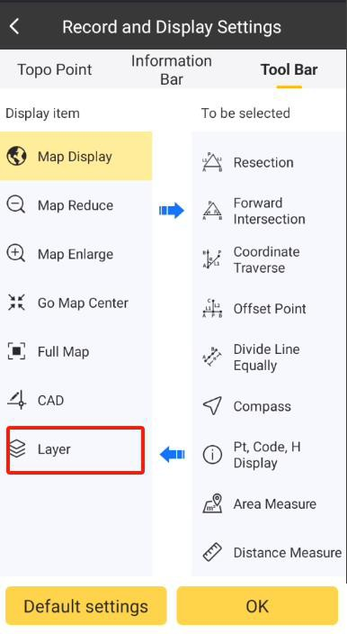

Open Layer Management to add a new layer, input layer name and select layer color.

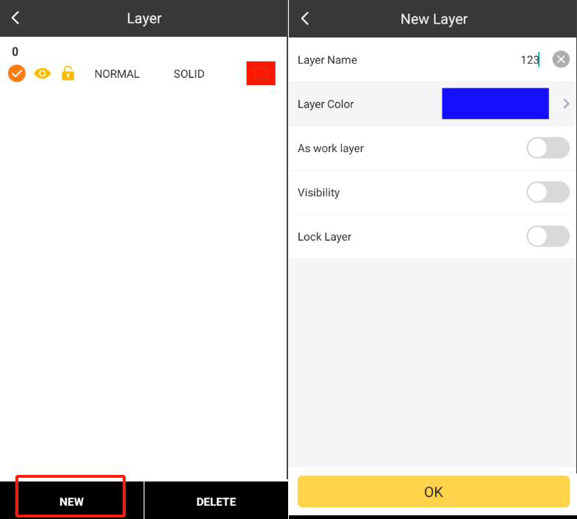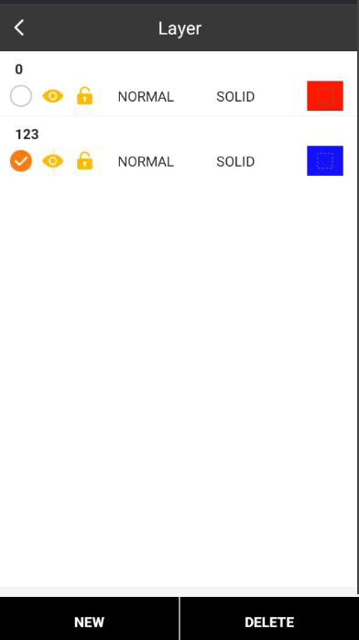

Select whether to use it as work layer, visibility and lock layer. The drawing opens in CAD function.

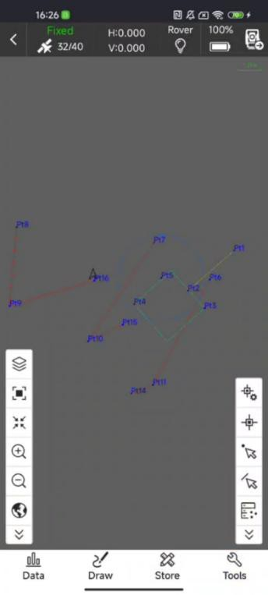

## Main operation process:

Conventional measuring points: using code for measuring points;

Graphic mapping: measuring line segments, polygons, curves, rectangles, arcs and other independent features;

Multi-line surveying and mapping: multiple lines simultaneously surveying and mapping operations, Z-type measurement, multi-line measurement in the same direction;

1. Conventional measuring points:

① Click the code box, select the code you need to use, and the code will be automatically filled into the code input box for saving;

② Open multi-selection coding, multi-selection to select the required coding, coding

automatically fill in the coding input box, save;

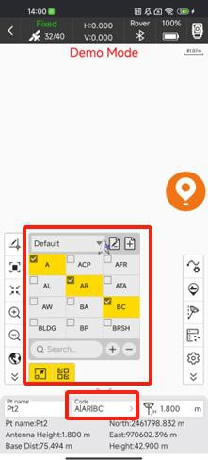

1. Graphic mapping:

① Open the code box, add a custom code box, or use the default code box;

② Turn on the graphic control function, select the graph to be drawn, long press to select more types and perform the measurement drawing according to the prompt information at the top of the interface;

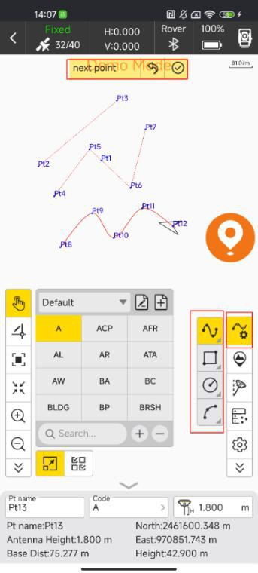

1. Multi-line mapping - Z-type mapping:

① Open the coding box, add the multi-line coding box, select the number of lines, Z-type measurement mode, click OK;

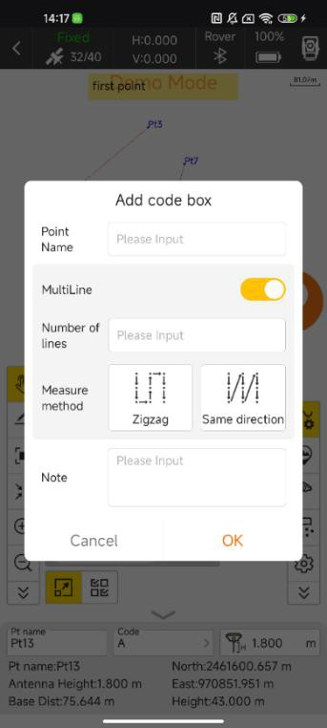

② Add custom codes, select Start code;

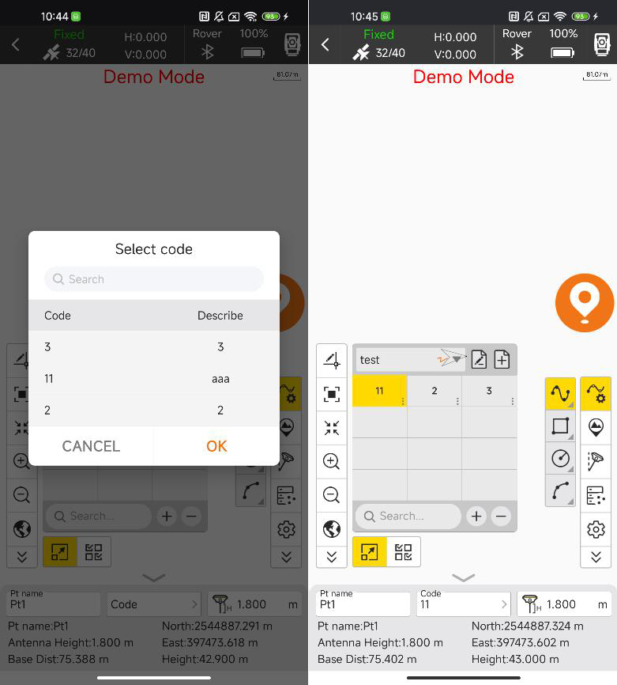

③ The user selects the polyline/curve line for measurement drawing;

④ In the measurement process, the measurement point drawing is carried out according to the selected measurement method, and the user needs to measure the number of lines in turn according to the number of lines set. The code of the same line is the same, and the

coding order in the coding box is automatically switched to use;

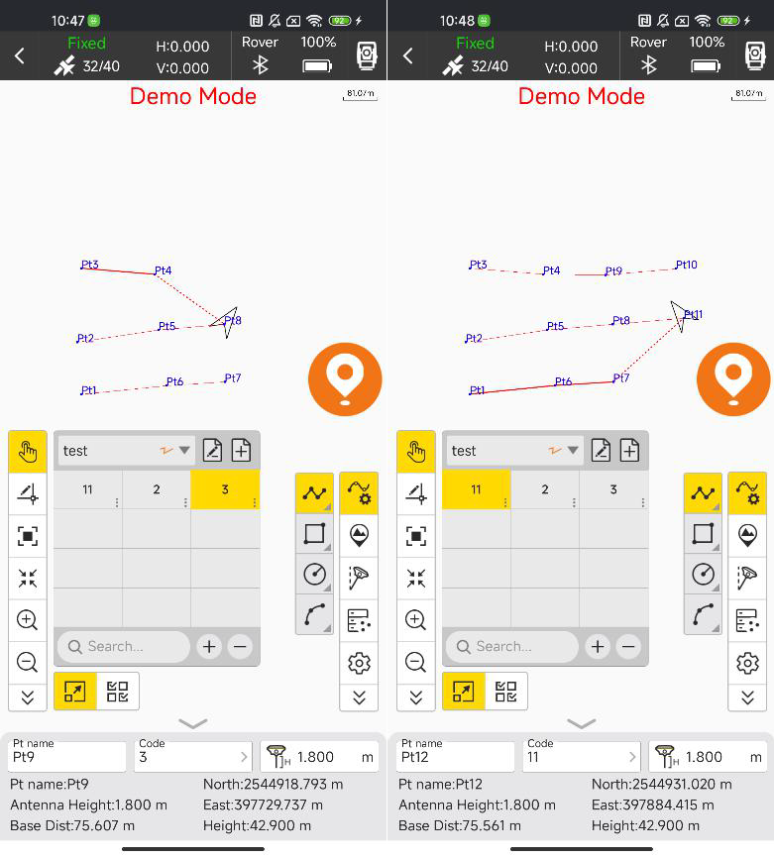

1. Multi-line mapping - Multi-line in the same direction:

The process of multiline mapping in the same direction is basically the same as that of Z-type mapping. Attention should be paid to the difference of multiline mapping in the same direction.

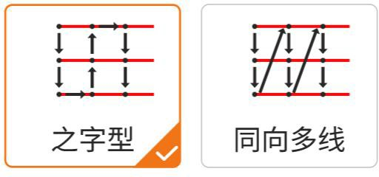Same direction

Zigzag

## CAD

CAD is mainly used to stakeout lines in the existing CAD graphics. By clicking this, we can enter to the CAD page.

The icons in side toolbar describe as follows:

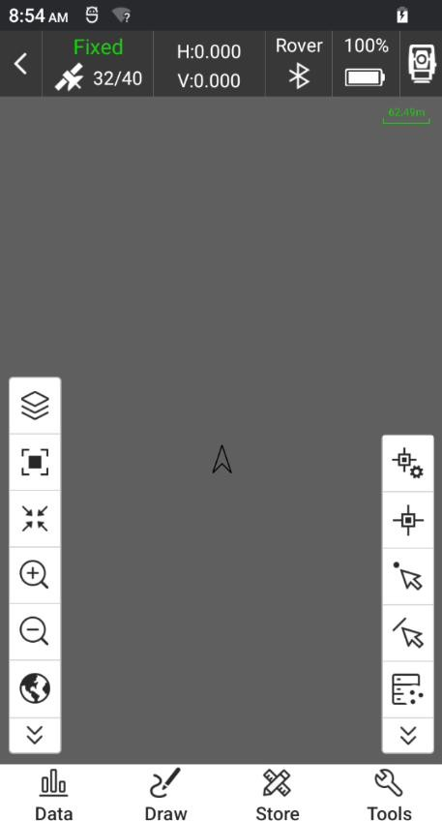

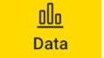:Tap Data icon will show CAD file open and export function.

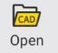: Import CAD file(*.dxf/*.dwg).

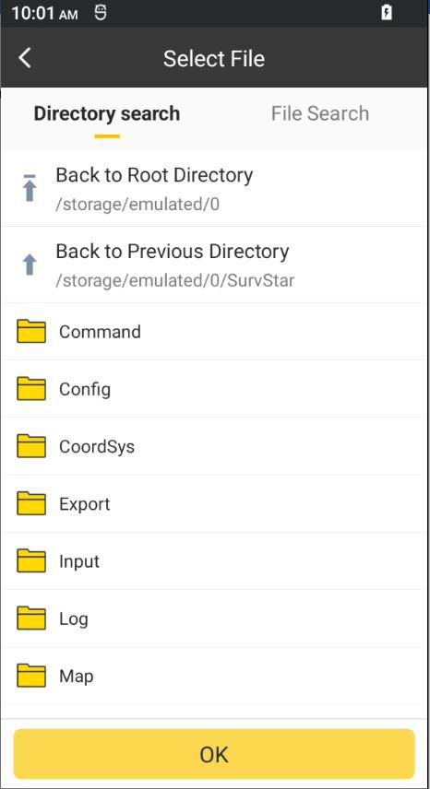

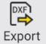 ：Export CAD file(*.dxf/*.dwg).

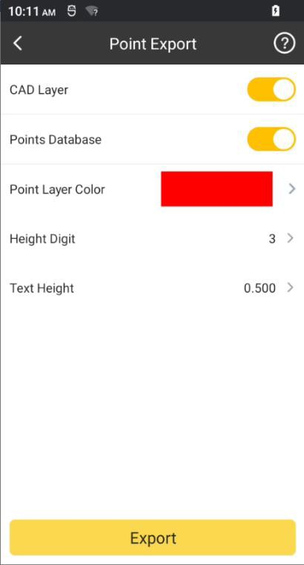 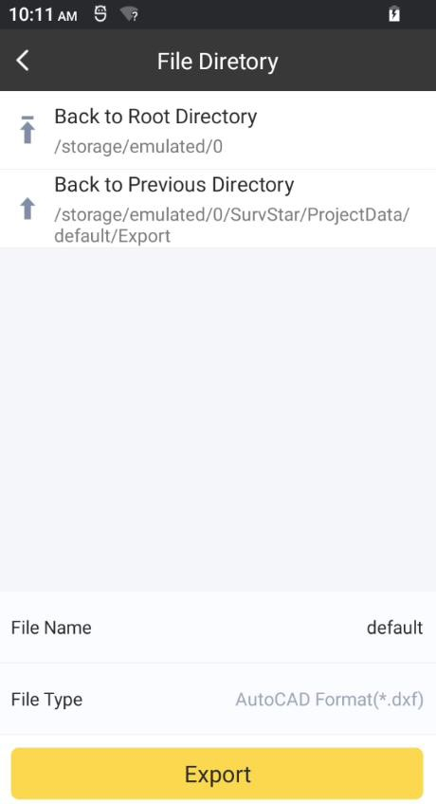

 :By tapping this drawing function ， we can plot many graph in screen

（line,polyline,polygon,square,rect,rectcenter,circle2p,circle3p,arc,spline）

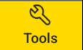:many function included(Two-circle intersection, two line intersection, element intersection, distance offset point, element offset etc.)

:delete，CAD back ground，Redraw，angle survey，distance survey，area survey， drawing unit，Explode.

 :CAD layer.

We can manage and check CAD layer by tapping this icon.

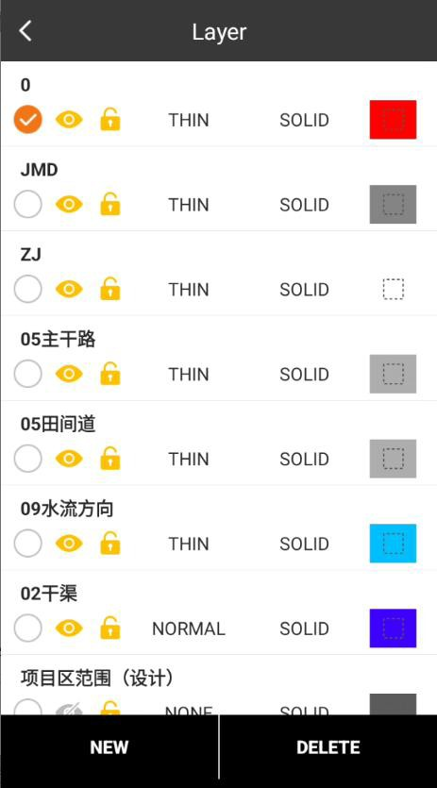

: Layer switches, controlling layer display.

: Layer freeze, cannot edit or modify after freezing. 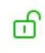 : Layer locking, cannot select after locking.

: Select target point.

By clicking this, we can select a surface feature in project. And it will be a target surface feature. The point closest to the selected feature is used as the target point.

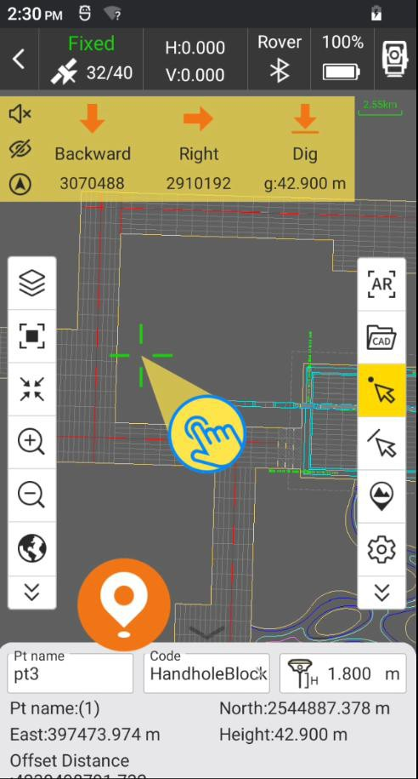

: Select target line.

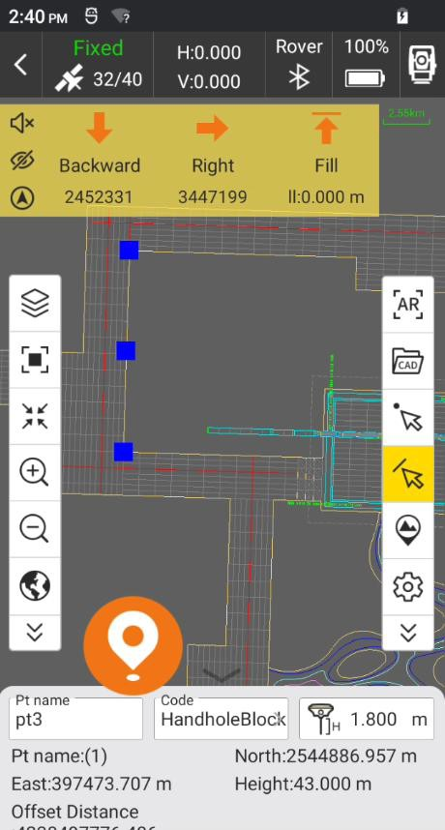

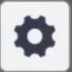: CAD stakeout settings.

It can set CAD stakeout settings, Prompt Distance; settings for Topo Point, Inform and Tool Bar are the same as that of Point Survey. Click Default settings and it can restore the changed settings.

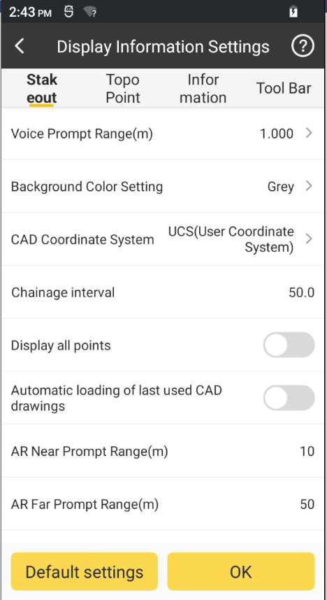

## PPK Survey

PPK (Post Processed Kinematic) is a post-processing differential technology to obtain centimeter level positioning accuracy information. Compared with RTK (Real Time Kinematic) positioning, PPK can record the data of mobile terminal and base station respectively for post-processing kinematic, so it is not limited to the communication link and protocol between base station and mobile station. It is also called Stop & Go.

1. We need to set a base station as static mode firstly. And then we start it with another device as rover mode.

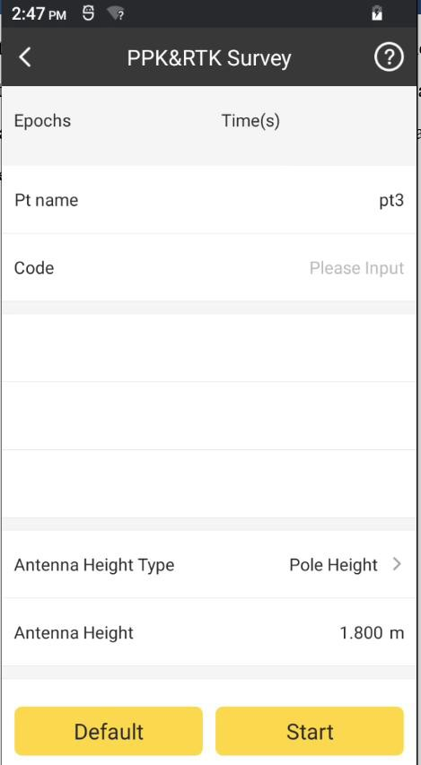

1. Set the Pt name, Code, Antenna Height Type, Antenna Height, Record Static Data On/Off, Sampling Time, Minimum Satellites and PDOP Limit. Before starting work, we need to take about 30 seconds standing to initialize the device, for the higher accuracy.



1. Put the device in the first point and click Start. It will collect this point and write the

information of this point into the record file. We can click to stop it.

Stop



1. After collecting the point, we can click to save the point and then go to the next

Save

point.

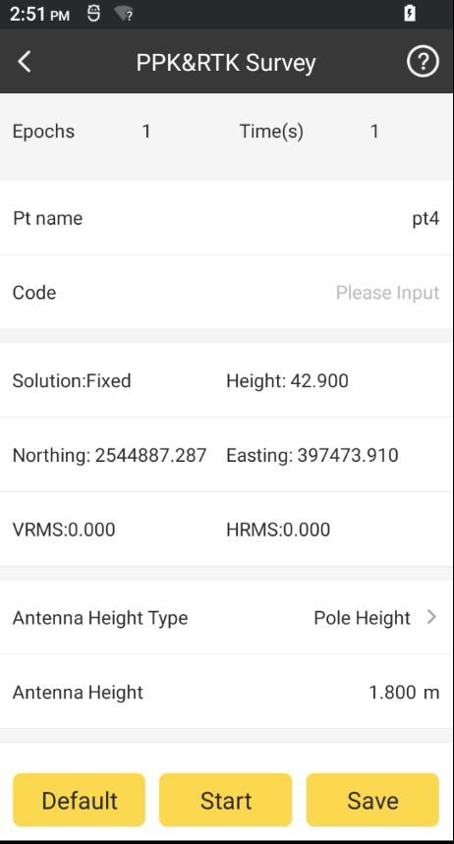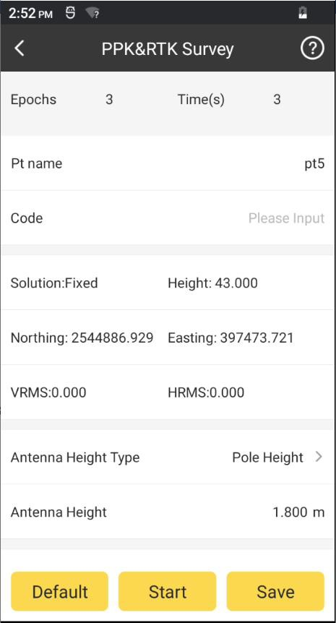

1. Repeat these steps until the project done.

## Elevation Control

Elevation control can calculate the design height of points within the range according to the design plane parameters, which is conducive to site leveling and earthwork calculation in the project.

1. Click  to open Surface manage page

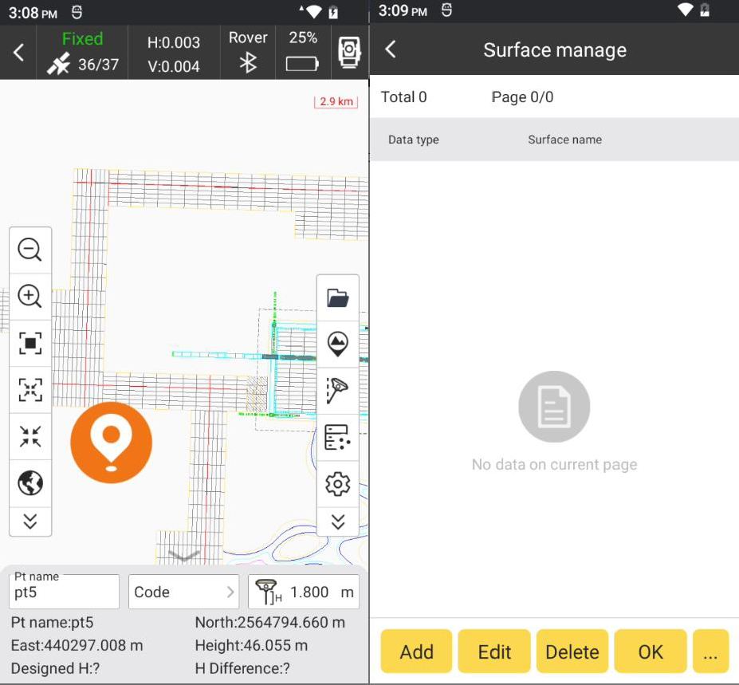

1. Add/Import Surface.

There are two ways to add/import surface. Import:

Click and click Import, select the surface file (*.es/*.sjw/*.xml) and click OK.

…

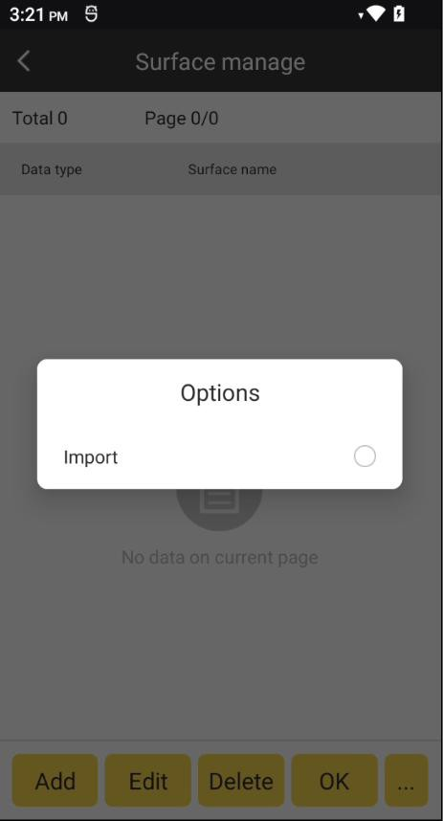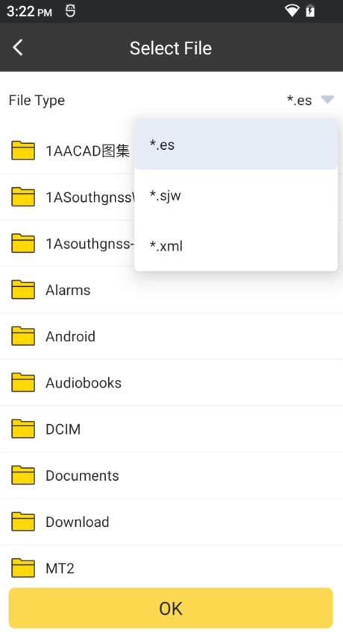

Add:

Click Add, select the Data Type to build elevation plane. We can use three ways to build it: one point with two slope, two points with one slope and Triangulation.

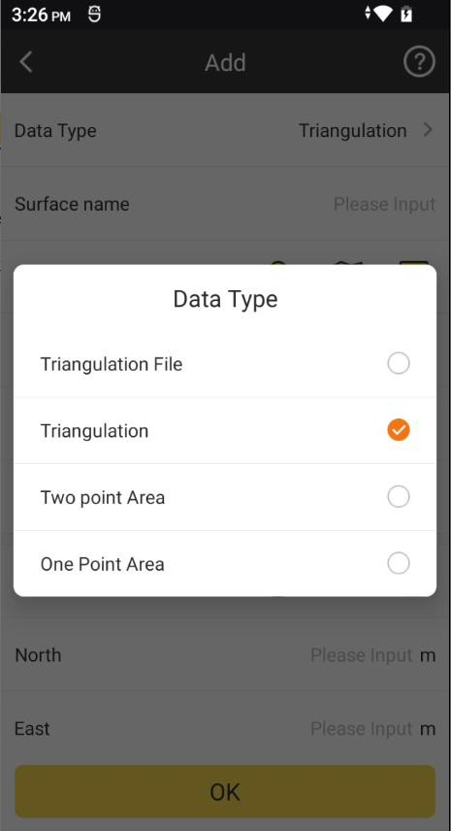

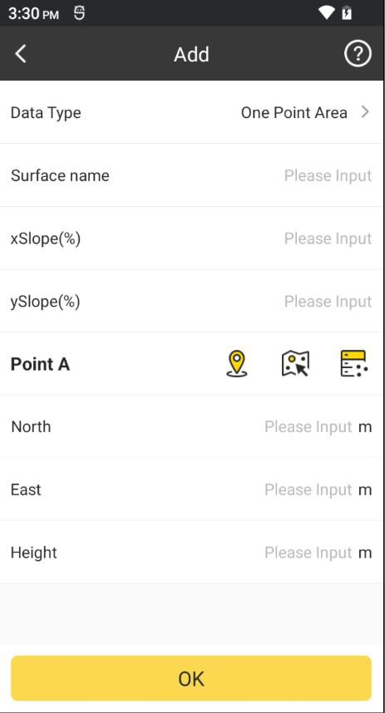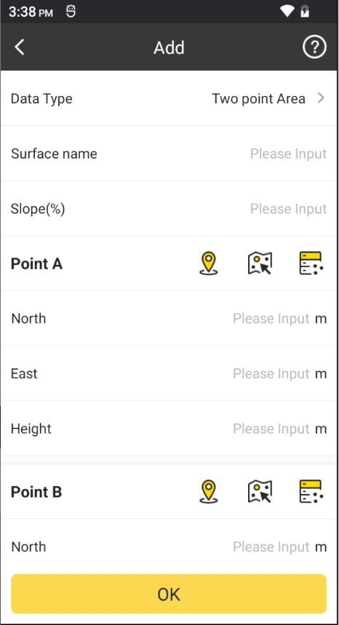

One point Two points

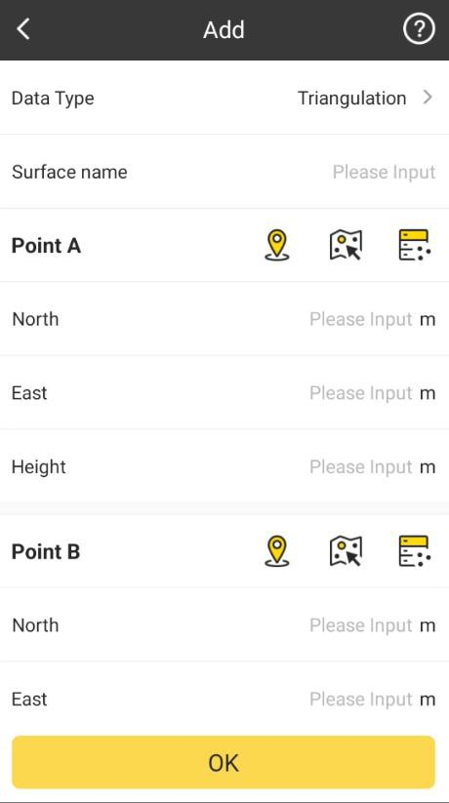

**Three points**

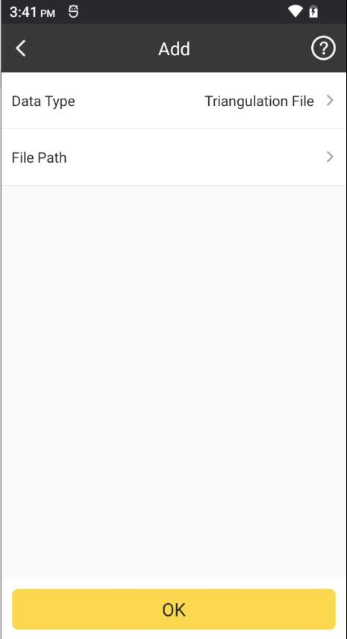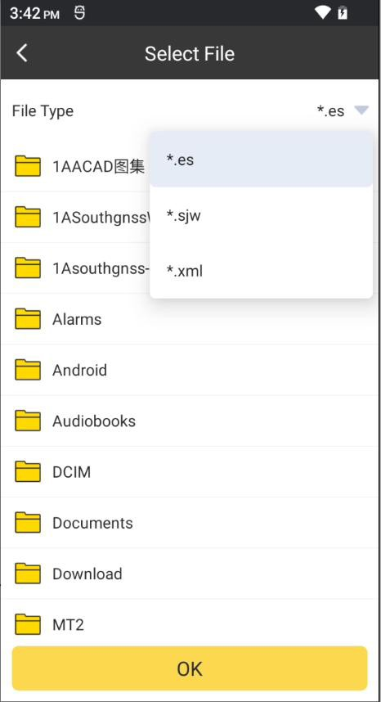

**Triangulation file**

1. Then we can select the surface and click to do the elevation control.

OK

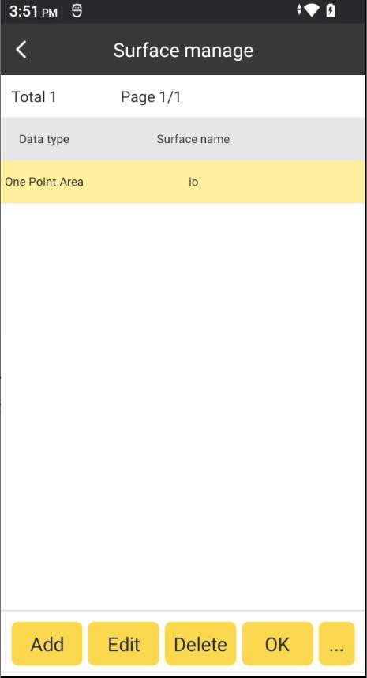

## GIS Survey

GIS survey can define the required feature attribute database and collect shape data containing various required feature attributes, which is convenient for post-processing of GIS data in the later stage.

1. For the new project, we need to import or input a feature manage database. Click 

and enter to feature manager page. We can also click the layer bar to enter to it.

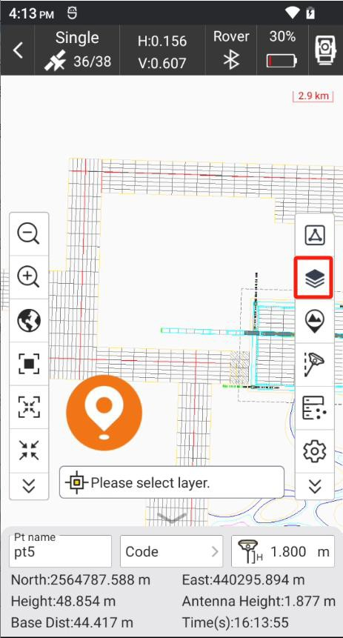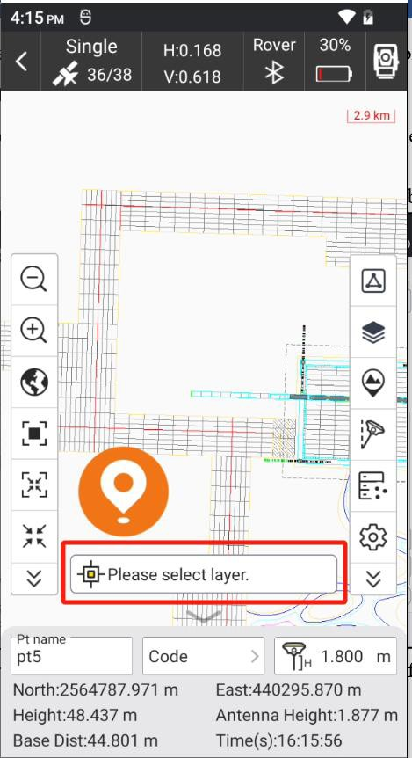

1. In feature manager, we can add, edit, delete, import and export the features.

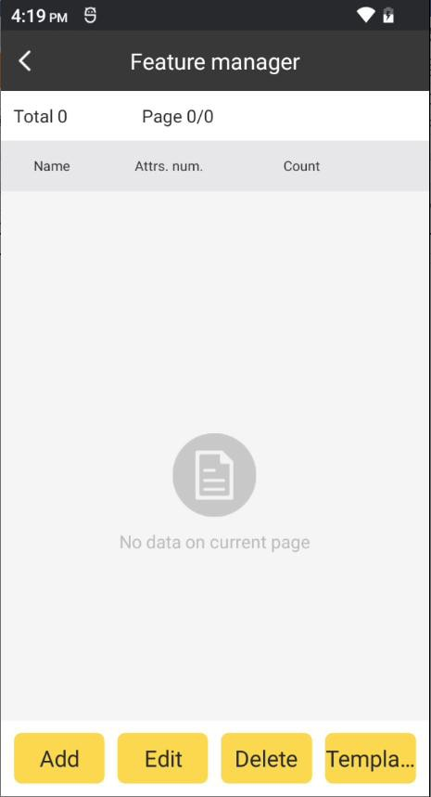

Add:

Click Add, input the feature name and nick name, choose the feature type (Point/PolyLine/Polygon) and set the feature style, then click OK.

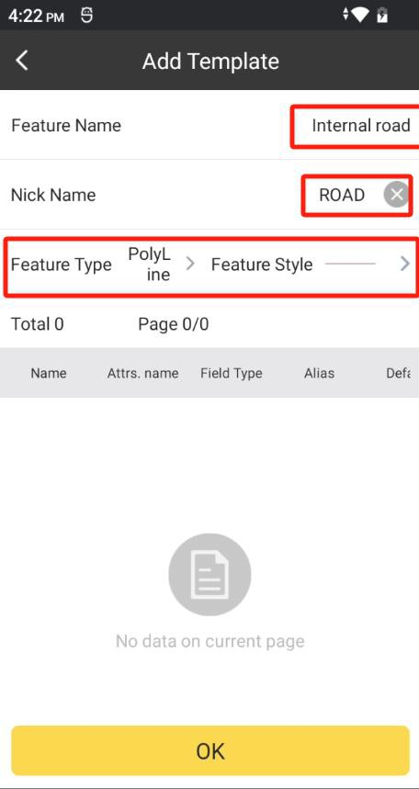 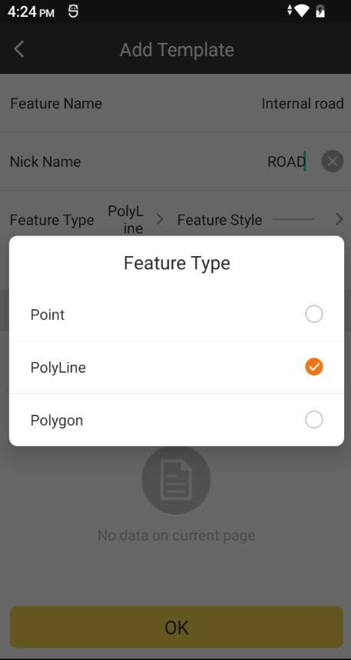

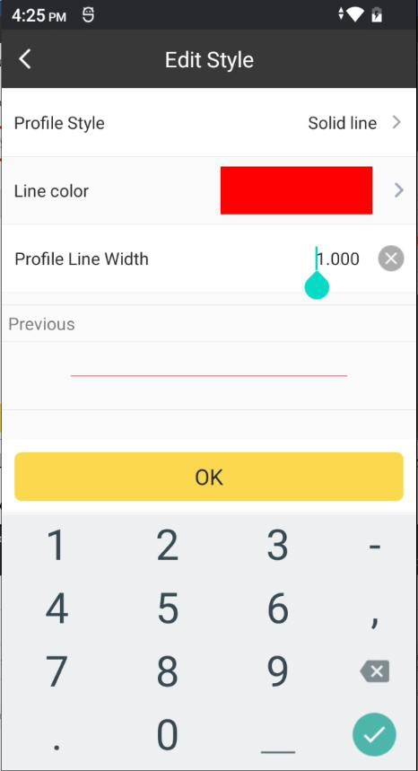

Then we need to add the attribute of it, click Add. Input the Attributes Name, Nick name,

Field Type and click OK. If the input of the attributes finished, click OK.

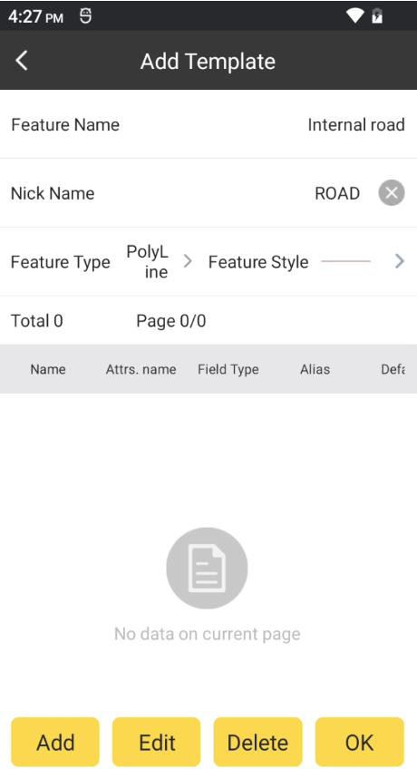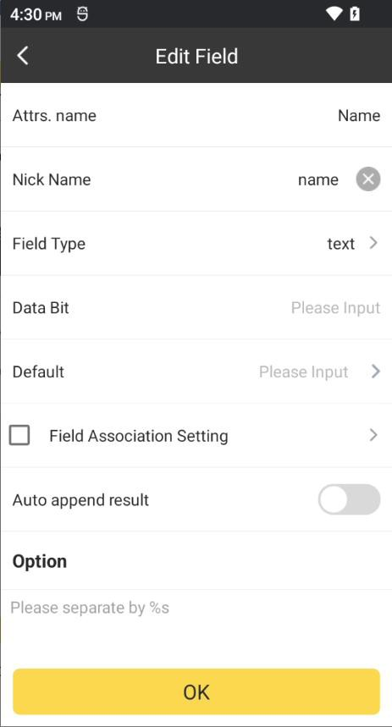

**Edit:** Select any feature, click Edit, then we can edit it.

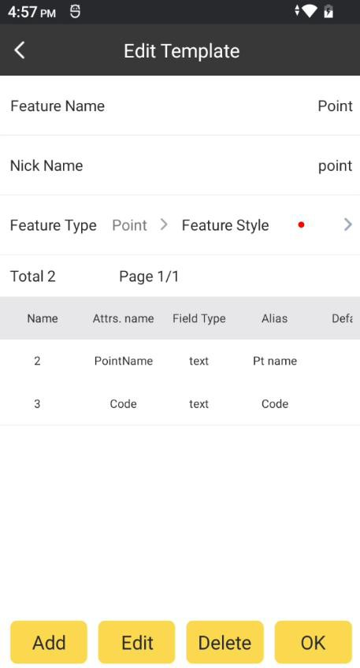

**Delete:** Select any feature, click Delete, then we can delete it.

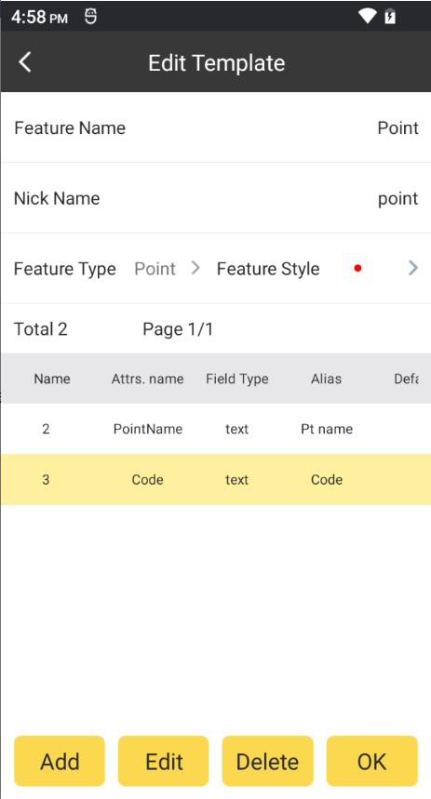

Default Template:

Click and click Default Template, there will load the default template to it. It has

Template

three features: Point, Line and Polygon.

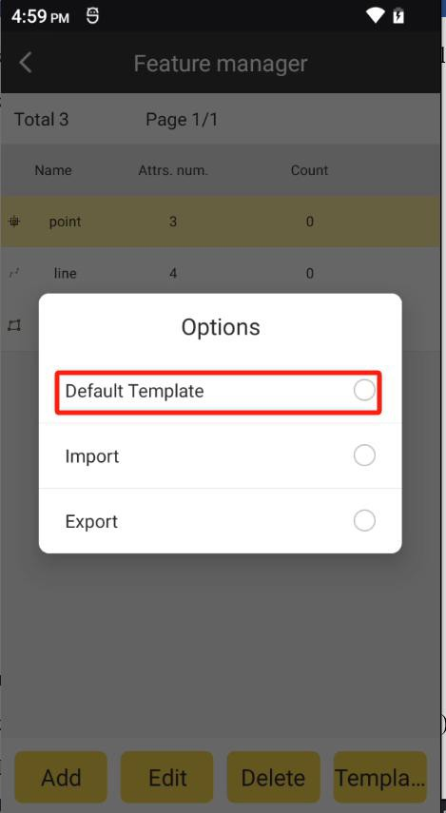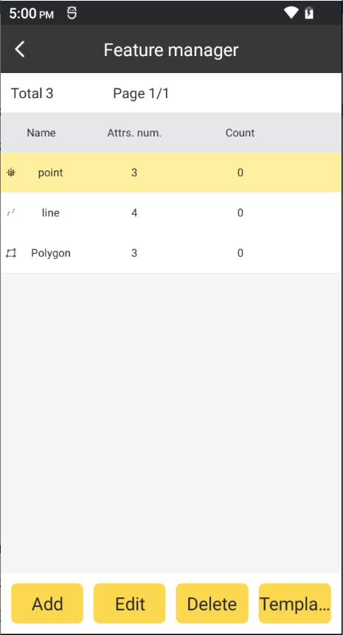

Import/Export Template:

Click

Template

and click

/ , select the template file(*.db)/select the export

path and click OK. The template file will be imported or exported.

|  |  |  |
| --- | --- | --- |
| Import |  | Export |

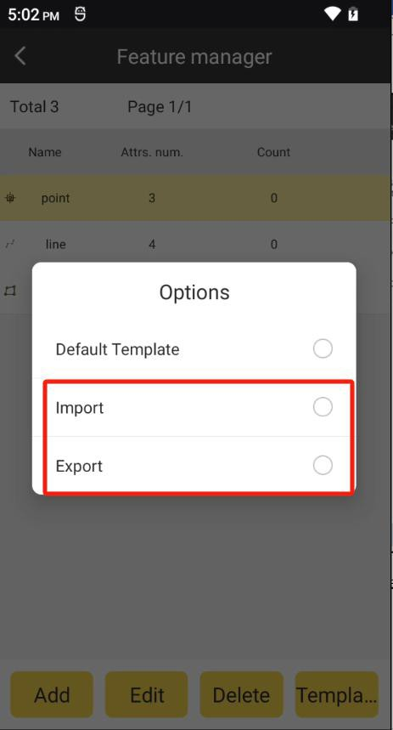

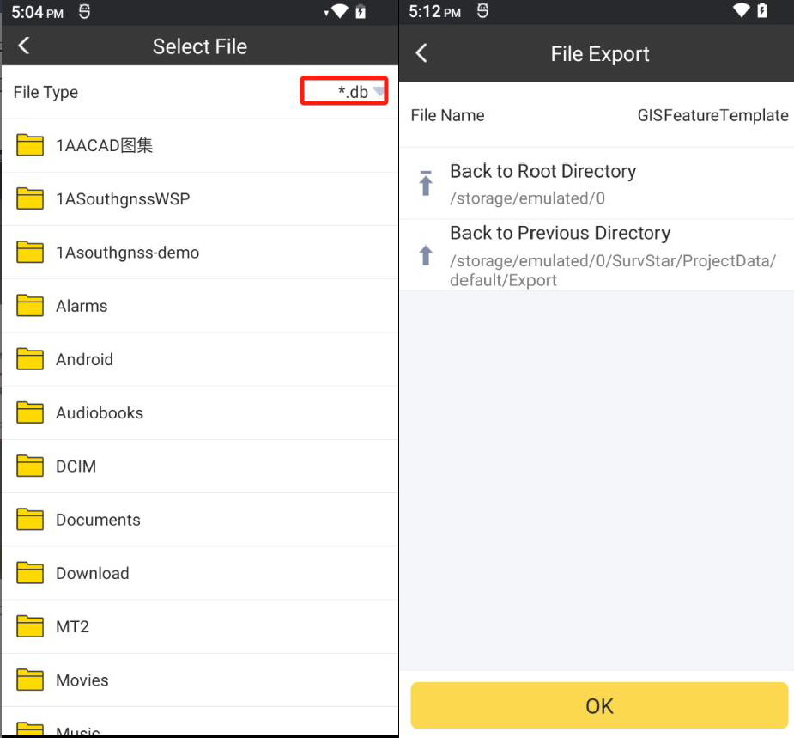

1. After the feature manager completed, we can use it by clicking the below layer bar. Select the feature and then we can start GIS survey.

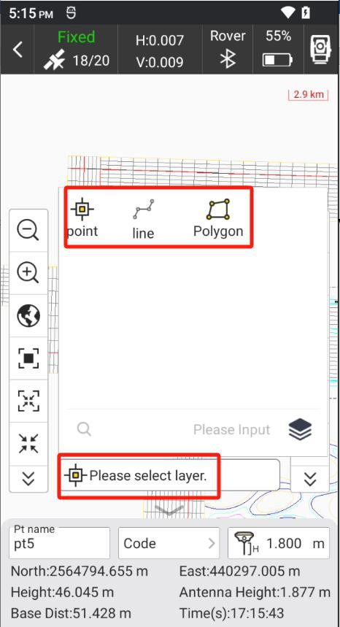

1. And then we can select a layer start to do GIS survey.

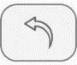: Click this, it will go back to the previous operation

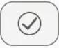: Click this, we can edit the attributes of current feature.

: Click this, we can finish surveying this feature.

1. We can check and manage the shape in Geometry Database. Click  and enter to Geometry Database. In Geometry Database, it can import/export shape file(*.shp), delete

and continue to survey the feature.

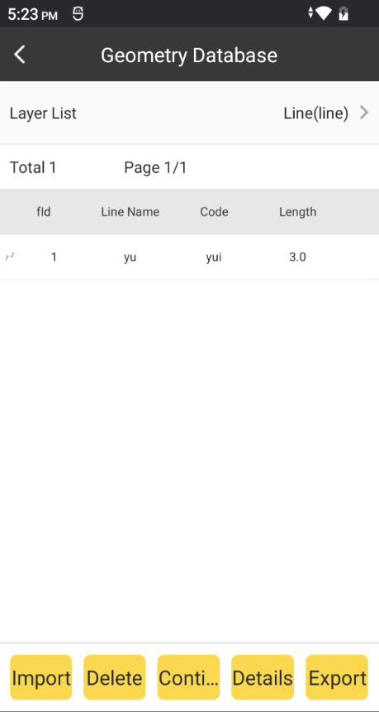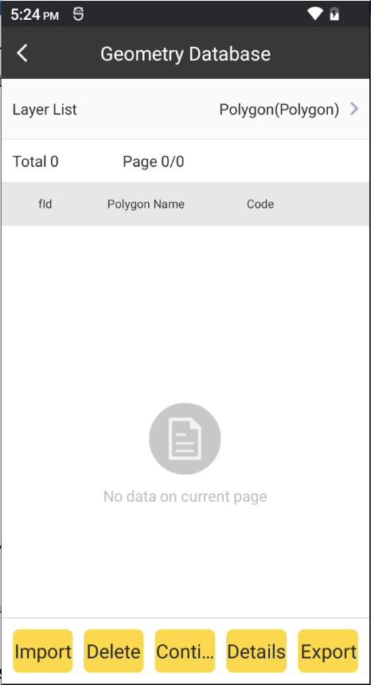

## Sea Survey

This function is being improved and tested.

## Line Construction Stakeout

This function is being improved and tested.

## Line Pointwise Stakeout

This function is being improved and tested.

## Cross-section Survey

This function is being improved and tested.

## Cross-section Stakeout

This function is being improved and tested.

# Chapter 7 Survey – Total Station

## Point

Click Survey->Point Survey to enter this interface.

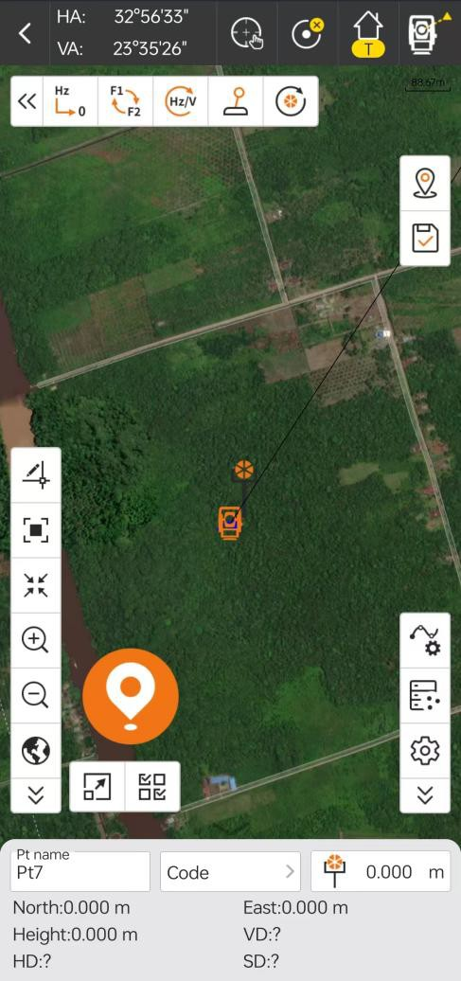

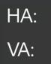: Displays information about the current angle of the device.

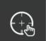: APR( Automatic Prism Recognition) and Track (Prism tracking) On/ Off.

: Selection of different measurement targets, measurement modes and whether the laser pointer is switched on or off.

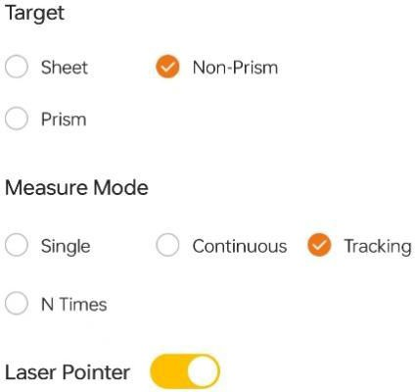

## Point Stakeout

Point stakeout is the process of inputting target coordinate in software and stakeout in field. By clicking this, we will enter to points database. Select any point, and click OK. Then we will enter to the point stakeout page.

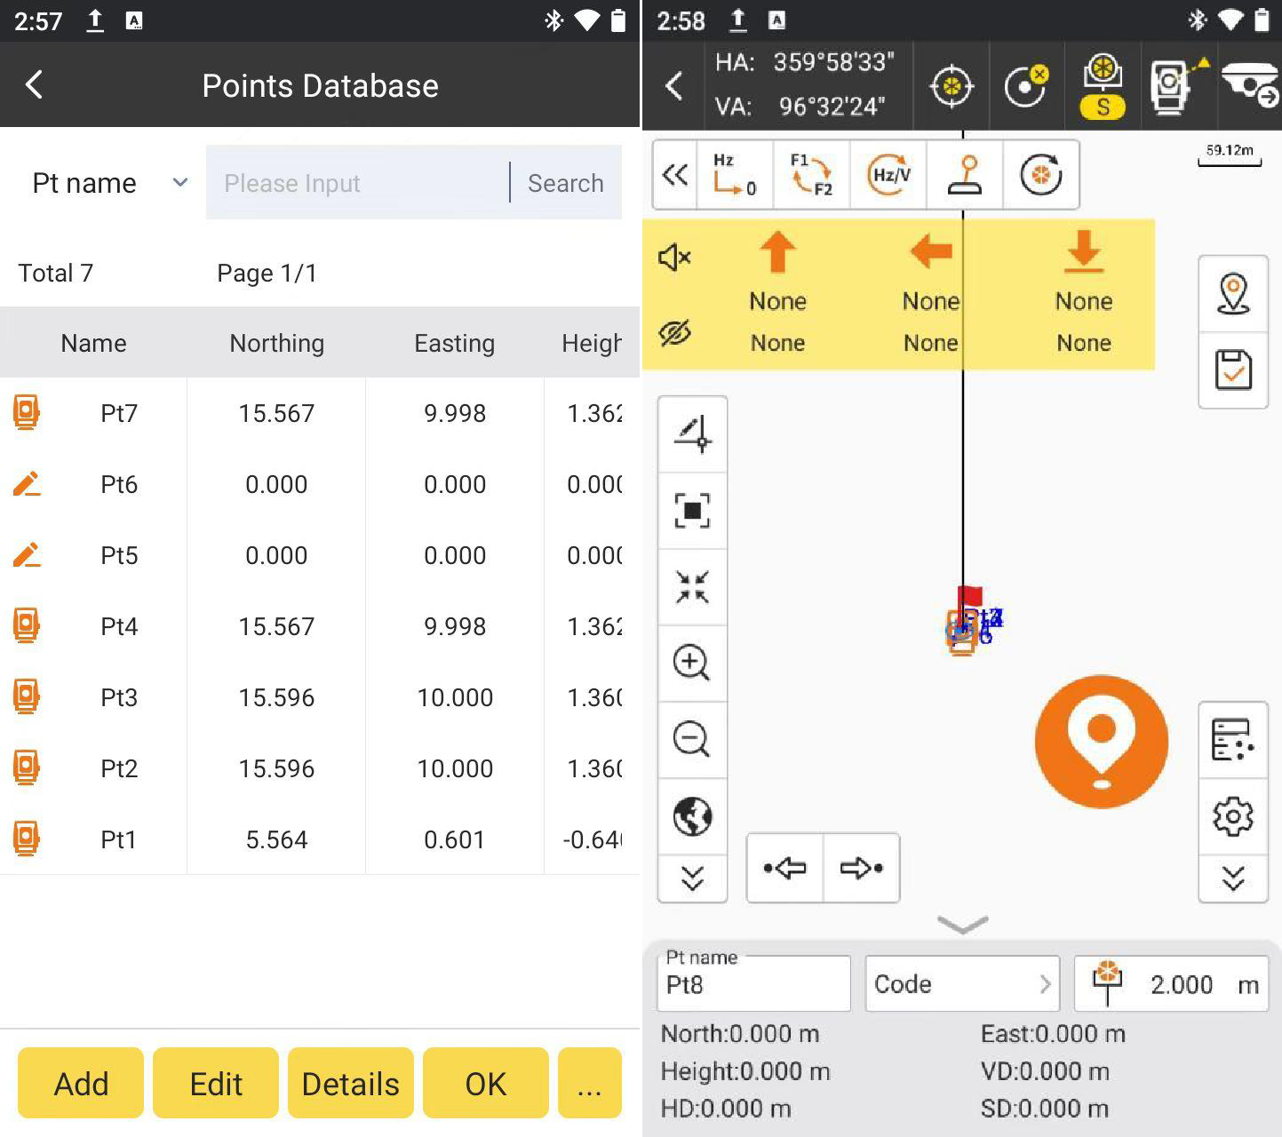

#### Arrows in left bar describe as follows:

To Forward/Backward: distance that receiver needs to move Forward/Backward from current position to stakeout point. To Forward arrow shows up and to Backward arrow shows down.

To Left/Right: distance that receiver needs to move Left / Right from current position to stakeout point. To Left arrow shows left and to Right arrow shows right. Fill/Dig: dig in stakeout point position. If the value is positive, perform excavation; if not, perform fill. If current height is higher than stakeout point arrow shows down. If current height is higher than stakeout point arrow shows up. ：open/close stakeout voice prompt.

：hide or show left arrow bar.

#### Point stakeout steps:

1. Select a point to stakeout in the points database, then click

to enter points

OK

stakeout page. Red flag is target stake point. Circle is current position of receiver. Arrow is direction indicator, indicating the direction of current receiver. When the arrow direction is same with the direction to the target point, please move in this direction, then you can reach the target point.

1. According to left status bar, move from the current point to the stakeout point, and excavate or fill the soil according to the height difference of the elevation.
2. When current point is within prompt range, there will be three concentric circles, which indicate it enters precise stakeout.
3. After you reach the stakeout point, please stake it.

## Line Stakeout

Line stakeout is the stakeout of designed line, including line mileage, left and right offset and elevation control within line. By clicking this, we will enter to Line List. Click Add, we can add the designed line with Line Name, the Start Point, End Point and Start Chainage. We can also import line file(*.SL).

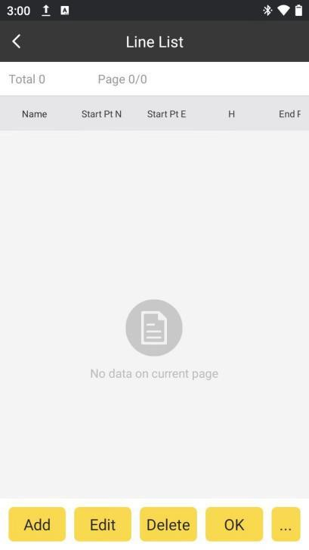 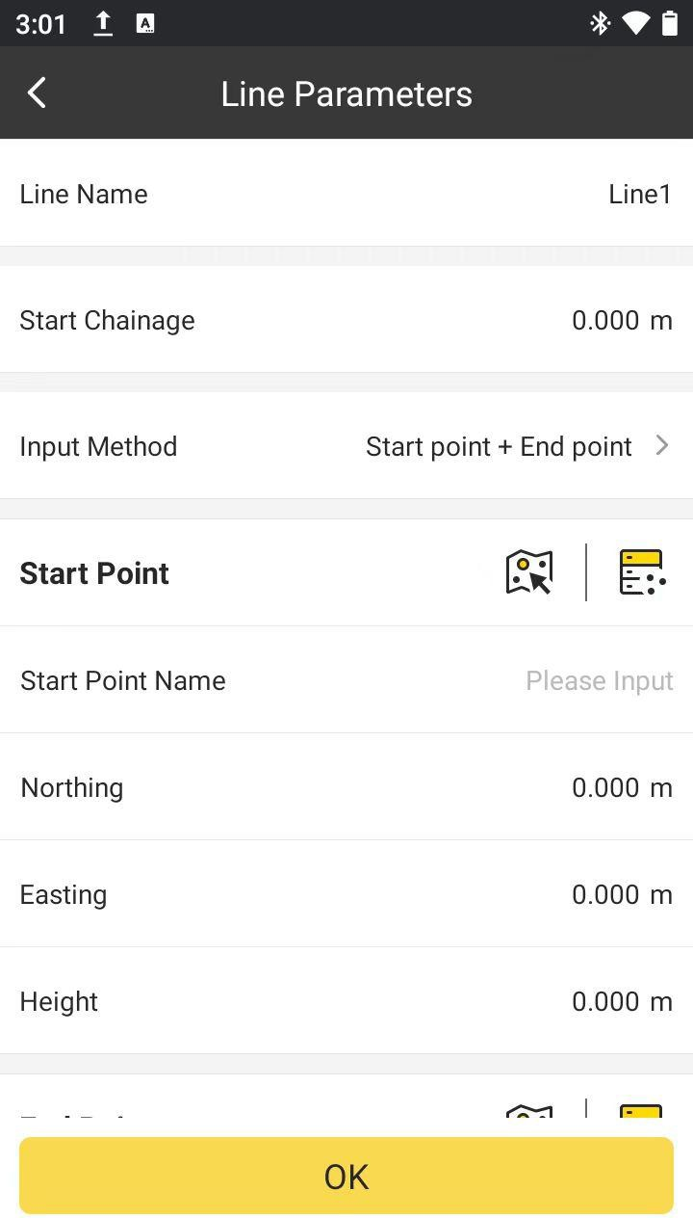

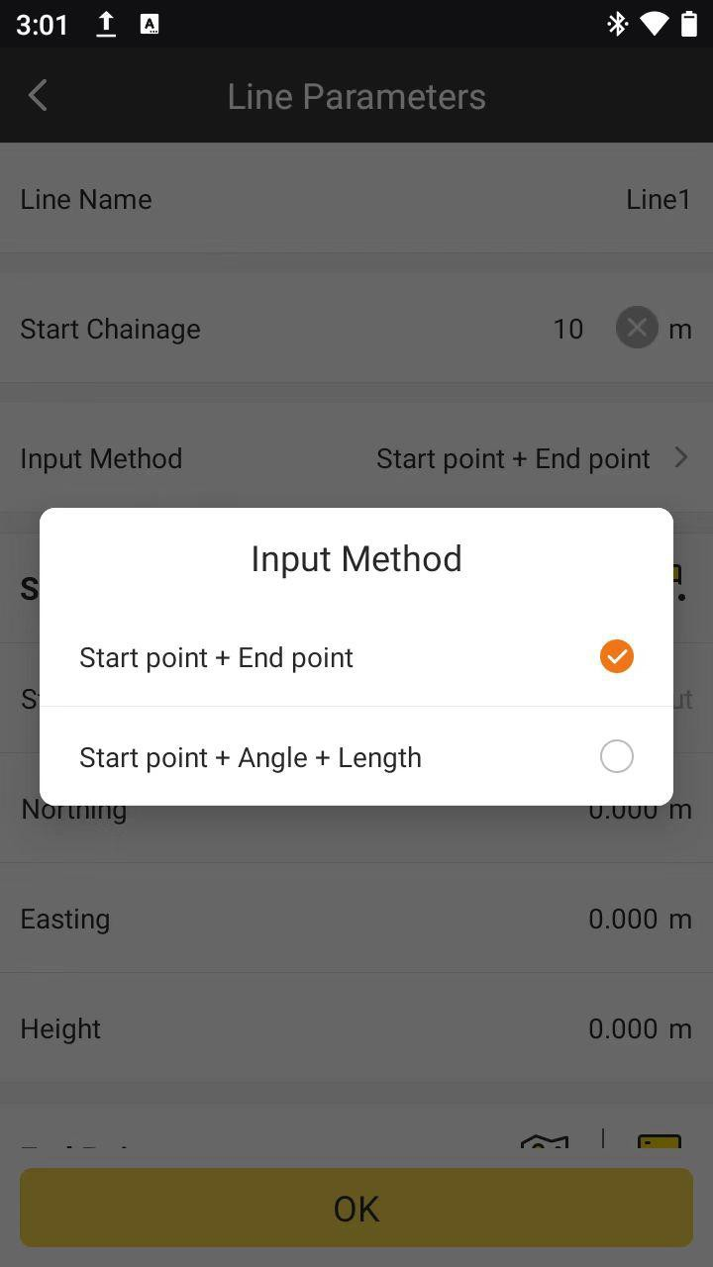

Select any line, and click OK. We can set the settings of stake, it including Chain Pile Stake On/Off, Auto Stake Nearest Point On/Off, Mileage, Range, Calculating Method and Stake interval. Click OK.

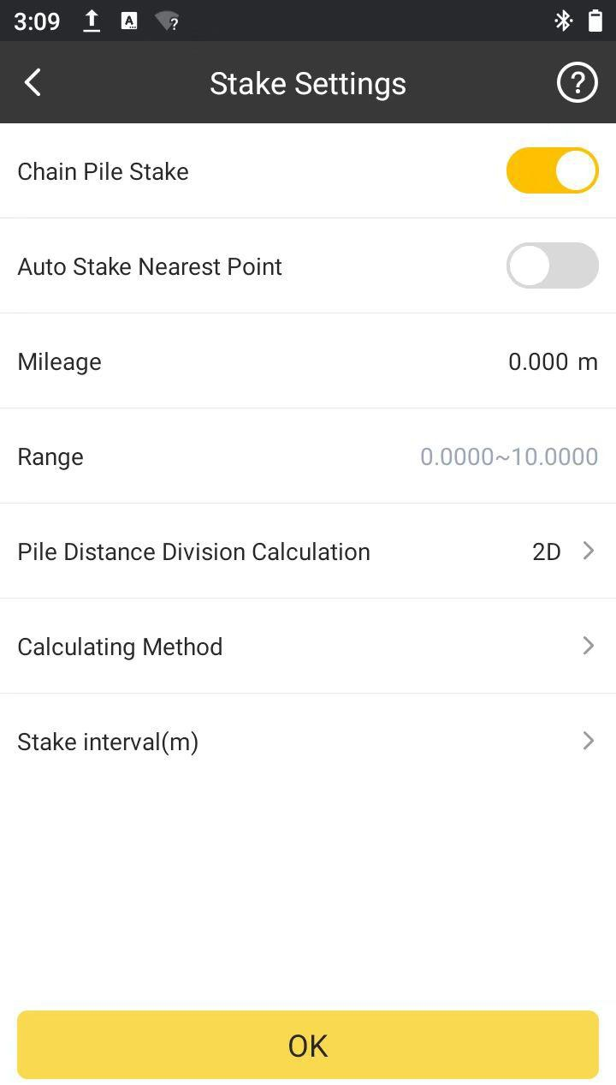

Then we will enter to the line stakeout page.

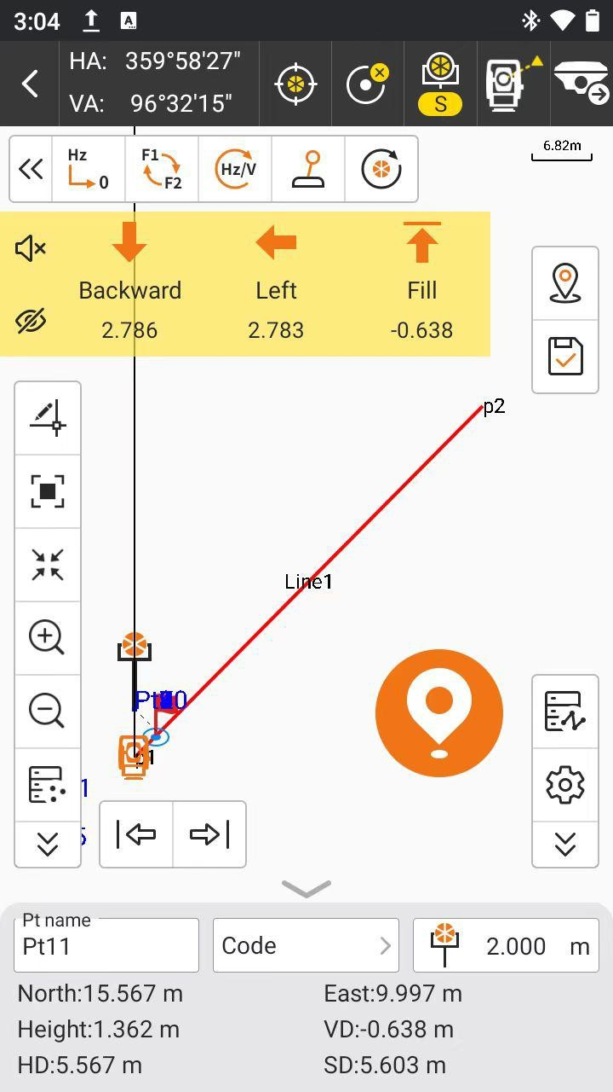

It can set line stakeout settings, including Prompt Distance, Reference Direction (Forward, North); settings for Topo Point, Inform and Tool Bar are the same as that

of Point Survey. Click and it can restore the changed settings.

Default settings

## CAD Stakeout

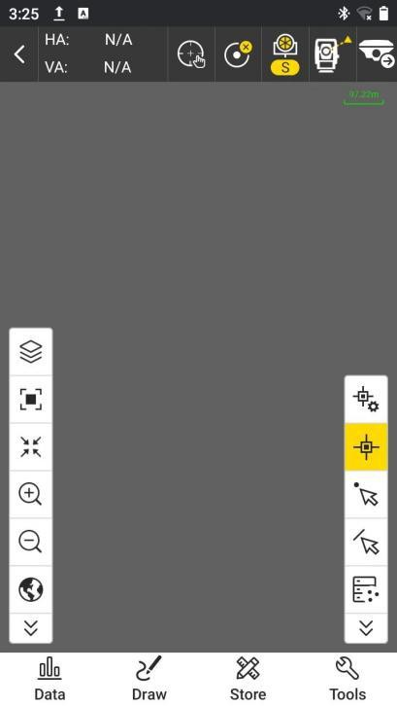CAD is mainly used to stakeout lines in the existing CAD graphics. By clicking this, we can enter to the CAD page.

#### ：CAD Layer.

We can manage and check the CAD layer by clicking this icon

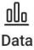 ：Import CAD file(*.dxf/*.dwg).

：By clicking this, there will be an arrow when touch and hold to move on the screen. The place indicated by the arrow is the place of the target point. It can also

show the coordinates of this point in the top of the page.

# Chapter 8 Tools

## Localization

In general, GPS receiver output data is WGS-84 latitude and longitude coordinates. The coordinates need to be converted to the construction measure coordinates, which requires software to calculate and configure coordinate conversion parameters. Localization is the main tool to complete this conversion.

It contains Add, Edit, Delete, Calculate, Import, Export and Settings operation.

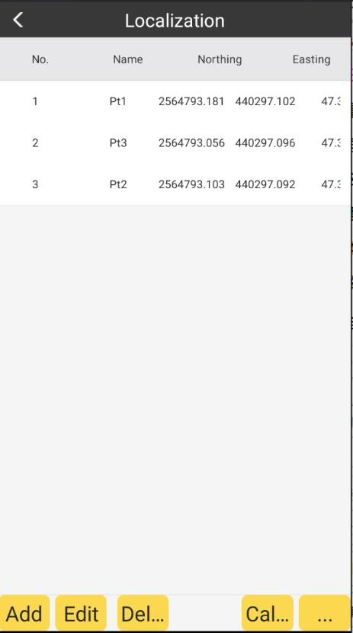

Add:

Click Add, we can add the coordinate point. If we have the surveyed point in database, we

can click the icon in the right of the Known(local) coordinates bar. And select the coordinate transformation points with the targeted coordinate. Click OK. Then the NEH

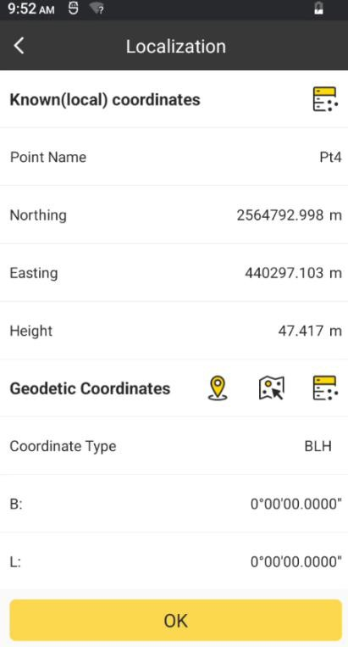will input automatically.

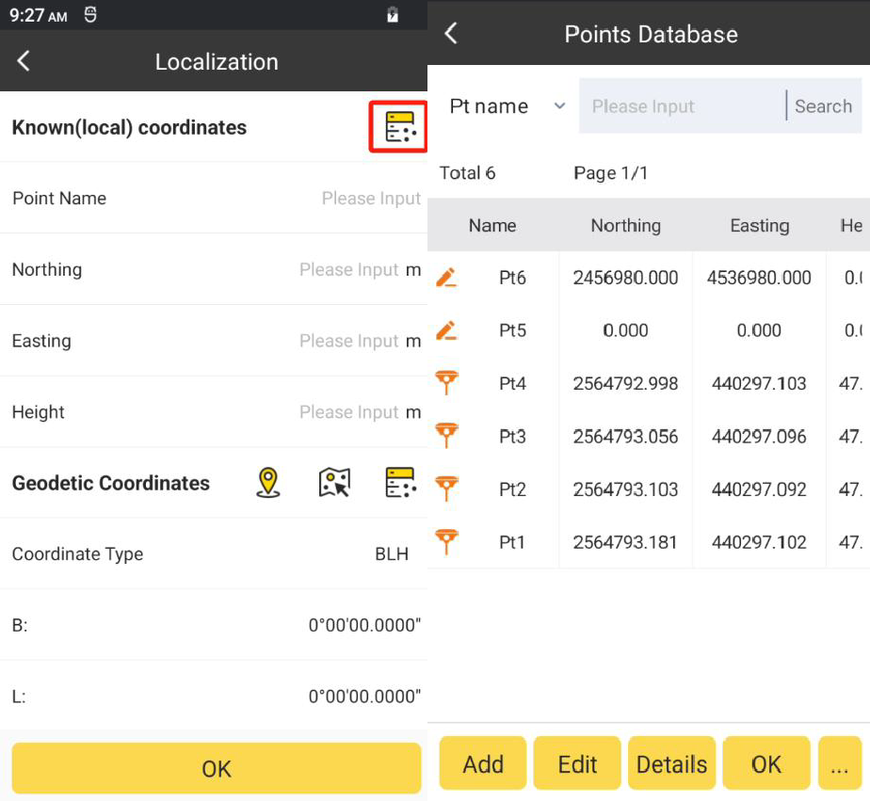

Or we can input the coordinate directly.

And then we need to input the same point’s BLH to it. If we If we have the surveyed BLH in point database, we can click the icon in the right of the Geodetic Coordinates bar. And select the same points with the BLH. Click OK. Then the BLH will input automatically.

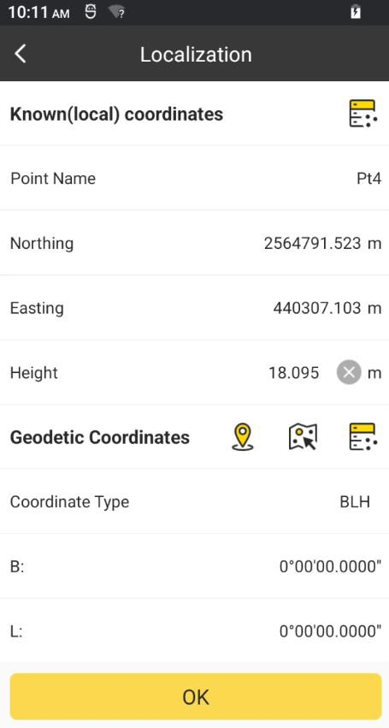 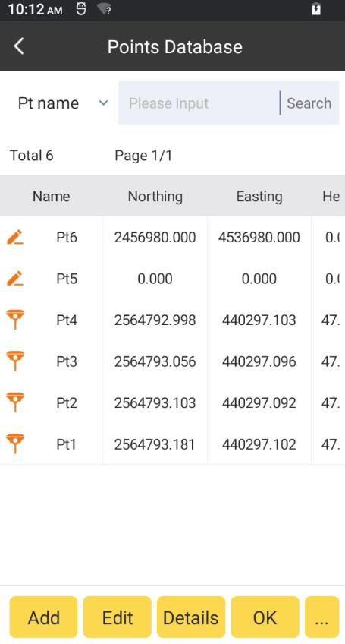

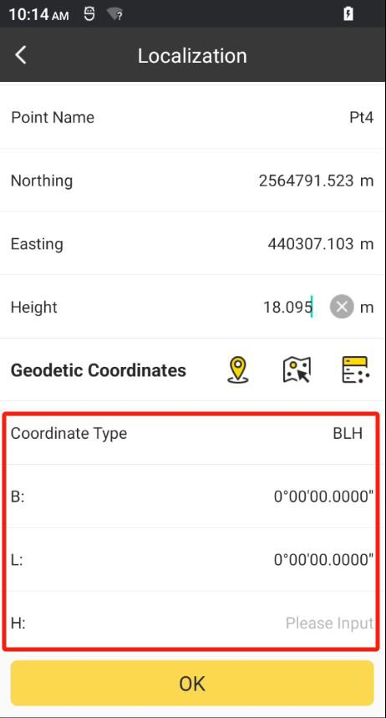

We can also input BLH directly.

We can also put the device in the point and collect the BLH in site. Click the icon in the

right of the Geodetic Coordinates bar. And click to collect it.

OK

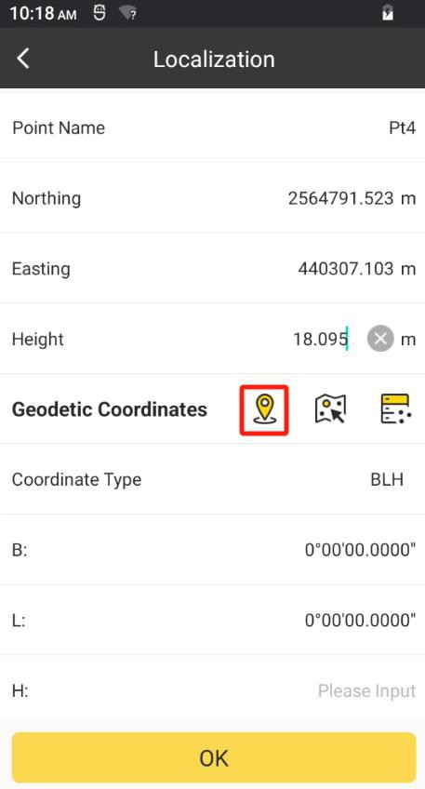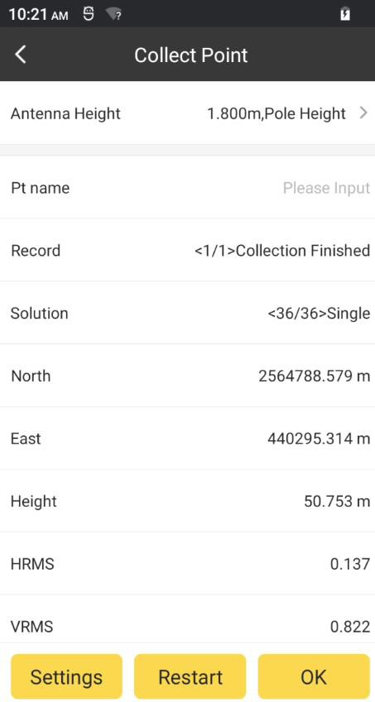

Then we need to select whether to use the point with horizontal control or vertical control. And Click OK. This point will participate in calculation.

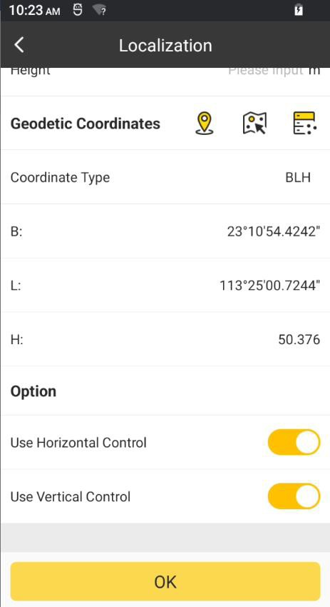 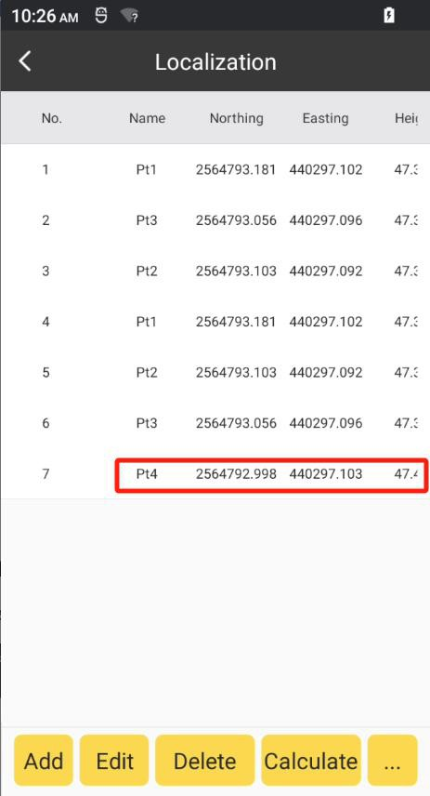

Edit:

Select any point and click Edit. We can edit the coordinate of the selected point and select whether to use the point with horizontal control or vertical control.

Delete:

Select any point and click Delete. We can delete the selected point.

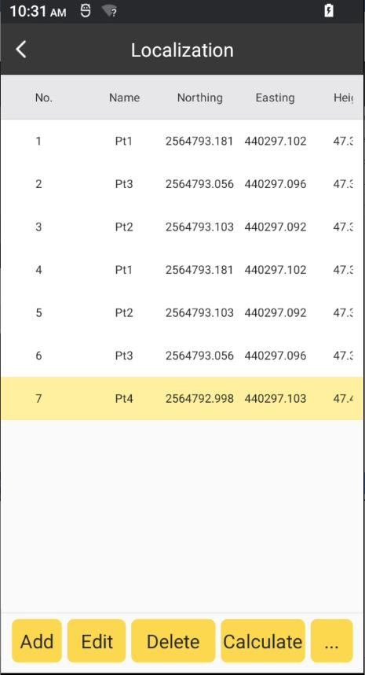

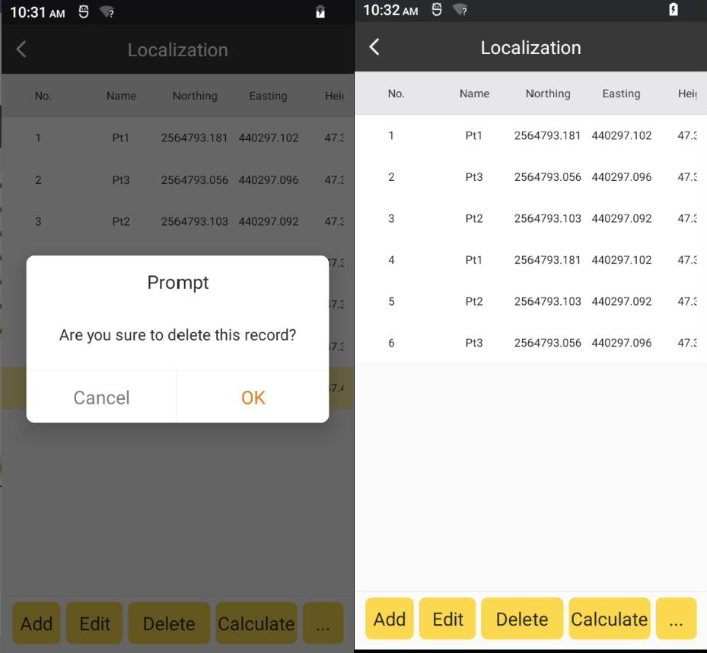

Calculate:

After the coordinate transformation points all inputted. We can click Calculate. Then there

will show a coordinates System report. We can save the report by clicking Save. And click Apply, the parameters will apply to the current project.

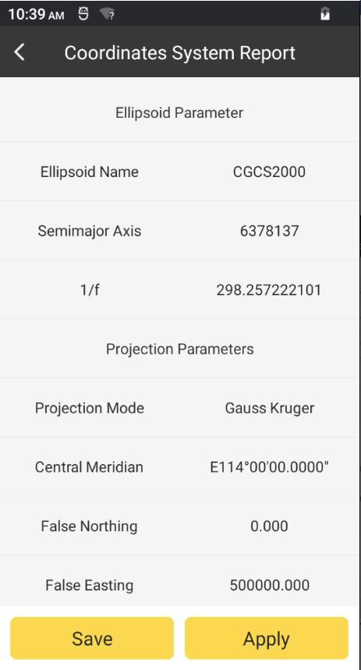

Import:

Click and Click Import. Select the file type: *.cot(dd.mmssss), *.cot(dd.dddddd) and

…

*.loc. Select file path and click the file. Click OK.

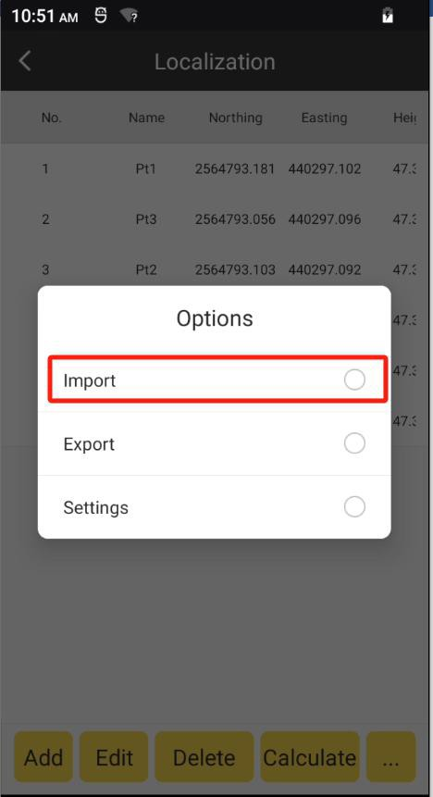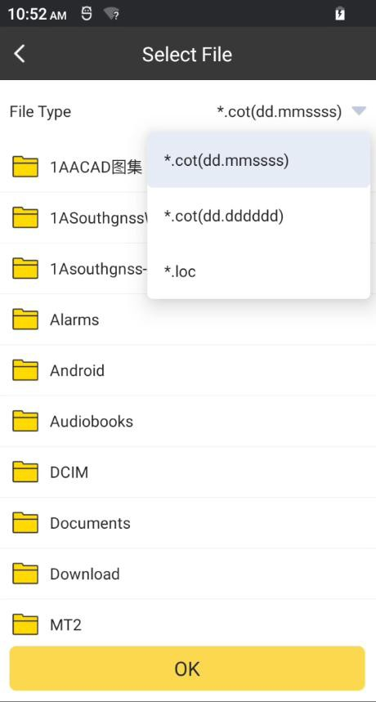

Export:

Click and Click Export. Select the file type: *.cot(dd.mmssss). Select file path and click

…

the file. Click Export.

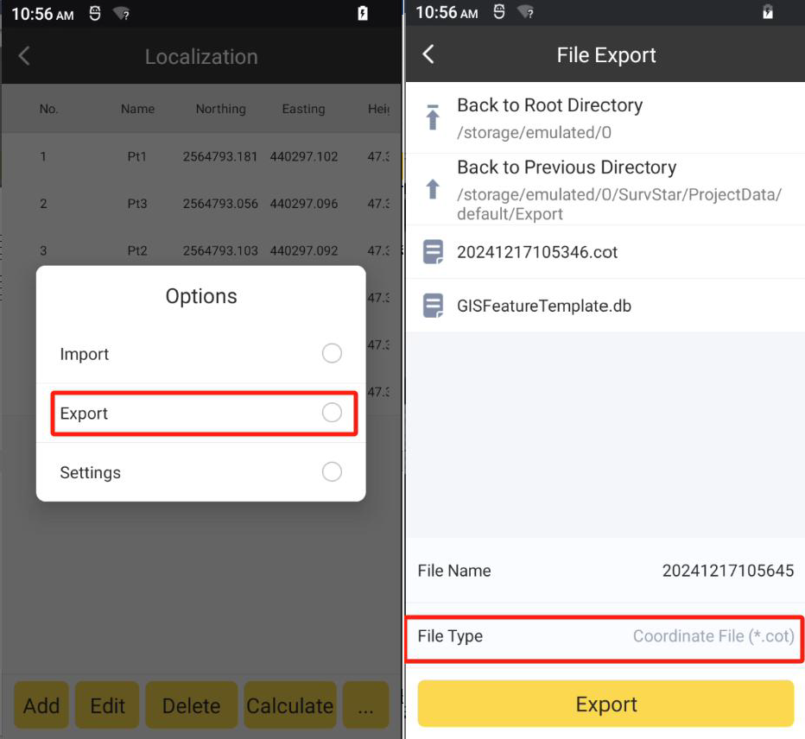

Settings:

Click and Click Settings. We can set localization method, height fitting method,

…

horizontal control accuracy limit and vertical control accuracy limit.

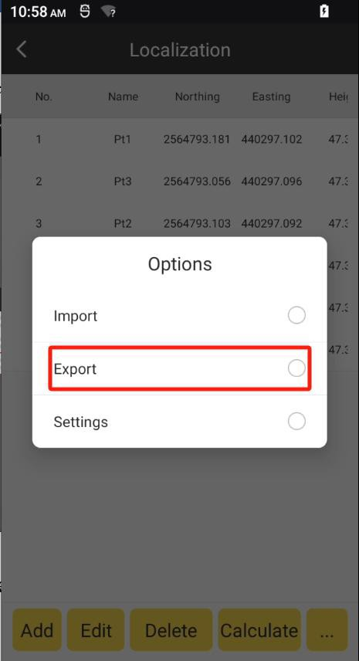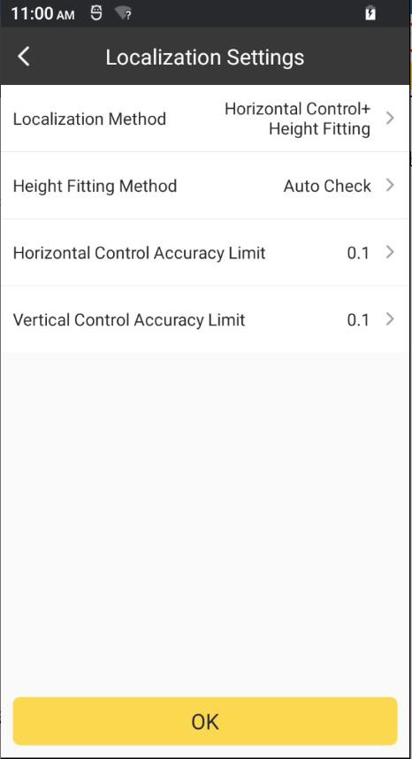

## Coordinate Converter

By clicking this, we can convert coordinate from BLH to NEH or from NEH to BLH in the current project parameters. We need to select the Conversion Type firstly.

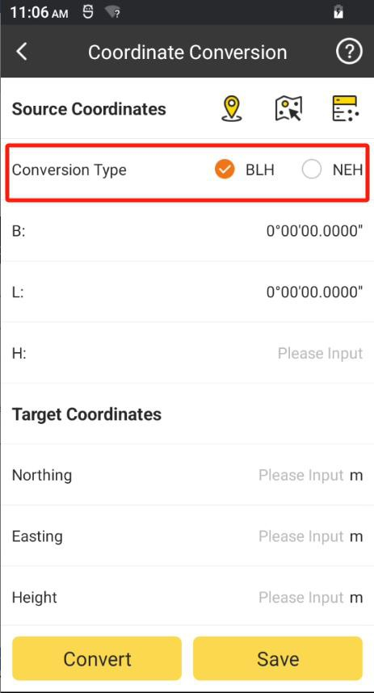 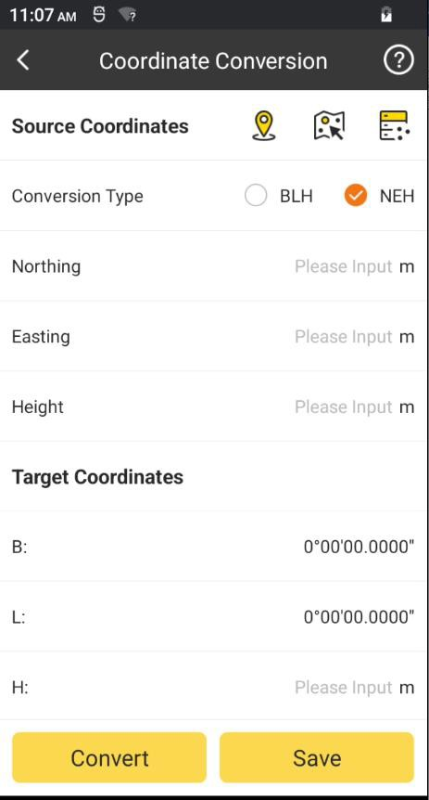

We can input coordinate directly.

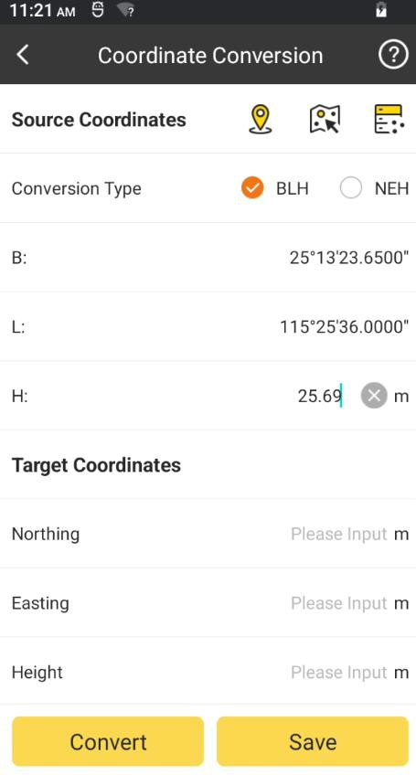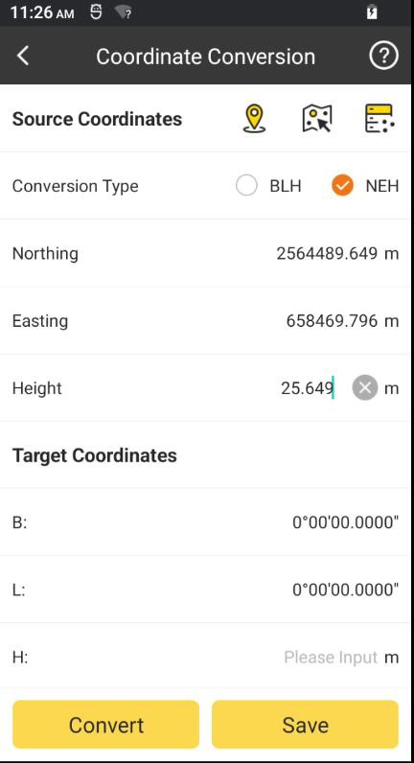

If we have the surveyed point in database, we can click the icon in the right of the Source

Coordinates bar. And select a point. Click OK. Then the BLH or NEH will input automatically.

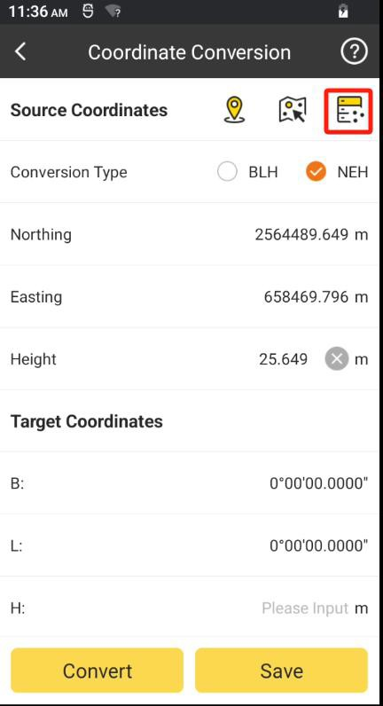

We can also put the device in the point and collect the coordinate in site. Click the icon in

the right of the Source Coordinates bar. And click to collect it.

OK

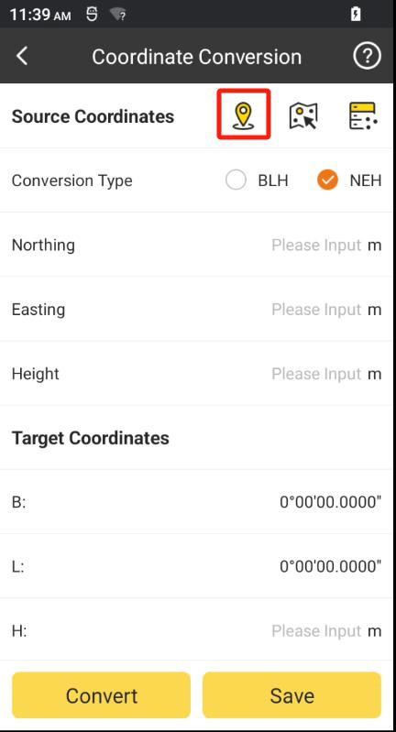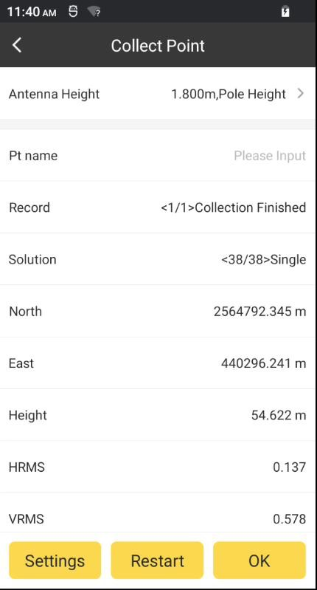

Click and the target coordinates will be calculated and shown in the below bars.

Convert

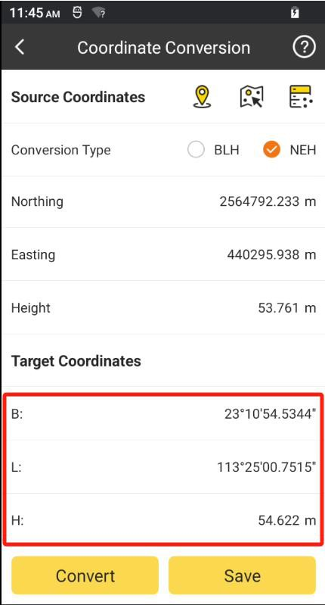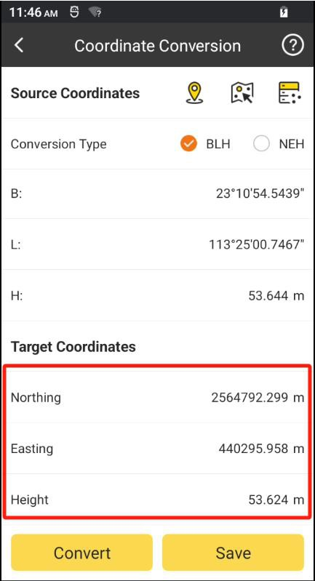

We can click to add the calculated coordinate to the point database.

Save

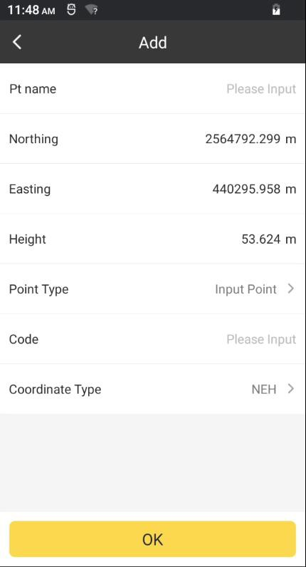

## Angle Converter

We can convert the angle format in this function. Select the input format and input the angle.

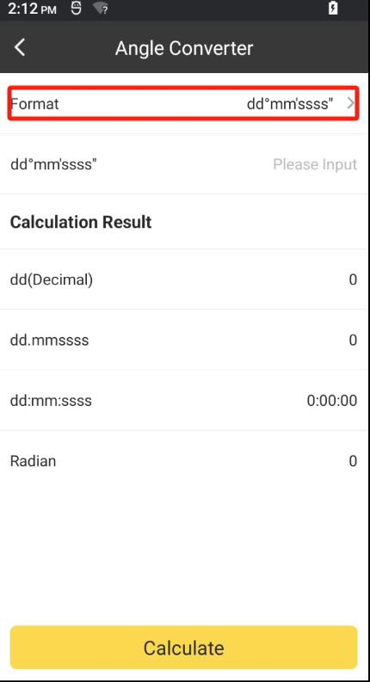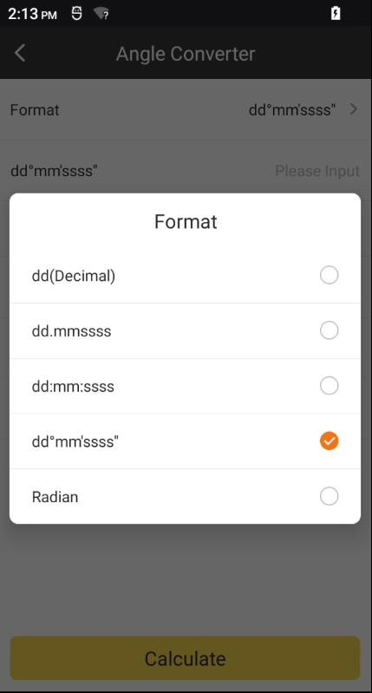

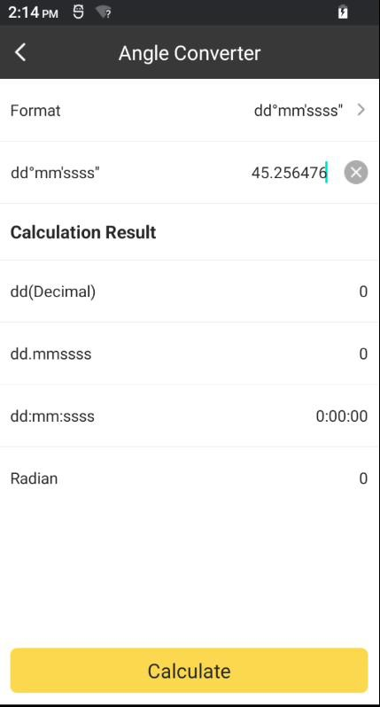

Click Calculate. Then it will be converted to other formats.

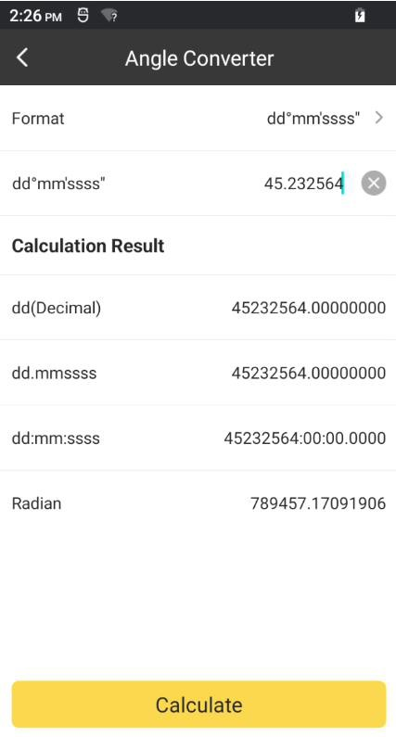

6-4 Perimeter and Area

We can use the coordinate of the points to calculate the perimeter and area. Click Add. We

can input the point directly.

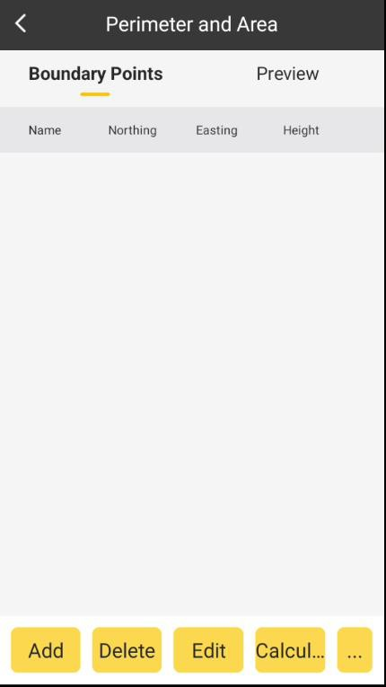

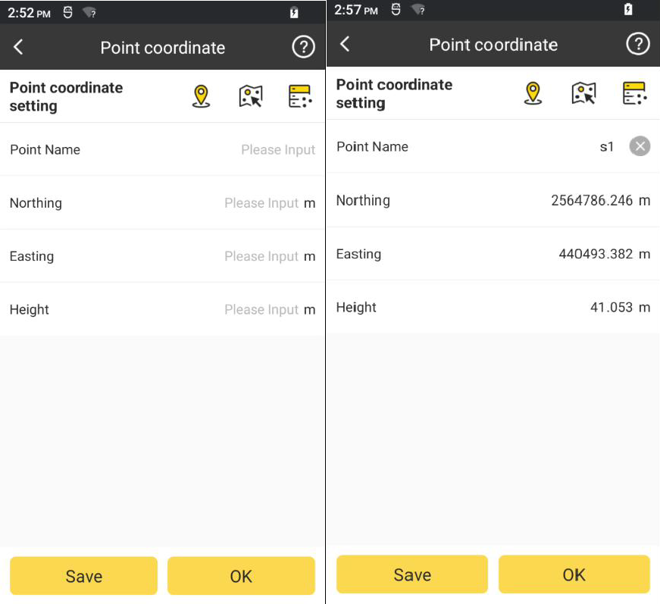

If we have the surveyed point in database, we can click the icon in the right of the Point coordinate setting bar. And select a point. Click OK. Then the NEH will input automatically.

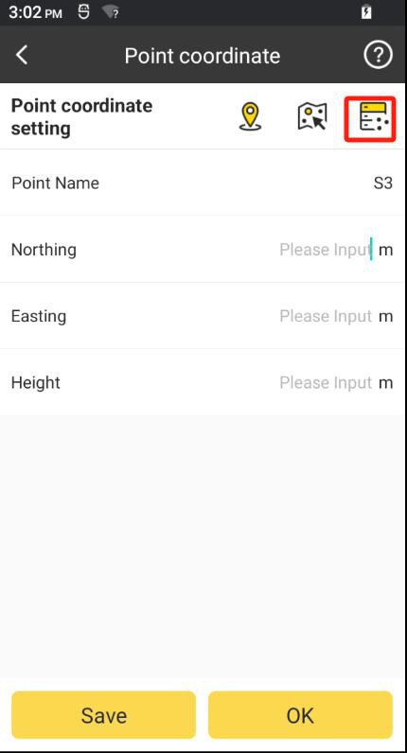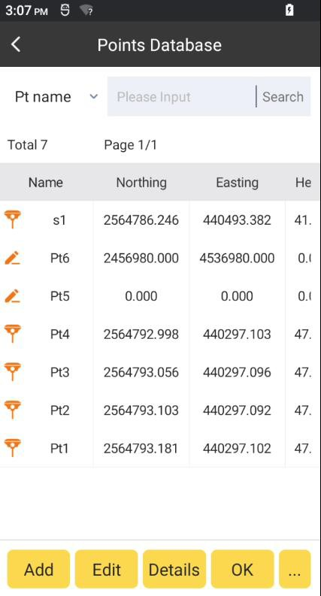

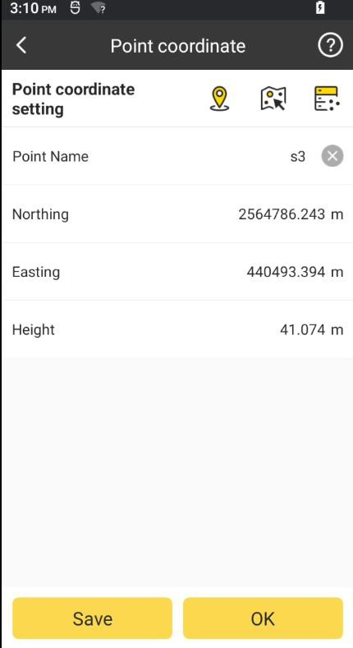

We can also put the device in the point and collect the coordinate in site. Click the icon in

the right of the Point coordinate setting bar. And click to collect it.

OK

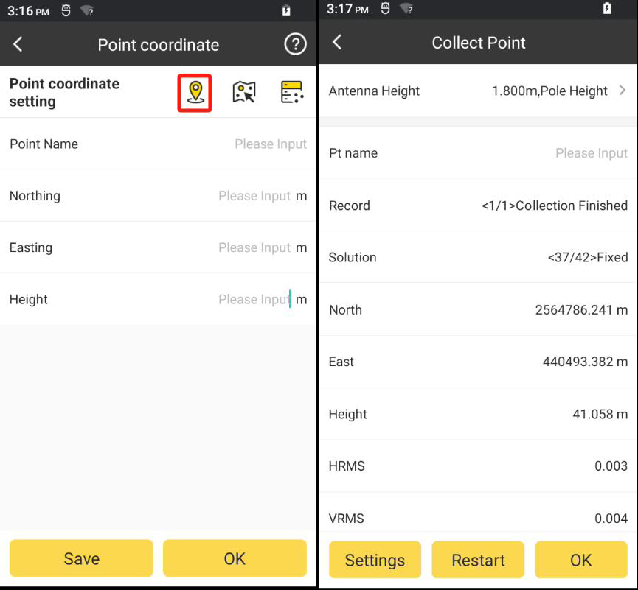

Click OK. And the point will add to point list.

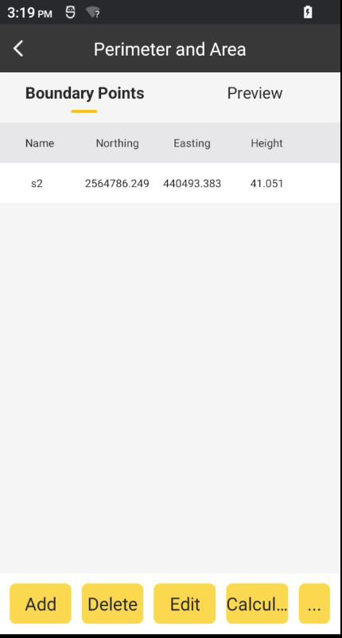

We can delete or edit a point after selecting it and then click When we finished the input of the points, then we click

Calculate

Delete

or Edit.

and there will show the

result of perimeter and area.

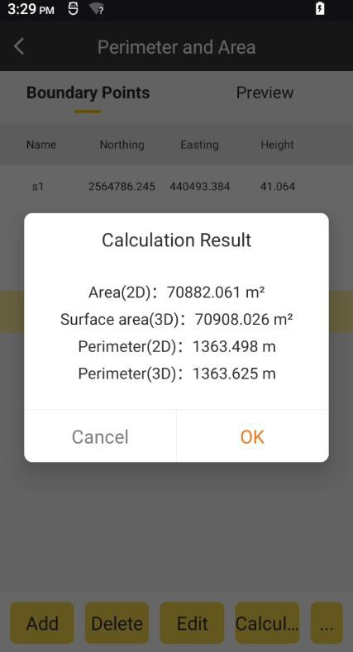

We can check the shape of the polygon by click the PREVIEW.

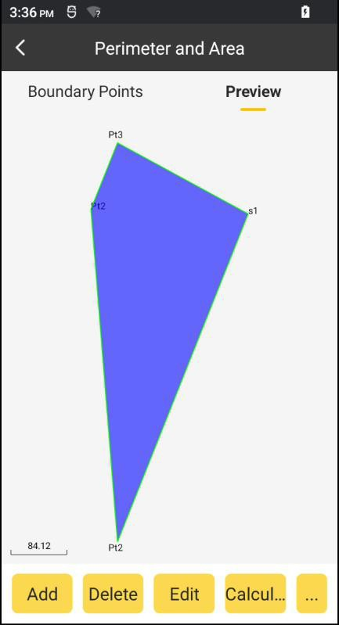

Import:

Click and Click Import. Select the file type: NEH Format(*.csv|dat|txt ) or Cass

…

Format(*.dat). Click OK. Select file path and click the file. Click OK.

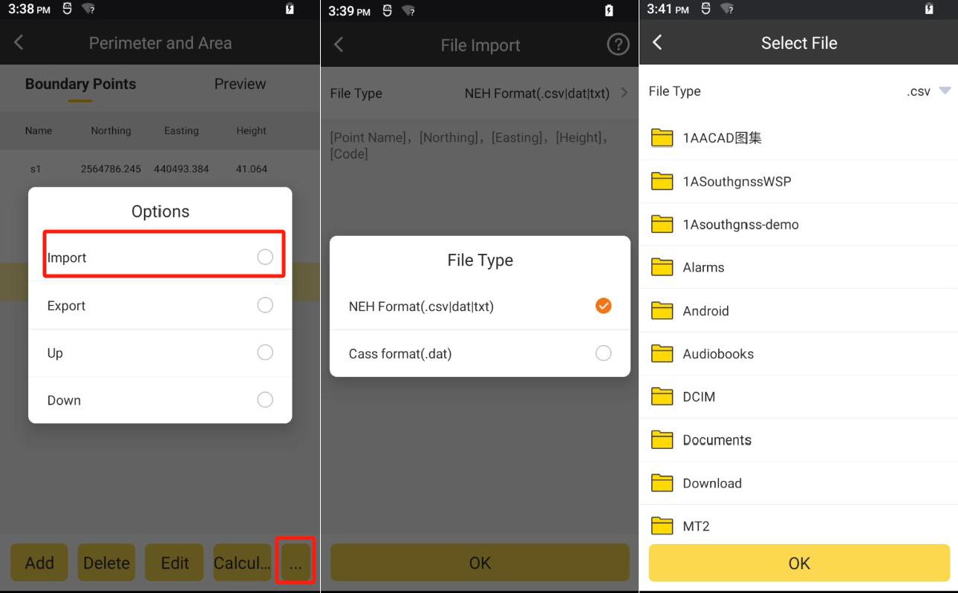

Export:

Click and Click Export. Select the file type: NEH Format(*.csv|dat|txt ) or Cass

…

Format(*.dat). Click OK. Select file path. Click OK.

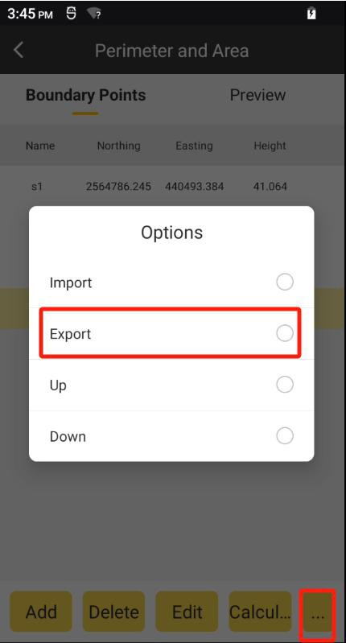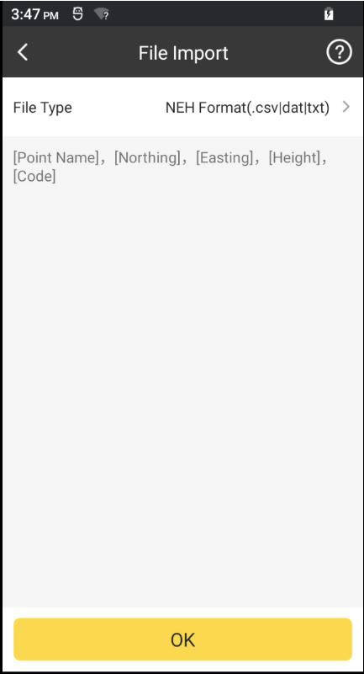

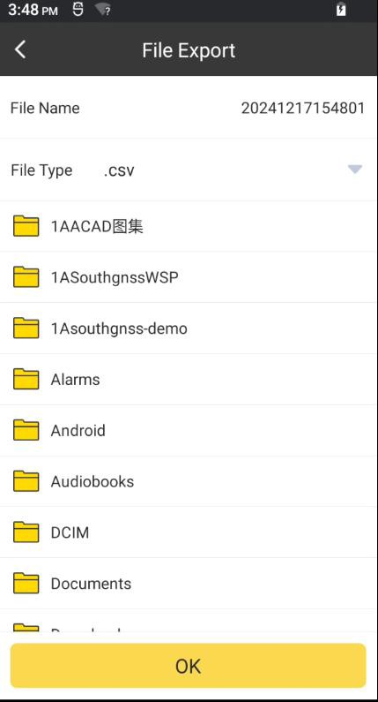

Delete Selected data: Click Delete. Click OK.

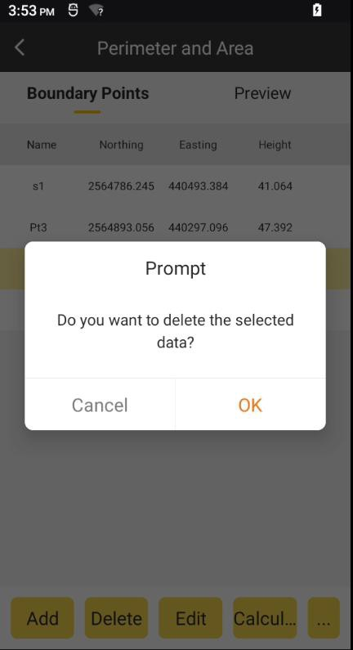

Up/Down Point:

Select a point, click and Click Up/Down. Then the selected point will move up/down.

…

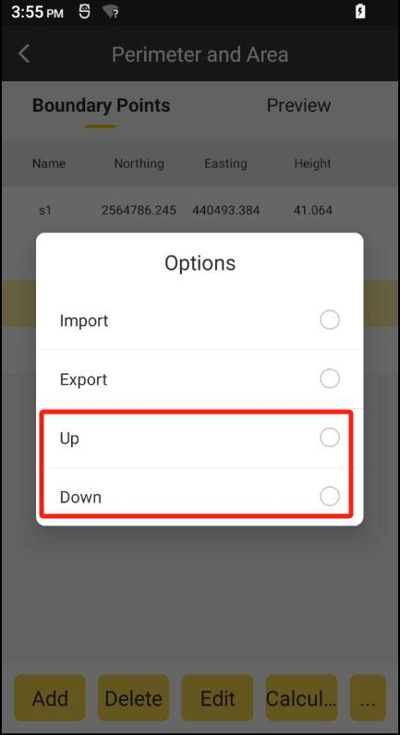

## COGO

Click COGO to enter to this page. According to the known coordinates, it can figure out position relations between point and point as well as between point and line. It includes Coordinate inverse calculation, Point line calculation, Vector, Two Lines Angle and other calculation, which will be introduced in the following.

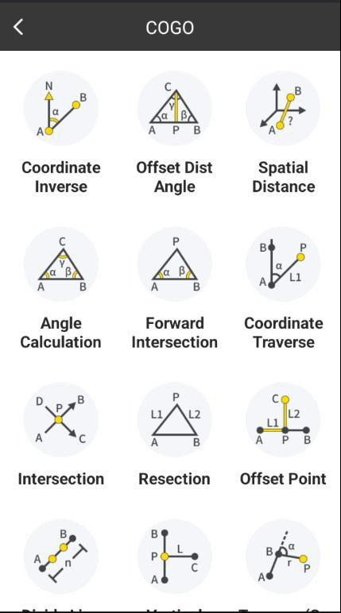

The following three icons in COGO Calculation mean:

: Collect current coordinate.

: Points Database.

There are three ways to set points: 1. Extract coordinates from Points Database; 2. Collect current GPS coordinates; 3. directly input values of Northing, Easting and Elevation.

Calculation result in COGO calculation can be stored in Points Database with Click Save.

## Coordinate Inverse

Set Start Point A and End Point B, and click to calculate the Horizontal Distance,

Calculate

Azimuth, H Difference, Slope Ratio and Slope Distance.

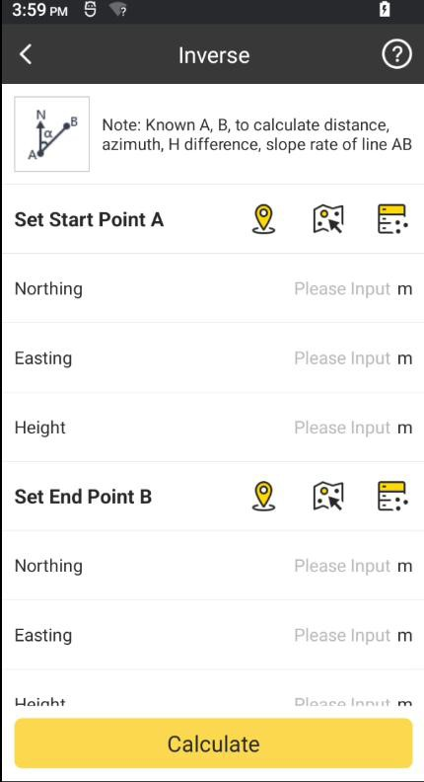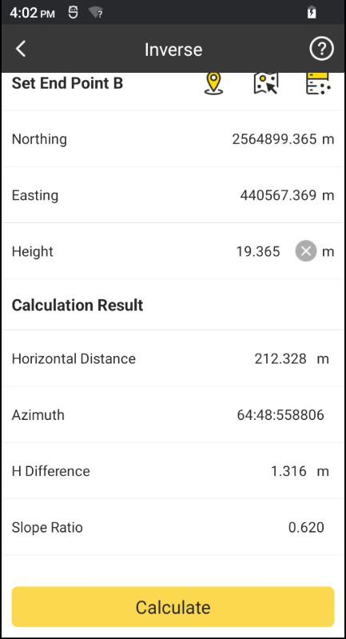

## Offset Distance/Angle

Set Start Point A, End Point B and Offset Point C, and then click to calculate the

Calculate

Distance(AC), Distance(BC), Distance(AP), Distance(BP), Offset Distance(CP), Offset Angle and Corner Angle.

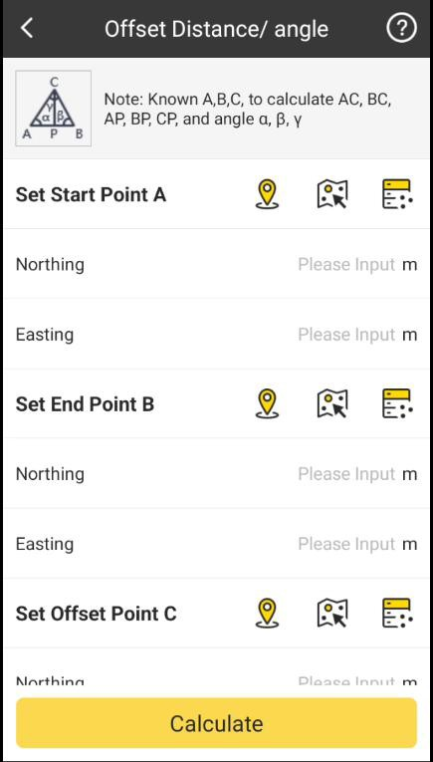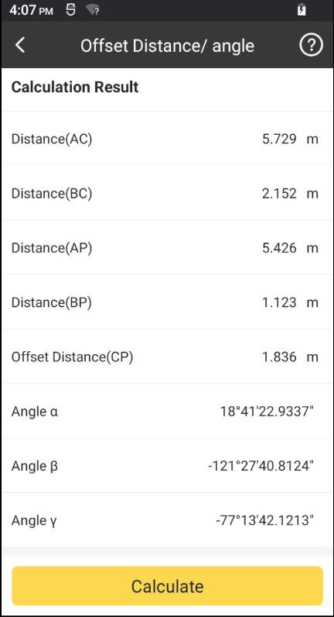

## Spatial Distance

Set Start Point A and End Point B, and then click Distance.

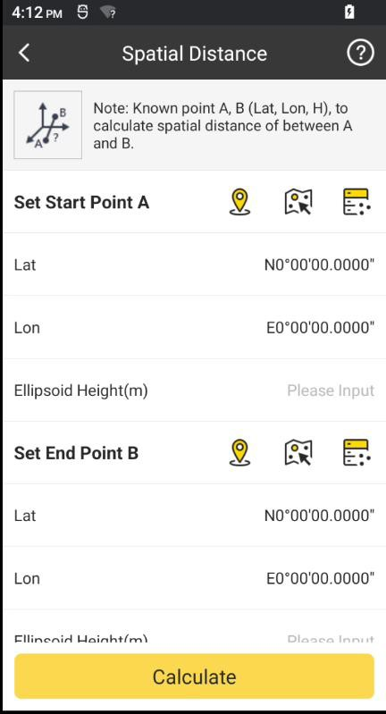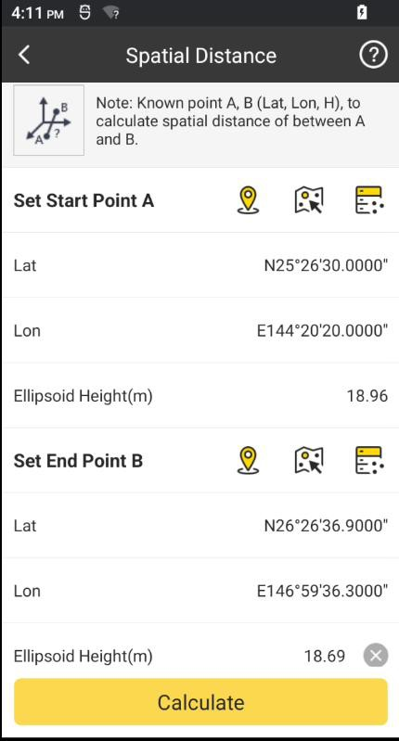

Calculate

to calculate the Spatial

## Angle Calculation

Set Point A, Point B and Point C, and then click BAC and ACB.

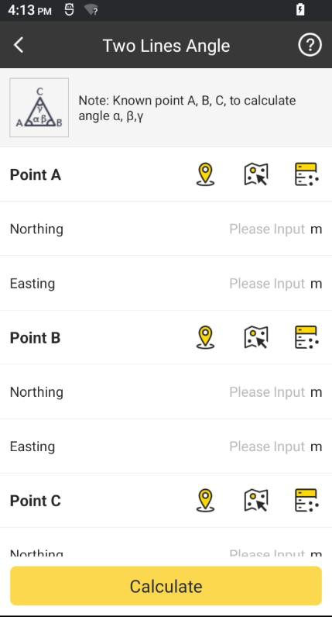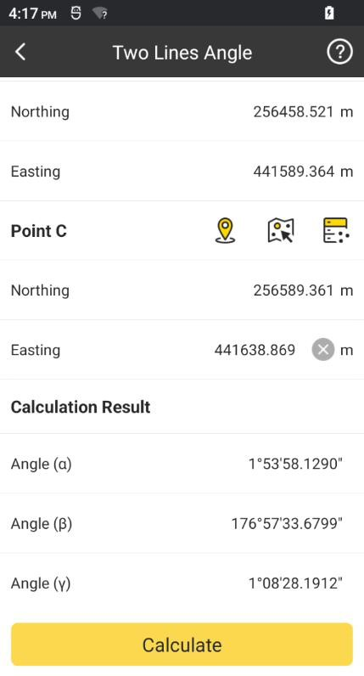

Calculate

to calculate the Angle ABC,

## Intersection

Set Point A, Point B, Point C and Point D, and then press intersection coordinates and intersect angle.

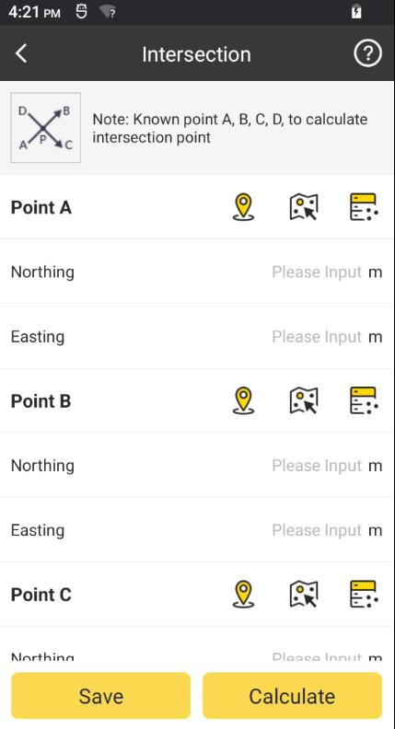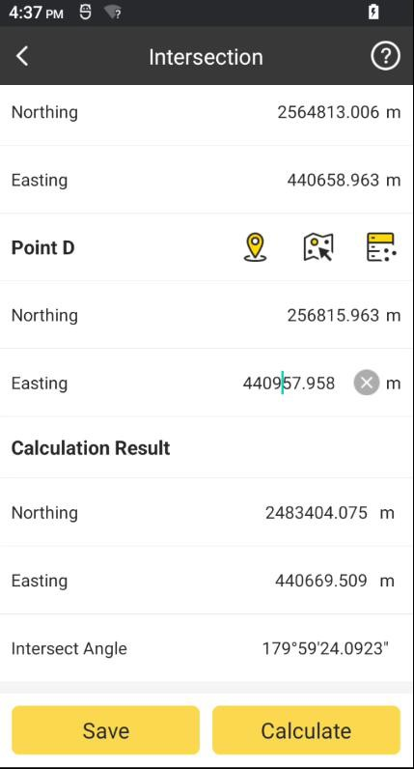

Calculate

to calculate the

## Resection

Set Line L1, L2, Point A and Point B, and then click coordinates.

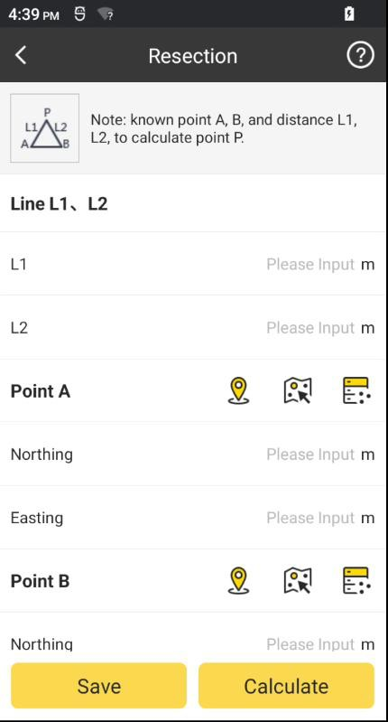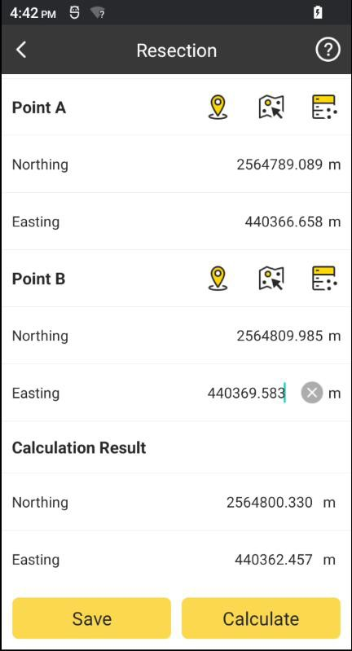

Calculate

to calculate the point

## Forward Intersection

Set Angle α, β, Point A and Point B, and then click to calculate the intersection

Calculate

point coordinates.

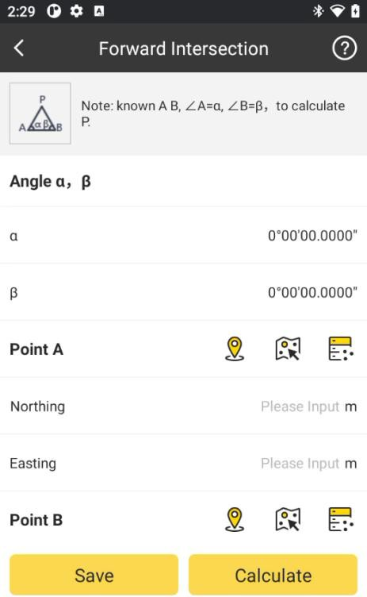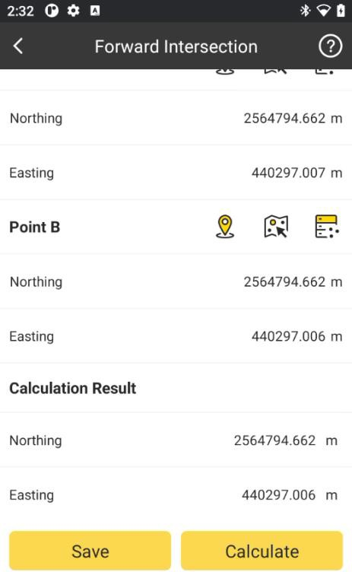

## Coordinate Traverse

Set Line L1, Angle α, Point A and Point B, and then click to calculate the

Calculate

traverse point coordinates.

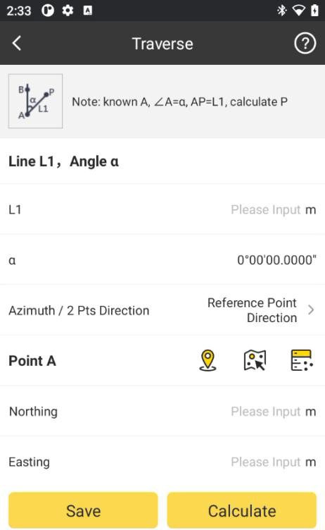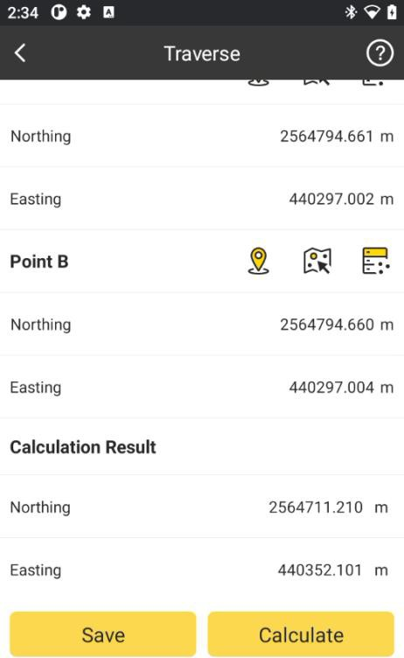

## Offset Point

Set Start Point A, End Points B, Line L1(from A to P), Line L2(Offset Distance), and then

click to calculate the offset point coordinates.

Calculate

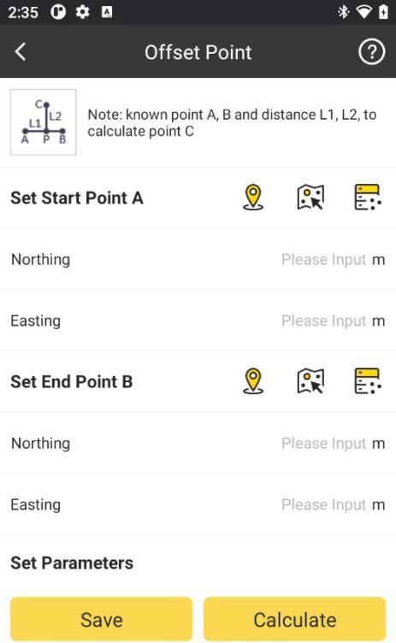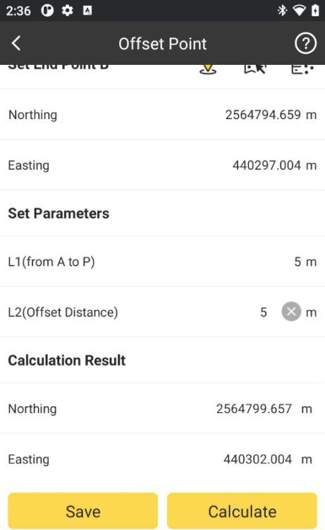

## Divide Line Equally

Set Start Point A, End Point B, and Section Number, and then click to

Calculation

calculate equally divided points’ coordinates.

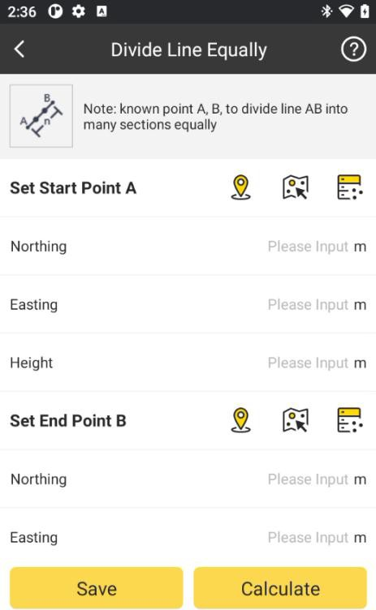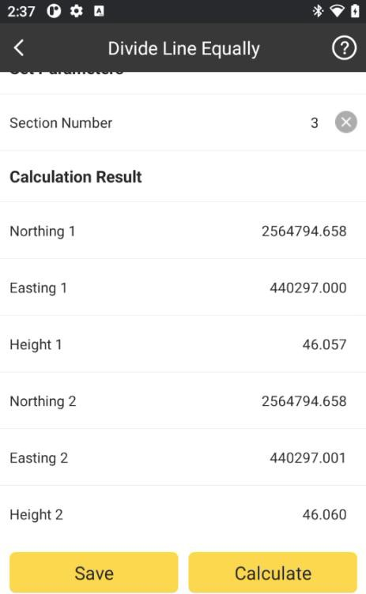

## Circle Center

Set Point A, Point B, and Point C, and then click to calculate Coordinates of

Calculation

the circle center.

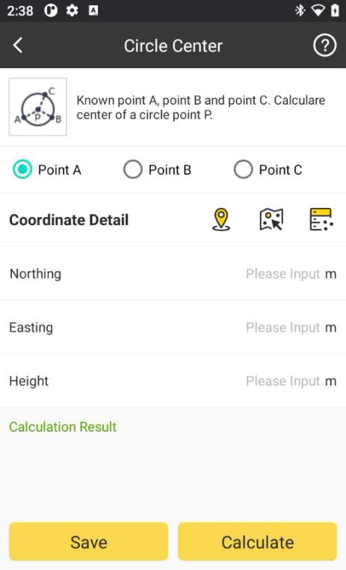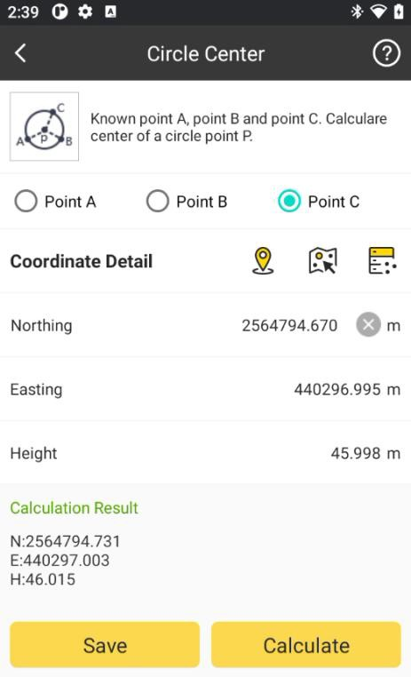

## Traverse Calculation(2 Pts direction)

Set Point A, Point B, Angle α and Line r, and then click coordinates.

Calculation

to calculate the point

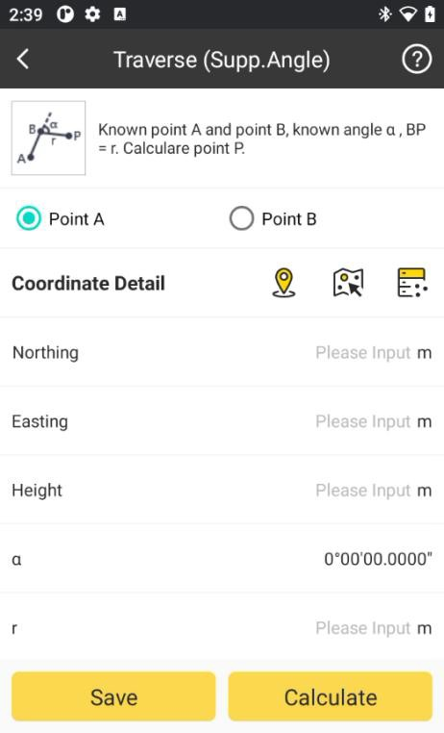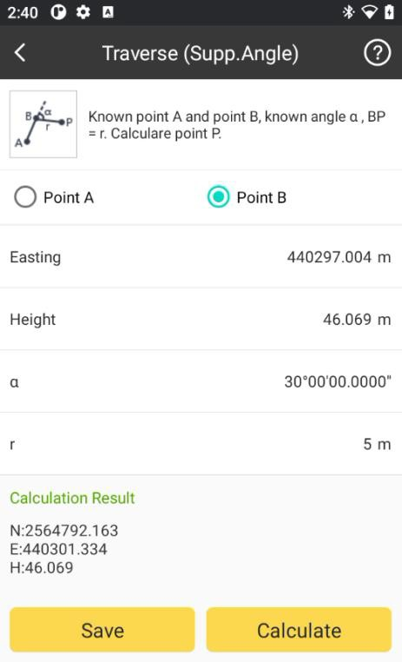

## FTP Share

In FTP Share, we can share files using FTP. And there are two FTP modes, by Client and by Server.

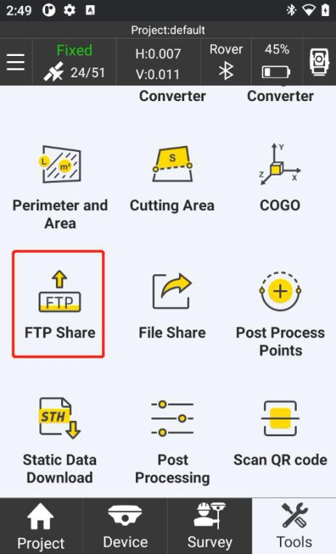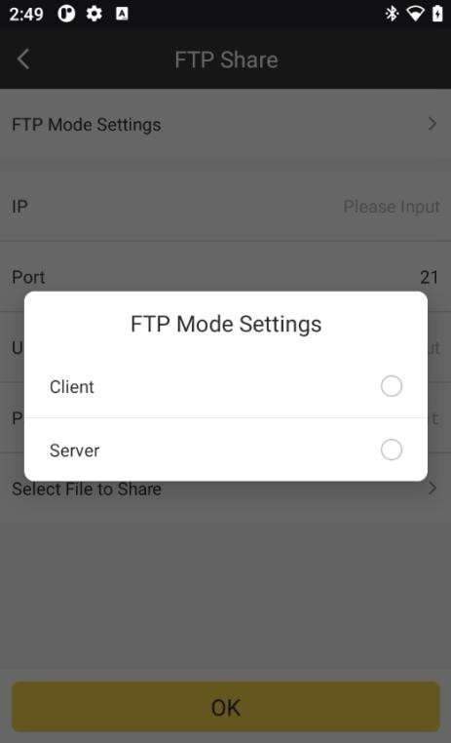

**Client Mode**: Upload files to FTP server.

We need to have a FTP server, and input IP, Username and Password to access the server.

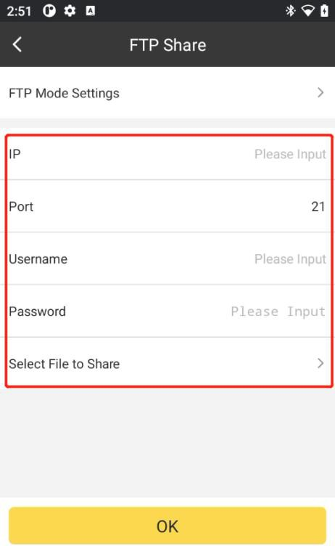

And then we can Select File to Share to upload files to the FTP server.

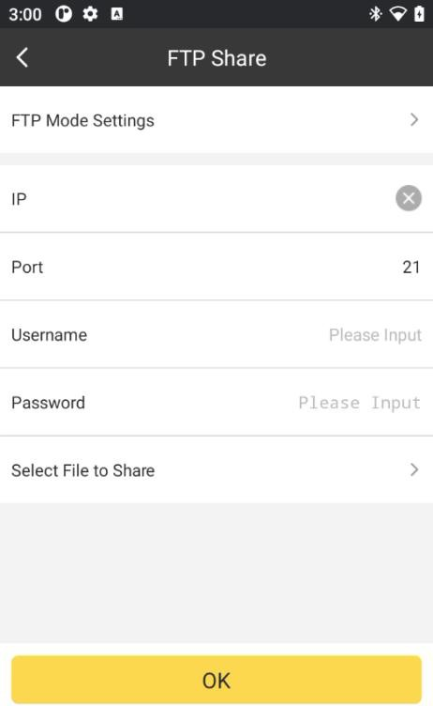

**Server Mode**: Make android device as FTP server

Another device must be in the same LAN of android device install SurvStar. By activating this mode, we can access to the android phone internal memory by FTP:// android device LAN IP:2121.

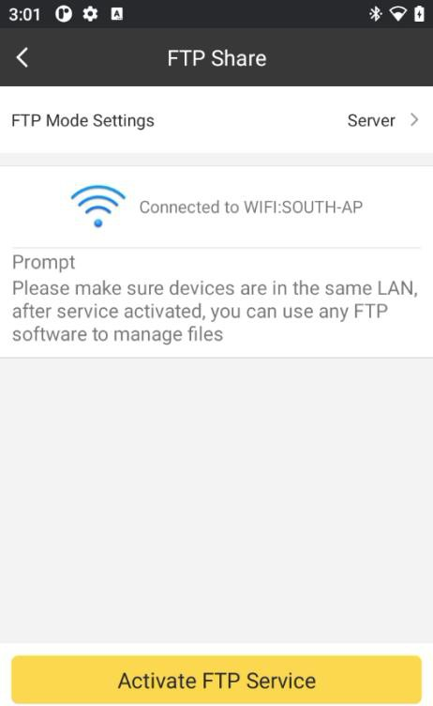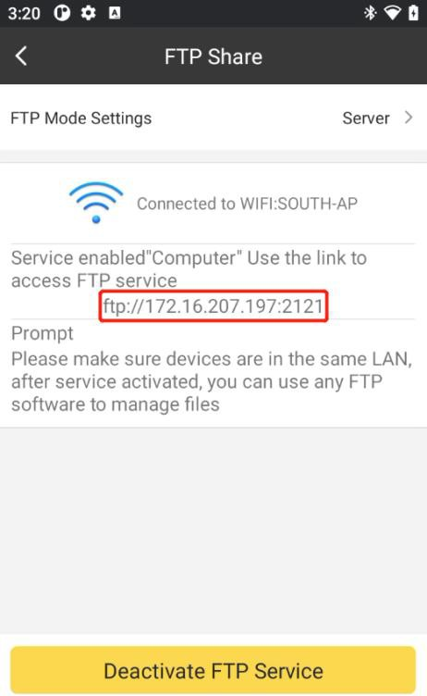

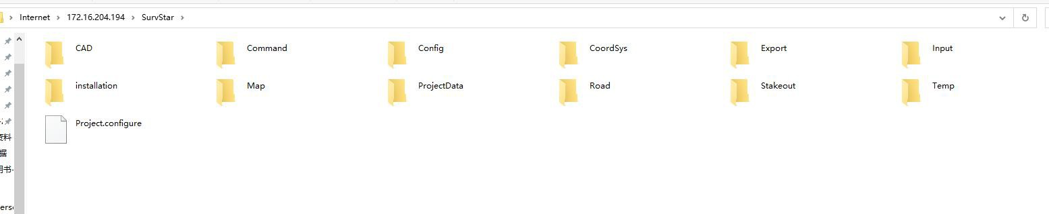

## File Share

By clicking this, we can share the data file to the other app or the other device. Select the shared file and click OK, then we can share the selected file.

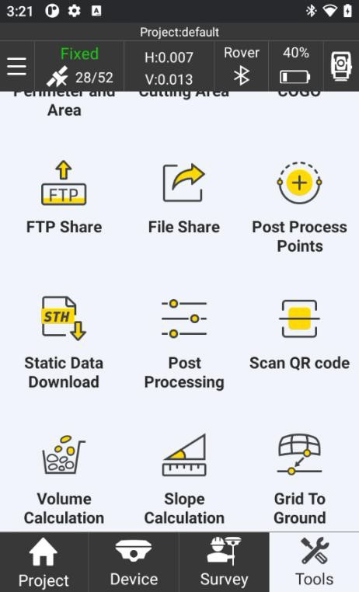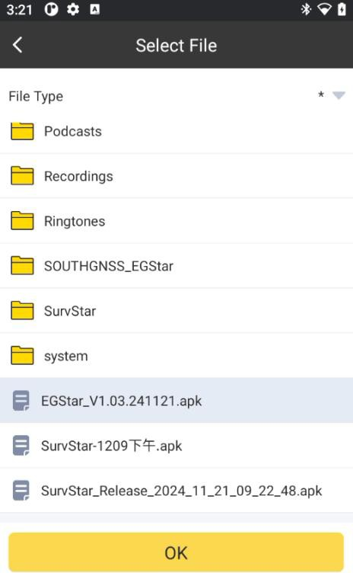

## Post-Process Points

In this section, we can make single point calibration for all collected points. If we know offsets in X, Y and H, we can input offset values directly.

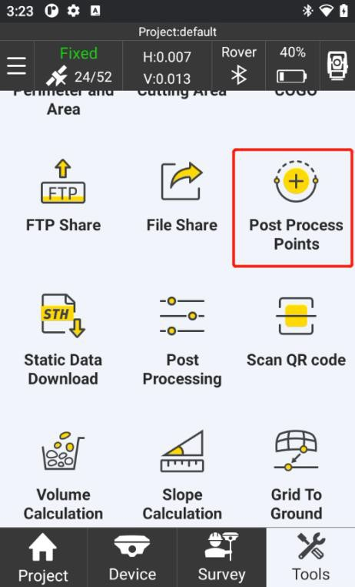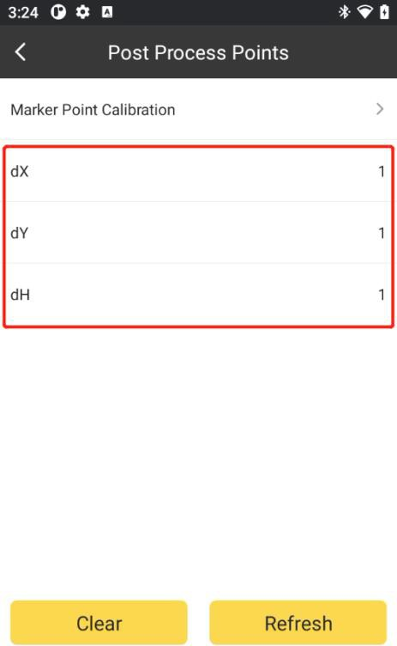

We can also click Marker Point Calibration to calculate the offset parameters.

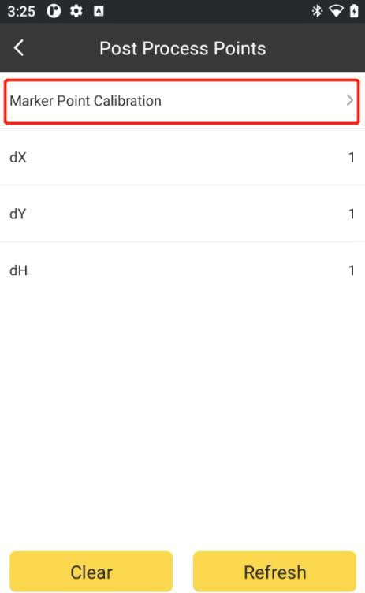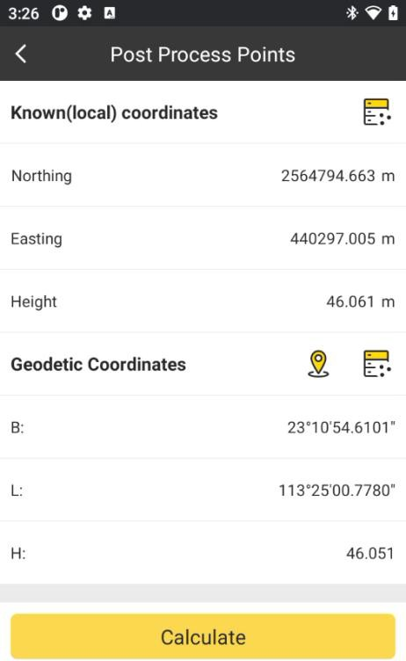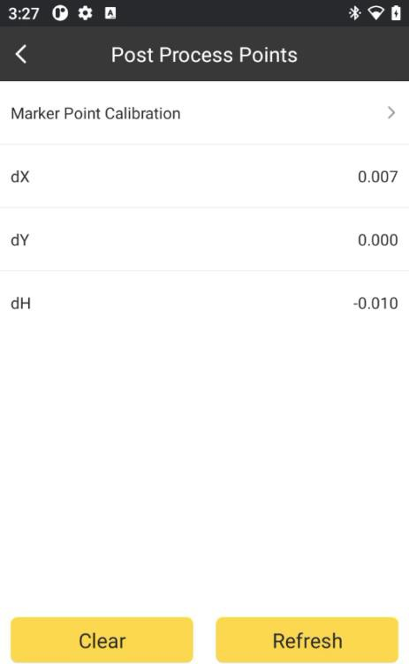

Then click Refresh, select the base to be calibrated, click Refresh. Then select the Starting

Time and the Ended Time, then the surveyed point in that period will be calibrated.

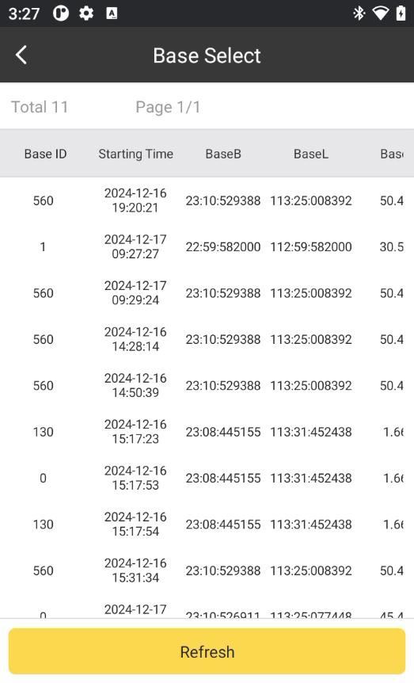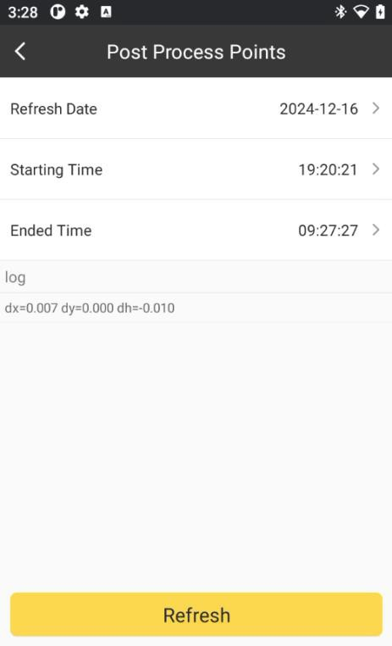

SurvStar User Manual